Experiment 1: Introduction and Comparative Study of Deep Learning Frameworks.

Objective:
To gain a foundational understanding of the architecture, syntax, and core functionalities of popular deep learning frameworks: TensorFlow, Keras, and PyTorch. This experiment aims to compare their approaches to building and training a simple neural network.

Tasks:
- Setup and Installation: Install the latest stable versions of TensorFlow, Keras, and PyTorch in your development environment.
Pytorch:
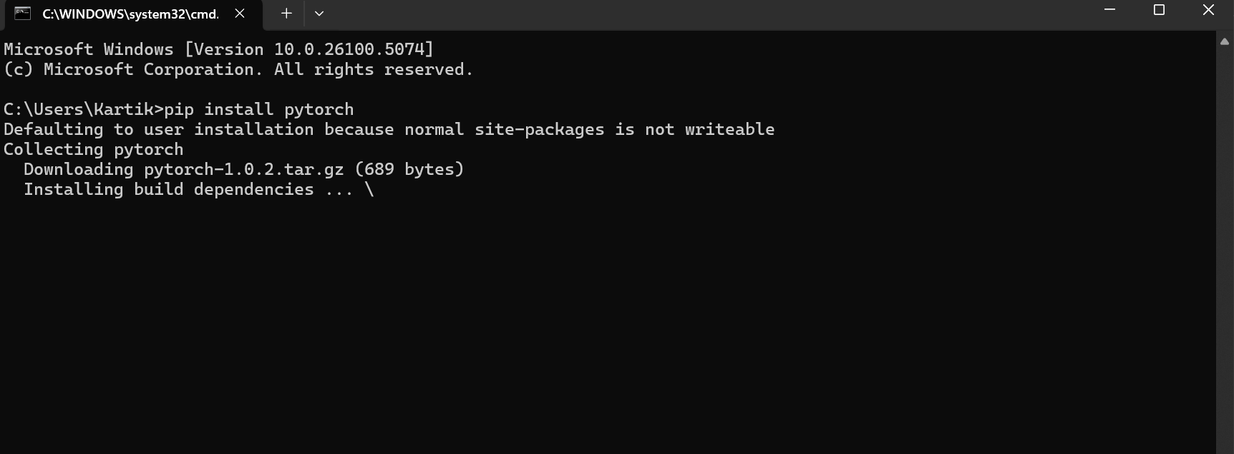
Keras:
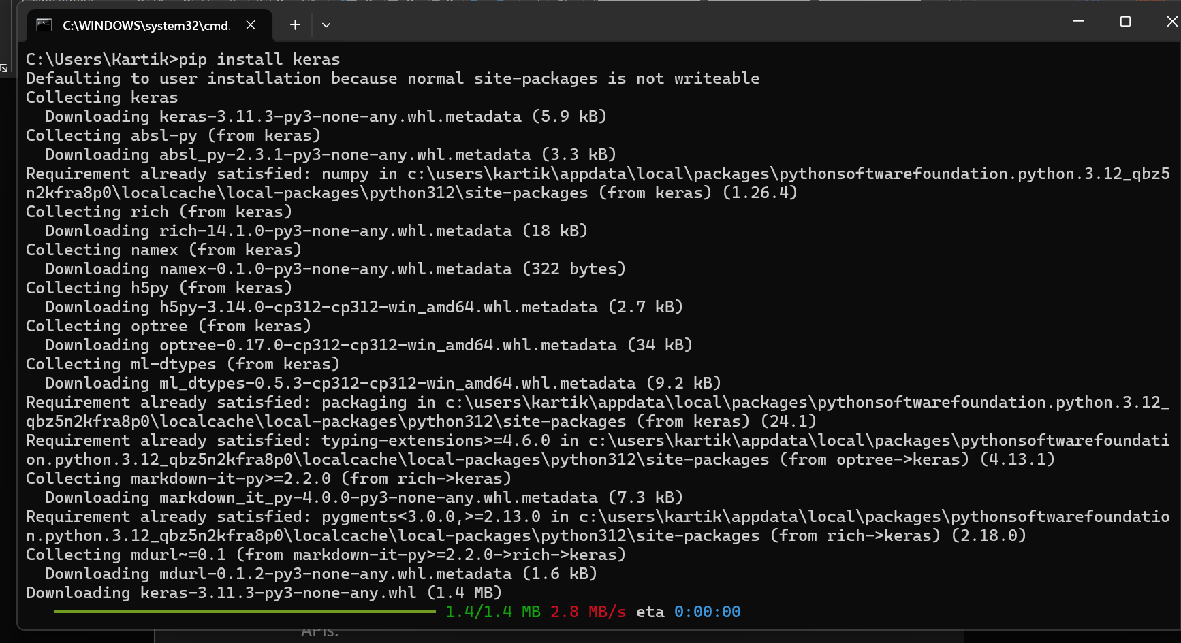
TensorFlow:
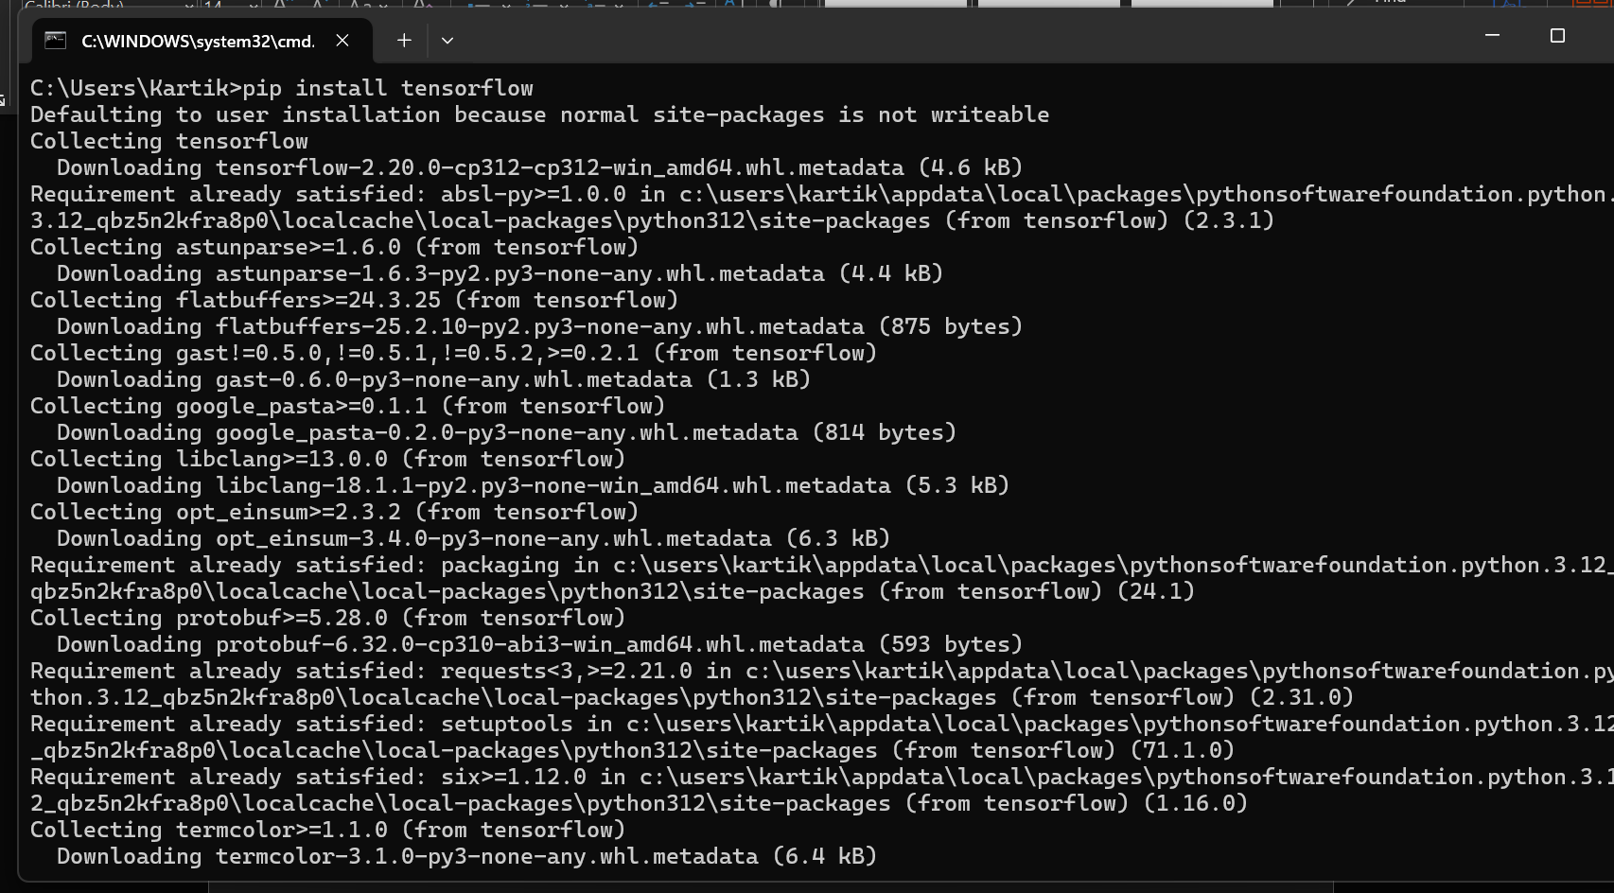

- Framework Exploration: Review the official "Getting Started" tutorials for each framework to understand their core concepts, such as tensors, computational graphs (in TensorFlow and PyTorch), and model-building APIs.
1. TensorFlow (and Keras)
The official TensorFlow guide now heavily emphasizes the Keras API for its simplicity and high-level abstraction.
Core Concepts from the "Getting Started" Tutorial:
- Tensors: Multi-dimensional arrays with a uniform type (dtype). They are the fundamental data structure, similar to NumPy's ndarray. A tensor has a shape (e.g., (batch_size, height, width, channels) for an image).
- Eager Execution: The default mode of operation. Operations are executed immediately and return concrete values, making debugging easy and the development process interactive. This makes TensorFlow feel much more like PyTorch and NumPy.
Computational Graphs (under the hood): Even in eager mode, TensorFlow builds graphs behind the scenes. You can still use tf.function to explicitly compile your Python code into a static, highly optimized graph. This is crucial for achieving maximum performance in production.
Model-Building APIs:
- Sequential API: Simplest API, for stacking layers linearly
2. PyTorch
PyTorch's "Getting Started" is built around its intuitive, imperative style.
Core Concepts from the "Getting Started" Tutorial:
- Tensors: Almost identical to NumPy arrays but with a killer feature: they can live on the GPU to accelerate computation. This is the core building block.
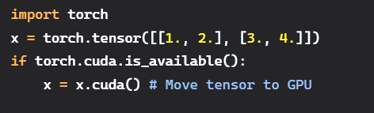
Dynamic Computational Graphs (Autograd): This is PyTorch's defining feature. The graph is built on-the-fly during the forward pass. Every tensor involved in a computation has a .grad_fn attribute that points to the function that created it, building a dynamic graph of the operation history.
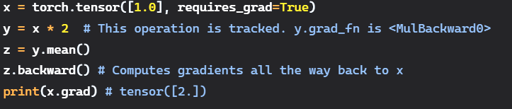

1. Code Verbosity and Readability
The amount of code required for a standard task (like training a simple neural network) varies significantly based on the framework's level of abstraction.
Task: Define and Train a Simple MNIST Classifier

2. API Design: Declarative vs. Imperative (Define-by-Run)
This is the most significant philosophical difference between the frameworks.
Feature | TensorFlow/Keras (Declarative) | PyTorch (Imperative / Define-by-Run) | JAX (Functional)
Core Philosophy | "Define the graph, then run it." You declare the structure of the model first. The execution is separate. | "Define by running." The computation graph is built on the fly as the forward method is executed. | "Transform pure functions." The model is a function that is transformed by grad, jit, etc.
Analogy | Blueprint for a car. You design all the parts and their connections before building it. | Building a car by hand. You put each piece on as you go, seeing the result immediately. | A box of tools and car parts. You use functional tools to assemble the car yourself.
Control Flow | Historically tricky in graph mode. Now handled well by AutoGraph in tf.function, but can still be a source of complexity. | Trivial. Uses native Python if, for, while statements. Highly intuitive. | Uses functional control flow from the jax.lax module (e.g., lax.scan, lax.cond), which is less intuitive than Python but required for jit.
Flexibility | High (especially with subclassing), but the graph can sometimes feel constraining for highly dynamic models. | Extremely High. The imperative style makes it easy to implement novel, complex, or changing architectures. | Maximum Flexibility. You have complete control over every part of the process. It's a foundation to build upon.
Performance | The static graph (tf.function) allows for advanced optimizations, leading to excellent and consistent production performance. | Dynamic graph can have overhead. The trend is towards "graph mode" via torch.jit.script or FX for better performance. | The functional style and jit allow for incredibly aggressive XLA optimizations, often leading to the best raw performance.

3. Debugging and Introspection
Ease of debugging is directly tied to the execution model.
PyTorch (Easiest)
- Native Python: Since the graph is built dynamically using standard Python code, you can use any Python debugger (PDB, IDE debuggers).
- Set Breakpoints: You can set a breakpoint inside the forward method, inspect tensors, print their values, and step through the code line-by-line exactly as you would with any other Python program.
- Introspection: Tensors are just objects. Printing them gives their immediate values. print(x.shape) or print(x) works as expected during execution.
TensorFlow (Good, with Caveats)
- Eager Execution: In the default eager mode, debugging is almost as easy as PyTorch. You can print tensor values and use debuggers.
- Graph Mode Complexity: The main challenge arises when using tf.function. Debugging the optimized graph is more difficult. Errors can be cryptic and point to the generated graph code, not your original Python code. Tools like tf.print are needed instead of print.
- tf.debugging Module: Provides useful functions like assert_equal, check_numerics to help track down issues.
JAX (Most Challenging)
- Functional Purity: The requirement for pure functions means you cannot use print statements for debugging inside JIT-compiled functions (@jit). The function might be executed only once during compilation, so the print would only fire once, not for every call.
- Specialized Tools: Requires learning JAX-specific debugging tools:
  - jax.debug.print(): A special print function that works inside JIT-compiled code.
  - jax.experimental.checkify: A library for adding runtime error checking and assertions to JIT-compiled code.
- Abstract Values: During JIT compilation, your code is traced with abstract values (shapes and dtypes, not concrete data). Errors might only be caught at this compilation stage, not during the initial Python execution.

