**CRYPTOGRAPHY**

• **Substitution2**

It seems that another encrypted message has been intercepted. The encryptor seems to have learned their lesson though and now there isn't any punctuation! Can you still crack the cipher?

I did frequency analysis for substitution first, following were the results:

|  |  |  |  |  |  |  |  |  |  |  |  |  |  |  |  |  |  |  |  |  |  |  |  |  |  |  |  |  |  |  |  |  |  |  |  |  |  |  |  |  |  |  |  |  |  |  |  |  |  |  |  |  |  |  |  |  |  |  |  |  |  |  |
| --- | --- | --- | --- | --- | --- | --- | --- | --- | --- | --- | --- | --- | --- | --- | --- | --- | --- | --- | --- | --- | --- | --- | --- | --- | --- | --- | --- | --- | --- | --- | --- | --- | --- | --- | --- | --- | --- | --- | --- | --- | --- | --- | --- | --- | --- | --- | --- | --- | --- | --- | --- | --- | --- | --- | --- | --- | --- | --- | --- | --- | --- | --- |
| |  |  |  |  | | --- | --- | --- | --- | | F | 175× | 13.87% |  | | N | 125× | 9.9% |  | | X | 103× | 8.16% |  | | Q | 102× | 8.08% |  | | L | 98× | 7.77% |  | | E | 83× | 6.58% |  | | T | 68× | 5.39% |  | | Z | 63× | 4.99% |  | | |  |  |  |  | | --- | --- | --- | --- | | Y | 61× | 4.83% |  | | A | 56× | 4.44% |  | | P | 46× | 3.65% |  | | W | 42× | 3.33% |  | | V | 39× | 3.09% |  | | G | 35× | 2.77% |  | | B | 34× | 2.69% |  | |  |

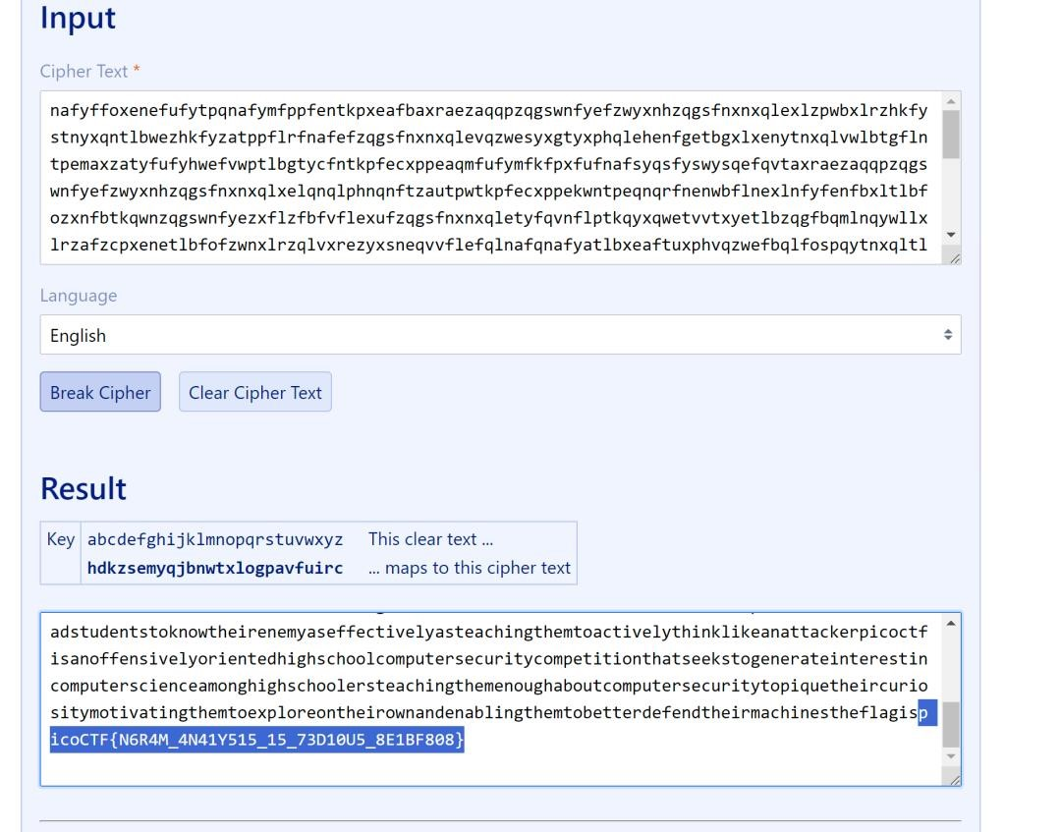

I came across <https://www.guballa.de/substitution-solver>which can solve any substitution cypher without the requirement of a key.

• **Transposition-trial**

Our data got corrupted on the way here. Luckily, nothing got replaced, but every block of 3 got scrambled around! The first word seems to be three letters long, maybe you can use that to recover the rest of the message.

Message - heTfl g as iicpCTo{7F4NRP051N5_16_35P3X51N3_V9AAB1F8}7

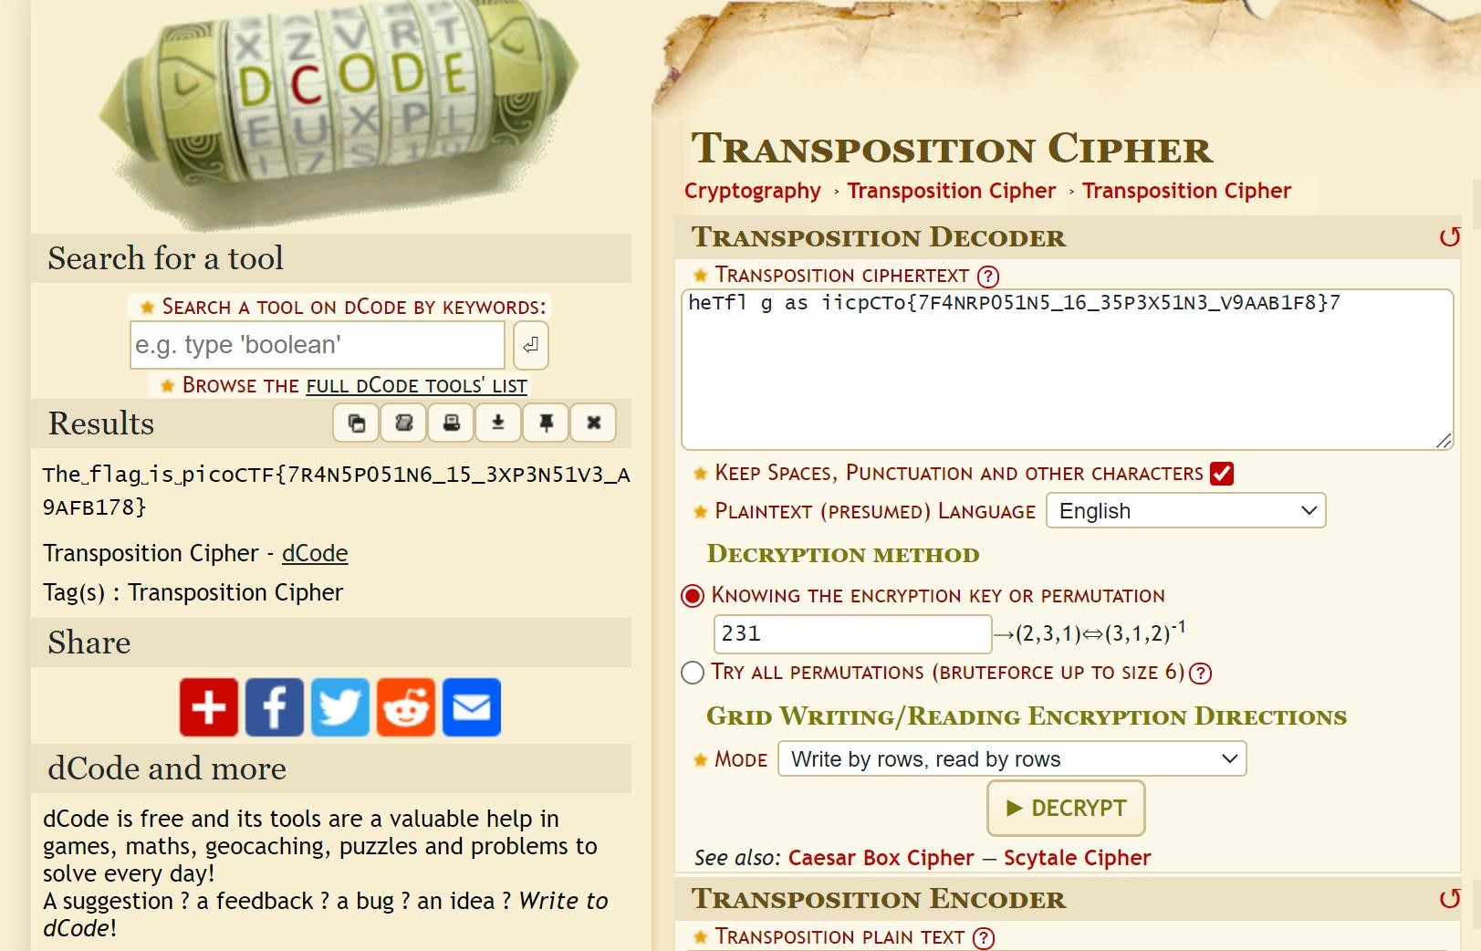

The code was 231 as the first word was 3 letter as given in the hint, read and written both in rows.