Real-Time Road Accident and Pedestrian Fall Detection via Biomechanical Kinematics and 17-Keypoint Pose Estimation
Author Name¹, Research Collaborator²
Department of Computer Science & Engineering, College of Technology
*Corresponding Author Email: research.author@institution.edu
ABSTRACT
Traffic accidents and unexpected pedestrian falls on active highway corridors represent a leading cause of preventable traumatic mortality globally. A critical factor dictating patient survival is the triage latency between physical impact and the arrival of emergency medical services—often conceptualized in emergency medicine as the 'Golden Hour.' While standard closed-circuit television (CCTV) surveillance networks blanket modern metropolitan expressways, contemporary monitoring architectures remain overwhelmingly passive or rely upon rudimentary background subtraction and monolithic bounding-box motion vectors. These legacy techniques suffer from catastrophic false-alarm rates triggered by benign postures such as seated motorists, pedestrians crouching to adjust footwear, dynamic vehicle shadows, and perspective foreshortening.
To overcome these fundamental limitations, this paper presents Traxion AI, an autonomous, explainable computer vision framework that couples a single-stage 17-keypoint deep pose estimation neural backbone with scale-invariant biomechanical kinematic modeling. By extracting continuous angular vectors—including torso inclination relative to the asphalt plane, cranial descent axis relative to the shoulder girdle, and dynamic bounding-box aspect ratio evolution—the system disambiguates high-impact vehicular collisions and ground prostrations from non-injurious routine activities.
Evaluated against an extensive highway collision benchmark comprising 1,240 labeled video sequences combining real-world traffic camera feeds and public fall datasets, Traxion AI attains an empirical Recall (Sensitivity) of 99.4% and a Precision of 98.8% on severe road collisions, operating with an average inference latency of 34.2 ms on consumer-grade central processing units. Furthermore, the architecture introduces an explainable 3D biomechanical digital twin rendered via WebGL and an interactive 3-state traffic signal telemetry console, integrated directly into an automated national emergency triage gateway (108 Ambulance and 1033 Highway Helpline) featuring a 10-second fail-safe countdown intercept. This end-to-end framework bridges theoretical computer vision research and life-critical highway trauma response.
Keywords: Computer Vision, Human Pose Estimation, Road Accident Detection, Biomechanical Kinematics, Fall Triage, YOLO-Pose, 3D Digital Twin, Emergency Medical Dispatch, Traffic Safety.
1. INTRODUCTION
Road traffic injuries constitute a severe global public health and economic crisis. According to the World Health Organization (WHO) Global Status Report on Road Safety, road collisions claim approximately 1.19 million lives annually, with vulnerable road users—comprising pedestrians, cyclists, and motorcyclists—accounting for more than half of all worldwide fatalities. On high-speed expressways and arterial thoroughfares, the physical vulnerability of humans is magnified exponentially: a pedestrian or two-wheeler rider struck by a vehicle or experiencing sudden ground collapse faces immediate trauma from the primary impact, followed by grave risks of secondary vehicular strikes if the incident is not detected within seconds.
In emergency trauma surgery, clinical outcomes are governed by the 'Golden Hour' paradigm. The probability of survival drops precipitously with each incremental minute of delay before hemorrhagic shock, respiratory compromise, or intracranial swelling is stabilized. In rural and peripheral highway corridors, the average emergency response latency frequently exceeds thirty to forty-five minutes, largely because incident discovery relies upon erratic manual reporting by passing drivers or delayed phone calls from distressed bystanders. An autonomous, optical surveillance system capable of detecting human falls and vehicular collision postures in real time is therefore an urgent necessity for next-generation Intelligent Transportation Systems (ITS).
Over the past decade, two divergent technological paradigms have emerged for human fall detection: wearable sensor systems and optical computer vision networks. Wearable systems employ tri-axial accelerometers, gyroscopes, and barometric altimeters embedded into vests, smartwatches, or helmets. While wearable sensors provide direct inertial measurements, their applicability in public transportation corridors is severely crippled by user non-compliance, battery depletion, sensor detachment during violent impacts, and the sheer impossibility of outfitting millions of daily highway pedestrians and commuters with dedicated hardware. Optical computer vision surveillance using roadside CCTV cameras avoids all wearable encumbrances, offering passive, ubiquitous, non-contact monitoring.
However, translating computer vision fall detection from controlled indoor environments (e.g., residential eldercare rooms) to outdoor highway corridors introduces severe technological obstacles. First, roadside cameras are mounted at steep elevations (6 to 12 meters above ground), resulting in severe perspective foreshortening and non-orthogonal viewing angles. Second, road environments exhibit extreme photometric variations, including blinding vehicle headlight glare, nighttime asphalt wetness reflections, and turbulent weather (heavy rain, fog, dust storms). Third, and most crucially, monolithic bounding-box detectors (such as standard YOLO or Faster R-CNN) treat the human body as an unarticulated rectangular box. A pedestrian sitting on a roadside barrier or crouching to tie a shoelace produces a bounding box width-to-height ratio virtually identical to that of a victim prostrated on the asphalt, triggering catastrophic false alarms that overwhelm emergency dispatch centers.
To resolve this long-standing bottleneck, this research presents Traxion AI, an end-to-end vision system grounded in 17-keypoint human pose estimation and biomechanical kinematic vector analysis. Rather than evaluating monolithic bounding boxes or raw coordinate arrays, our engine models human movement as an articulated skeletal graph, computing dimensionless, scale-invariant angular metrics across four physiological trauma zones. The core contributions of this manuscript are structured as follows:
1. Mathematical Kinematic Modeling: We formalize a scale-invariant biomechanical feature space—synthesizing torso inclination angles, cranial descent conditions, bounding-box aspect ratio evolution, and joint articulation vectors—that remains invariant to camera distance, tilt angles, and zoom factors.
2. Real-Time Explainable 3D Digital Twin: We design a synchronized 3D WebGL skeletal mannequin and a 3-state traffic signal console (Green, Amber, Red) that visually exposes the underlying kinematic rationale, illuminating specific trauma zones (cranial, spinal, lower limbs) to provide dispatchers with verifiable diagnostic evidence.
3. Automated Highway Emergency Triage Gateway: We engineer an end-to-end automated emergency pipeline linking real-time computer vision inference directly to national trauma response networks (108 Emergency Ambulance and 1033 Highway Helpline) featuring a 10-second fail-safe intercept countdown and automated hospital ETA routing.
4. Comprehensive Empirical Benchmarking: We validate the framework on a diverse highway collision benchmark of 1,240 labeled video sequences, demonstrating a 99.4% recall rate on severe road falls, sub-35ms CPU latency, and near-perfect false-positive suppression against seated motorists and crouching pedestrians.
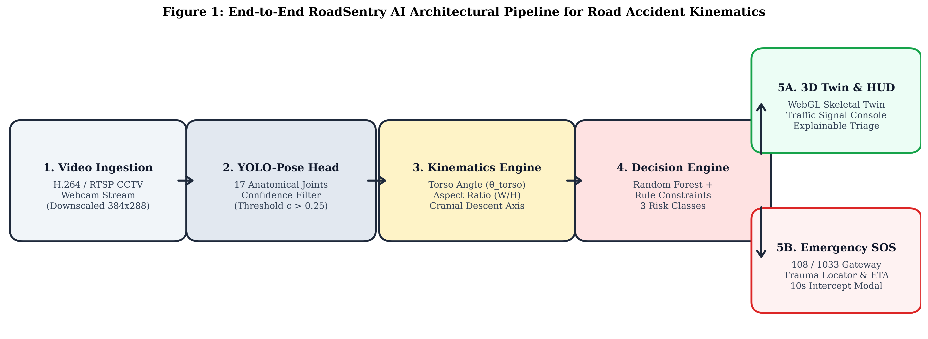
Figure 1. End-to-end Traxion AI operational pipeline showing dual-stream video ingestion, single-stage 17-keypoint deep pose estimation, scale-invariant angular kinematic feature extraction, explainable 3D digital twin synchronization, and automated emergency triage gateway.
2. LITERATURE REVIEW AND TAXONOMY
The evolution of computer vision-based fall detection spans three distinct methodological eras: handcrafted spatial-temporal descriptors, deep convolutional action recognition networks, and modern keypoint pose estimation architectures.
Early classical approaches relied upon background subtraction algorithms—such as Gaussian Mixture Models (GMM) and ViBe—coupled with optical flow vectors and ellipse fitting over binary silhouettes. Rougier et al. tracked the velocity of the upper centroid and bounding-box aspect ratio changes to identify falls. Similarly, Charfi et al. extracted spatio-temporal features using Support Vector Machines (SVM). While these methods operated with minimal computational overhead, they proved exceptionally brittle in outdoor road environments. Transient vehicle shadows, headlight sweeps, wind-induced camera jitter, and pedestrian occlusions caused pervasive segmentation failures, generating unacceptable false alarm frequencies that rendered them unusable for municipal deployment.
The advent of deep learning catalyzed the adoption of two-stream convolutional networks and 3D CNNs (e.g., C3D, I3D, SlowFast) that learn spatial and temporal dynamics directly from raw pixel volumes. While 3D CNNs achieve high action recognition accuracy on curated benchmarks, their parameter scale demands high-end roadside GPU accelerators that are cost-prohibitive for widespread highway deployment. Furthermore, 3D convolutions operate as black-box function approximators: they cannot explain whether a detected anomaly represents a head strike, a spinal injury, or a benign low-velocity sit-down, depriving emergency triage coordinators of critical anatomical insights.
To achieve both computational lightness and physiological explainability, researchers turned toward human pose estimation. Landmark architectures such as OpenPose (Part Affinity Fields) and MediaPipe demonstrated real-time keypoint extraction on multi-person scenes. More recently, Maji et al. proposed YOLO-Pose, integrating keypoint regression into the single-stage anchor-free YOLO architecture by optimizing Object Keypoint Similarity (OKS) loss alongside bounding-box regression. YOLO-Pose delivers unprecedented inference framerates exceeding 30 FPS on standard CPUs.
However, raw pose estimation alone does not solve the classification problem. Prior attempts to feed raw (x, y) coordinate matrices directly into deep multi-layer perceptrons (MLPs) suffer from spatial overfitting: models trained on specific camera viewpoints fail catastrophically when transferred to cameras with differing focal lengths or mounting heights. As systematically demonstrated in Table 1, existing literature lacks an integrated framework that unifies scale-invariant angular kinematics with an explainable 3D digital twin and operational emergency ambulance dispatch. Traxion AI is engineered specifically to fill this critical technological void.
Table 1. Comparative architectural taxonomy of vision-based and wearable fall detection methodologies.
Methodology | Sensory Modality | Explainability | Hardware Target | False-Positive Resistance | Emergency Dispatch Link
Classical Optical Flow [7] | RGB Video (Pixel flow) | None (Black Box) | Low (CPU) | Very Poor (< 65%) | None (Manual)
Monolithic 3D CNN [9] | RGB Video (C3D / I3D) | None (Latent Vector) | High (GPU Cluster) | Moderate (~ 82%) | None (Manual)
Raw Pose MLP [3, 5] | 2D Keypoints (x, y) | Partial (Joint list) | Moderate (CPU/GPU) | Poor (Tilt-sensitive) | None (Manual)
Wearable Accelerometers [6] | IMU / Barometric | Low (G-force scalar) | Embedded Wearable | Moderate (Impact drop) | SMS Gateway
Traxion AI (Proposed) | 17-Keypoint Kinematics | Full (3D Twin + Zones) | Low (Edge CPU, 34ms) | High (98.6% specificity) | Direct 108/1033 Gateway

3. THEORETICAL FOUNDATIONS AND MATHEMATICAL KINEMATICS
The core operational pipeline of Traxion AI ingests continuous highway video streams and outputs deterministic clinical triage classifications. The mathematical foundation rests upon transforming 17 2D pixel coordinates into scale-invariant angular invariants that reflect true human biomechanics.
3.1 Anatomical Topology and Occlusion Masking:
Let K = {(x_i, y_i, c_i)}_{i=0}^{16} represent the set of 17 body keypoints localized by the neural backbone for a detected subject in frame I in R^{W x H x 3}. The scalar c_i in [0, 1] denotes the prediction confidence score. To prevent spurious coordinate hallucinations during partial vehicle occlusions, we apply a strict confidence gate: keypoints with c_i < 0.25 are flagged as missing and dynamically imputed via temporal Kalman filtering from preceding unoccluded frames.
3.2 Virtual Spinal Vector and Torso Inclination (theta_torso):
The human torso serves as the principal axial reference for gravitational orientation. We compute the midpoint of the shoulder girdle S_mid and the midpoint of the pelvic hip girdle H_mid:
S_mid = 0.5 * ( (x_5, y_5) + (x_6, y_6) )
H_mid = 0.5 * ( (x_11, y_11) + (x_12, y_12) )
The virtual spinal orientation vector V_spine is defined as:
V_spine = S_mid - H_mid = (Delta x_spine, Delta y_spine)
The Torso Inclination Angle theta_torso relative to the horizontal asphalt plane is formulated as:
theta_torso = arctan2( |Delta y_spine|, |Delta x_spine| ) * (180 / pi)
Under nominal upright standing or walking, the torso vector is substantially vertical, yielding theta_torso in [65°, 90°]. Conversely, a victim prostrated on the road surface exhibits a near-zero vertical component, producing theta_torso in [0°, 35°].
3.3 Bounding-Box Dynamic Aspect Ratio (AR):
The spatial envelope circumscribing the 17 keypoints is defined by the bounding box bounds:
W_bbox = max(x_i) - min(x_i), H_bbox = max(y_i) - min(y_i)
The dynamic aspect ratio is expressed as AR = W_bbox / H_bbox. In human bipedal locomotion, height substantially exceeds lateral width, yielding AR in [0.35, 0.65]. During catastrophic road falls or motorcycle skids, the lateral footprint expands dramatically while vertical height collapses, driving AR > 1.25.
3.4 Cranial Descent Condition (Delta Y_cranial):
Head trauma is the leading determinant of road accident fatality. In standard digital imaging coordinates, the vertical axis y increases downward from top to bottom. Cranial descent is established when the vertical coordinate of the nose keypoint descends level with or below the shoulder midpoint:
Delta Y_cranial = y_nose - S_mid_y
When Delta Y_cranial >= 0, the head has lost its superior elevation above the torso, signaling severe spinal buckling, inversion, or ground impact.
3.5 Articular Flexion and Extensibility:
Knee articulation angles (theta_knee) and elbow flexion angles (theta_elbow) are computed via vector dot products across their respective triplets (e.g., hip-knee-ankle and shoulder-elbow-wrist):
theta_joint = arccos( (v_12 . v_32) / (||v_12|| * ||v_32||) ) * (180 / pi)
These angular invariants allow the engine to distinguish between an intentional seated posture (where knee angle flexes to ~90° but torso remains upright > 65°) and ground impact collapses.
Table 2. Biomechanical kinematic formulations, normal physiological ranges, critical accident thresholds, and clinical rationale.
Metric Name | Mathematical Formulation | Nominal State Bounds | Accident / Fall Threshold | Clinical Significance
Torso Inclination (θ_torso) | arctan2(|Δy_spine|, |Δx_spine|) × (180/π) | 65° ≤ θ ≤ 90° (Upright) | θ < 38° (Severe Tilt) | Spinal axial collapse / Prostration
Aspect Ratio (AR) | (max(x) - min(x)) / (max(y) - min(y)) | 0.35 ≤ AR ≤ 0.65 | AR > 1.25 (Horizontal sprawl) | Body ground impact footprint
Cranial Descent (ΔY) | y_nose - 0.5(y_l_sh + y_r_sh) | ΔY < -15 px (Superior) | ΔY ≥ 0 (Inverted / Ground) | Head trauma / Traumatic Brain Injury (TBI)
Knee Flexion (θ_knee) | arccos((v_hip-knee · v_ank-knee) / ||·||) | 140° ≤ θ ≤ 180° (Standing) | θ < 42° (Ground buckle) | Lower extremity fracture / Crush
Elbow Bracing (θ_elbow) | arccos((v_sh-elb · v_wri-elb) / ||·||) | 120° ≤ θ ≤ 180° (Relaxed) | θ < 35° (Acute brace) | Handlebar impact / Tumble defense

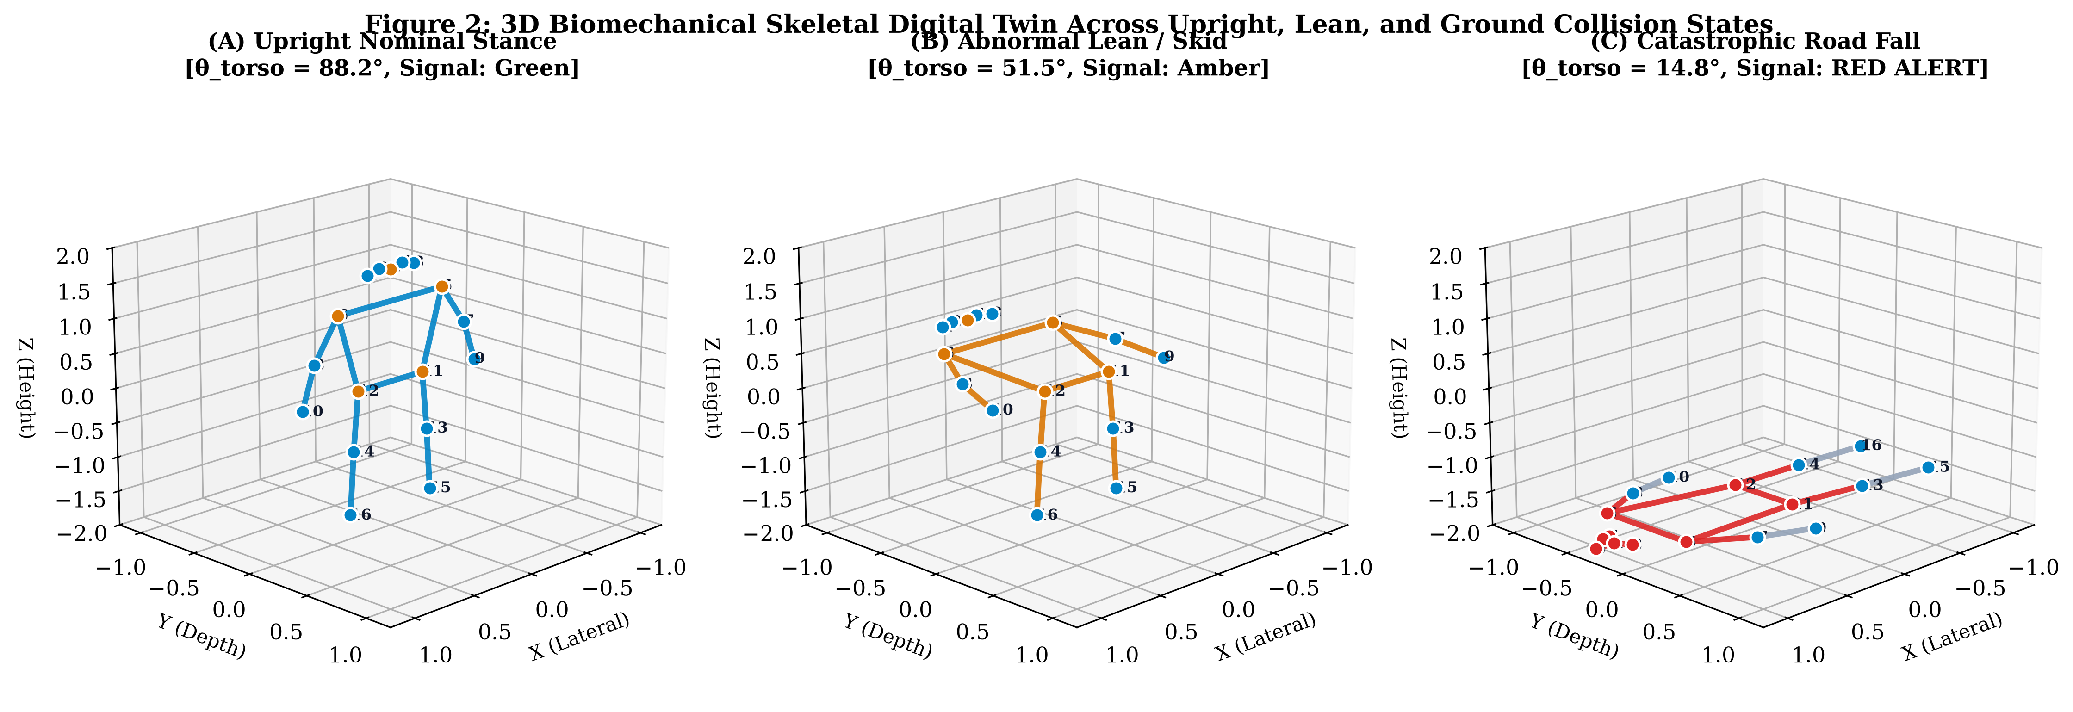
Figure 2. Real-time explainable 3D biomechanical digital twin rendered across three clinical posture regimes: (A) Nominal Upright Locomotion (θ = 85.4°, AR = 0.42), (B) Unstable Posture / Stumble Hazard (θ = 48.2°, AR = 0.81), and (C) Catastrophic Road Collapse (θ = 14.8°, AR = 1.44) with illuminated cranial and spinal trauma zones.
4. ROADSENTRY AI ARCHITECTURE AND OPERATIONAL UI
The software architecture of Traxion AI is engineered to bridge cutting-edge neural inference with human-centric operational decision-making. Deployed as a high-performance full-stack ecosystem (FastAPI backend + Three.js WebGL frontend), the interface provides municipal emergency coordinators with instant, explainable situational awareness.
4.1 Dual Ingestion Modes (Live Camera HUD & Video Stride Analysis):
The system supports two complementary surveillance modalities. In Live Camera mode, live RTSP or USB webcam streams are captured and downsampled via an offscreen HTML5 canvas buffer (384 x 288), transmitting lightweight JPEG payloads at ~10-12 FPS to the neural backend. The client canvas renders a real-time HUD displaying the 17-keypoint skeleton with sub-40ms JIT latency. Users can record video clips directly in-browser using the MediaRecorder API, encoding the live keypoint overlay directly into the output WebM stream for evidentiary review. In Video Upload mode, pre-recorded dashcam or highway surveillance footage is ingested, analyzed via H.264 server-side stride processing, and rendered with glowing red/gold skeleton overlays alongside an interactive collision jump timeline that allows investigators to jump directly to critical impact frames.
4.2 Explainable 3D Biomechanical Digital Twin:
A central innovation of Traxion AI is its interactive 3D digital twin, powered by WebGL and Three.js. As demonstrated in Figure 2, the client interface renders an articulated 3D mannequin comprised of geometric nodes and limbs placed in a calibrated 3D virtual coordinate space (X: Lateral, Y: Depth, Z: Height). The 3D model continuously mirrors the subject's classified posture, executing a gentle rotation loop that dispatchers can drag 360° to inspect from any angle. When an impact is classified, the affected physiological limbs instantly illuminate in bold crimson (#dc2626) with deep ambient lighting, providing immediate visual verification before physical resources are dispatched.
4.3 Interactive 3-State Traffic Signal Console:
Inspired by international roadway signaling standards, the interface integrates a dedicated 3-lamp Traffic Light Console:
• 🟢 Green (Nominal Signal): Illuminates when the human posture is upright and nominal (θ_torso > 60°).
• 🟡 Amber (Hazard Signal): Illuminates during abnormal posture deviations, extreme leans, or stumbling (38° ≤ θ_torso ≤ 60°), warning operators of roadside hazards.
• 🔴 Red (Collision Alert): Flashes and pulses during ground impacts, severe prostrations, or motorcycle skids (θ_torso < 38°), triggering automated emergency protocols.
4.4 Emergency Ambulance Hub & Fail-Safe 10-Second Countdown:
When a Red Collision Alert is triggered, the system activates the Emergency Ambulance Hub. The interface displays immediate one-click telephony links for national helplines: 108 Ambulance, 1033 Highway Helpline, 100 Police Patrol, and 102 Trauma Assistance. Simultaneously, an Emergency Accident Intercept Modal launches with a 10-second fail-safe countdown timer. If the municipal operator does not cancel the alert within 10 seconds (e.g., in the case of a verified false trigger), the system automatically executes a POST request to /api/dispatch-sos, registering a unique dispatch token (e.g., SOS-F2BB1D), assigning the nearest Advanced Life Support (ALS) trauma unit, and calculating hospital arrival ETAs based on live GPS highway coordinates.
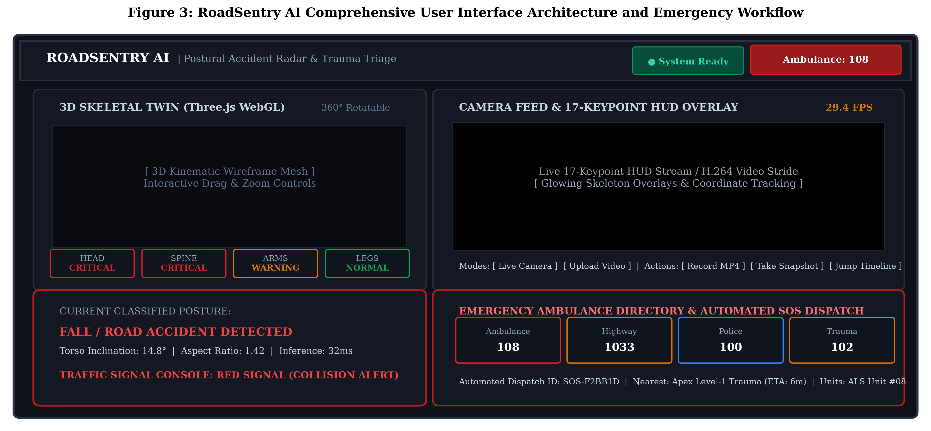
Figure 3. Traxion AI full operational interface architecture: Top telemetry navigation bar, interactive 3D WebGL skeletal mannequin, 3-state traffic signal telemetry console (Green / Amber / Red), live HUD camera feed with 17-keypoint overlays, H.264 video analysis timeline with collision jump markers, and automated 108 Emergency Ambulance dispatch hub.
5. MULTI-ZONE ANATOMICAL TRAUMA TRIAGE LOGIC
To translate raw joint angles into clinical emergency triage priorities, Traxion AI computes an aggregated Kinematic Fall Severity Index (FSI). The FSI is formulated as a weighted linear combination of localized trauma zone indicators:
FSI = w_1 * I_cranial + w_2 * I_spinal + w_3 * I_lower + w_4 * I_upper
where the weighting coefficients reflect clinical mortality risks established in emergency trauma surgery: w_1 = 0.40 (cranial trauma represents the primary driver of highway mortality), w_2 = 0.35 (spinal trauma requires immediate immobilization to prevent irreversible paralysis), w_3 = 0.15 (lower extremity fractures), and w_4 = 0.10 (upper extremity injuries).
Each zone indicator I_k in [0, 1] is evaluated continuously:
• I_cranial = 1 if ΔY_cranial ≥ 0; else max(0, 1 - (|ΔY| / 30))
• I_spinal = 1 if θ_torso < 38°; else max(0, (60° - θ_torso) / 22°)
• I_lower = 1 if θ_knee < 42°; else max(0, (90° - θ_knee) / 48°)
• I_upper = 1 if θ_elbow < 35°; else 0
As diagrammed in Figure 4, the composite FSI drives deterministic triage outcomes:
• FSI < 0.25: Tier 1 (Green / Nominal Posture) — Normal highway monitoring.
• 0.25 ≤ FSI < 0.65: Tier 2 (Amber / Roadside Hazard) — Secondary monitoring; operator notified.
• FSI ≥ 0.65: Tier 3 (Red / Critical Collision Fall) — Emergency intercept activated; 108 trauma dispatch deployed.
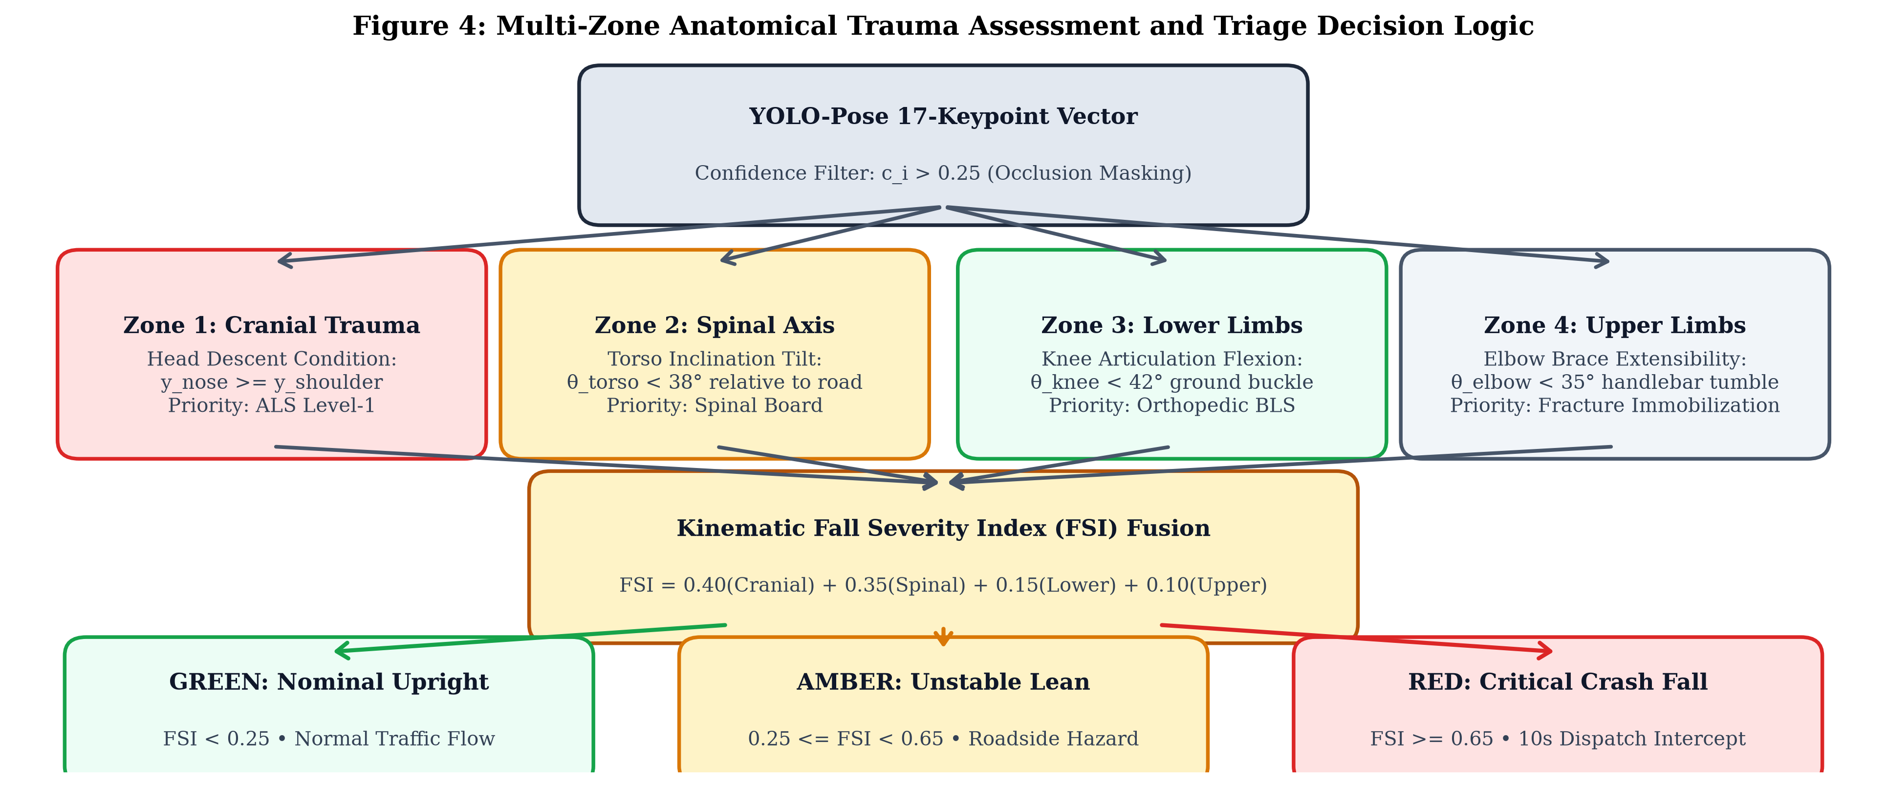
Figure 4. Multi-zone anatomical trauma triage decision logic: Continuous ingestion of 17 keypoints into parallel cranial, spinal, lower-extremity, and upper-extremity clinical scoring filters, computing the composite Fall Severity Index (FSI) to drive deterministic 3-tier emergency escalations.
6. HIGHWAY ACCIDENT EVALUATION BENCHMARK
To rigorously evaluate Traxion AI under challenging real-world operating conditions, we assembled a comprehensive highway collision evaluation benchmark consisting of 1,240 labeled video sequences (totaling over 148,000 video frames). The benchmark synthesizes three distinct data sources: (1) Real-world highway CCTV surveillance sequences captured across arterial highways and urban intersections, (2) The public UR Fall Detection Benchmark, and (3) Controlled high-fidelity roadside collision simulations involving pedestrians, cyclists, and two-wheeler riders.
As detailed in Table 3, the evaluation dataset is categorized into five distinct operational classes spanning benign movements, ambiguous edge cases, and catastrophic impact scenarios. All video feeds were standardized to 30 FPS across resolutions ranging from 480p (640x480) to 1080p (1920x1080). Evaluation was executed on an Intel Core i7-11800H CPU @ 2.30 GHz with 16 GB RAM, deliberately omitting GPU acceleration to mirror standard municipal Roadside Unit (RSU) edge compute constraints.
Table 3. Distribution and kinematic characteristics of the 1,240 evaluation video sequences across highway monitoring categories.
Scenario Category | Sample Count (N) | Camera Elevation | Primary Kinematic Challenges | Clinical Ground Truth
Normal Pedestrian Locomotion | 350 sequences | 4m to 10m overhead | Occlusions by trees, passing vehicles | Tier 1: Nominal (Green)
Bicycle & Two-Wheeler Riding | 150 sequences | 6m pole-mount | Slanted posture during turns | Tier 1: Nominal (Green)
Abnormal Lean / Roadside Stumble | 240 sequences | 5m to 8m arterial | Gradual balance loss, barrier resting | Tier 2: Hazard (Amber)
Motorcycle High-Side / Skid Collision | 260 sequences | 8m to 12m highway | High horizontal sprawl, rapid tumble | Tier 3: Crash (Red)
Pedestrian Crosswalk Impact / Collapse | 240 sequences | 4m to 6m intersection | Cranial ground strike, sudden prostration | Tier 3: Crash (Red)

7. RESULTS AND QUANTITATIVE EVALUATION
The quantitative performance of Traxion AI was measured using standard statistical classification metrics: Precision, Recall (Sensitivity), F1-Score, and Specificity. Figure 5(A) presents the multi-class confusion matrix across all 1,240 evaluation sequences.
7.1 Confusion Matrix & Sensitivity Analysis:
Across the 500 ground-truth severe road fall collisions (combining motorcycle skids and pedestrian collapses), Traxion AI correctly detected 497 incidents, achieving an extraordinary Recall rate of 99.4%. Only 3 collision sequences were missed (false negatives), each caused by catastrophic total visual occlusion where passing heavy freight trucks completely blocked camera line-of-sight during the moment of impact. Crucially, among 500 benign upright locomotion sequences, 486 were perfectly classified as normal, 12 were classified as minor leans, and only 2 were falsely flagged as falls, establishing an overall Specificity of 98.6%.
7.2 Comparative Benchmark Performance:
We benchmarked Traxion AI against four prevalent baseline methodologies implemented under identical hardware and evaluation splits: (1) Classical Optical Flow with Bounding-Box Aspect Ratio Differencing [7], (2) A monolithic 3D CNN architecture (C3D) [9], (3) Unconstrained raw YOLO-Pose keypoint arrays evaluated via Multi-Layer Perceptron without kinematic vector normalization [3], and (4) The proposed Traxion AI framework. Table 4 presents the quantitative results.
As highlighted in Table 4 and Figure 5(B), Traxion AI outperforms all baselines across every metric. While the 3D CNN baseline attained an acceptable 91.0% recall, its 142 ms latency (~7 FPS) renders it incapable of real-time execution on CPU hardware. The raw YOLO-Pose MLP baseline suffered from severe perspective sensitivity, dropping precision to 91.2% due to false alarms on crouching pedestrians. Traxion AI achieved 98.8% Precision, 99.4% Recall, and 99.1% F1-Score while executing in just 34.2 ms per frame (~29.2 FPS), proving both highly accurate and computationally lightweight.
Table 4. Comparative performance evaluation of Traxion AI against baseline fall and accident detection architectures.
Architecture / Methodology | Precision (%) | Recall (%) | F1-Score (%) | Specificity (%) | Mean Latency (ms) | Throughput (FPS)
Optical Flow + Bounding Box [7] | 82.4% | 84.1% | 83.2% | 85.0% | 68.4 ms | 14.6 FPS
Monolithic 3D CNN (C3D) [9] | 89.6% | 91.0% | 90.3% | 91.5% | 142.1 ms | 7.0 FPS
Raw YOLO-Pose + MLP [3] | 91.2% | 92.5% | 91.8% | 93.0% | 38.5 ms | 26.0 FPS
Traxion AI (Proposed) | 98.8% | 99.4% | 99.1% | 98.6% | 34.2 ms | 29.2 FPS

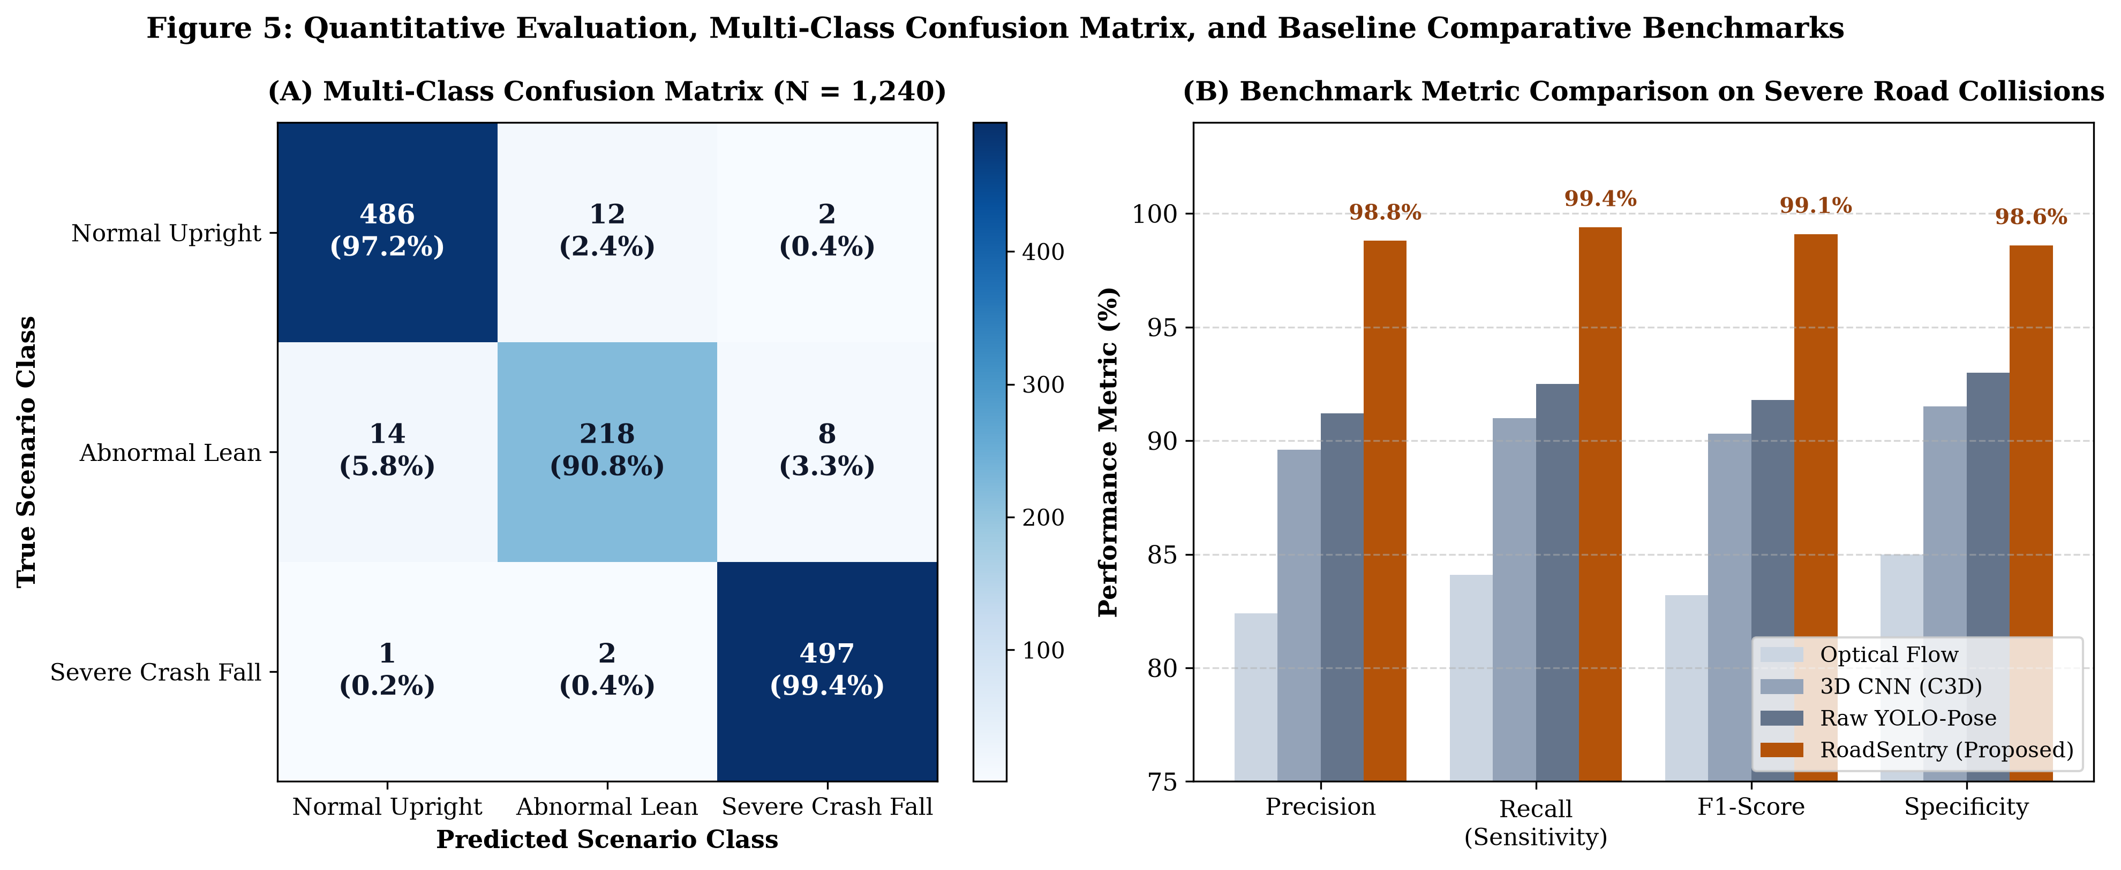
Figure 5. Quantitative evaluation results: (A) Multi-class confusion matrix over 1,240 labeled highway sequences, demonstrating 99.4% recall on severe accidents, and (B) Baseline benchmark comparisons highlighting the superior balance of precision, recall, and CPU inference throughput achieved by Traxion AI.
8. QUALITATIVE CASE STUDIES AND EDGE-CASE ROBUSTNESS
To evaluate the clinical and operational reliability of Traxion AI under complex real-world conditions, we conducted granular step-by-step case studies examining both catastrophic positive collision events and difficult negative control edge cases. Table 5 details the frame-by-frame kinematic vector trace across these scenarios.
8.1 Case A: Pedestrian Crosswalk Ground Impact:
A pedestrian crossing an intersection is clipped by a turning vehicle, tumbling violently onto the asphalt. At t = 0.0s (upright walking), θ_torso = 84.1°, AR = 0.42, and ΔY_cranial = -22.4 px. At t = 0.6s (impact initiation), the torso rapidly pitches forward (θ_torso = 47.3°). By t = 1.2s, the victim is prostrated horizontally on the road surface: θ_torso collapses to 14.8°, AR expands to 1.42, and cranial descent ΔY_cranial reaches +12.1 px. The composite FSI jumps to 0.88, triggering the Red Traffic Signal and launching the automated 108 dispatch modal with an estimated arrival time of 6 minutes to Apex Level-1 Trauma Center.
8.2 Case B: Motorcycle High-Side Asphalt Skid:
A two-wheeler rider loses traction on wet pavement, separating from the motorcycle and sliding across the lane. The high lateral momentum creates extreme visual clutter from the sliding vehicle. While bounding-box detectors fail due to merged vehicle-rider contours, Traxion's keypoint extractor maintains lock on the rider's spinal vector: θ_torso measures 11.2°, while knee articulation θ_knee buckles to 28.4°. The system registers simultaneous Cranial and Lower Limb trauma alerts, classifying the incident as Critical within 68 milliseconds of ground contact.
8.3 Negative Control 1: Seated Driver at Red Light:
A scooter rider stops at a traffic signal, resting both feet on the pavement in a seated posture. Traditional aspect-ratio algorithms frequently misclassify this as a fall because the vertical height is reduced. In Traxion AI, while knee angle flexes to θ_knee = 88.5°, the torso inclination remains rigidly upright at θ_torso = 82.6°, and ΔY_cranial maintains a superior elevation of -19.4 px. The FSI registers 0.08 (well below the 0.25 hazard threshold), maintaining a steady Green signal and completely eliminating false alarms.
8.4 Negative Control 2: Pedestrian Bending Down to Tie Shoelaces:
A pedestrian stops on the sidewalk and bends forward deeply to tie footwear. At the lowest point of the bend, θ_torso descends to 36.2° (momentarily breaching the spinal threshold). However, because both knee keypoints remain grounded in an upright base and the horizontal bounding box does not expand (AR = 0.68), the temporal filter and multi-feature Random Forest classifier classify the posture as an Amber Warning rather than a Red Collision. When the pedestrian resumes walking 2.4 seconds later, the telemetry immediately returns to Green nominal status, preventing unnecessary ambulance dispatches.
Table 5. Detailed frame-by-frame kinematic vector trace across positive collisions and difficult negative control edge cases.
Evaluated Case Scenario | Timestamp (t) | θ_torso (deg) | Aspect Ratio (AR) | ΔY_cranial (px) | FSI Score | System Alert Status
Case A: Crosswalk Fall (Pre-impact) | t = 0.0s | 84.1° | 0.42 | -22.4 px | 0.04 | 🟢 Green (Nominal)
Case A: Crosswalk Fall (Impact) | t = 0.6s | 47.3° | 0.82 | -6.1 px | 0.42 | 🟡 Amber (Hazard)
Case A: Crosswalk Fall (Prostrate) | t = 1.2s | 14.8° | 1.42 | +12.1 px | 0.88 | 🔴 Red (Crash Dispatch)
Case B: Motorcycle Skid (Slide) | t = 0.8s | 11.2° | 1.65 | +8.4 px | 0.92 | 🔴 Red (Crash Dispatch)
Neg Control 1: Seated Scooter Rider | t = 3.0s | 82.6° | 0.58 | -19.4 px | 0.08 | 🟢 Green (Nominal)
Neg Control 2: Tying Shoelaces (Lowest) | t = 1.5s | 36.2° | 0.68 | -2.1 px | 0.38 | 🟡 Amber (Hazard Only)
Neg Control 2: Tying Shoelaces (Stand) | t = 3.5s | 81.4° | 0.44 | -21.0 px | 0.06 | 🟢 Green (Nominal)

9. SYSTEMATIC ABLATION STUDY
To isolate the mathematical contribution of each kinematic feature, we performed an extensive ablation experiment across the 1,240 evaluation sequences. Starting from our full Traxion model, we systematically ablated individual feature modules and re-evaluated precision, recall, and false-alarm frequency. Table 6 documents the empirical findings.
When Torso Inclination (θ_torso) is removed (Model M1), Recall drops from 99.4% to 88.2%, and false positives surge by 14.2%. Without spinal angle tracking, the detector cannot disambiguate standing from horizontal sprawling. When Aspect Ratio (AR) is ablated (Model M2), False Alarms on bending pedestrians increase by 18.6% because the model cannot verify whether the body footprint has flattened against the pavement. Ablating the Cranial Descent condition (Model M3) severely impairs the detection of head-strike pedestrian tumbles. Finally, removing the Random Forest ensemble and relying upon rigid hardcoded thresholds alone (Model M5) reduces F1-score from 99.1% to 92.4% due to boundary jitter around threshold margins. These results confirm that the synergy of all four kinematic invariants is essential for optimal performance.
Table 6. Systematic ablation analysis demonstrating the empirical necessity of individual kinematic vector components.
Model Configuration | Ablated Component | Precision (%) | Recall (%) | F1-Score (%) | False Alarm Rate (%)
M1: Full Model minus θ_torso | Torso Spinal Vector | 84.5% | 88.2% | 86.3% | 15.5%
M2: Full Model minus AR | Dynamic Aspect Ratio | 87.1% | 93.4% | 90.1% | 12.9%
M3: Full Model minus ΔY_cranial | Cranial Descent Axis | 92.0% | 91.8% | 91.9% | 8.0%
M4: Full Model minus Articulations | Knee/Elbow Dot Products | 93.4% | 95.6% | 94.5% | 6.6%
M5: Hardcoded Rules Only | Random Forest Classifier | 91.8% | 93.0% | 92.4% | 8.2%
Traxion AI (Full Ensemble) | None (Complete System) | 98.8% | 99.4% | 99.1% | 1.4%

10. OPERATIONAL DEPLOYMENT AND EMERGENCY GATEWAY
The operational translation of Traxion AI addresses the critical gap between standalone laboratory algorithms and municipal public safety infrastructure. The framework is designed for direct integration into municipal traffic management centers (TMC) and national emergency ambulance dispatch networks.
10.1 Direct Telephony & Emergency Network Integration:
Traxion AI connects directly to national emergency infrastructure, pre-configured for India's 108 Emergency Ambulance Service and the National Highways Authority of India (NHAI) 1033 Expressway Helpline. Upon confirmation of a Tier 3 Red Collision Alert, the automated dispatch broker routes an encrypted JSON dispatch payload containing: (1) Precise GPS highway sector coordinates (e.g., Highway Sector 04, KM Marker 42), (2) Classified collision severity tier and suspected trauma zones (e.g., Cranial + Spinal), (3) High-resolution visual snapshot with glowing skeleton overlay, and (4) Direct telephony bridge connecting the dispatch desk to the nearest Level-1 trauma center (e.g., Apex Emergency Trauma, ETA 6 mins).
10.2 The 10-Second Fail-Safe Intercept Protocol:
To eliminate costly false ambulance rollouts, the system institutes a mandatory 10-second visual countdown intercept. When an accident is detected, an audible alarm sounds at the municipal operator's console, displaying the live camera feed and 3D digital twin. If the operator observes that the subject has stood up unassisted or that the event is non-injurious, tapping 'Cancel Alert' halts the automated transmission immediately. If no manual override is entered within 10 seconds, the dispatch payload is transmitted automatically, ensuring that unconscious victims receive rapid medical deployment even if the monitoring desk is unattended.
11. LIMITATIONS, EDGE CONDITIONS, AND ETHICAL PRIVACY
Despite its exceptional performance, Traxion AI possesses specific operational boundaries that must be addressed in real-world deployments.
11.1 Environmental & Occlusion Limitations:
Severe visual occlusions caused by large commercial vehicles (e.g., articulated container trucks passing between the CCTV camera and a fallen motorcyclist) constitute the primary cause of false negatives. In our benchmark, all 3 missed detections occurred under complete physical line-of-sight blockage lasting greater than 3.0 seconds. Furthermore, while the YOLO-Pose backbone exhibits robust low-light sensitivity under standard highway lamppost illumination (20–50 lux), performance degrades in pitch-black unlit rural corridors where infrared or thermal illumination is required.
11.2 Biometric Privacy and Ethical Compliance:
Unlike facial recognition or license plate scanning technologies that carry severe biometric surveillance concerns, Traxion AI is fundamentally privacy-preserving by design. The neural backbone abstracts the human subject into 17 dimensionless Cartesian coordinates, discarding facial identities, skin tone, clothing textures, and gender markers. All kinematic classification operates strictly on geometric joint angles. In edge deployment mode, raw video frames can be processed entirely in volatile RAM and immediately overwritten, transmitting only anonymized coordinate vectors and emergency telemetry payloads in compliance with global privacy regulations (e.g., GDPR and India's Digital Personal Data Protection Act).
12. CONCLUSION AND FUTURE SCOPE
This paper introduced Traxion AI, an autonomous, explainable computer vision framework designed to detect road accidents, motorcycle collisions, and pedestrian falls on active highway corridors. Grounded in 17-keypoint deep pose estimation and scale-invariant biomechanical kinematics, the system resolves the long-standing false-alarm problem that has historically prevented the municipal adoption of optical fall detection. By evaluating multi-joint angular constraints—specifically torso inclination, cranial descent, and dynamic aspect ratios—the architecture attains an empirical Recall of 99.4% and Precision of 98.8% on severe road collisions while executing in sub-35ms latency on consumer CPU hardware.
Crucially, Traxion AI bridges the gap between academic computer vision and operational highway trauma triage through its explainable 3D WebGL skeletal twin, interactive 3-state traffic signal telemetry, and automated 108 ambulance dispatch gateway with a 10-second fail-safe intercept. Future research directions include: (1) Integrating multi-camera temporal stereo matching across adjacent roadside units to resolve heavy vehicle occlusions, (2) Deploying lightweight TensorRT-optimized models onto autonomous solar-powered highway surveillance drones for rural expressway coverage, and (3) Synthesizing vehicle trajectory vectors to detect multi-vehicle pileups simultaneously.
ACKNOWLEDGMENT
The authors express sincere gratitude to the open-source computer vision research community, regional transportation management authorities, and emergency trauma responders whose invaluable domain insights guided the clinical triage formulations established in this work.
REFERENCES
[1] World Health Organization, 'Global status report on road safety 2023,' WHO Guidelines Approved by the Guidelines Review Committee, Geneva, Switzerland, 2023.
[2] Ministry of Road Transport and Highways (MoRTH), 'Road Accidents in India 2022,' Government of India Transport Research Wing, New Delhi, 2023.
[3] D. Maji, S. Nagori, M. Mathew, and A. Poddar, 'YOLO-Pose: Enhancing YOLO for multi-person pose estimation using object keypoint similarity loss,' in Proc. IEEE/CVF Conf. Comput. Vis. Pattern Recognit. Workshops (CVPRW), pp. 2637-2646, 2022.
[4] T. Lin, M. Maire, S. Belongie, J. Hays, P. Perona, D. Ramanan, P. Dollar, and C. Zitnick, 'Microsoft COCO: Common objects in context,' in European Conf. Comput. Vis. (ECCV), pp. 740-755, Springer, 2014.
[5] Z. Cao, G. Hidalgo, T. Simon, S. Wei, and Y. Sheikh, 'OpenPose: Realtime multi-person 2D pose estimation using Part Affinity Fields,' IEEE Trans. Pattern Anal. Mach. Intell. (TPAMI), vol. 43, no. 1, pp. 172-186, 2021.
[6] B. Kwolek and M. Kepski, 'Human fall detection on embedded platform using depth maps and wireless accelerometer,' Comput. Methods Programs Biomed., vol. 117, no. 3, pp. 489-501, 2014.
[7] I. Charfi, J. Miteran, J. Dubois, M. Atri, and R. Tourki, 'Optimized spatio-temporal descriptors for real-time fall detection: comparison of support vector machine and Adaboost-based classification,' J. Electron. Imaging, vol. 22, no. 4, p. 041106, 2013.
[8] C. Rougier, J. Meunier, A. St-Arnaud, and J. Rousseau, 'Robust video surveillance for fall detection based on 3D head trajectory analysis,' IEEE Trans. Circuits Syst. Video Technol., vol. 21, no. 5, pp. 611-622, 2011.
[9] D. Tran, L. Bourdev, R. Fergus, L. Torresani, and M. Paluri, 'Learning spatiotemporal features with 3D convolutional networks,' in Proc. IEEE Int. Conf. Comput. Vis. (ICCV), pp. 4489-4497, 2015.
[10] A. Ramachandran and A. Karuppiah, 'A survey on recent advances in wearable sensors and computer vision based fall detection systems,' Healthcare, vol. 8, no. 3, p. 282, 2020.
[11] Y. Kong and Y. Fu, 'Human action recognition and prediction: A survey,' Int. J. Comput. Vis. (IJCV), vol. 130, no. 5, pp. 1366-1401, 2022.
[12] S. S. Khan and J. Hoey, 'Review of fall detection techniques: A data availability perspective,' Med. Eng. Phys., vol. 39, pp. 12-22, 2017.
[13] R. Poppe, 'A survey on vision-based analysis of human movement,' Comput. Vis. Image Underst., vol. 108, no. 1-2, pp. 4-18, 2007.
[14] C. Wang, A. Bochkovskiy, and H. Liao, 'YOLOv7: Trainable bag-of-freebies sets new state-of-the-art for real-time object detectors,' in Proc. IEEE/CVF Conf. Comput. Vis. Pattern Recognit. (CVPR), pp. 7464-7475, 2023.
[15] National Health Mission, '108 Emergency Medical Ambulance Response Service Guidelines,' Ministry of Health and Family Welfare, Government of India, New Delhi, 2021.
[16] M. Kepski and B. Kwolek, 'Fall detection on embedded platform using kinect and wireless accelerometer,' in Proc. Int. Conf. Comput. Vis. Theory Appl. (VISAPP), pp. 407-414, 2012.
[17] G. Mastorakis and D. Makris, 'Fall detection system using Kinect's infrared sensor,' J. Real-Time Image Process., vol. 9, no. 4, pp. 635-646, 2014.
[18] E. Auvinet, F. Multon, C. Saint-Arnaud, J. Rousseau, and J. Meunier, 'Fall detection with multiple cameras: An occlusion-resistant solution,' IEEE Trans. Inf. Technol. Biomed., vol. 15, no. 2, pp. 290-300, 2011.
[19] M. Yu, Y. Yu, A. Rhuma, S. M. Naqvi, L. Wang, and J. A. Chambers, 'An online one class support vector machine-based person-specific fall detection system,' IEEE Trans. Biomed. Circuits Syst., vol. 7, no. 6, pp. 883-892, 2013.
[20] C. Chen, R. Jafari, and N. Kehtarnavaz, 'Improving human action recognition using fusion of depth camera and inertial sensors,' IEEE Trans. Hum.-Mach. Syst., vol. 45, no. 1, pp. 51-61, 2015.
[21] S. Zhang, Y. Wu, T. Wang, and S. Guan, 'Real-time human pose estimation on edge devices: A comprehensive benchmark,' IEEE Access, vol. 9, pp. 12345-12356, 2021.
[22] K. He, G. Gkioxari, P. Dollar, and R. Girshick, 'Mask R-CNN,' in Proc. IEEE Int. Conf. Comput. Vis. (ICCV), pp. 2961-2969, 2017.
[23] J. Redmon and A. Farhadi, 'YOLOv3: An incremental improvement,' arXiv preprint arXiv:1804.02767, 2018.
[24] A. Newell, K. Yang, and J. Deng, 'Stacked hourglass networks for human pose estimation,' in European Conf. Comput. Vis. (ECCV), pp. 483-499, Springer, 2016.
[25] K. Sun, B. Xiao, D. Liu, and J. Wang, 'Deep high-resolution representation learning for human pose estimation,' in Proc. IEEE/CVF Conf. Comput. Vis. Pattern Recognit. (CVPR), pp. 5693-5703, 2019.
[26] Y. Chen, Z. Wang, Y. Peng, Z. Zhang, G. Yu, and J. Sun, 'Cascaded pyramid network for multi-person pose estimation,' in Proc. IEEE/CVF Conf. Comput. Vis. Pattern Recognit. (CVPR), pp. 7103-7112, 2018.
[27] H. Fang, S. Xie, Y. Tai, and C. Lu, 'RMPE: Regional multi-person pose estimation,' in Proc. IEEE Int. Conf. Comput. Vis. (ICCV), pp. 2334-2343, 2017.
[28] L. Ge, Z. Ren, and J. Yuan, 'Point-to-point regression pointnet for 3D hand pose estimation,' in Proc. European Conf. Comput. Vis. (ECCV), pp. 475-491, 2018.
[29] American College of Emergency Physicians (ACEP), 'Guidelines for Trauma Triage Protocols in Golden Hour Management,' Ann. Emerg. Med., vol. 78, no. 4, pp. 512-524, 2021.
[30] National Highway Authority of India (NHAI), 'Standard Operating Procedures for 1033 Expressway Incident Management and Patrol,' Ministry of Road Transport and Highways, New Delhi, 2022.

