UNIT 5

HUMAN PHYSIOLOGY

Chapter 16

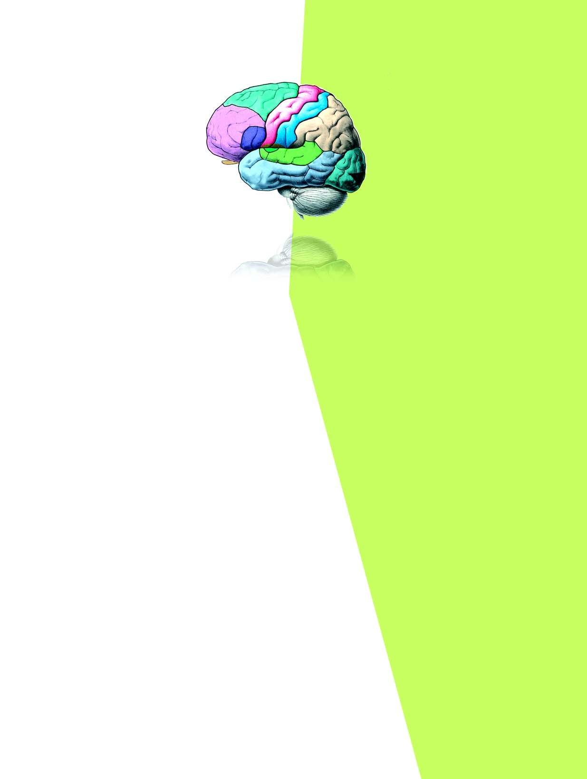

Digestion and Absorption

Chapter 17

Breathing and Exchange of Gases

Chapter 18 Body Fluids and Circulation

Chapter 19

Excretory Products and their Elimination

Chapter 20

Locomotion and Movement

Chapter 21

Neural Control and Coordination

Chapter 22

Chemical Coordination and Integration

The reductionist approach to study of life forms resulted in increasing use of physico-chemical concepts and techniques. Majority of these studies employed either surviving tissue model or straightaway cell- free systems. An explosion of knowledge resulted in molecular biology. Molecular physiology became almost synonymous with biochemistry and biophysics. However, it is now being increasingly realised that neither a purely organismic approach nor a purely reductionistic molecular approach would reveal the truth about biological processes or living phenomena. Systems biology makes us believe that all living phenomena are emergent properties due to interaction among components of the system under study. Regulatory network of molecules, supra molecular assemblies, cells, tissues, organisms and indeed, populations and communities, each create emergent properties. In the chapters under this unit, major human physiological processes like digestion, exchange of gases, blood circulation, locomotion and movement are described in cellular and molecular terms. The last two chapters point to the coordination and regulation of body events at the organismic level.

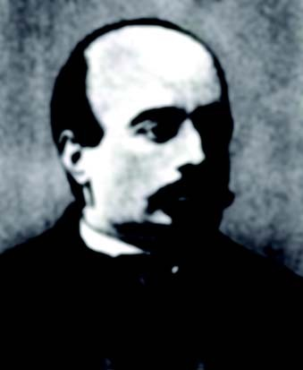

ALFONSO CORTI, Italian anatomist, was born in 1822. Corti began his scientific career studying the cardiovascular systems of reptiles. Later, he turned his attention to the mammalian auditory system. In 1851, he published a paper describing a structure located on the basilar membrane of the cochlea containing hair cells that convert sound vibrations into nerve impulses, the organ of Corti. He died in the year 1888.

Alfonso Corti

(1822 ñ 1888)