Module 3 – Activity

An UPDATE statement that changes the state to ‘NY' for all records in the CUSTOMER table.

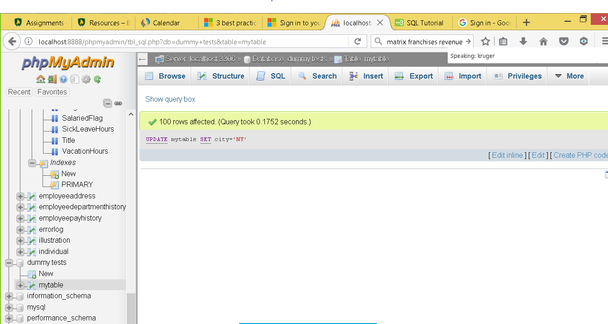

<http://127.0.0.1:8888/phpmyadmin/tbl_sql.php?db=dummy+tests&table=mytable>

An ALTER TABLE statement to ADD an additional column to the CUSTOMERS table with an appropriate data type. http://127.0.0.1:8888/phpmyadmin/tbl_sql.php?db=dummy+tests&table=mytable

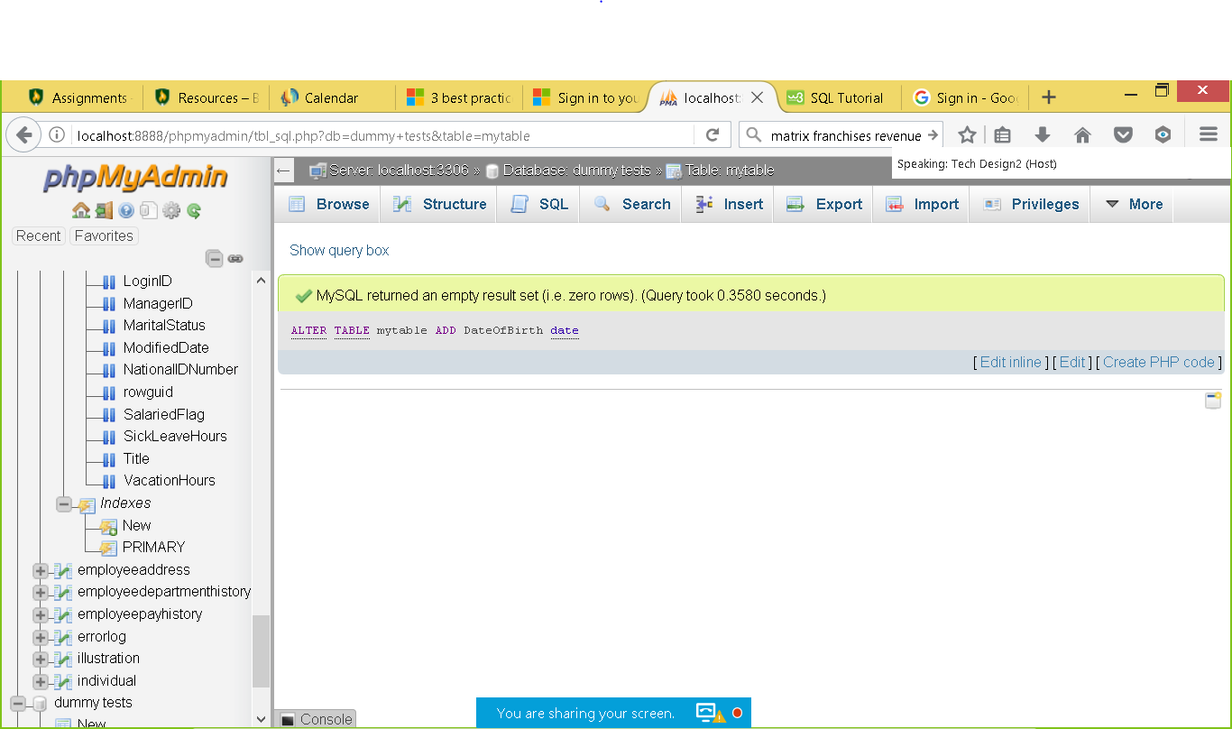

An ALTER TABLE statement to DROP the column you just added to the CUSTOMERS table.

http://127.0.0.1:8888/phpmyadmin/tbl_sql.php?db=dummy+tests&table=mytable

