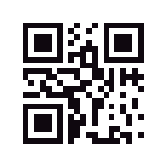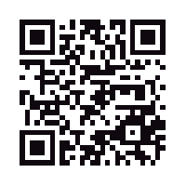**Patent and Trademark Bureau**  **REMINDER**

230 Park Avenue www.patentandtrademarkbureau.us

**D**

3rd Floor West, Helmsley Building

New York, NY 10169

United States of America

|  |  |  |
| --- | --- | --- |
| Correspondence address:  **{ownerName}**  **{@ownerAddress}** | | |
| **Trademark name: {tradeMark}** | | |
| **Registration Number: {regNumber}** | | **Number of classes: {classCount}** |
| **Your trademark is about to expire. Maintenance date: {renewalDate}**  Your trademark registration requires a filing between the **5th** and **6th** years after registration to remain valid.  Sign and return this document in order to renew your trademark. | | |
| TRADEMARK | | GRAPHIC REPRESENTATION |
| Type of mark: | {markType} | {%logoPath} |
| Register: | {register} |
| Renewal date: | {renewalDate} |
| Filing date: | {filingDate} |
| Date in location: | {dateInLocation} |
| Registration date: | {regDate} |
| Classes: | {intClasses} |
| Serial number: | {serialNumber} |
| IMPORTANT INFORMATION | | |
| **Date: _____/ ______/ __________**  **Name, Last name: ________________________________**  **E-mail: ________________________________**  **Phone: ________________________________**  **Position: ________________________________**  **Signature: ________________________________**  **SIGN AND RETURN IN THE ENCLOSED ENVELOPE** | | Please return this document with your signature and/or company stamp in the appropriate space if you would like to renew your trademark. Your trademark will be renewed for the period of another five (5) years. **The maintenance fee is $925 for one class and $325 for each additional class for the whole period of five (5) years.** You will receive an invoice from us after we have received this signed document from you. By signing this document you place an order for filing and automatically empower Patent and Trademark Bureau to renew the trademark stated above on your behalf. This order is optional and only acts as a reminder. Patent and Trademark Bureau is a private service company within the intellectual property area that reminds companies when their trademarks are due for the maintenance. Patent and Trademark Bureau is non-governmental company and is not connected to any of the governmental organizations. You may also contact your legal representative to perform the maintenance for you. If you have any questions regarding your trademark maintenance process, please contact us via e-mail: info@patentandtrademarkbureau.us or telephone/fax 646 616 7529. |