1. Write a query to get a Product list (id, name, unit price) where current products cost
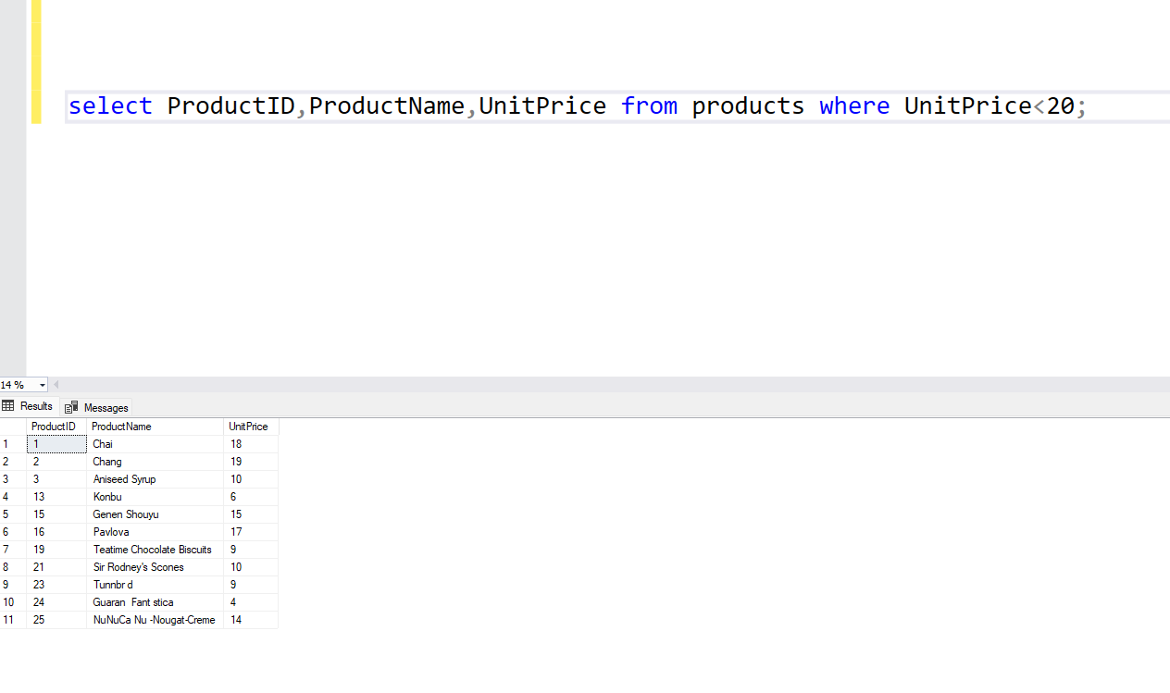
less than $20.

2. Write a query to get Product list (id, name, unit price) where products cost between
$15 and $25.

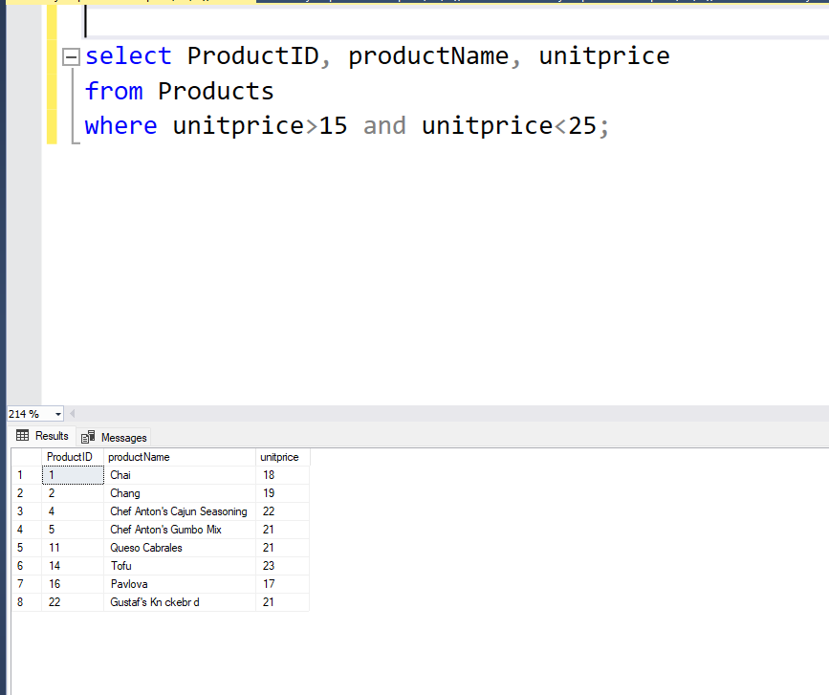

3. Write a query to get Product list (name, unit price) of above average price.
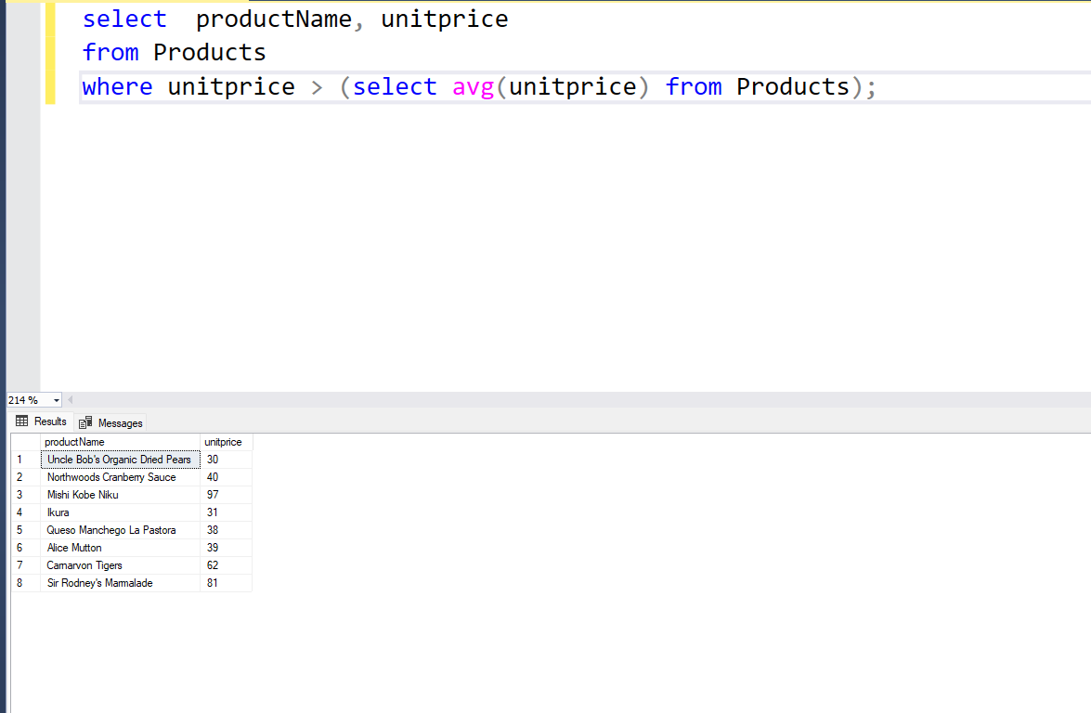

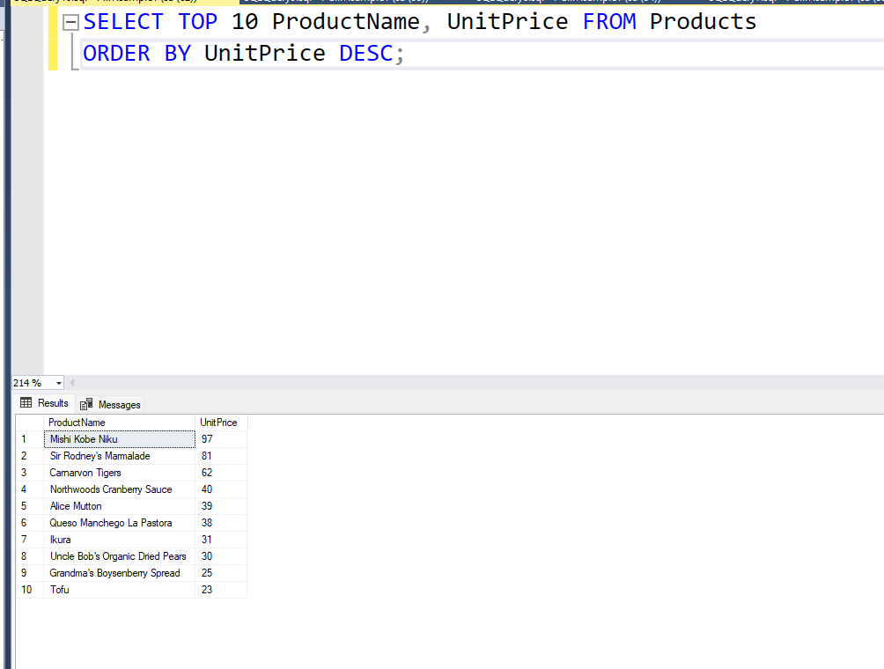
4. Write a query to get Product list (name, unit price) of ten most expensive products.

5. Write a query to count current and discontinued products.

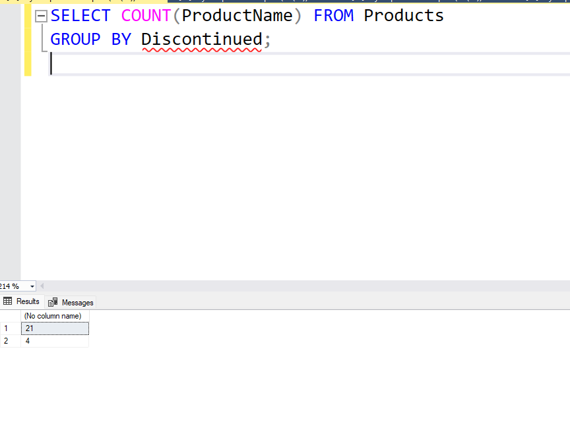

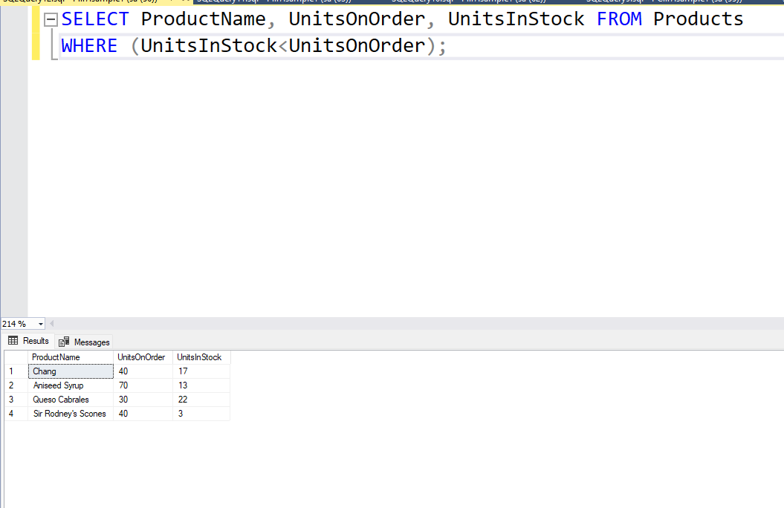
6. Write a query to get Product list (name, units on order , units in stock) of stock is lessthan the quantity on order.

