Microcontroller
MS51FB9AE
Charging IC
BQ24735RGRR
External 12VDC Supply (as AC mains)
H-bridges
Solenoids
Externally Control
CM
Common Supply
Microcontroller
MS51FB9AE
Charging IC
BQ24735RGRR
External 12VDC Supply (as AC mains)
Battery
H-bridges
Solenoids
Externally Control
I2C
Common Supply
- Block diagram of whole system

Microcontroller
MS51FB9AE
Charging IC
BQ24735RGRR
Battery
H-bridges
Solenoids
I2C
Common Supply

I2C
Battery
(B) Externally Solenoid control when AC ON (C) Solenoid control using MCU when AC OFF

Note:
Common supply indicates the 12v to 3.3V converter.
CM indicates charging mode

Project Flow – System Operation Description

- The system is powered through an external +12VDC supply (as a AC mains considered), which serves as the primary source for all components. This input voltage is distributed to three main sections:

- Battery Charger Circuit – A dedicated charger IC (BQ24735RGRR) receives the +12 V input to both charge the battery and supply power to the system load when AC mains is available.
- H-Bridge Driver Stage – The +12 V directly powers H-Bridge drivers responsible for controlling the solenoid locks.
- DC-DC Conversion Stage – A +12 V to +3.3 V converter provides regulated power (common power supply )to the micro-controller (MS51FB9AE) and other low-voltage logic circuits.

System Start-Up

When power is first applied, the microcontroller (MCU) immediately performs its initialization sequence. All I/O pins are configured, peripherals such as I²C, GPIO, and timers are initialized, and the internal AC mains status flag is set to “present.” At this stage, the MCU sends an I²C command to the charger IC, enabling battery charging.

Normal Operation – AC Mains Available

During normal operation, the MCU continuously monitors the AC mains detect signal, from the supply line. If AC power is present, the charger remains active, supplying the load while charging the battery. The solenoid locks and unlock action are taking by externally and microcontroller sets its all pin as output mode in low state.

AC Mains Loss Detection & Response

If the AC mains supply fails, the MCU first applies a 1-second verification delay to avoid false triggers caused by noise or brief interruptions. Once the absence of mains is confirmed, the MCU initiates an unlock sequence for both solenoid locks. This is achieved by sending a 100 ms pulse to the H-Bridge driver inputs controlling each solenoid, after which the control pins are reset to their idle state. The MCU then updates its internal state to “AC Loss Mode.”

Battery Operation Mode

In the absence of AC mains, the battery takes over as the power source, supplying the MCU, H-Bridge drivers, and solenoids. The charger IC remains disabled until AC power is restored. This ensures minimal battery drain and avoids unnecessary switching activity inside the charger.

AC Mains Recovery

When AC power returns, the MCU detects the change, updates its internal state, and re-enables the charger through I²C commands. The system then seamlessly transitions back to Normal Operation Mode, with the battery charging and the solenoids are control by externally.

H-Bridge & Solenoid Control

The MCU has control over the unlock actions of the solenoids. Each solenoid unlock is driven by its dedicated H-Bridge, and the firmware determines the exact timing, duration, and sequencing of control pulses. This precise control ensures reliable unlock operation while minimizing power consumption.

Here is the project flow chart

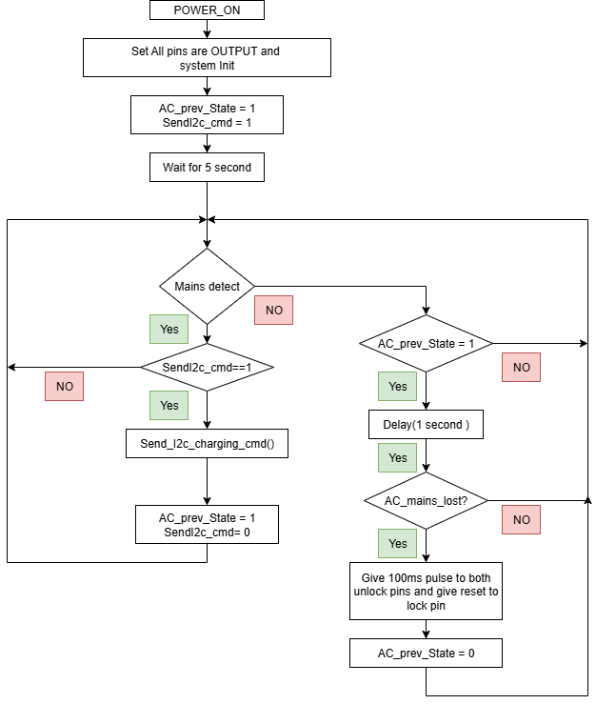
- Project flow chart

