Battery charger and Gun Control
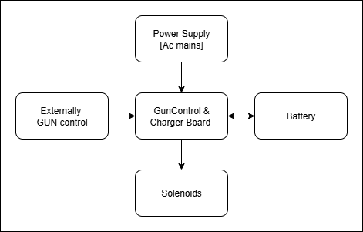
Blockdiagram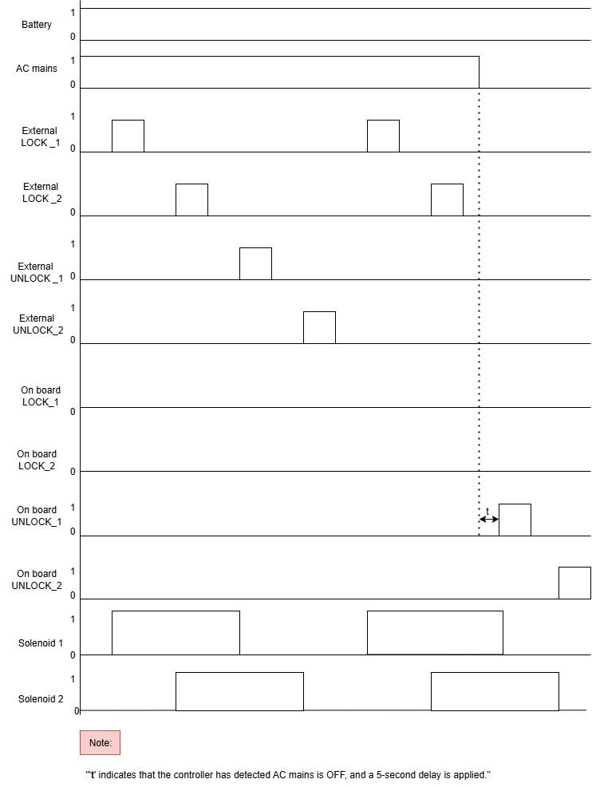
Waveforms
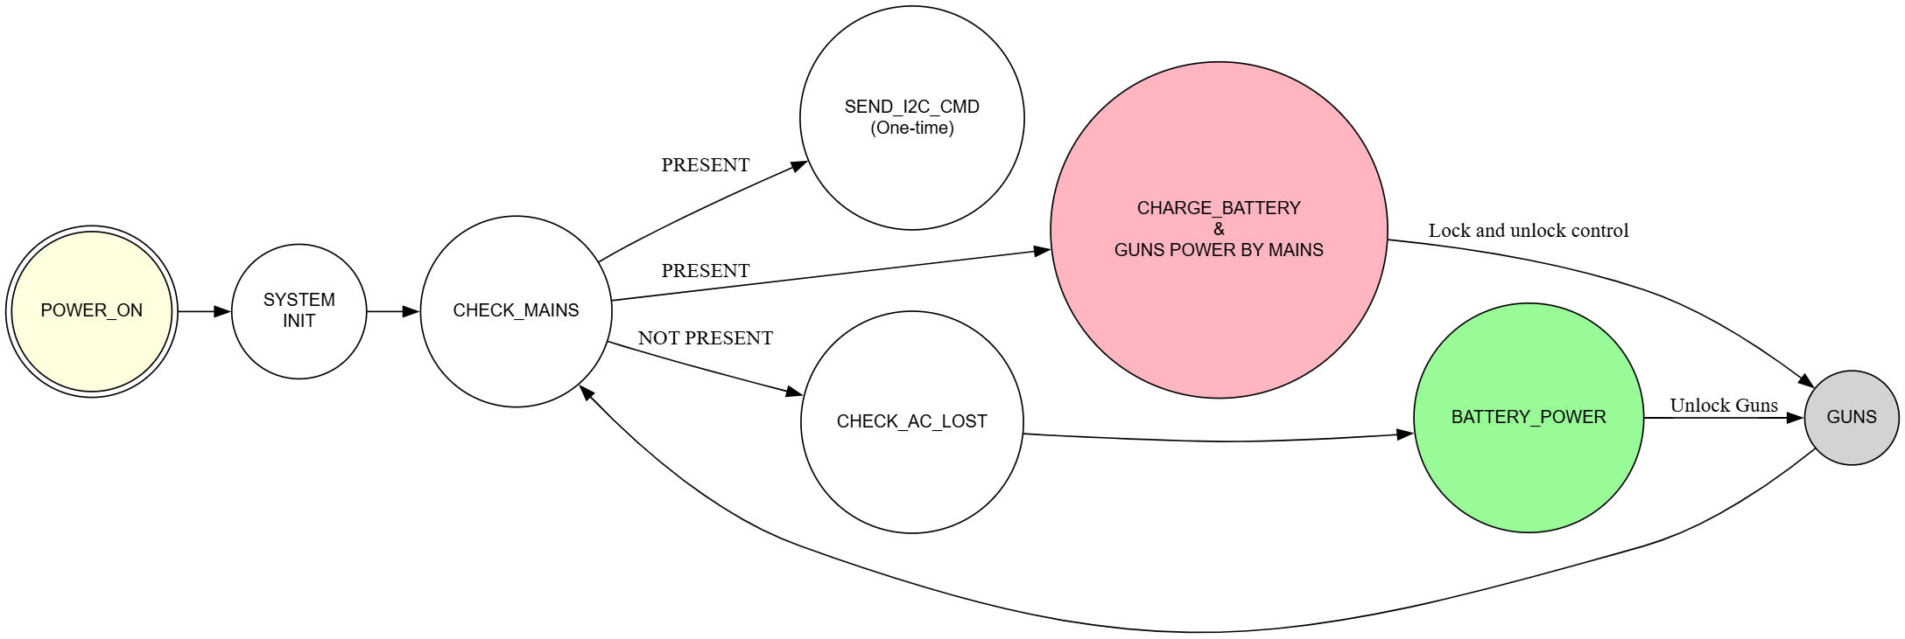

Finite state machine
Project Flow – System Operation Description
1. System Power-Up

* IF +12 V DC (AC mains) is present at startup
→ MCU initializes all peripherals (I²C, GPIO, timers)
→ Sets AC mains status = PRESENT
→ Sends I²C command to charger IC (BQ24735) to start charging the battery.

2. Normal Operation – AC Mains Available

* IF AC mains detect = PRESENT
→ Charger IC supplies system load and charges the battery.
→ MCU keeps all solenoid control pins in output, low state (idle).
→ Solenoid lock/unlock actions are driven externally.

3. AC Mains Loss Detection

* IF AC mains detect = NOT PRESENT
→ MCU waits 1 second for confirmation (noise/false trigger filter).

* IF mains still absent after delay
→ MCU sends 100 ms unlock pulse to both solenoid H-Bridge inputs.
→ MCU resets control pins to idle state.
→ Updates state = AC LOSS MODE.

4. Battery Operation Mode

* IF system is in AC LOSS MODE
→ Battery powers MCU, H-Bridge drivers, and solenoids.
→ Charger IC is disabled to minimize drain.
→ Only essential operations are performed.

5. AC Mains Recovery

* IF AC mains detect = PRESENT again
→ MCU updates AC mains status = PRESENT
→ Sends I²C command to charger IC to re-enable charging.
→ System transitions back to Normal Operation Mode.

6. H-Bridge & Solenoid Control

* IF unlock action is triggered (during AC loss or specific events)
→ MCU drives the corresponding H-Bridge with a precisely timed pulse.
→ Ensures reliable solenoid actuation and minimal power consumption.

