Task 1: - Draw a labelled diagram of a desktop PC, clearly marking the motherboard, CPU, RAM, GPU, and both HDD and SSD storage components.
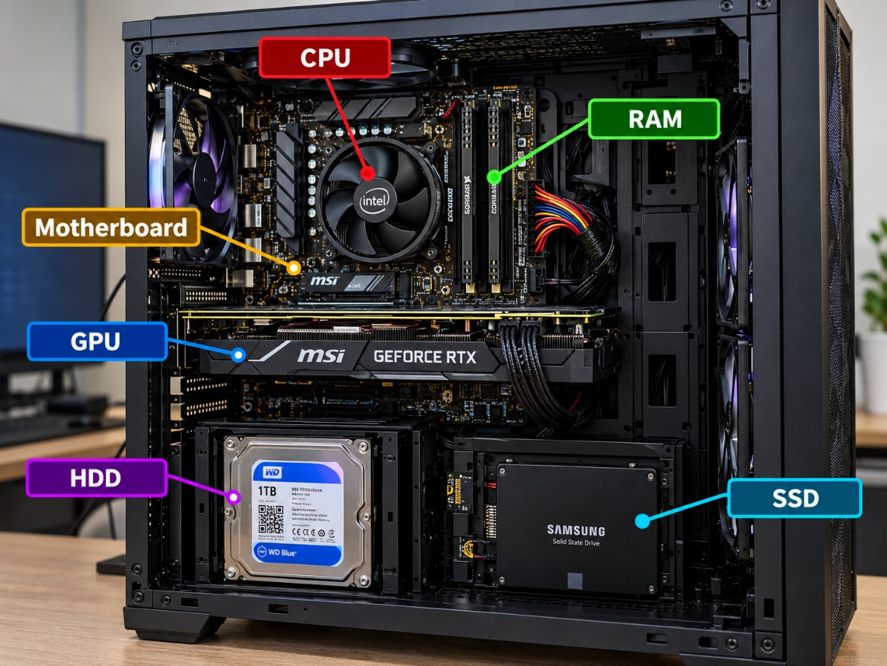

Task 2: - Create a comparison table showing the main differences between HDD and SSD storage in terms of speed, durability, and typical use cases.
Feature | HDD (Hard Disk Drive) | SSD (Solid State Drive)
Technology | Uses rotating magnetic disks (platters) and a moving read/write head. | Uses flash memory chips with no moving mechanical parts.
Speed | Slower because it must physically move its read/write head and rotate its disks. | Much faster because it accesses data electronically.
Typical speed | A typical 7,200 RPM HDD delivers around 100–200 MB/s for sequential transfers. | SATA SSDs typically reach around 500–550 MB/s; NVMe SSDs can reach several thousand MB/s.
Boot time | Usually takes longer to start the operating system. | Usually starts the operating system much faster.
Game loading | Games and levels generally take longer to load. | Games and levels generally load faster, reducing waiting time.
Durability | Less resistant to physical shock because it contains moving parts. | More resistant to physical shock because it has no moving parts.
Noise | May produce spinning or clicking sounds during operation. | Operates silently.
Power consumption | Generally, consumes more power, particularly while spinning. | Generally, consumes less power, making it suitable for battery-powered laptops.
Heat | Mechanical operation can generate heat. | Usually produces less heat, although high-performance NVMe SSDs can become hot under heavy workloads.
Storage capacity | Commonly available in multi-terabyte capacities, including 1 TB, 2 TB, 4 TB and more. | Commonly available in capacities such as 256 GB, 512 GB, 1 TB and 2 TB or more.
Cost per GB | Usually cheaper, making large storage capacities affordable. | Usually more expensive per GB, although prices vary by capacity and model.
Laptop use | Found in older or budget laptops and some laptops designed for large storage capacity. | Common in modern laptops because of its speed, low noise and shock resistance.
Desktop PC use | Suitable for storing large files, backups, photos, videos and archives. | Suitable for the operating system, applications, games and frequently accessed files.
Gaming PC use | Useful for storing a large game library when cost and capacity matter most. | Preferred for the operating system and games that benefit from faster loading.
Lifespan | Mechanical parts can wear out over time; physical shock can damage the drive. | Has limited write endurance, but a good-quality SSD can last many years under normal use.
Best advantage | High capacity at a lower cost. | High speed, silent operation and better shock resistance.
Main disadvantage | Slower, noisier and more vulnerable to physical shock. | Higher cost per GB and finite write endurance.

Task 3: - Write a short explanation (2-3 sentences each) describing the role of the CPU, RAM, and GPU in running a game like PUBG or Free Fire on a PC.

1. CPU (Central Processing Unit)
The CPU is the brain of the computer that processes game instructions and calculations. In games like PUBG or Free Fire, it handles player movements, game logic, enemy actions, and other background tasks to keep the game running smoothly.
2. RAM (Random Access Memory)
RAM temporarily stores the game data, maps, textures, and other information that the CPU needs quickly. Sufficient RAM helps the game run smoothly, reduces slowdowns caused by memory shortages, and allows other applications to run in the background.
3. GPU (Graphics Processing Unit)
The GPU renders the game's graphics, including characters, buildings, shadows, lighting, and visual effects. A powerful GPU can provide better graphics quality and higher frame rates (FPS), resulting in smoother gameplay.

TASK 4: - Imagine you want to upgrade your PC to run the latest version of FIFA smoothly. List which hardware components you would consider upgrading and explain why for each.
To run the latest FIFA-style football game smoothly on a PC, I would upgrade the following hardware components.
The aim is to achieve stable FPS, fast loading times, good graphics quality, and minimal lag. The exact requirements depend on the specific game version, such as EA SPORTS FC 26.

1. Hardware components to upgrade
No. | Hardware component | Recommended upgrade | Why is it important?
1 | CPU (Processor) | A modern Intel Core i5 or AMD Ryzen 5, or better | The CPU processes game logic, player movements, opponent AI, and physics calculations. A faster processor helps maintain stable FPS and reduces CPU-related stuttering.
2 | GPU (Graphics Card) | A dedicated NVIDIA GeForce RTX or AMD Radeon RX graphics card that meets the game's requirements | The GPU renders players, stadiums, grass, shadows, lighting, and animations. A suitable GPU improves visual quality and frame rates, especially at 1080p or higher resolutions.
3 | RAM (Memory) | At least 16 GB; 32 GB for heavier multitasking | RAM stores the game's active data and other running applications. Adequate memory reduces slowdowns caused by memory shortages.
4 | SSD (Storage) | A SATA SSD or, preferably, an NVMe SSD | An SSD reduces boot times, game loading times, and loading delays compared with a traditional HDD. It also improves overall system responsiveness.
5 | Power Supply Unit (PSU) | A reliable PSU with sufficient wattage for the selected CPU and GPU | A suitable PSU provides stable power to all components. A graphics card upgrade may require a higher-wattage PSU and compatible power connectors.
6 | Motherboard | A compatible motherboard if the existing one does not support the new CPU, RAM, or GPU requirements | The motherboard connects all hardware components. Its CPU socket, chipset, memory support, expansion slots, and firmware determine which upgrades are possible.
7 | Cooling system | A suitable CPU cooler and adequate case fans | Gaming generates heat. Proper cooling helps prevent thermal throttling, which can reduce performance when the CPU or GPU becomes too hot.
8 | Monitor | A Full HD (1920 × 1080) monitor with a 120 Hz or 144 Hz refresh rate, if desired | A higher refresh rate can display more frames per second, making player movement and gameplay appear smoother when the PC can produce enough FPS.
9 | Internet connection | A stable broadband connection using Ethernet or reliable Wi-Fi | A stable connection helps reduce online latency, packet loss, and connection interruptions in online matches. Internet speed alone does not guarantee low ping.
10 | Case and airflow | A case with adequate ventilation and clearance for the graphics card | Good airflow helps keep components cool. A larger or better-ventilated case may be necessary for a high-performance GPU.

2. Minimum practical and recommended gaming setup
Component | Practical starting point | Recommended for a smoother experience
CPU | Modern 4–6 core processor | Modern 6-core processor or better
GPU | Dedicated GPU meeting the game's minimum requirements | Mid-range dedicated GPU suitable for 1080p gaming
RAM | 8 GB only if the specific game supports it | 16 GB dual-channel RAM
Storage | HDD may work if supported | SSD with sufficient free space
PSU | Correct wattage and connectors for the existing hardware | Quality PSU sized for the upgraded system
Monitor | 60 Hz Full HD | 120–144 Hz Full HD
Cooling | Working stock cooling | Adequate CPU and case cooling

3. Additional upgrade possibilities
- Upgrade from HDD to SSD: Especially useful if Windows and the game currently run from an HDD.
- Upgrade RAM in dual-channel configuration: For example, 2 × 8 GB instead of 1 × 16 GB, if supported by the motherboard.
- Upgrade the GPU first: If the CPU is already capable but graphics performance and FPS are poor.
- Upgrade the CPU first: If the GPU is sufficiently powerful but gameplay stutters during demanding match situations.
- Upgrade the motherboard and RAM together: May be necessary when changing to a newer CPU platform or DDR5 memory.
- Upgrade the PSU: Essential when the new graphics card requires more power than the current unit can safely provide.
- Improve cooling: Useful if temperatures are high or performance drops during longer gaming sessions.
- Upgrade the monitor: Worth considering after the PC can consistently produce the desired frame rate.
4. Recommended upgrade priority
- Priority 1 — GPU
For better graphics quality and higher FPS when the graphics card is the performance bottleneck.
- Priority 2 — CPU
For stable frame rates, game calculations, and reducing CPU-related stuttering.
- Priority 3 — RAM
Aim for 16 GB for a modern gaming PC, subject to the game's requirements.
- Priority 4 — SSD
For faster booting, game launches, and loading screens.

- Priority 5 — PSU, cooling and compatibility
Ensure the upgraded hardware receives adequate power, stays cool, and fits the existing system.
Conclusion
To run the latest FIFA-style football game smoothly, I would focus on a capable CPU, a dedicated GPU, at least 16 GB of RAM, and an SSD.
I would also verify the motherboard, PSU, cooling, and monitor before upgrading. The best results come from balancing all components rather than upgrading only one part.

