Task 1: -Draw a labelled diagram of an ATX motherboard and mark at least 8 different slots and ports (such as RAM slots, PCIe slots, SATA ports, USB headers, CPU socket, power connector, etc.)
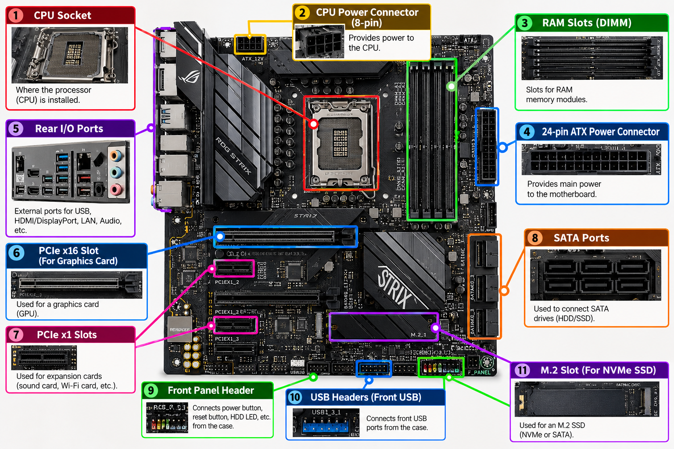

TASK 2: - Research and list 3 popular CPU socket types (for example: LGA1151, AM4, LGA1200) and name one compatible CPU model for each.

Research: Three Popular CPU Socket Types and Compatible Processors
1. Introduction
A CPU socket is a connector on a computer's motherboard that holds the Central Processing Unit (CPU) and provides the electrical connections needed for communication between the processor and the motherboard.
Different processors use different socket designs. Therefore, when selecting a CPU, it is important to check the socket type, motherboard chipset, BIOS compatibility, and supported memory.
The three popular CPU socket types discussed below are:
- Intel LGA1151
- AMD AM4
- Intel LGA1200
2. Intel LGA1151 Socket
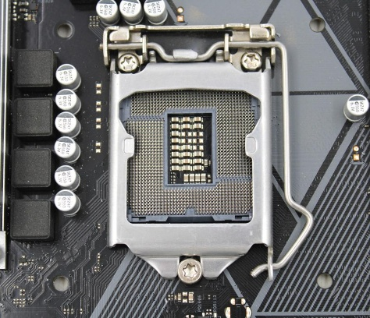
Manufacturer: Intel
Compatible CPU example: Intel Core i7-9700
Main features
- LGA stands for Land Grid Array. The electrical contacts are located in the motherboard socket, while the processor has contact pads.
- LGA1151 has 1,151 contact positions.
- It is used by certain 6th, 7th, 8th, and 9th generation Intel Core desktop processors, depending on the motherboard chipset.
- Compatible motherboards use DDR4 memory.
- Common motherboard chipsets include Intel 100-, 200-, and 300-series families, but support differs between generations.
Compatible CPU example: Intel Core i7-9700
The Intel Core i7-9700 is a 9th-generation desktop processor with 8 cores and 8 threads. It has a base frequency of 3.0 GHz and a maximum turbo frequency of up to 4.7 GHz.
It is suitable for gaming, programming, multitasking, and general desktop computing.
Important compatibility point: The Core i7-9700 requires a compatible Intel 300-series motherboard, such as a suitable B365 or Z390 board. A motherboard designed for a 6th-generation LGA1151 processor generally cannot run this CPU, even though the socket name is the same.

3. AMD AM4 Socket
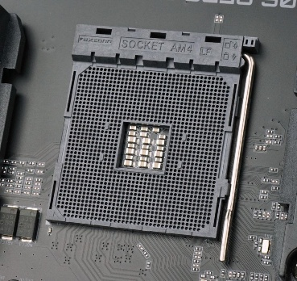
Manufacturer: AMD
Compatible CPU example: AMD Ryzen 5 5600
Main features
- AM4 is a socket designed for AMD desktop processors.
- It supports selected AMD Ryzen processor families, including compatible Ryzen 1000, 2000, 3000, 4000-series desktop APUs, and 5000-series models, depending on the motherboard.
- It supports DDR4 memory.
- It is used on motherboards with chipsets such as A520, B450, B550, X470, and X570, subject to processor and BIOS compatibility.
- Many AM4 processors use a pin-grid-array design, in which the CPU has pins that fit into the motherboard socket.
Compatible CPU example: AMD Ryzen 5 5600
The AMD Ryzen 5 5600 is a desktop processor based on AMD's Zen 3 architecture.
Specification | Details
Socket | AM4
CPU cores | 6
Threads | 12
Base clock | 3.5 GHz
Maximum boost clock | Up to 4.4 GHz
Default TDP | 65 W
Memory support | DDR4
Integrated graphics | Not included; a dedicated graphics card is required
Latest Version
Uses and applications
The Ryzen 5 5600 is suitable for:
- Gaming and esports titles.
- Programming and software development.
- General desktop and office applications.
- Multitasking and everyday content creation.
Important compatibility point: Although the Ryzen 5 5600 uses the AM4 socket, not every AM4 motherboard supports it out of the box. A BIOS update may be required. Check the motherboard manufacturer's CPU support list before installation.

4. Intel LGA1200 Socket
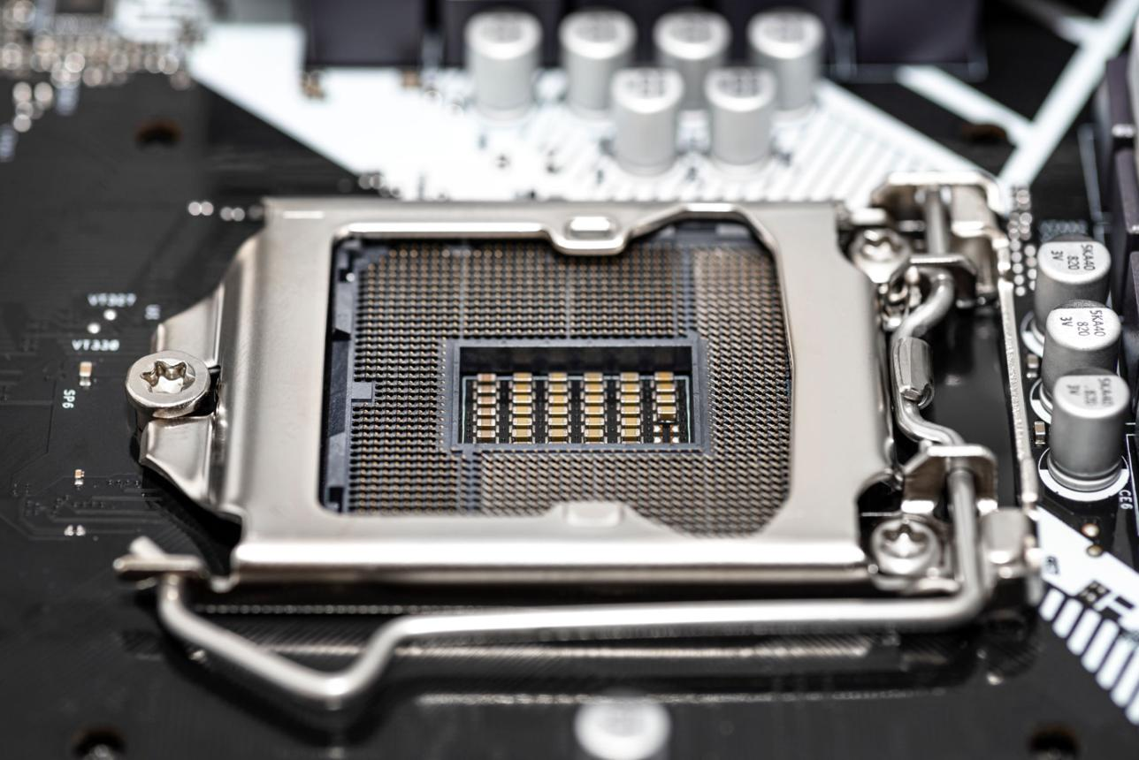
Manufacturer: Intel
Compatible CPU example: Intel Core i7-10700
Main features
- LGA stands for Land Grid Array.
- LGA1200 has 1,200 contact positions.
- It supports 10th- and 11th-generation Intel Core desktop processors.
- Compatible motherboards use Intel 400-series or 500-series chipsets, with certain chipset restrictions.
- It supports DDR4 memory.
- It is mechanically and electrically different from LGA1151, so processors from Compatible CPU example: Intel Core i7-10700
The Intel Core i7-10700 is a 10th-generation desktop processor designed for the LGA1200 socket.
Specification | Details
Socket | LGA1200
CPU cores | 8
Threads | 16
Base clock | 2.9 GHz
Maximum turbo frequency | Up to 4.8 GHz
TDP | 65 W
Memory support | DDR4-2933
Integrated graphics | Intel UHD Graphics 630
Intel's official specification page lists these processor details.

Intel
Uses and applications
The Intel Core i7-10700 is suitable for:
- Gaming with a compatible graphics card.
- Software development and compiling programs.
- Multitasking with several applications.
- Video editing and general productivity workloads.
Important compatibility point: The i7-10700 requires an LGA1200 motherboard. Compatible boards commonly use Intel 400-series or 500-series chipsets, but individual chipset restrictions and BIOS requirements must be checked.
5. Comparison of the three CPU socket types
Feature | Intel LGA1151 | AMD AM4 | Intel LGA1200
Manufacturer | Intel | AMD | Intel
Example CPU | Core i7-9700 | Ryzen 5 5600 | Core i7-10700
Processor generation | 8th/9th Gen example | Ryzen 5000 series | 10th Gen example
CPU cores | 8 | 6 | 8
Threads | 8 | 12 | 16
Memory type | DDR4 for i7-9700 | DDR4 | DDR4
Typical chipset families | Intel 300 series for i7-9700 | AMD 400/500 series, among others | Intel 400/500 series
Common applications | Gaming and desktop computing | Gaming and multitasking | Gaming and productivity
The comparison uses the specific CPU models listed above. The specifications are not universal to every processor using these sockets.
6. Why CPU socket compatibility matters
Before installing a processor, check these five items:
- Socket type: The CPU must physically and electrically match the motherboard socket.
- Chipset: The motherboard chipset must support the processor family.
- BIOS version: Older motherboard firmware may need an update for a newer CPU.
- Memory support: Confirm the supported DDR generation and memory configuration.
- Power and cooling: Ensure the motherboard's power delivery and CPU cooler are suitable for the processor.
Conclusion
The LGA1151, AM4, and LGA1200 are three important desktop CPU socket types. LGA1151 supports selected older Intel processors, AM4 supports selected AMD Ryzen processors, and LGA1200 supports Intel's 10th- and 11th-generation desktop processors.

TASK 3: - Explain in your own words the primary functions of the CPU and the chipset on a motherboard, and describe how they work together when you open a music app like Spotify.
1. Primary Functions of the CPU and Chipset
CPU (Central Processing Unit): The CPU is the brain of the computer. It executes instructions, performs calculations, and controls the operations of software and hardware. It processes the tasks required to run applications.
Chipset: The chipset manages communication between the CPU and other components connected to the motherboard, such as USB ports, storage devices, and other peripherals. It helps coordinate data transfer between these components and the CPU.
2. How They Work Together When Opening Spotify
- User action: When you click the Spotify icon, the operating system receives your command.
- CPU processing: The CPU executes the instructions needed to launch Spotify.
- Data access: The computer reads Spotify's program files from the SSD or HDD into RAM.
- Chipset communication: The chipset helps manage communication with connected devices, such as storage drives and USB audio devices, while the CPU coordinates the application's operations.
- Application display: The CPU processes the application tasks, and the graphics hardware displays Spotify's interface on the screen.
- Music playback: When you play a song, Spotify receives the audio data through the internet or local storage. The CPU and audio hardware process the playback, and the sound is sent to your speakers or headphones.
Conclusion: The CPU processes instructions and performs tasks, while the chipset helps manage communication between the CPU and motherboard-connected components. Together, they help Spotify launch, display its interface, and play music smoothly.
TASK 4: - Find a clear photo of a real motherboard (from the internet or your own device), and identify at least 5 different ports or slots by circling them and labelling each one.
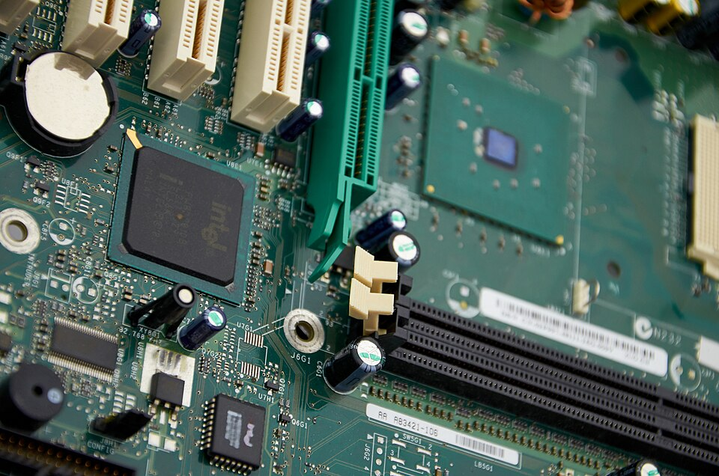

No. | Port / Slot / Component | Description
1 | RAM Slots (DIMM Slots) | The long slots used to install RAM modules, which temporarily store data and instructions for the CPU.
2 | PCI Expansion Slots | The long white slots used to connect expansion cards, such as network, sound, or other add-on cards.
3 | Chipset | The large Intel chip on the left side helps manage communication between the CPU and supported motherboard components.
4 | CPU Socket | The processor mounting area. It is located toward the upper-right portion of the image, under the greenish square retention area.
5 | CMOS Battery | The round silver battery in the upper-left corner maintains the motherboard's real-time clock and helps preserve BIOS/firmware settings when power is disconnected.
6 | IDE Connector | The long, narrow connector near the right edge is likely an IDE/PATA connector, used on older motherboards to connect compatible hard drives or optical drives.
7 | Power Regulation Components | The capacitors and nearby circuitry help regulate and stabilize voltage supplied to motherboard components.

