TASK 1: -Create a comparison table listing the main differences between DDR3, DDR4, and DDR5 RAM, including speed, voltage, and typical use cases.
Feature | DDR3 | DDR4 | DDR5
Full form | Double Data Rate 3 | Double Data Rate 4 | Double Data Rate 5
Data transfer speed | 800–2133 MT/s | 1600–3200 MT/s | 4800–8800+ MT/s
Operating voltage | 1.5 V (typically) | 1.2 V | 1.1 V
Power efficiency | Lowest of the three | Better than DDR3 | Best of the three
Typical capacity per module | Commonly 2–8 GB | Commonly 4–32 GB | Commonly 8–64 GB or more
Performance | Suitable for basic tasks on older systems | Good for everyday computing and gaming | Higher bandwidth for demanding applications
Typical use cases | Older desktops and laptops | Mainstream PCs and many gaming systems | Newer desktops, high-performance gaming, and workstations
Compatibility | Requires a DDR3-compatible motherboard | Requires a DDR4-compatible motherboard | Requires a DDR5-compatible motherboard

TASK 2: - Open your laptop or desktop (with power disconnected), locate the RAM slots, and take a clear photo of the installed RAM module. Reinstall the RAM module and verify that your system boots up successfully.
Procedure
- Shut down the computer and disconnect the power cable. For a laptop, disconnect the charger and remove the battery if it is designed to be removable.
- Open the case or RAM access panel. Refer to your device manual before opening it.
- Locate the RAM module. On a desktop, it is installed in long DIMM slots on the motherboard. On many laptops, it is installed in smaller SO-DIMM slots; some laptops have soldered RAM that cannot be removed.
- Remove the RAM carefully. Discharge static electricity by using appropriate ESD precautions. Release the retaining clips and handle the module by its edges.
- Take a clear photograph showing the RAM module and its slot. Include the module label if possible.
- Reinstall the RAM. Align the notch with the slot, insert the module evenly, and press until it is fully seated and the retaining clips engage.
- Reconnect power and start the computer. Confirm that the system reaches the operating system and that the installed memory is detected.
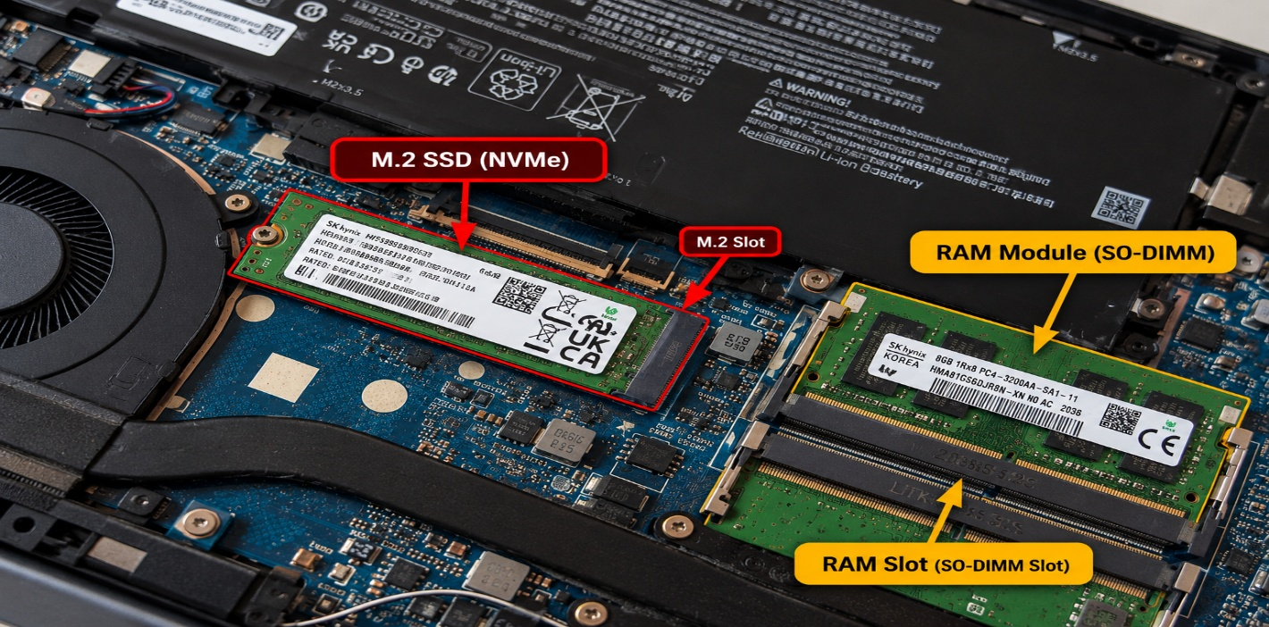

TASK 3: - List three key differences between HDD, SSD, and NVMe storage types, and for each, name one app or use case (from apps you use daily) that would benefit most from that storage type.
Comparison of HDD, SSD, and NVMe Storage
Feature | HDD | SSD (SATA) | NVMe SSD
1. Technology | Uses spinning magnetic disks | Uses flash memory with no moving parts | Uses flash memory and the high-speed PCIe interface
2. Speed | Slow: around 100–200 MB/s | Faster: around 500–550 MB/s | Very fast: commonly 3,000–7,000+ MB/s, depending on the drive
3. Cost and capacity | Lower cost per GB; good for large storage | Moderate cost; good balance of speed and capacity | Often costs more per GB than HDDs; ideal for high performance
Best use case | Storing photos, videos, and backups | Opening everyday apps such as Google Chrome or Spotify | Loading large games, video editing, and demanding software
Daily app examples
- HDD — Google Drive backups: Useful for storing large collections of downloaded files, photos, and videos locally.
- SATA SSD — Spotify: Helps the operating system and Spotify launch faster and improves general responsiveness.
- NVMe SSD — Games such as PUBG or EA SPORTS FC: Helps reduce loading times for large game files and assets.
Conclusion: HDD is best for affordable, high-capacity storage. SATA SSD is suitable for everyday computing, while NVMe SSD offers the highest performance for demanding applications.
TASK 4: - Remove the storage drive (HDD or SSD) from your system, take a photo of the connector type (SATA, M.2, or NVMe), and reinstall the drive. Confirm that your device recognizes the storage after reassembly.
Procedure
- Shut down your computer and disconnect the power cable or charger. Follow your device's service manual and use appropriate electrostatic discharge (ESD) precautions.
- Locate the storage drive. It may be a 2.5-inch SATA HDD/SSD or an M.2 SSD installed directly on the motherboard.
- Remove the drive carefully. Disconnect the SATA data and power cables for a SATA drive, or remove the retaining screw and gently slide out an M.2 drive.
- Take a clear photograph of the drive's connector. Make sure the connector and drive label are visible.
- Reinstall the drive. Reconnect the SATA cables or insert the M.2 drive at the correct angle and secure it with its retaining screw.
- Reassemble the computer and reconnect the power.
- Verify detection. Start the computer and check whether the drive appears in BIOS/UEFI or in Windows Disk Management and File Explorer.
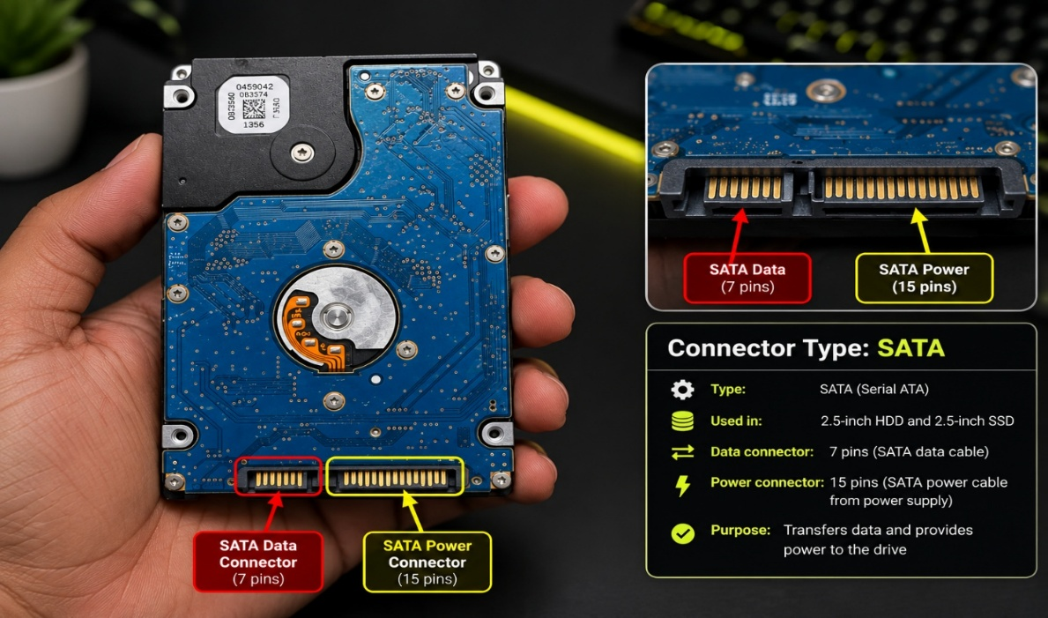

A SATA (Serial Advanced Technology Attachment) hard disk drive (HDD) is a storage device used to store the operating system, applications, documents, photos, videos, and other data. The given photograph shows a 2.5-inch HDD with its printed circuit board (PCB) and SATA connectors.
The drive has two main connectors:
- SATA Data Connector (7 pins): This connector transfers data between the hard drive and the motherboard through a SATA data cable.
- SATA Power Connector (15 pins): This connector supplies electrical power to the hard drive from the computer's power supply or a compatible laptop power connection.
The HDD contains moving magnetic disks that store data. Its electronic circuit board controls the drive's operation and manages communication with the computer.

