Task 1: - Open your own laptop or desktop (or use an online PC hardware simulator if you don't have access to a real system) and identify the GPU model installed. Write down the GPU's brand, model number, and whether it is integrated or dedicated.

- My System uses AMD Radeon Graphics integrated into the AMD Ryzen 5 5500U processor.

GPU Identification
Feature | Details
Brand | AMD
Model | AMD Radeon Graphics (Ryzen 5 5500U integrated GPU)
GPU type | Integrated GPU (iGPU)
Memory | Shared system RAM
Primary function | Processes graphics, displays images and videos, and supports gaming and other graphics applications.

Task 2: - Take a clear photo or screenshot of the cooling system (fan, heatsink, or liquid cooling setup) inside your PC or from a PC hardware simulator. Label the main cooling components and briefly describe their function.
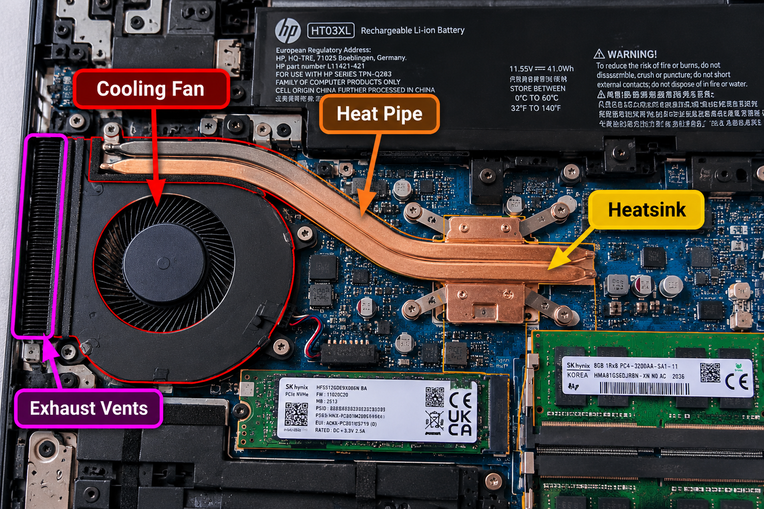

Components and their functions
No. | Component | Function
1 | Cooling Fan | Draws air through the cooling assembly to remove heat from internal components.
2 | Heat Pipe | Transfers heat away from the CPU and other heat-generating components toward the heatsink.
3 | Heatsink | Dissipates heat into the airflow, helping keep the processor at a safe operating temperature.
4 | Exhaust Vents | Allow hot air to escape from the laptop.

Task 3: - Create a comparison table listing at least 3 differences between air cooling and liquid cooling systems for GPUs, including factors like cost, efficiency, and maintenance.

Feature | Air Cooling | Liquid Cooling
1. Cooling method | Uses fans and a metal heatsink to remove heat from the GPU. | Uses liquid to transfer heat to a radiator, where fans dissipate it.
2. Cost | Usually cheaper and more affordable. | Usually more expensive due to the pump, radiator, tubing, and liquid-cooling hardware.
3. Cooling efficiency | Effective for most gaming GPUs, depending on the heatsink and airflow. | Can provide better heat management under sustained heavy loads, depending on the system design.
4. Noise level | Fans may become loud under heavy gaming loads. | Can be quieter in some setups, but pump and radiator fans still produce noise.
5. Maintenance | Requires occasional dust cleaning and fan checks. | Requires checking the pump, radiator, and tubing; custom loops need more maintenance.
6. Risk of damage | No liquid leakage risk; fan failure is a possible issue. | Liquid leakage is a potential risk, although sealed all-in-one (AIO) systems are designed to minimize it.
7. Installation | Generally easier to install and maintain. | More complex, especially for custom loops or GPU water blocks.
8. Best use case | Budget and mainstream gaming PCs. | High-end systems, overclocking, and specialized builds

Task 4: - Imagine you are building a gaming PC for streaming IPL matches and playing graphics-heavy games. Choose between air cooling and liquid cooling for your GPU, and justify your choice in 3-4 sentences based on your research.

1. Cooling Performance: I would choose a high-quality air-cooled GPU with a large heatsink and multiple fans. It can effectively remove heat from the GPU while playing graphics-heavy games and streaming IPL matches simultaneously.
2. Cost-Effectiveness: Air cooling is generally more affordable than liquid cooling. It allows me to spend more of my budget on a powerful GPU, processor, and RAM for better gaming and streaming performance.
3. Maintenance: Air cooling requires minimal maintenance. I would regularly clean dust from the GPU fans, heatsink, and PC case to maintain cooling efficiency and prevent overheating.
4. Reliability and Airflow: Air-cooled GPUs are generally reliable because they do not use liquid pumps or tubing. I would install additional case fans to maintain proper airflow and keep the GPU temperature stable during long gaming sessions.
5. Final Justification: I would select air cooling because it offers a good balance of performance, cost, reliability, and ease of maintenance. Liquid cooling could be considered for a high-end GPU requiring additional thermal management, but air cooling is sufficient for most gaming and streaming PCs when properly designed.

