Task 1: - List all the main components you find inside a desktop PC after opening the cabinet, and write a short description (1-2 lines) for each.
Main Components Inside a Desktop PC Cabinet
- Motherboard: The main circuit board that connects all computer components and allows them to communicate with one another.
- CPU (Central Processing Unit): Executes instructions, performs calculations, and controls the computer's operations.
- RAM (Random Access Memory): Temporarily stores data and programs currently in use so the CPU can access them quickly.
- HDD (Hard Disk Drive): Uses magnetic disks to store the operating system, applications, games, and files permanently.
- SSD (Solid-State Drive): Stores data using flash memory and provides faster boot times and application loading than a traditional HDD.
- GPU (Graphics Processing Unit): Processes graphics and images for games, videos, and other visual applications. It may be integrated or installed as a separate graphics card.
- PSU (Power Supply Unit): Converts electricity from the wall outlet into the required power for the computer's internal components.
- CPU Cooler: Uses a heatsink and fan, or a liquid-cooling system, to remove heat from the processor and prevent overheating.
- Cabinet Cooling Fans: Circulate air inside the cabinet to remove hot air and maintain suitable operating temperatures.
- CMOS Battery: Provides power to the motherboard's real-time clock and helps preserve BIOS/UEFI settings when the computer is switched off.
- RAM Slots (DIMM Slots): Hold the RAM modules and connect them electrically to the motherboard.
- PCIe Expansion Slots: Allow additional cards, such as graphics cards, sound cards, and network adapters, to be installed.
- M.2 Slot: Holds compatible M.2 SSDs directly on the motherboard, supporting NVMe or SATA storage depending on the slot.
- SATA Connectors and Cables: Connect SATA-compatible HDDs and SSDs to the motherboard for data transfer.
- Power Cables and Connectors: Deliver power from the PSU to the motherboard, CPU, graphics card, and storage drives.
- Optical Drive (CD/DVD Drive): Reads or writes CDs and DVDs, if the computer has one installed.
- Front-Panel Connectors: Connect the cabinet's power button, reset button, and indicator lights to the motherboard.
- Cabinet (PC Case): Houses and protects the internal components while providing mounting points and ventilation.

Task 2: - create the step-by-step image of the Take clear photos or draw labelled diagrams of each step as you disassemble a desktop PC, and organize them in a document with captions explaining what you did at each step. Include steps like unplugging power, removing side panel, disconnecting cables, and removing RAM, HDD/SSD, and motherboard.
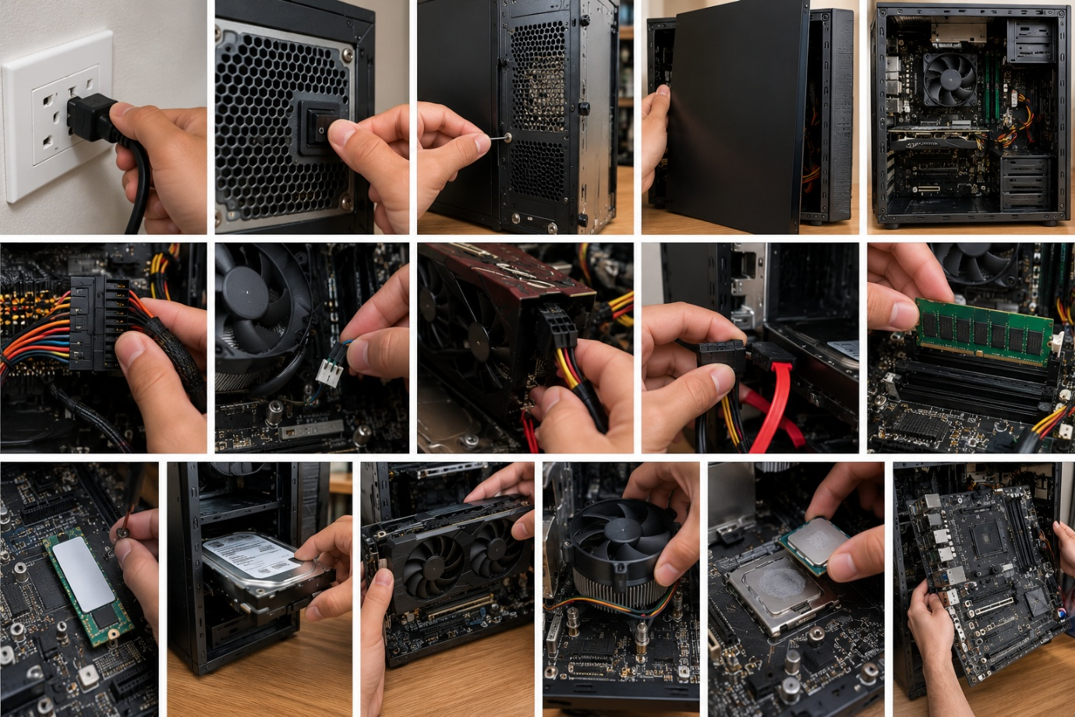

Desktop PC Disassembly: Detailed Explanation of Each Step
Step 1: Unplug the power cable
- Shut down the computer using the operating system's Shut down option.
- Turn off the PSU switch at the back of the cabinet, if available.
- Unplug the main power cable from the wall socket.
- Disconnect the power cable from the computer and remove external cables such as the monitor, keyboard, and mouse.
Purpose: To prevent electric shock, accidental startup, and damage to internal components.
Step 2: Turn off the PSU switch
- Locate the power supply unit at the rear of the cabinet.
- Find the switch marked I/O or ON/OFF.
- Move the switch to O (OFF).
- Confirm that the computer is unplugged before opening the cabinet.
Purpose: To ensure the power supply is switched off before handling internal components.
Step 3: Remove the side-panel screws
- Locate the screws securing the side panel at the rear of the cabinet.
- Use a suitable screwdriver to loosen and remove them.
- Keep the screws in a small container.
- Check whether the panel uses thumbscrews or a special release mechanism.
Purpose: To release the cabinet panel and provide access to the internal components.
Step 4: Remove the side panel
- Hold the side panel firmly with one hand.
- Slide it backward or lift it away, depending on the cabinet design.
- Place the panel somewhere safe to prevent scratches or bending.
- Inspect the inside of the cabinet without touching the components unnecessarily.
Purpose: To expose the motherboard, RAM, storage drives, graphics card, and other internal parts.
Step 5: Identify the main components
- Locate the motherboard, which is the main circuit board.
- Identify the CPU cooler, RAM modules, and graphics card.
- Locate the HDD or SSD and the PSU.
- Observe the power cables, SATA cables, fan connectors, and expansion slots.
Purpose: To understand the component layout before starting removal.
Step 6: Disconnect the motherboard power cable
- Locate the large 24-pin ATX power connector attached to the motherboard.
- Press its retaining clip to release the connector.
- Pull the connector straight out while holding its plastic body.
- Disconnect the separate CPU power connector near the processor if required.
Purpose: To disconnect the main electrical supply from the motherboard.
Precaution: Never pull the wires or force the connector.
Step 7: Disconnect the CPU cooler fan cable
- Locate the small fan cable connected to the motherboard header marked CPU_FAN.
- Identify its retaining tab, if present.
- Grip the connector body and pull it gently away from the header.
- Keep the cable clear of the cooler and surrounding components.
Purpose: To disconnect the CPU cooling fan before removing the motherboard or cooler.
Step 8: Disconnect the graphics card power cable
- Locate the PCIe power cable connected to the graphics card, if one is installed.
- Press the connector's release clip.
- Pull the connector straight out without twisting it excessively.
- Move the cable aside so it does not obstruct card removal.
Purpose: To disconnect the additional power supplied to a dedicated graphics card.
Note: Some graphics cards do not require a separate power cable.
Step 9: Disconnect the SATA power and data cables
- Locate the SATA data cable connecting the HDD or SATA SSD to the motherboard.
- Disconnect the SATA data cable by holding its connector.
- Disconnect the SATA power cable supplied by the PSU.
- If an optical drive is installed, disconnect its cables in the same way.
Purpose: The data cable transfers information, while the power cable supplies electricity to the storage drive.
Step 10: Remove the RAM module
- Locate the RAM modules in the long DIMM slots beside the CPU socket.
- Open the retaining clips at the ends of the occupied slot, according to its design.
- Hold the RAM module by its edges.
- Lift it straight out and store it in an antistatic bag.
Purpose: To remove the computer's temporary working memory safely.
Precaution: Avoid touching the gold contacts or forcing the module out while a clip remains engaged.
Step 11: Remove the M.2 SSD
- Locate the M.2 SSD mounted directly on the motherboard.
- Remove its small retaining screw with an appropriate screwdriver.
- Allow the SSD to rise slightly from the mounting point.
- Pull it gently out of the connector at the same angle.
- Store it in an antistatic bag.
Purpose: To remove compact solid-state storage used for the operating system, applications, and files.
Note: Not every desktop has an M.2 SSD.
Step 12: Remove the HDD or SATA SSD
- Confirm that the drive's data and power cables are disconnected.
- Locate the screws, bracket, or tray securing the drive.
- Remove the mounting screws or release the tray.
- Slide the drive out of the cabinet carefully.
- Keep the drive on a safe, stable surface.
Purpose: To remove the computer's permanent storage device.
Precaution: Handle HDDs gently because their internal mechanical parts can be damaged by impact.
Step 13: Remove the graphics card
- Remove the screws securing the graphics card bracket to the rear of the cabinet.
- Ensure that its power cable is disconnected, if present.
- Release the retaining latch on the PCIe slot.
- Support the card with both hands and lift it straight out.
- Place it on an antistatic surface or in an antistatic bag.
Purpose: To remove the dedicated graphics processor used for gaming, rendering, and other graphics-intensive tasks.
Precaution: Do not pull the card before releasing the PCIe latch.
Step 14: Remove the CPU cooler
- Disconnect the CPU fan cable if it has not already been disconnected.
- Locate the cooler's mounting screws, clips, or retention mechanism.
- Loosen the screws gradually and evenly, following the cooler manufacturer's instructions.
- Carefully separate the cooler from the processor.
- Clean off old thermal paste when appropriate before reinstallation.
Purpose: To remove the cooling assembly that transfers heat away from the CPU.
Precaution: If the cooler sticks to the processor because of dried thermal paste, do not pull it forcefully.
Step 15: Remove the CPU
- Confirm that the CPU cooler has been removed.
- Identify the socket retention lever or bracket.
- Release the retention mechanism according to the socket design.
- Lift the processor carefully by its edges.
- Store it in a suitable protective case.
Purpose: To remove the processor that executes instructions and performs calculations.
Precaution: CPU sockets differ. Avoid touching the pins or contact pads, and never force the processor out.
Step 16: Remove the motherboard
- Check that all power cables, storage cables, fan leads, and front-panel connectors are disconnected.
- Remove any remaining components that obstruct access.
- Locate and remove the motherboard mounting screws.
- Support the motherboard with both hands and lift it away from the cabinet.
- Place it on a clean, flat antistatic surface.
Purpose: To remove the main circuit board that connects the CPU, RAM, storage, GPU, and other components.
Precaution: Lift the board carefully so it does not catch on the cabinet's mounting standoffs.

Task 3: - Reassemble the PC you disassembled, documenting each step with a brief explanation of what you connected or installed and why the order matters.
Step 1: Prepare the cabinet and components
- Keep the PC unplugged and place the cabinet on a clean, stable surface.
- Arrange the motherboard, CPU, cooler, RAM, storage drives, GPU, PSU, and screws.
- Use an antistatic wrist strap if available and hold components by their edges.
Why the order matters: Preparing everything first reduces the risk of losing screws or damaging components during installation.
Step 2: Install the motherboard
- Position the motherboard inside the cabinet, aligning its mounting holes with the case standoffs.
- Check that no extra standoff is touching the underside of the board.
- Install and tighten the mounting screws gently.
Why the order matters: The motherboard provides the mounting points and connections for most internal components.
Step 3: Install the CPU
- Open the CPU socket retention mechanism.
- Align the processor's marked corner with the corresponding socket marker.
- Lower the CPU into place without forcing it, then secure the retention mechanism.
Why the order matters: The CPU must be correctly seated before the cooler is installed.
Step 4: Install the CPU cooler
- Apply thermal paste if required by the cooler's instructions; some coolers come with paste pre-applied.
- Position the cooler over the CPU and secure its mounting mechanism evenly.
- Connect the cooler fan cable to the motherboard's CPU_FAN header.
Why the order matters: The cooler must make proper contact with the CPU to prevent overheating.
Step 5: Install the RAM
- Open the retaining clips on the correct DIMM slots.
- Align the notch on each RAM module with the slot's key.
- Press evenly until the module is fully seated and the clips lock into place.
Why the order matters: RAM is easier to install before large coolers or other components restrict access to the slots.
Step 6: Install the M.2 SSD
- Insert the M.2 SSD into its motherboard connector at the recommended angle.
- Gently lower the drive and secure it with its retaining screw.
- Reinstall its heatsink, if one was removed.
Why the order matters: The M.2 slot can become harder to reach after the graphics card or other components are installed.
Step 7: Install the HDD or SATA SSD
- Slide the drive into its mounting tray or drive bay.
- Secure it with the appropriate screws or retention mechanism.
- Leave the data and power cables accessible for connection.
Why the order matters: Securing the drive first prevents it from moving and placing strain on its cables.
Step 8: Install the power supply unit (PSU)
- Position the PSU in its designated cabinet compartment.
- Align its mounting holes and secure it with the appropriate screws.
- Route the motherboard, CPU, storage, and GPU power cables toward their connectors.
Why the order matters: Installing the PSU before final cable management makes routing the power cables easier.
Step 9: Install the graphics card
- Align the graphics card with the appropriate PCIe slot and rear expansion opening.
- Press it gently into the slot until it is fully seated and the retention latch engages.
- Secure its bracket to the cabinet and connect its required power cables.
Why the order matters: The GPU needs correct slot alignment and secure mounting. Install it after components that are easier to access without it.
Step 10: Connect the motherboard power cables
- Connect the 24-pin ATX power cable to the motherboard.
- Connect the CPU power cable, usually a 4-pin or 8-pin connector near the CPU socket.
- Connect any additional power cables required by the installed hardware.
Why the order matters: The motherboard and CPU require these connections before the computer can start correctly.
Step 11: Connect storage and other internal cables
- Connect the SATA data cable from each SATA drive to the motherboard.
- Connect SATA power from the PSU to each applicable drive.
- Reconnect case fans, front-panel buttons, USB headers, and audio headers according to the motherboard manual.
Why the order matters: These connections enable storage access, cooling, front-panel controls, and cabinet ports.
Step 12: Check all connections and cable routing
- Verify that the RAM, GPU, and power connectors are fully seated.
- Ensure that the CPU cooler fan and case fans are connected.
- Route cables away from fan blades and secure loose cables neatly.
Why the order matters: A final inspection helps prevent startup failures, poor airflow, and short circuits caused by loose connections.
Step 13: Close the cabinet
- Check that no tools or loose screws remain inside.
- Align the side panel with the cabinet frame and slide or fit it into position.
- Secure the panel with its screws.
Why the order matters: Closing the cabinet protects the components and restores the intended airflow path.
Step 14: Reconnect external devices and test
- Connect the power cable, monitor, keyboard, mouse, and other required peripherals.
- Switch on the PSU and start the computer.
- Check that the system reaches the BIOS/UEFI screen or operating system, and confirm that the RAM, storage drives, and fans are detected or operating correctly.

Task 4: -Create a checklist of safety precautions and tools needed before starting the PC assembly/disassembly process, and explain why each is important.
1. Safety Precautions
No. | Safety precaution | Why it is important
1 | Shut down the PC properly. | Prevents data loss and ensures the computer stops running.
2 | Unplug the power cable. | Prevents accidental startup and reduces electrical hazards.
3 | Switch off the PSU. | Helps ensure the PC's power supply is switched off before handling components.
4 | Use an anti-static wrist strap. | Helps prevent electrostatic discharge (ESD), which can damage electronic components.
5 | Work on a clean, dry surface. | Reduces the risk of spills, dust contamination, and accidental damage.
6 | Hold components by their edges. | Prevents damage to delicate pins, contacts, and circuitry.
7 | Take photos before disconnecting cables. | Makes it easier to reconnect cables correctly during reassembly.
8 | Keep screws in a container. | Prevents screws from getting lost or falling into the cabinet.
9 | Avoid liquids and metal objects near components. | Reduces the risk of short circuits and physical damage.
10 | Never open the PSU enclosure. | Internal capacitors can retain dangerous electrical charge even after unplugging.
11 | Check connector alignment before installation. | Prevents bent pins, broken connectors, and damage to motherboard slots.
2. Tools and Equipment Required
No. | Tool or equipment | Why it is important
1 | Phillips screwdriver | Removes and tightens cabinet, motherboard, and drive screws.
2 | Anti-static wrist strap | Helps protect sensitive components from static electricity.
3 | Screw container or magnetic tray | Keeps screws organized during assembly and disassembly.
4 | Anti-static mat or bags | Provides safer storage and handling for electronic components.
5 | Flashlight or work light | Helps locate small screws and connectors inside the cabinet.
6 | Needle-nose pliers (optional) | Helps retrieve accessible small screws; never use them to force connectors.
7 | Thermal paste | Helps transfer heat between the CPU and cooler when fresh paste is required.
8 | Cable ties or Velcro straps | Keeps cables organized and away from cooling fans.
9 | Soft brush or compressed air | Removes dust from fans, heatsinks, and cabinet vents.
10 | PC or motherboard manual | Provides model-specific instructions and connector diagrams.

3. Final Checklist Before Starting
- The computer is shut down and unplugged.
- The workspace is clean, dry, and well-lit.
- All necessary tools are available.
- Static-protection measures are ready.
- Reference photos have been taken before disconnecting cables.
- Components and connectors have been identified.
- Screws and removed components can be stored safely.

