VEER NARMAD SOUTH GUJARAT UNIVERSITY,SURAT
.J.P. Dawar Institute of Information Science & Technology, SUrat

M.sc.(INFORMATION TECHNOLOGY) semester-8
m.sc.(information technology)
5 year Integrated course
Year 2025-2026
Shoe Store Management System
GUIDED BY:
Ms.Vini Surti
submitted by:
hardik sachdev spid: 2022026306
Krunal Rana spid: 2021013586
Introduction:
The Shoe Store Management System is a web-based application designed to manage and automate the operations of a shoe retail business. The system provides an efficient platform for managing products, customers, orders, and payments in a structured and organized manner.
In today’s digital era, online shopping has become an essential part of business operations. Manual management of shoe inventory, customer records, and order processing can be time-consuming and prone to errors. This system aims to overcome these challenges by providing a centralized and computerized solution.

The system is divided into two main modules:

Customer Module:
Customers can register, login, browse different shoe categories, view product details, add items to the cart, place orders, and make payments online. The system also allows customers to track their orders and view order confirmations.

Admin Module:
The admin is responsible for managing the overall system. The admin can add, update, or delete categories, brands, and shoe products. The admin can also manage customer orders and update order statuses.
The system ensures proper data storage using a structured database design, maintaining relationships between users, products, orders, and payments. It improves efficiency, reduces manual errors, enhances customer experience, and provides better business control.
Overall, the Shoe Store Management System provides a reliable, secure, and user-friendly solution for managing an online shoe store.
Database design-Shoe Store Management System
1.USer
Field | Datatype | Key | Null | description
User_id | Int | Primary | NotNull | Stores User Id
Name | Varchar(50) | - | NotNull | Stores User’s Name
Email | Varchar(50) | - | NotNull | Stores Email Id
Password | Varchar(50) | - | NotNull | Stores User’s Password
Role | Enum | - | NotNull | Admin or Customer
Phone | Int | - | NotNull | Stores User’s Phone Number
Created_at | TimeStamp | - | NotNull | Stores Created Time

2.Categories
(Formal,Sports,Casual,Sneaker)
Field | Datatype | Key | Null | description
Category_id | Int | Primary | Not Null | Stores Category Id
Category_name | Varchar(50) | - | Not Null | Stores Category Name
Description | Varchar(50) | - | Not Null | Stores Description

3.Brand
Field | Datatype | Key | Null | description
Brand_Id | Int | Primary | Not Null | Stores Brand_Id
Brand_Name | Varchar(50) | - | Not Null | Stores Brand_Name
Country | Varchar(50) | - | Not Null | Stores Country Name
4.Shoes
Field | Datatype | Key | Null | description
Shoe_Id | Int | Primary | NotNull | Stores Stoes Id
Shoe_name | Varchar(50) | - | NotNull | Stores Shoe Name
Brand_Id | Int | Foreign | NotNull | Stores Brand Id
Category_Id | Int | Foreign | NotNull | Stores category Id
Price | Int | - | NotNull | Stores price
Color | Varchar(50) | - | NotNull | Stores color
Image | Varchar(50) | - | NotNull | Stores Image
Description | Varchar(50) | - | NotNull | Stores Description
Status | Enum | - | NotNull | Available or Out Of Stock

5.cart
Field | Datatype | Key | Null | description
Cart_id | Int | Primary | NotNull | Stores Cart Id
User_id | Int | Foreign | NotNull | Stores User Id
Shoe_id | Int | Foreign | NotNull | Stores Shoe Id
Size | Int | - | NotNull | Stores Size
Quantity | Int | - | NotNull | Stores Quantiy
Added_At | TimeStamp | - | NotNull | Stores Added_At Date

6.Orders
Field | Datatype | Key | Null | description
Order_Id | Int | Primary | Not Null | Stores Order Id
User_Id | Int | Foreign | Not Null | Stores User Id
Order_Date | Date | - | Not Null | Stores Order_Date
Total_amount | Int | - | Not Null | Stores Total_amount
Payment_Method | Varchar(50) | - | Not Null | Stores Payment Method
Order_Statue | Enum | - | Not Null | PLACED , SHIPPED , DELIVERED , CANCELLED

7.payment
Field | Datatype | Key | Null | description
Payment_id | Int | Primary | Not Null | Stores Payment Id
Order_Id | Int | Foreign | Not Null | Stores Order Id
Payment_Method | Enum | - | Not Null | Cod , Online
Transaction_Status | Enum | - | Not Null | Pending , Success , Failed
Payment_Date | TimeStamp | - | Not Null | Stores Payment Date

8.booking_service
Field | Datatype | Key | Null | description
Booking_service_id | Int | Primary | Not Null | Stores Booking Service Id
booking_id | Int | Foreign | Not Null | Stores Booking Id
quantity | Int | - | Not Null | Stores Quantity
amount | Int | - | Not Null | Stores Amount

9.Reviews
Field | Datatype | Key | Null | description
review_id | Int | Primary | Not Null | Stores Review Id
user_id | Int | Foreign | Not Null | Stores User Id
shoe_id | Int | Foreign | Not Null | Stores Shoe Id
rating | Int | - | Not Null | Stores Rating
comment | Int | - | Not Null | Stores Comments

E-R DiAGRAM:
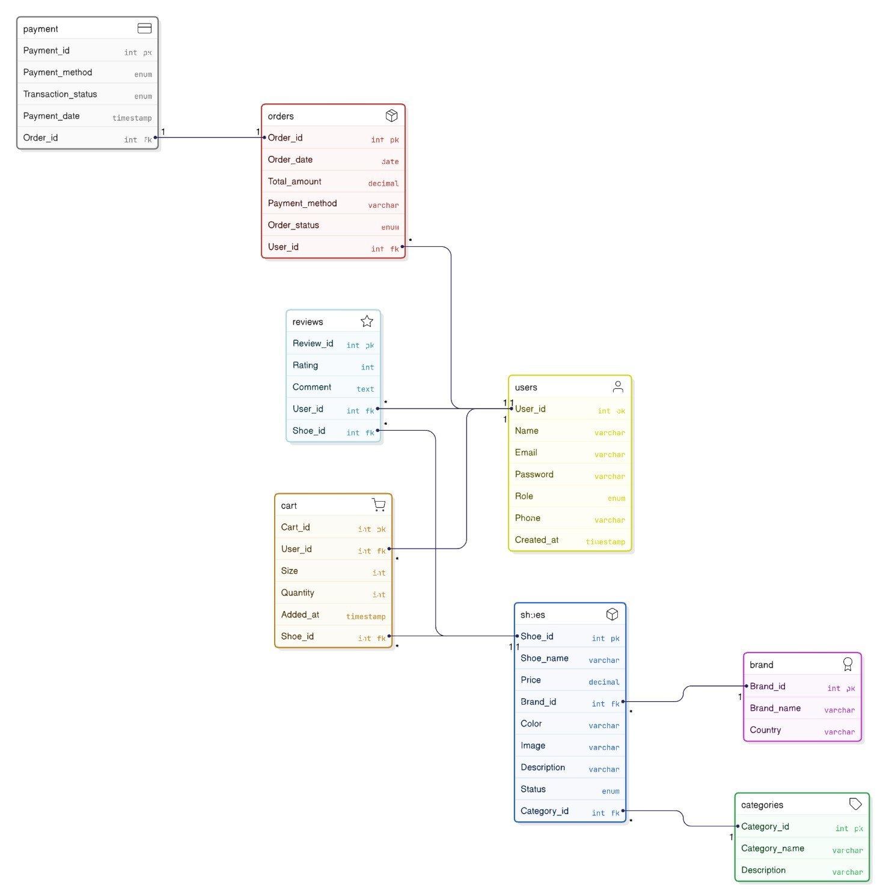

Activity Diagram:
1.customer:
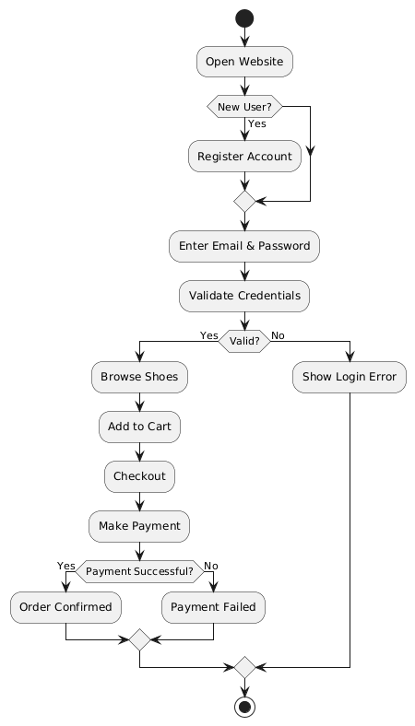
2.Admin:
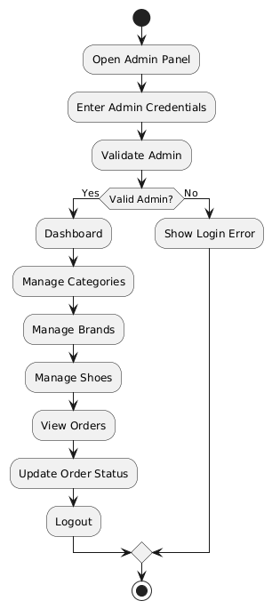
Level-0 dfd:

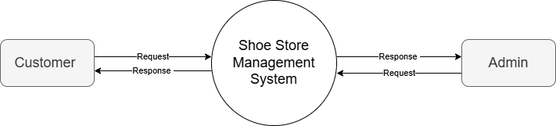

Level-1 dfd:
1.customer:
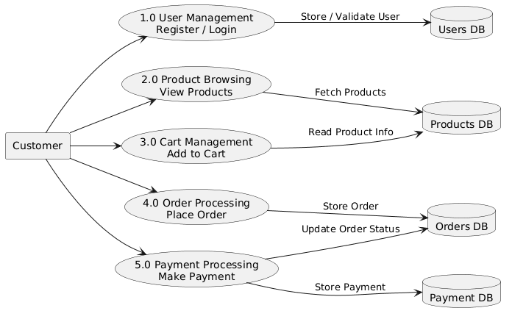
2.Admin:

