**Git tutorial**

version control tool-

to track changes in the computer files

to work with many people

1)why use git-

undo mistake

distributed development

dont mix things up

community support

master branch – main branch

sub branch

check git version

**git –version**

basic commands

make new folder

move to folder

**# use git init**

to initialize new project

we are in master brach

create a file

**staging area**

file → staging area → commit(checkpoint)

**# use git add filename**

it will move to staging area

**# use git status**

current changes

list the files you have changed and those you still need to add to commit

**# use git commit**

powerful tool

it will help me to come back to previous file if any error occur . Old version of file can be retrieve.

**# Use git commit – m “message”**

short message what changes you made in that file

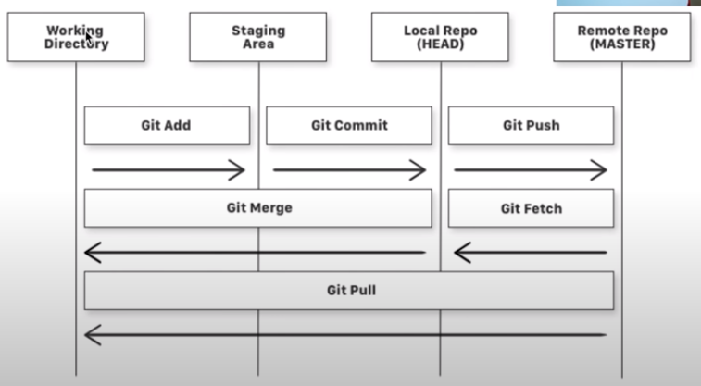

show the logs of commited files

**# use git logs**

### **#**use git rm –cached <file name>

to remove files from staging area or (unstage)

branching:-

initial branch is master branch which git provide

**# use git branch branch_name**

to create new branch

it only create branch

**# use git checkout branch_name**

to enter into that branch

same files are stored which are in master branch

**# use git commit -am “message”**

addition of two commands add and commit

**# use git checkout master**

it will return to master

* any changes in branches will not be shown in master branch if we make changes in files which are in sub branch and commit it . It will be in sub branch only . We have update master branch separately. *

**# use git merge <branch_name>**

to merge a branch into current branch

if I want to merge sub_branch into master_branch then

I should be in master_branch and then use commands

git merge sub_branch

**git and github are different**

git is only version control tool it is in local machine

github is the web hosting service

github

go to github

create new repo

copy

git remote add origin https://github.com/krunal1999/firstrepo.git

and paste in git bash

**# use git remote -v**

to check count of remote

**# use git push -u origin master**

to upload on github

**# use git push origin sub_branch**

first use git checkout sub_branch then use above command

it will create new branch on github

**compare and pull reques**t

to merge sub_branch into master_branch on remote host we have to use compare and pull request.

Eg . If I am working on open source project and fix a bug in project then I can request to pull my request or merge my code with master code

** remote server and local server are different **

**use git pull**

all changes in remote file will be saved in local files

**creating .gitignore file**

we can save filenames that should be accessible to others

first create .gitignore file

then create config.txt and write any code etc

then write config.txt filename in .gitignore

then add and commit and push on github

**use git add .**

To add all files which had changes

**fork**

it will make a copy of others project in our own repo