**DBMS Assessment**

**Write SQL query to solve the problem given below**

Consider three table named as city, customer and country

**City Table:-**

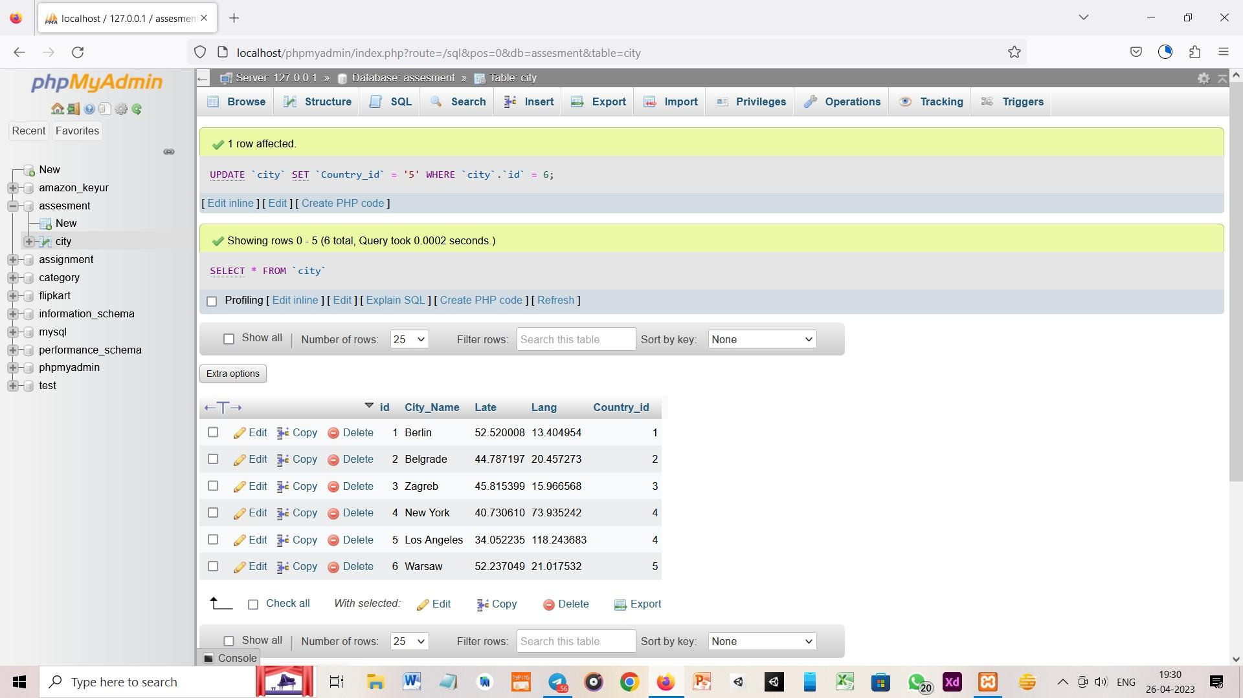

**Customer Table:-**

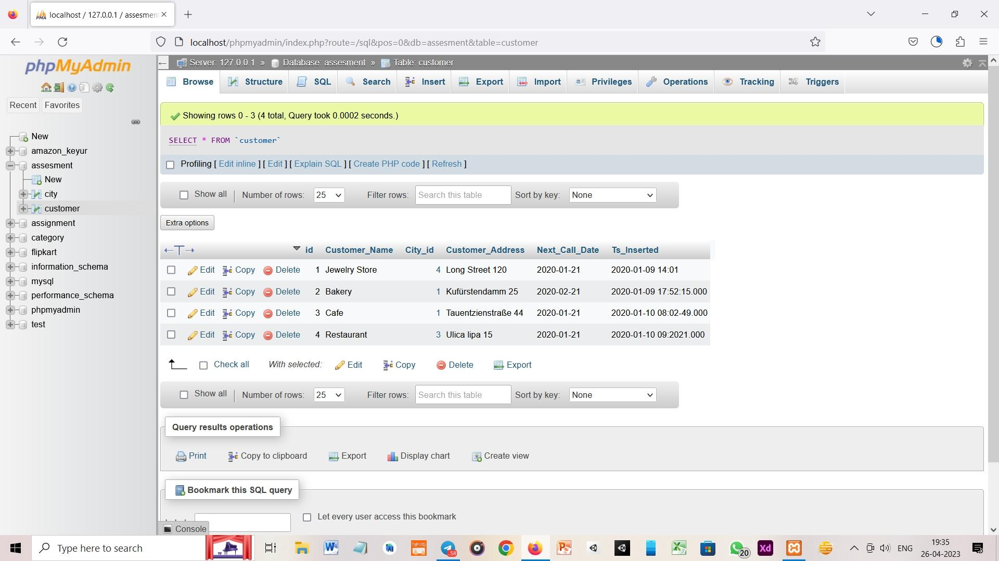

**Country Table:-**

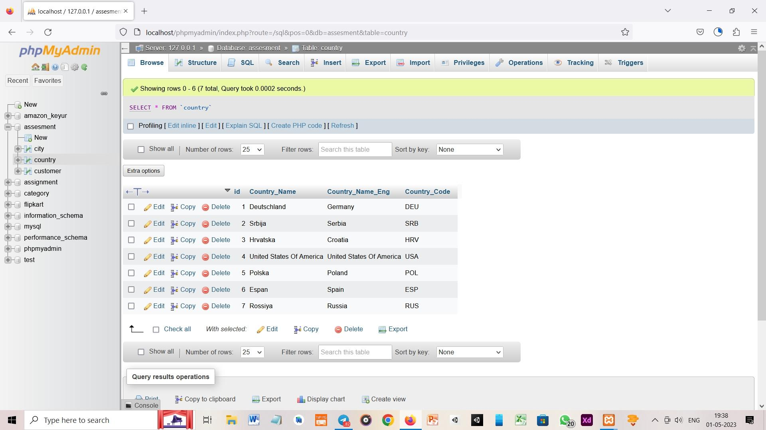

**Task 1**

1. List all Countries and customers related to these countries.

Ans:- SELECT Customer_Name, Country_Name FROM customer JOIN country, city WHERE customer.City_id = city.id AND city.Country_id = country.id



1. For each country displaying its in English, the name of the city customer is located in as well as the name of the customer

Ans:- SELECT customer.Customer_Name, country.Country_Name_Eng FROM customer JOIN country, city WHERE customer.City_id = city.id AND city.Country_id = country.id

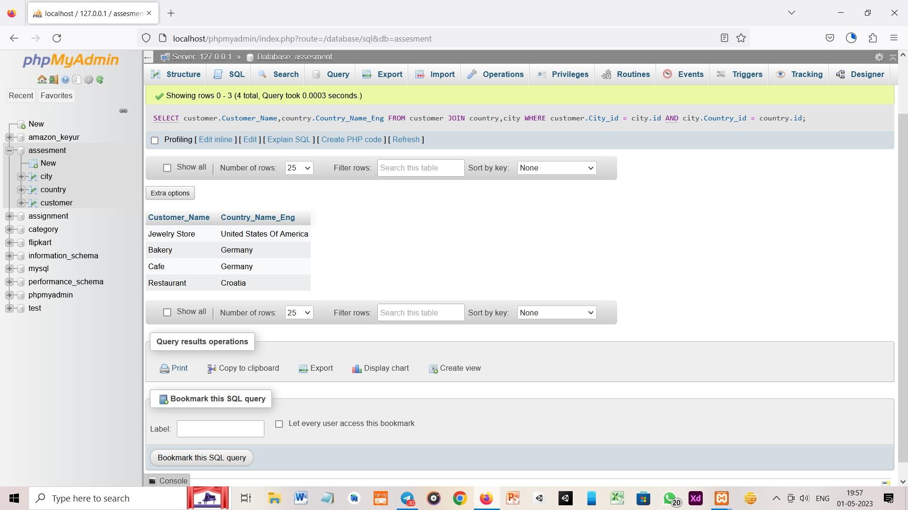

**Task 2**

1. Return the list of all countries that have pairs(exclude countries which are not referenced by any city). For such pairs return all customers

Ans:- SELECT country.Country_Name FROM country JOIN city,customer WHERE NOT EXISTS (SELECT * FROM customer WHERE customer.City_id = city.id) AND NOT EXISTS (SELECT * FROM city WHERE city.Country_id = country.id )

1. Return even pairs of not having a single customer

Ans:- SELECT customer.Customer_Name FROM customer JOIN city,country WHERE NOT EXISTS (SELECT * FROM customer WHERE customer.City_id = city.id) AND NOT EXISTS (SELECT * FROM city WHERE city.Country_id = country.id )