***DBMS ASSIGNMENT***

1. **What is a database?**

A database is information that is set up for easy access, management and updating. Computer databases typically store aggregations of data records or files that contain information, such as sales transactions, customer data, financials and product information.

1. **What is Difference Between DBMS and RDBMS?**

**Database Management System (DBMS)** is a software that is used to define, create and maintain a database and provides controlled access to the data.

**Relational Database Management System (RDBMS)** is an advanced version of a DBMS.

**DBMS:**

* DBMS stores data as file.
* Data elements need to access individually.
* No relationship between data.
* Normalization is not present.
* DBMS does not support distributed database.
* It stores data in either a navigational or hierarchical form.
* It deals with small quantity of data.
* The data in a DBMS is subject to low security levels with regards to data manipulation.
* It is used for small organization and deal with small data

**RDBMS:**

* RDBMS stores data in tabular form.
* Multiple data elements can be accessed at the same time.
* Data is stored in the form of tables which are related to each other.
* Normalization is present.
* RDBMS supports distributed database.
* It uses a tabular structure where the headers are the column names, and the rows contain corresponding values.
* It deals with large amount of data.
* There exists multiple levels of data security in a RDBMS.
* It is used to handle large amount of data.

1. **What is Normalization?**

* Normalization is the process of organizing the data in the database.
* Normalization is used to minimize the redundancy from a relation or set of relations. It is also used to eliminate undesirable characteristics like Insertion, Update, and Deletion Anomalies.
* Normalization divides the larger table into smaller and links them using relationships.
* The normal form is used to reduce redundancy from the database table.

1. **What is SQL Key Constraints? Write an Example of SQL Key Constraints?**

Constraints are used to limit the type of data that can go into a table. This ensures the accuracy and reliability of the data in the table. If there is any violation between the constraint and the data action, the action is aborted.

* **NOT NULL –** Ensures that a column cannot have a NULL value
  + **UNIQUE –** Ensures that all values in a column are different
  + **PRIMARY KEY –** A combination of a NOT NULL and UNIQUE. Uniquely identifies each row in a table
  + **FOREIGN KEY –** Prevents actions that would destroy links between tables
  + **CHECK –** Ensures that the values in a column satisfies a specific condition
  + **DEFAULT –** Sets a default value for a column if no value is specified
  + **CREATE INDEX –** Used to create and retrieve data from the database very quickly

**Ex:** CREATE TABLE Persons (

ID int NOT NULL,

LastName varchar(255) NOT NULL,

FirstName varchar(255),

Age int,

PRIMARY KEY (ID)

);

1. **What is trigger and how to Create a Trigger in SQL?**

A trigger is a stored procedure in database which automatically invokes whenever a special event in the database occurs. For example, a trigger can be invoked when a row is inserted into a specified table or when certain table columns are being updated.

**SYNTAX:**

Create trigger [trigger_name]

[before | after]

{insert | update | delete}

On [table_name]

[for each row]

[trigger_body]

1. **What is SQL and How to Create a table with Foreign Key?**

* SQL stands for Structured Query Language. It is used for storing and managing data in relational database management system (RDMS).
* It is a standard language for Relational Database System. It enables a user to create, read, update and delete relational databases and tables.
* All the RDBMS like MySQL, Informix, Oracle, MS Access and SQL Server use SQL as their standard database language.
* SQL allows users to query the database in a number of ways, using English-like statements.

**SYNTAX:**

CREATE TABLE TABLE_NAME(

Column 1 datatype,

Column 2 datatype,

Column 3 datatype FOREIGN KEY REFERENCES Table_name(Column name), //Column which has to be a forigen key

..

..

Column n

)

**Task 1: SQL Practices Table Name : Student and Exam**

* **Student Table**

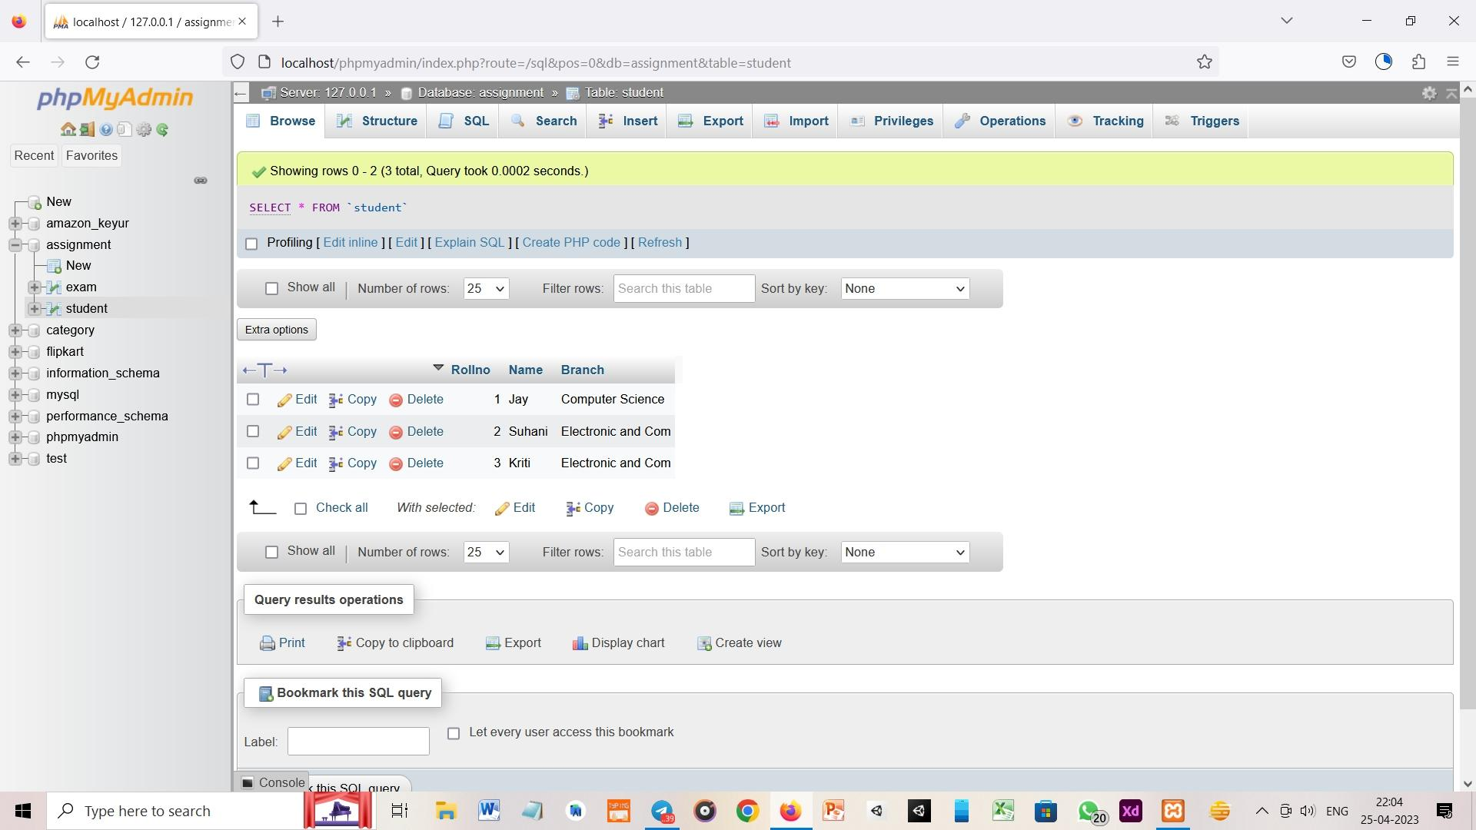

1. **How to Create Table student write an SQL Query?**

Create table student (

Rollno int(255) primary key ,

Name varchar (200),

Branch varchar (200)

);

Insert into student (Rollno,Name,Branch) values (1,”Jay”,”Computer Science”);

Insert into student (Rollno,Name,Branch) values (2,”Suhani”,”Electronic and Com”);

Insert into student (Rollno,Name,Branch) values (3,”Kriti”,”Electronic and Com”);

**EXAM TABLE:-**

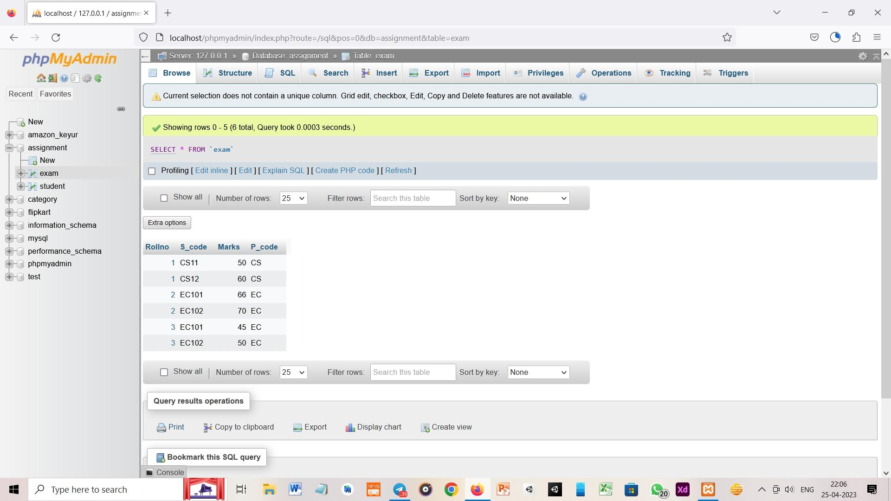

1. **How to Create a Exam table with Foreign key on roll no write a SQL Query?**

Create table Exam (

Rollno int (255),

S_code varchar(200),

Marks int(255),

P_code varchar(200),

FOREIGN KEY Exam(Rollno) REFRENCES Student(Rollno)

);

Insert into Exam (Rollno,S_code,Marks,P_code) values (1,”CS11”,50,”CS”);

Insert into Exam (Rollno,S_code,Marks,P_code) values (1,”CS12”,60,”CS”);

Insert into Exam (Rollno,S_code,Marks,P_code) values (2,”EC101”,66,”EC”);

Insert into Exam (Rollno,S_code,Marks,P_code) values (2,”EC102”,70,”EC”);

Insert into Exam (Rollno,S_code,Marks,P_code) values (3,”EC101”,45,”EC”);

Insert into Exam (Rollno,S_code,Marks,P_code) values (3,”EC102”,50,”EC”);

**Task 2: User Table**

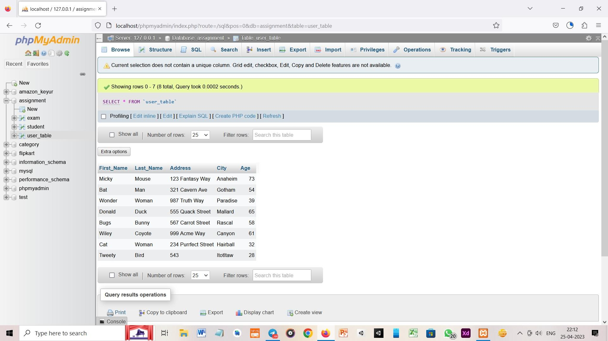

1. **How to Create a Table user write a SQL query?**

Create table user(

First_Name varchar(200),

Last_Name varchar(200),

Address varchar(200),

City varchar(200),

Age int (255)

);

Insert into user(First_Name,Last_Name,Address,City,Age) values (“Micky”,”Mouse”,”123 Fantasy Way”,”Anaheim”,73);

Insert into user(First_Name,Last_Name,Address,City,Age) values (“Bat”,”Man”,”321 Cavern Ave”,”Gotham”,54);

Insert into user(First_Name,Last_Name,Address,City,Age) values (“Wonder”,”Woman”,”987 Truth Way”,”Paradise”,39);

Insert into user(First_Name,Last_Name,Address,City,Age) values (“Donald”,”Duck”,”555 Quack Street”,”Mallard”,65);

Insert into user(First_Name,Last_Name,Address,City,Age) values (“Bugs”,”Bunny”,”567 Carrot Street”,”Rascal”,58);

Insert into user(First_Name,Last_Name,Address,City,Age) values (“Wiley”,”Coyote”,”999 Acme Way”,”Canyon”,61);

Insert into user(First_Name,Last_Name,Address,City,Age) values (“Cat”,”Woman”,”234 Purrfect Street”,”Hairball”,32);

Insert into user(First_Name,Last_Name,Address,City,Age) values (“Tweety”,”Bird”,”543”,”Itotltaw”,28);

**Task 3: Employee and Incentive Table**

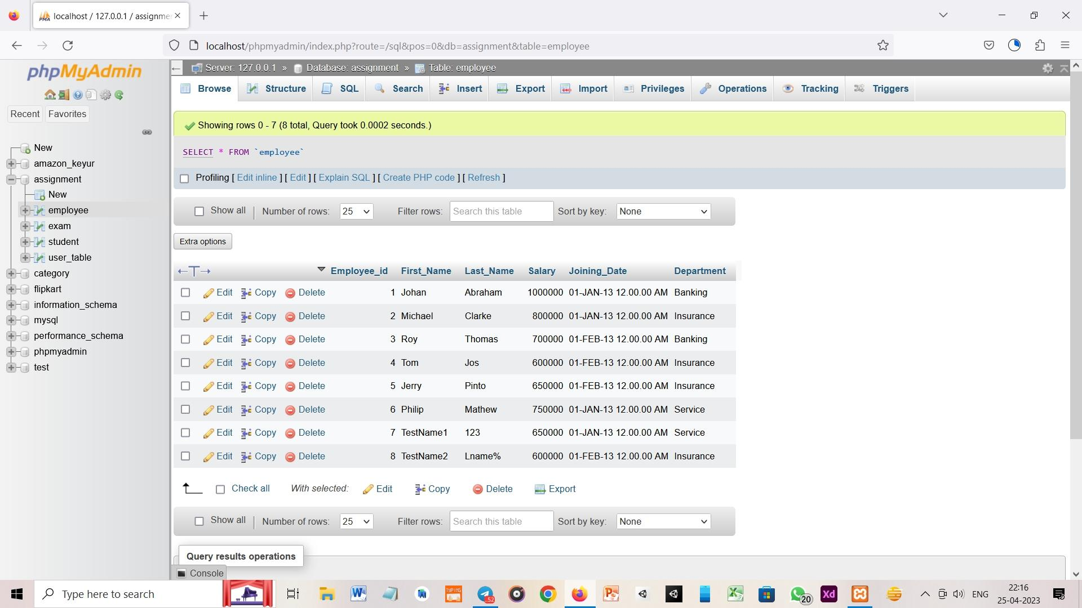**Employee Table:**

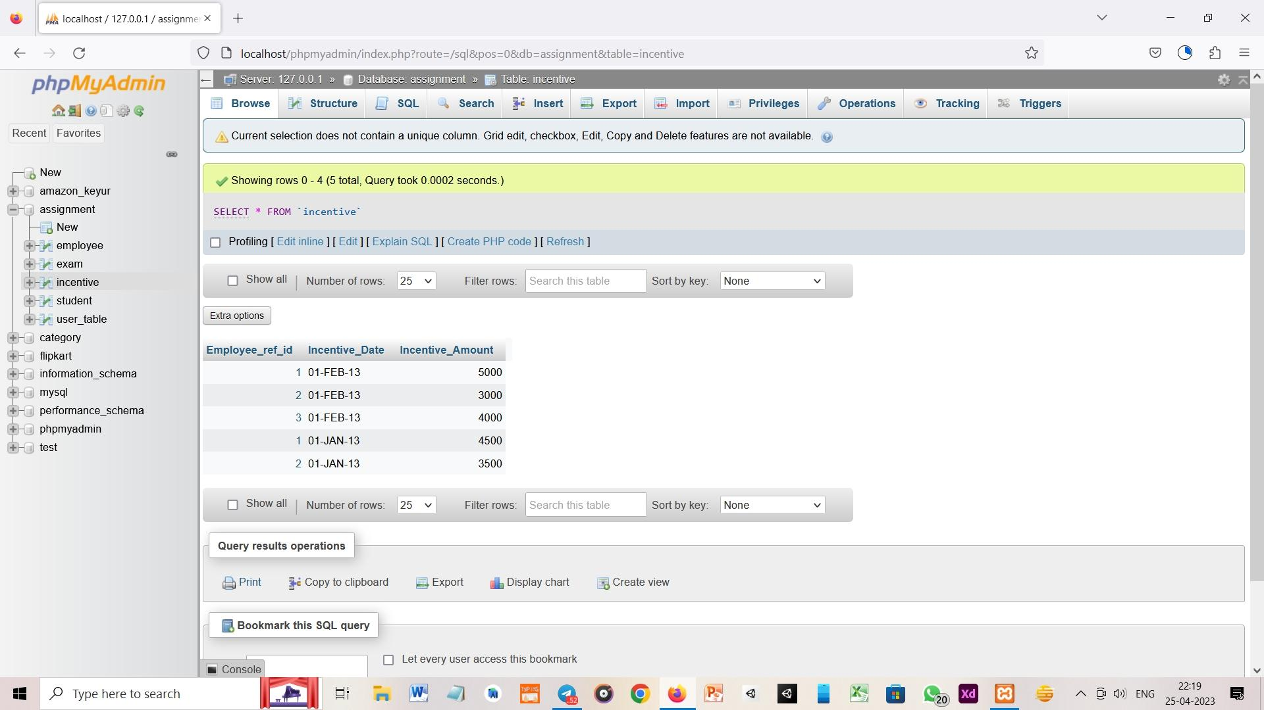 **Incentive Table:-**

**Query:-**

a. Get First_Name from employee table using Roy name “Employee Name”.

Ans:- Select First_Name As Employee_Name from Employee where First_Name = “Roy”

b. Get FIRST_NAME, Joining Date, and Salary from employee table.

Ans: Select First_Name,Joining_Date,Salary from Employee

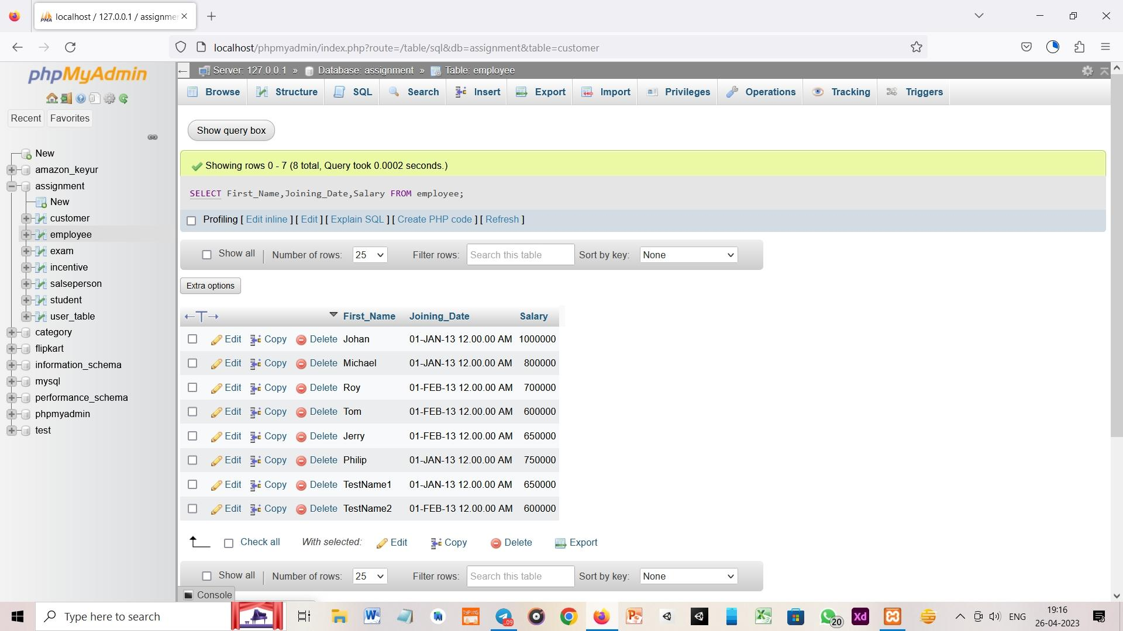

c.Get all employee details from the employee table order by First_Name Ascending and Salary descending?

Ans:- Select * from Employee order by First_Name asc

Ans:- Select * from Employee ORDER BY Salary DESC

d. Get employee details from employee table whose first name contains ‘J’.

Ans:- Select * from Employee where First_Name Like “J%”

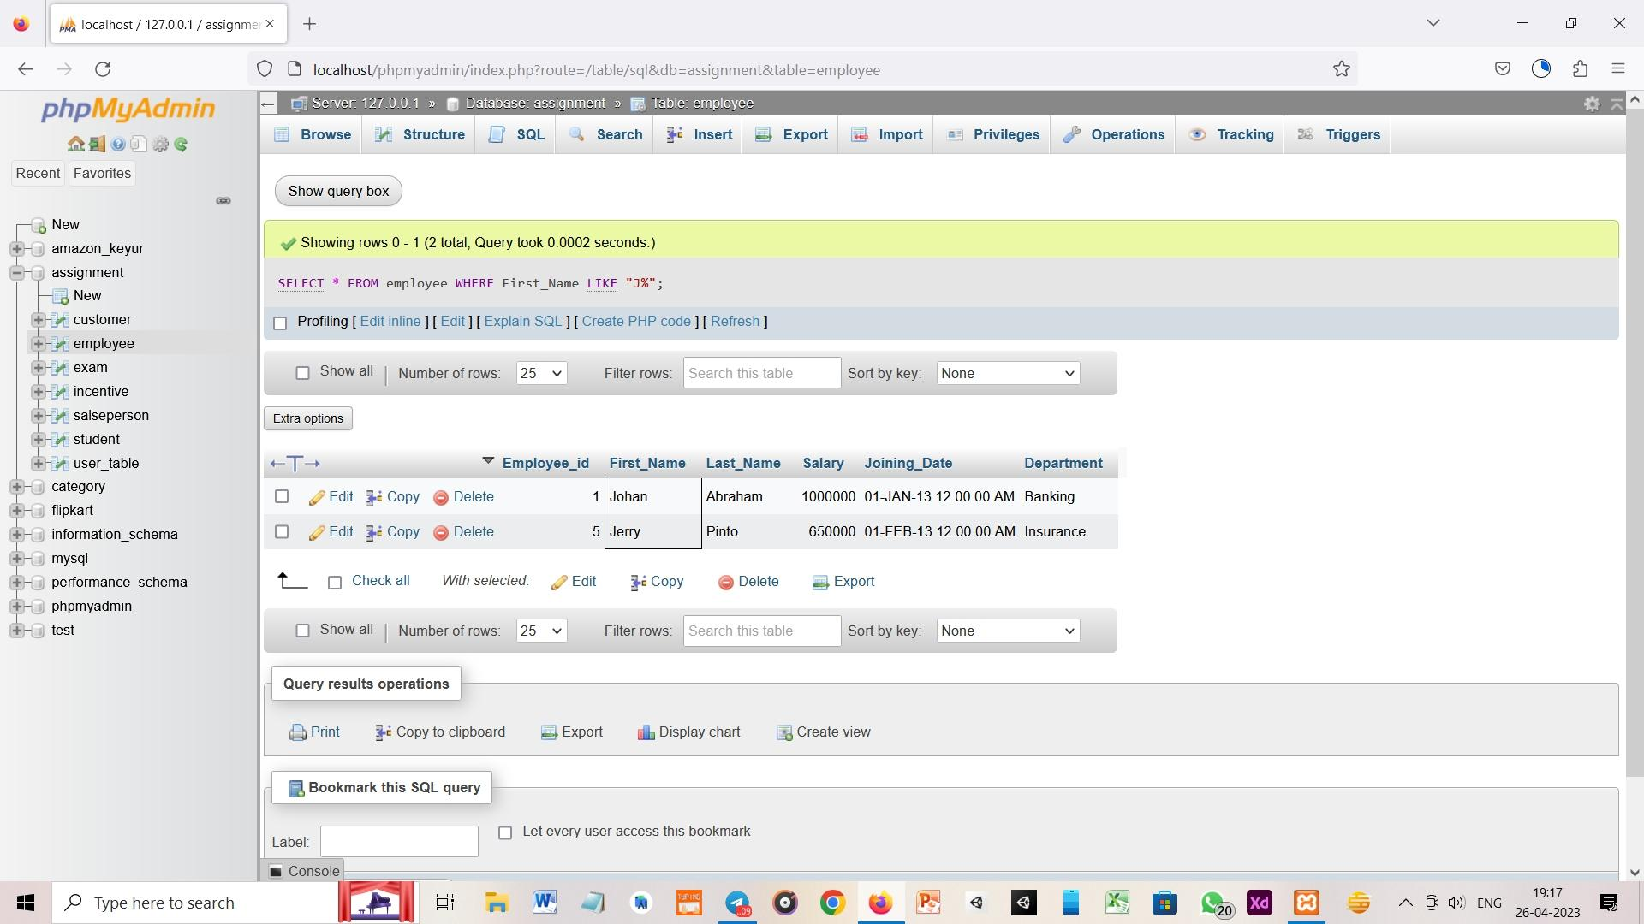

e. Get department wise maximum salary from employee table order by salary ascending?

Ans:- Select Department, Salary from Employee order by Salary asc

f. Create After Insert trigger on Employee table which insert records in view table

Ans:- DELIMITER $$

CREATE TRIGGER insert_trigger after INSERT on Employee for Each ROW

BEGIN

INSERT into update_trg(emp_id,emp_name,emp_dpart,Date_Time) VALUES(new.Employee_id,new.First_name,new.Department);

END

$$

g. Select first_name, incentive amount from employee and incentives table for those employees who have incentives and incentive amount greater than 3000.

Ans:- select First_Name,Incentive_Amount From Employee join Incentive where Employee_id = Employee_ref_id and Incentive_Amount>3000

**Task:- 4 Salesperson and Customer Table**

**Salesperson Table:-**

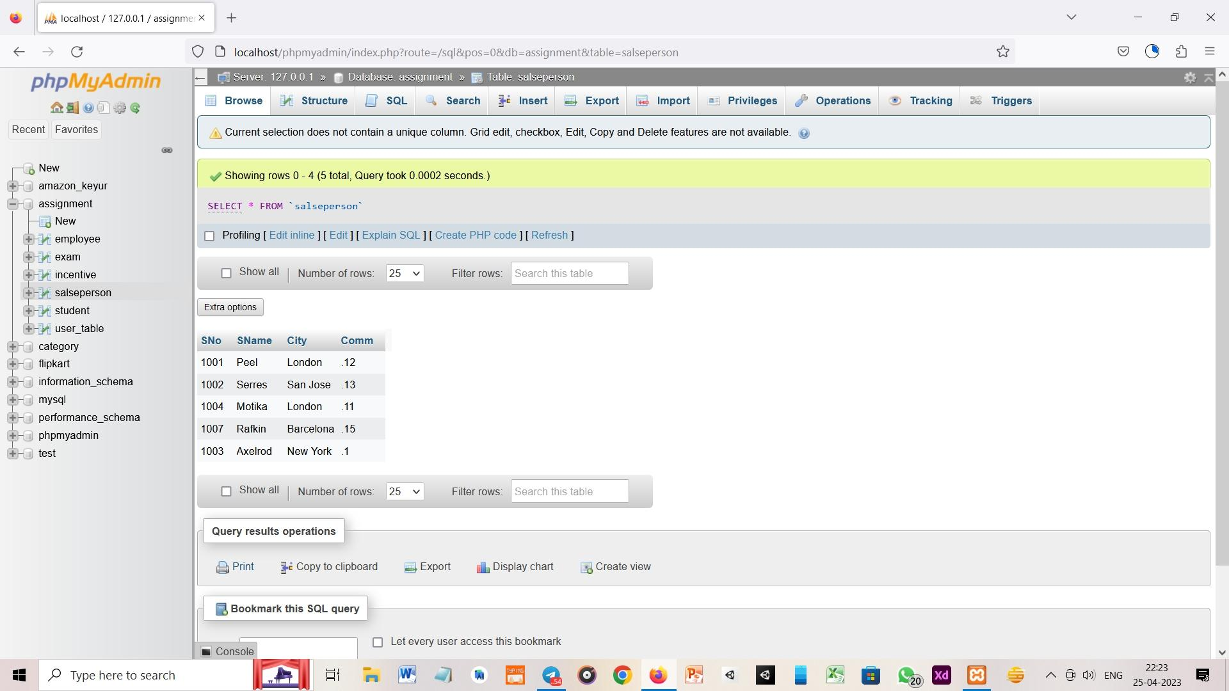

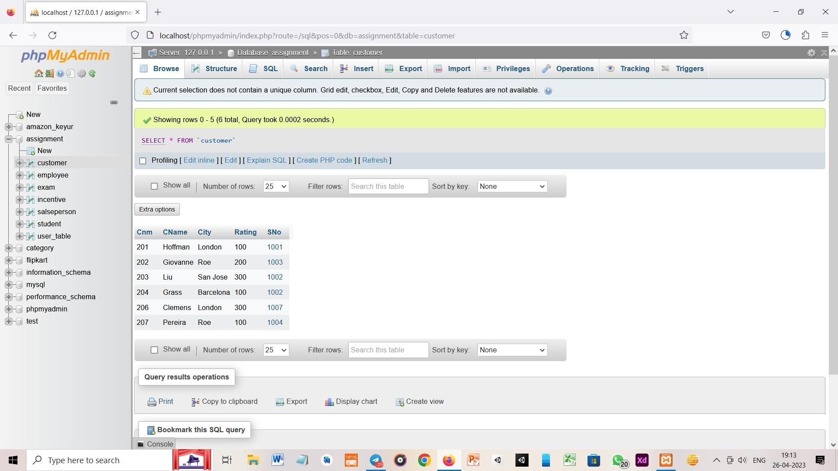**Customer Table:-**

**Query:-**

a. All Rating for more than 100.

Ans:- SELECT Rating From Customer where Rating>100

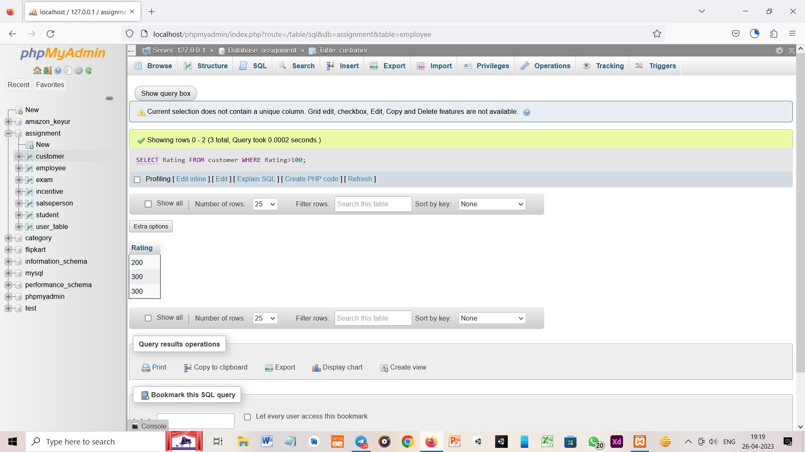

b. Names and cities of all salespeople in London with commission above 0.12

Ans:- SELECT Sname, City FROM salesperson where City='London' And Comm >= '.12'

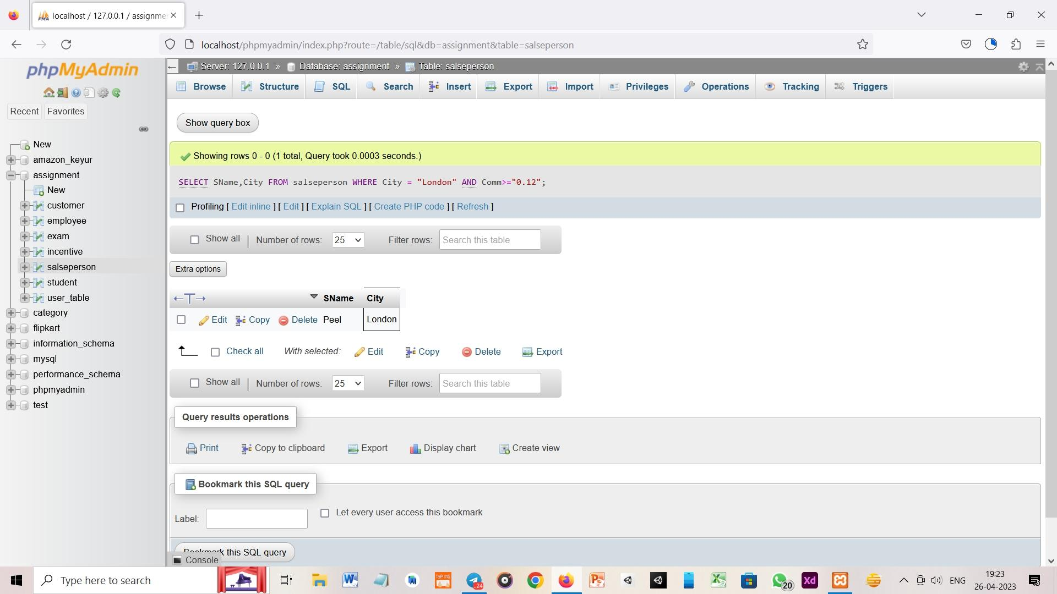

c. All salespeople either in Barcelona or in London

Ans:- SELECT Sname from salesperson where City=’Barcelona’ or city=’London’

d. All salespeople with commission between 0.10 and 0.12. (Boundary values should be excluded).

Ans:- SELECT Sname from salesperson where Comm BETWEEN ‘.10’ and ‘.12’;

e. All customers excluding those with rating <= 100 unless they are located in Rome

Ans: SELECT * from customer where Rating>=100 and City!=’Roe’