

Assignment-1
Richardson Maturity Model (Level 0 - 3)

Problem Definition: -

- Evaluate the Task Management API built in Practical 4 against the Richardson Maturity Model.
- Identify which level (0, 1, 2, or 3) the current API satisfies and justify your answer.
- Improve the API to reach at least Level 2 if it does not already satisfy it.
- Document the evaluation and improvement in a MATURITY.md file in your assignment repository.

Evaluation Conclusion & Level 2 Justification:

The Task Management API built in Practical 4 satisfies Level 2 of the Richardson Maturity Model based on the following criteria:
- 1. HTTP Verbs Mapping: GET /tasks retrieves the task list safely. GET /tasks/:id fetches a specific task. POST /tasks creates a new task. PUT /tasks/:id updates an existing task, and DELETE /tasks/:id removes a task.
- . Meaningful Status Codes: Returns 200 OK for successful GET/PUT/DELETE, 201 Created for POST, 400 Bad Request for validation failures, 404 Not Found for missing tasks/routes, and 500 Internal Server Error for server failures without leaking stack traces.

Richardson Maturity Model(RMM) Evaluation Table:

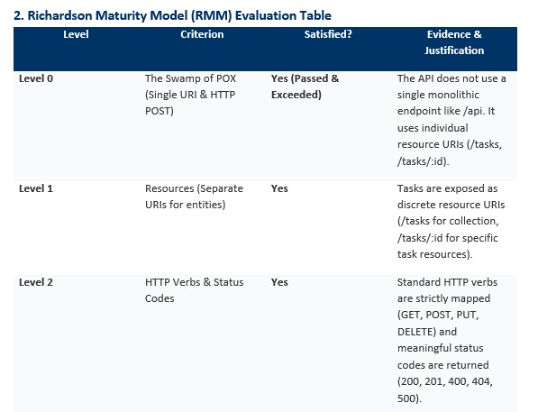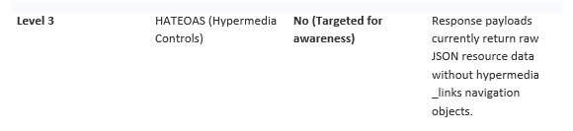

Level 3: HATEOAS Awareness & Representation:

To achieve Level 3 maturity, response bodies must include a hypermedia links section (_links) allowing clients to dynamically discover available actions:

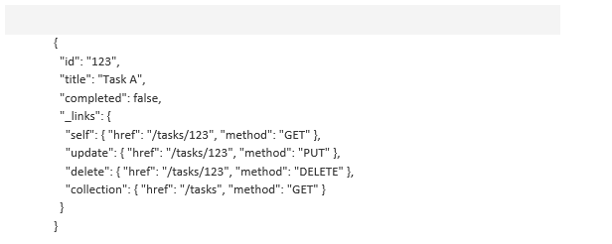

Analysis: Why Most Production APIs Stop at Level 2:

- Payload Overhead & Bandwidth: Adding _links objects to every item in large JSON arrays increases payload size, consuming additional bandwidth.
- Client Architecture: Front-end applications (React, Angular, Mobile Apps) hardcode client-side API calls. Dynamic link parsing adds code complexity with minimal gain.
- Documentation Standards: OpenAPI / Swagger specifications provide clear, versioned documentation out of the box, making dynamic link discovery redundant.
- Lack of Standardization: Competing formats (HAL, JSON-LD, Siren) prevent a single standard, leading teams to stick to clean Level 2 JSON.

Github Link:- krunal9116/assignment-w4-D25IT137

