

Practical-2

Problem Definition: -
- Extend the portfolio application from Practical 1 by adding React
Router.
- Implement a navigation bar with at least 3 routes: Home, Projects, and
Contact.
- Each route must render a distinct component without a full page reload.
- Add at least 2 useState variables used meaningfully one for toggling UI
visibility and one for managing a form input on the Contact page.
- The Contact page must include a controlled input that captures and
displays user input in real time.

Screenshots:-Home-Page: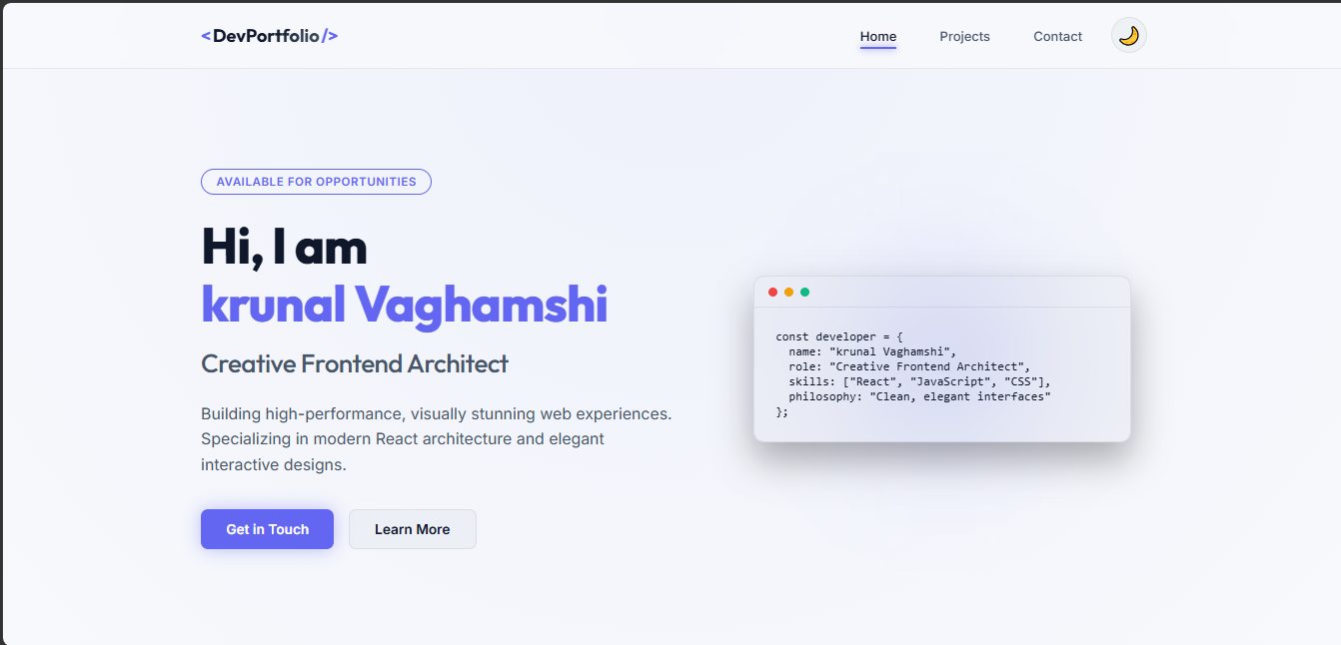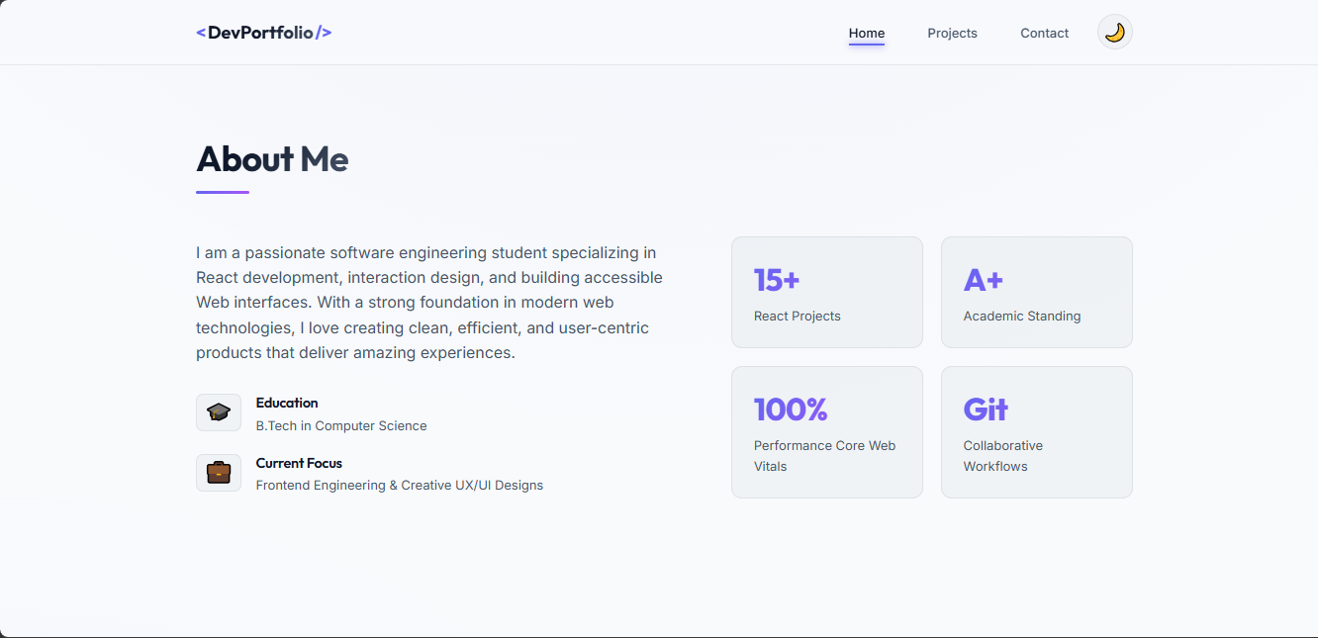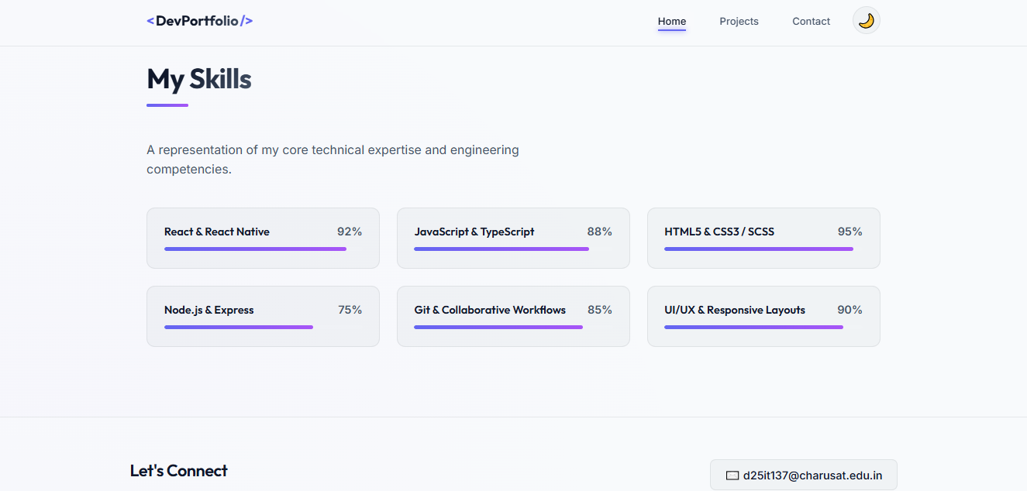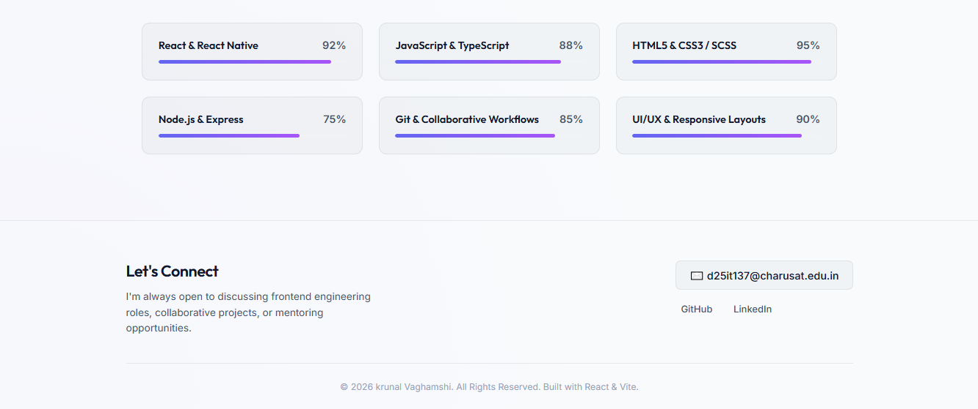

Projects-Page: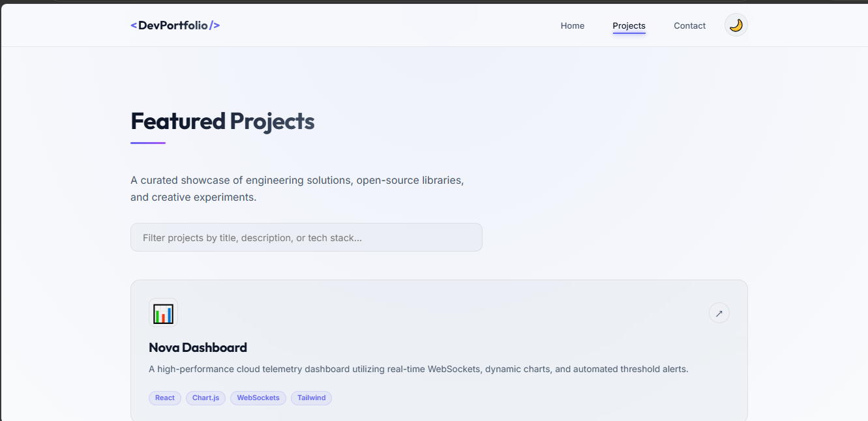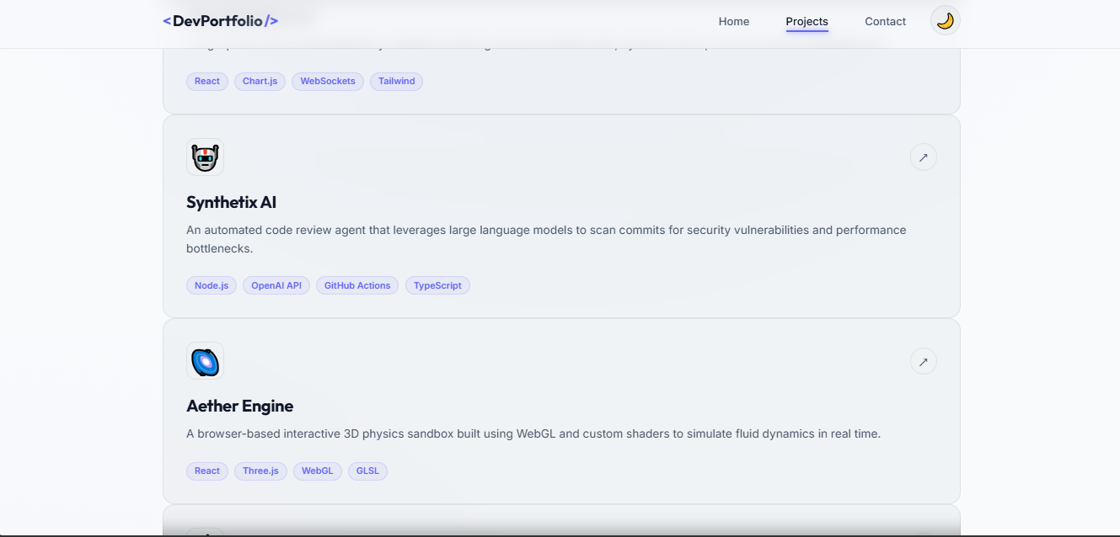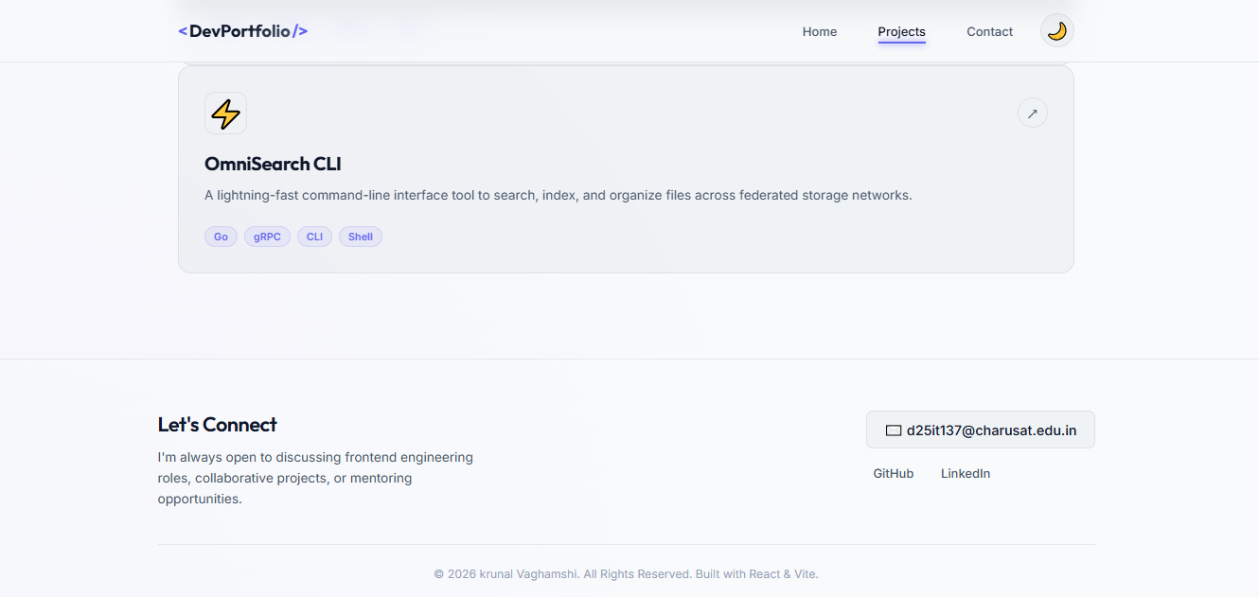

Contact Page:

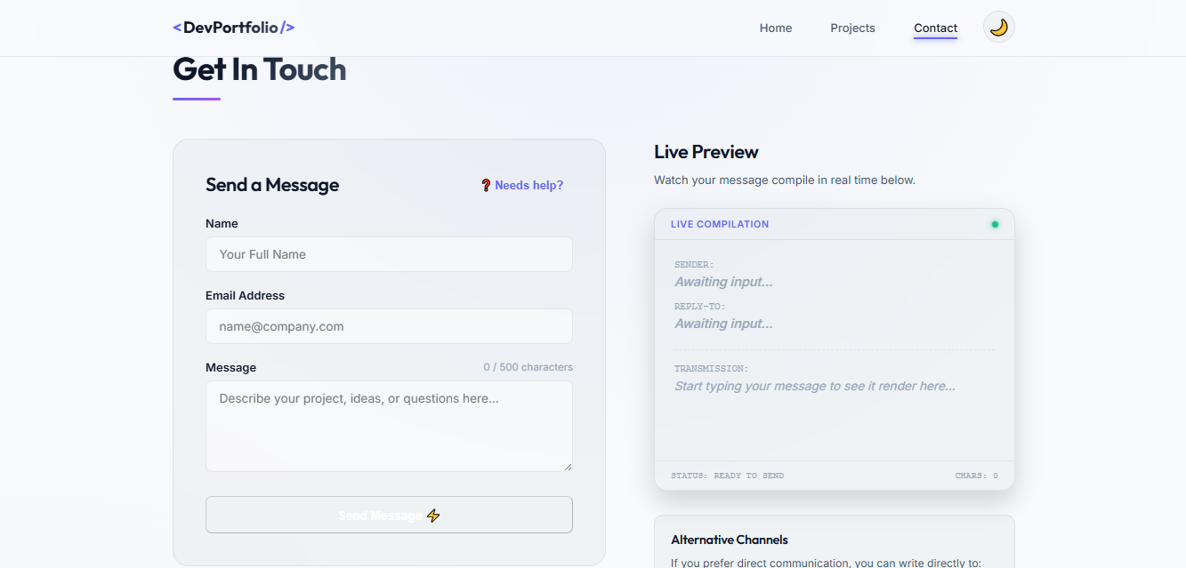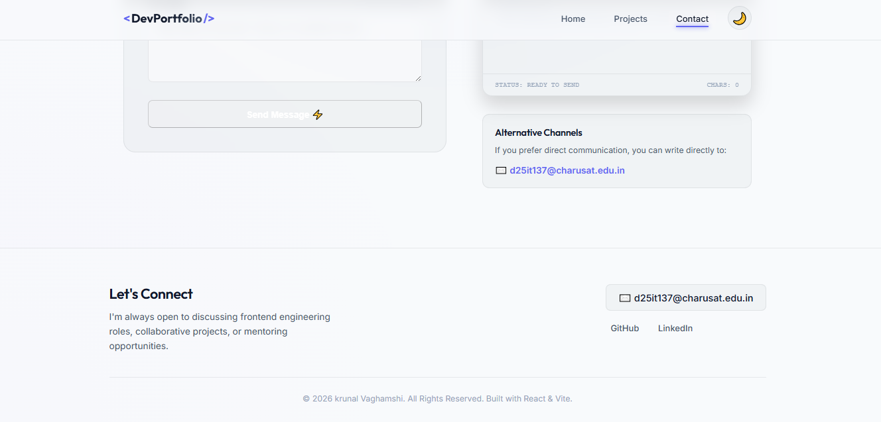

Github Link:- AWDF/p1 at main · krunal9116/AWDF

