

**Department of Computer Science & Engineering**

**Certificate**

This is to certify that Mr./Ms. **Krunal Gangadharrao Dhote**

of **V th** Semester of Bachelor of Engineering in **Computer Science and Engineering** of P. R. Pote (Patil) College of Engineering & Management, Amravati, has completed the term work satisfactory in subject **DBMS** for the academic year 2021- 2022 as prescribed in the curriculum.

|  |  |
| --- | --- |
| **Place: Amravati** | **PRN No: 198480093** |
| **Date: Dec. 13, 2021** | **Roll No: 334** |

|  |  |
| --- | --- |
| **Subject Teacher** | **Head of the Department** |

**Practical 1 :** To Study the DBMS, RDBMS and Design the Entity Relationship Diagram

**Practical 2 :** To Implement Data Definition Language and Data Manipulation Language

Create table to store information of students and their departmentsas follows:

Student (id, name, age, phone, address, deptid)

Department (deptid, dname, location)

1. Create a table with several attributes and different constarints.

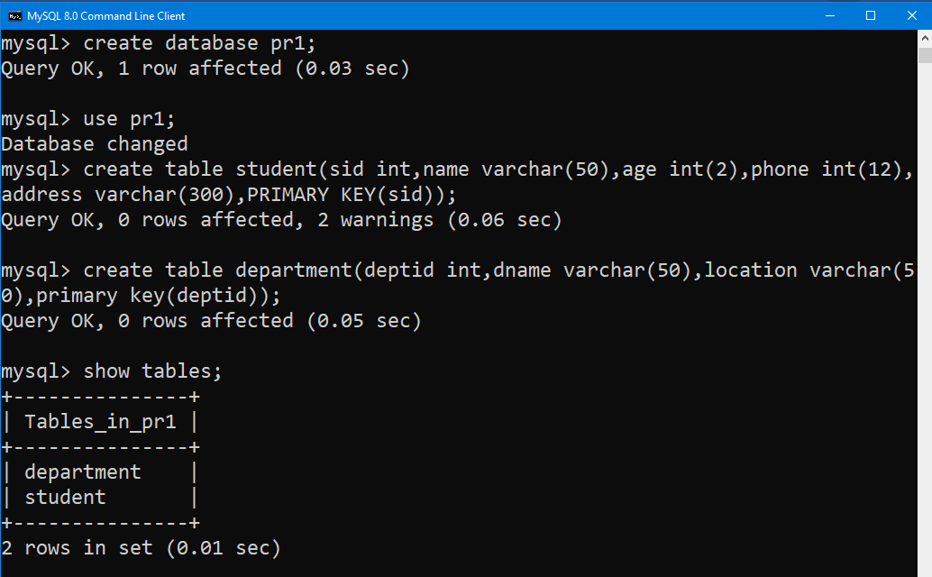

1. Describe the schema of the table

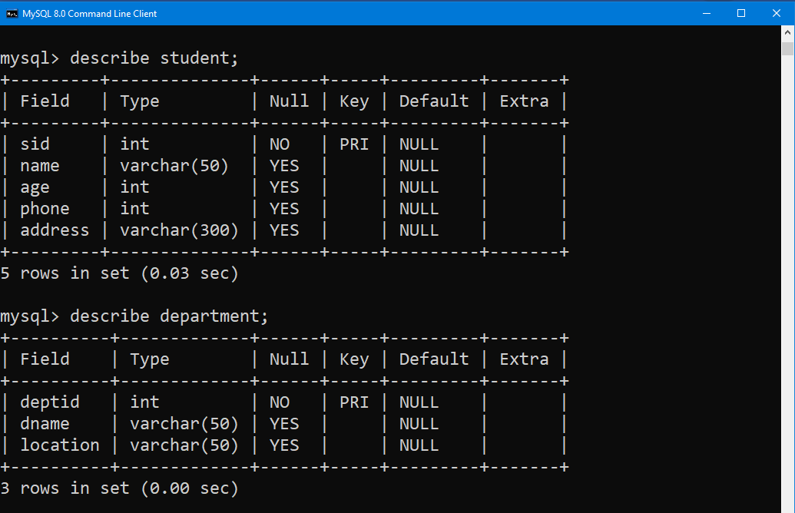

1. Add a column BTno in students table.
2. Change the data type of BTno.

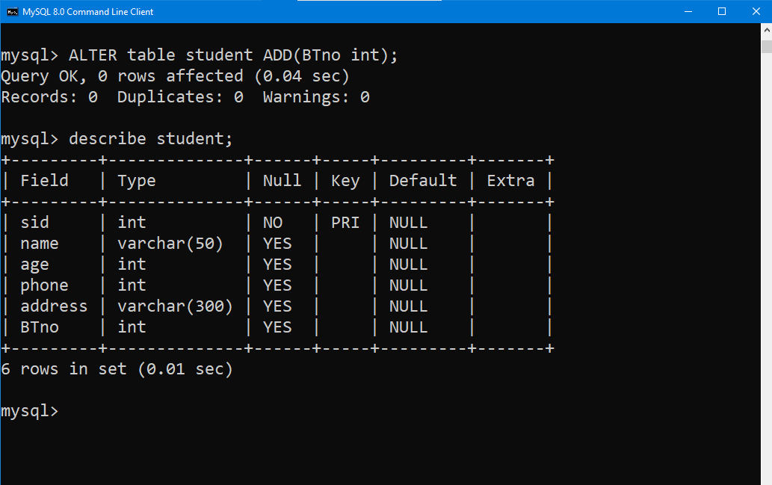

1. Rename the column phone to phno.

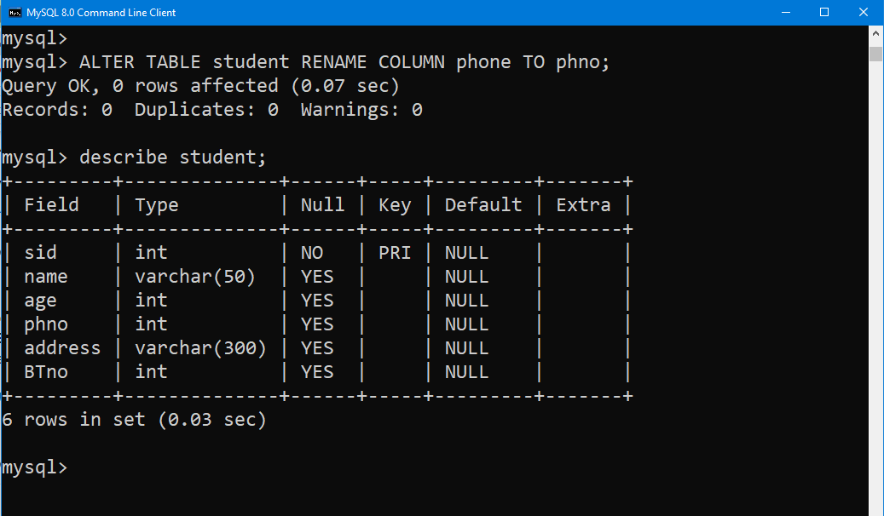

1. Delete the column age.

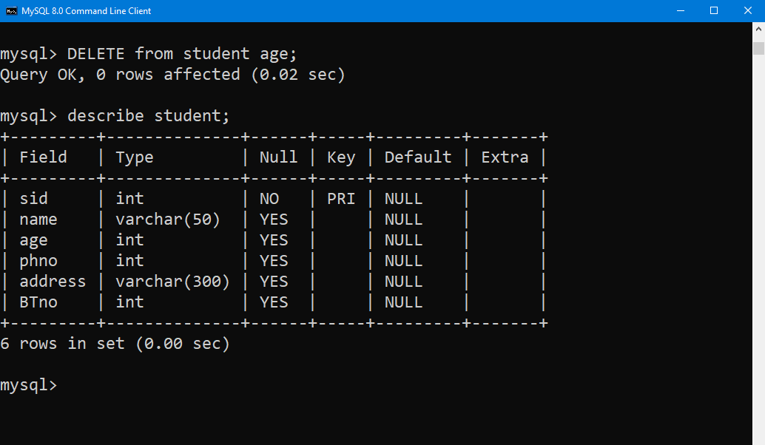

1. Rename the table department as Branch

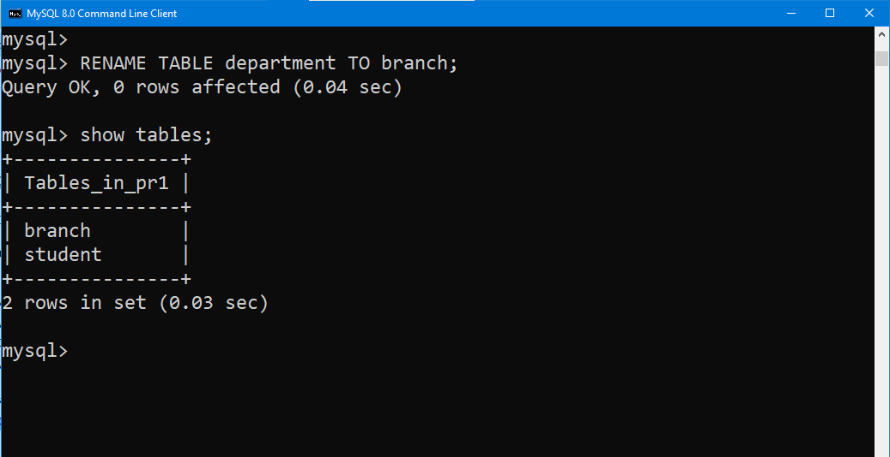

1. Delete the table data.

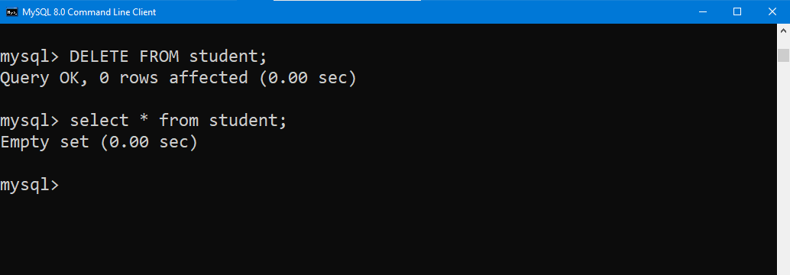

i) Delete the table schema

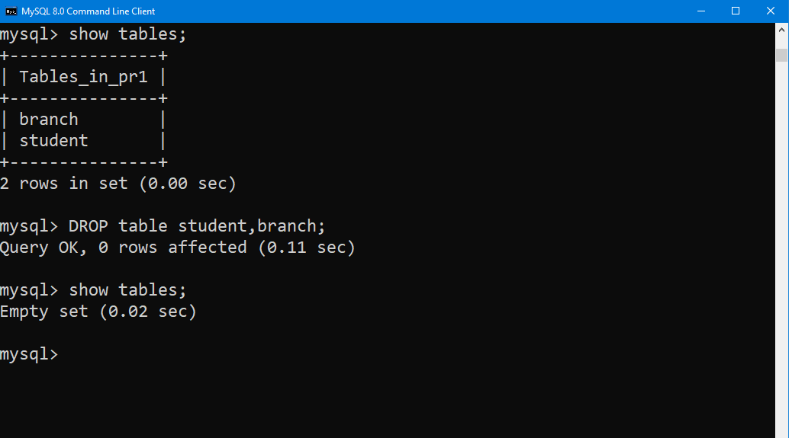

**Practical 3 :** To Implement various types of integrity constraints in SQL

Add the actual data of the students and department in the tables created in practical 2 and perform the following Queries.

1. Make Id of Student a primary key.

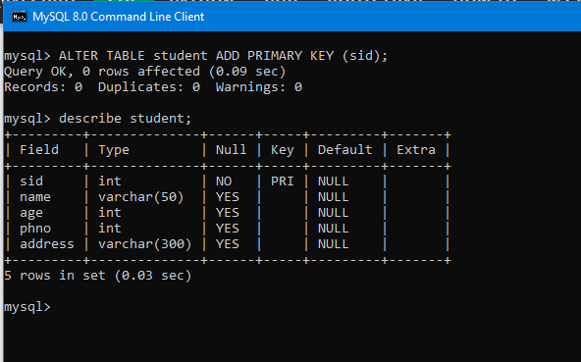

1. Make the Name and address field as not null.



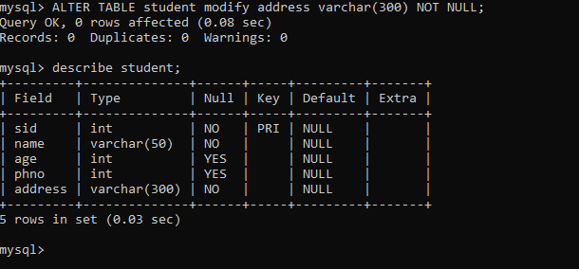

1. Impose constraint on BTno such that values are unique.

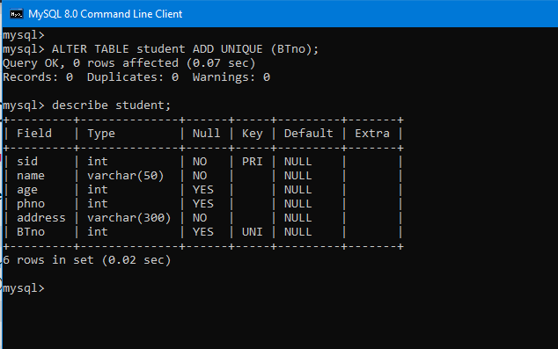

1. Insert default value of age as 20

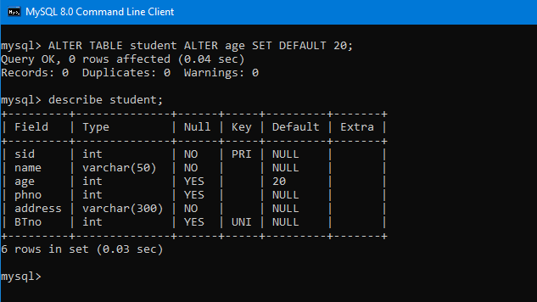

1. Insert multiple rows in the table one by one

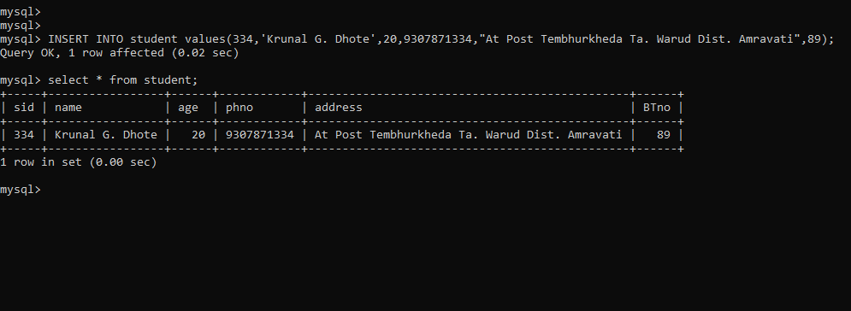

1. Insert multiple rows using single query.

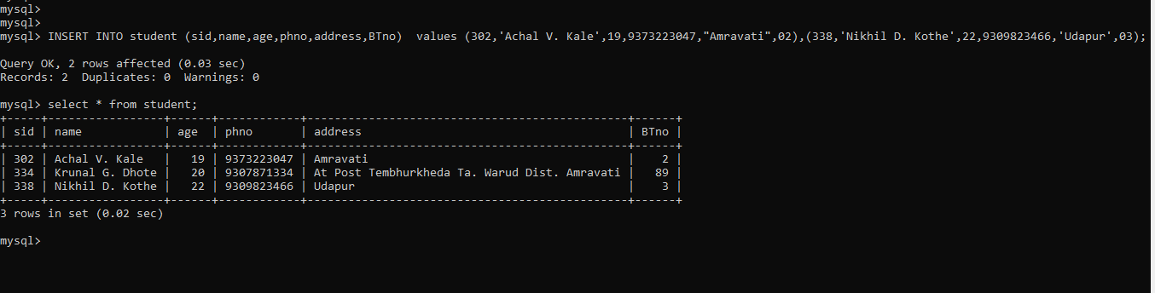

1. Insert some rows skipping values of some attributes.

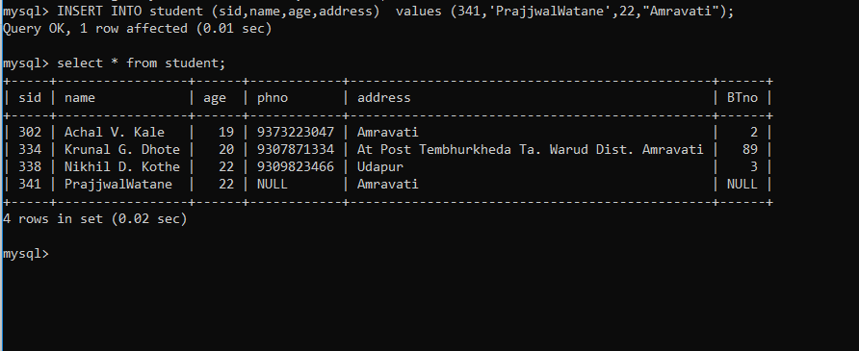

1. Display the complete data entered into the tables.

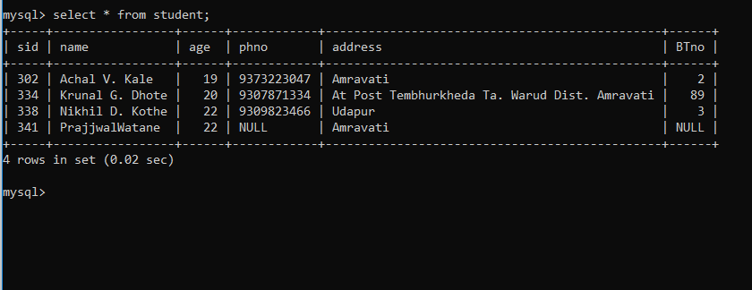

1. Update student name whose id is 341

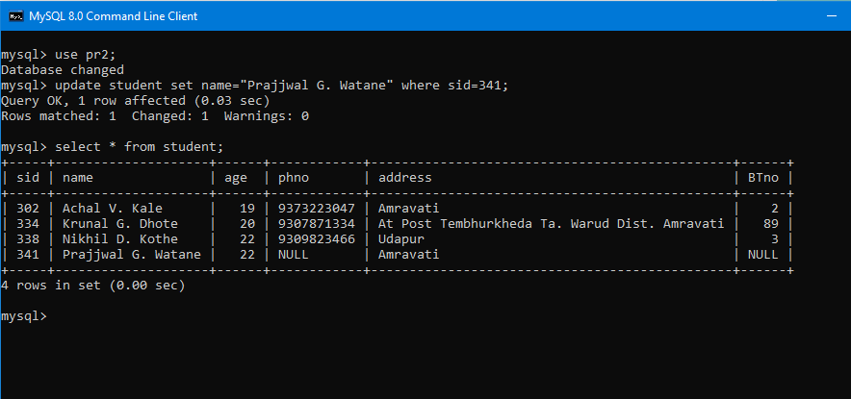

1. Change address and phone no of student with name XYZ.

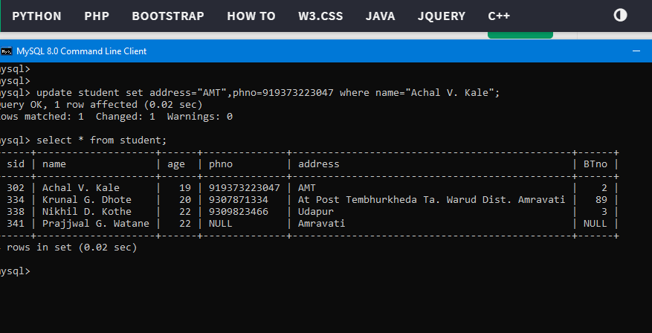

1. Delete the phone no of student 23.
2. Delete the students who belong to Amravati city.

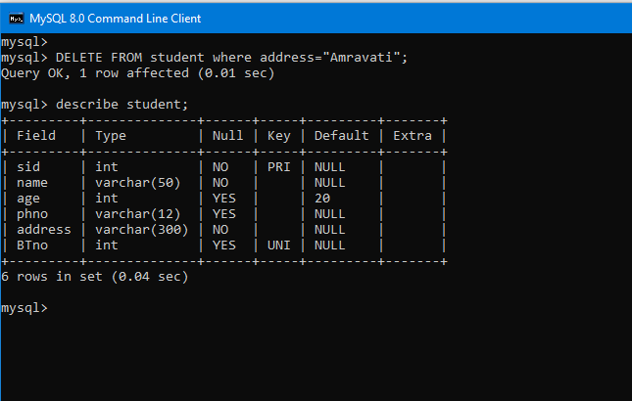

1. Display all students who belong to city Akola.

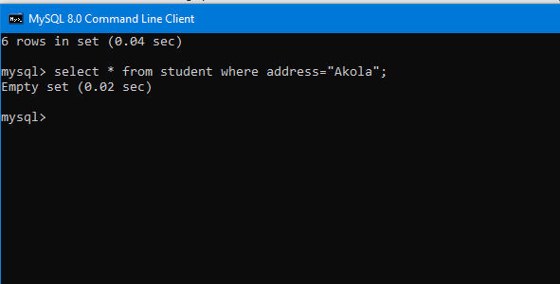

1. Display the student names with their department names.

**Practical 4 :** To study operators, expressions, functions and sub queries in SQL

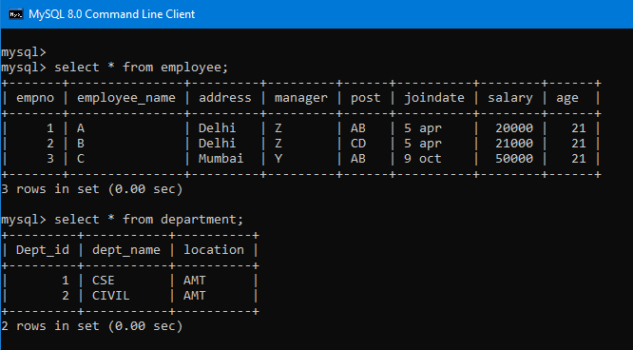

1. Find out the difference between maximum and minimum salary of employee.

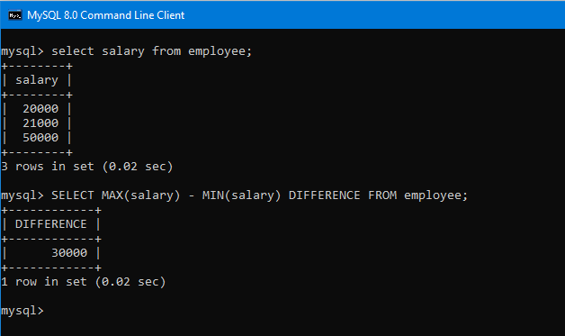

1. Display name and date of joining of employee who join in month of January.

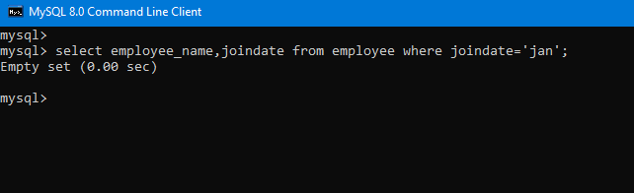

1. Find out the most experienced employee.

4) Display employee name in small letter.

5) Calculate experience of each employee and print with employee name.

6) Display the months between 1 June 2010 & 1 August 2012.

7) List all jobs available in employee table.

8) List the employee name and salary whose salary greater than salary of any name.

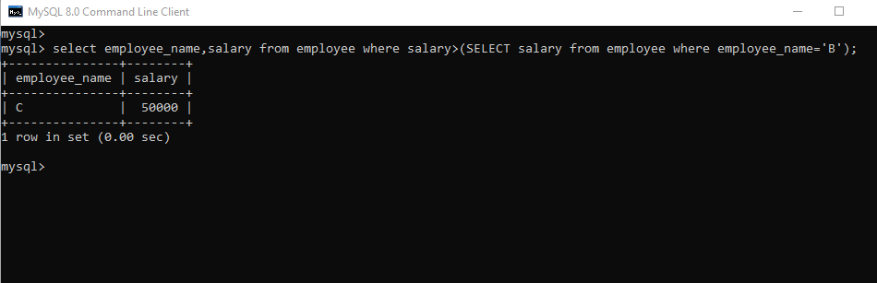

**Practical 5:** To Implement SELECT command with different clauses and SET operators in SQL.

1) List all employees who work as clerk analyst or both.

2) List all employee who work in both dept 30, 40.

3) List all employees who work as analyst but not managers.

4) List number of employees who belong to same job.

5) Display total salary spent for each job.

6) List all employees in alphabetical order.

7) Display manager name and no. of employee who has more than 1 employee working under him. 8) Display all employees in order starting from largest salary.

9) Display no. of employees working in each department along with department name.

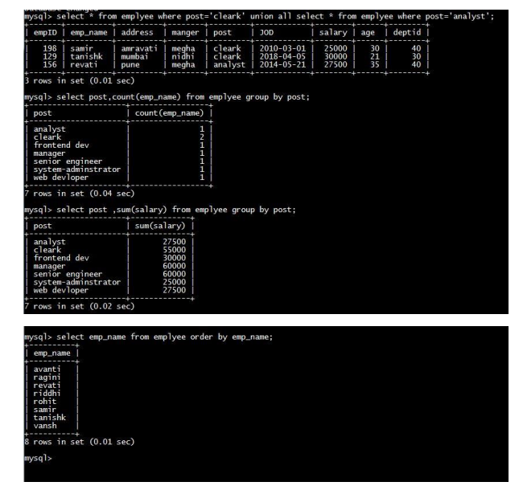

**Practical 6 :** To Implement various types of joins in SQL

1) Display id, post, deptname and dept location of employee using equijoin, innerjoin, natural join with USING and ON clause.

2) Display id, name, location having deptid > its dept using non equijoin.

3) Display employee name manager name its department with job of manager using self join.

4) Perform Cartesian product of employee and department table using cross join.

5) Display all the information of employee and department using left right and full outer join.

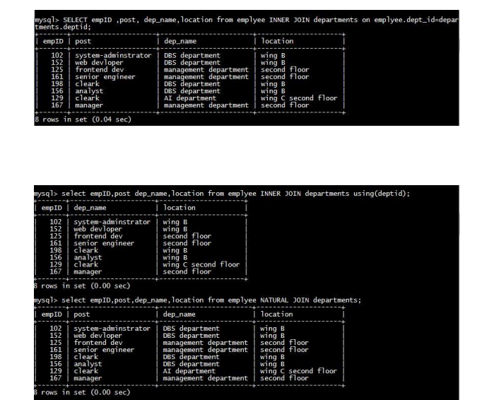

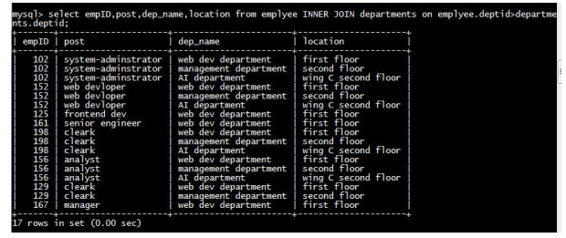

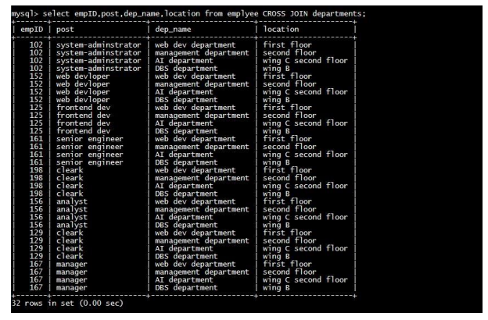

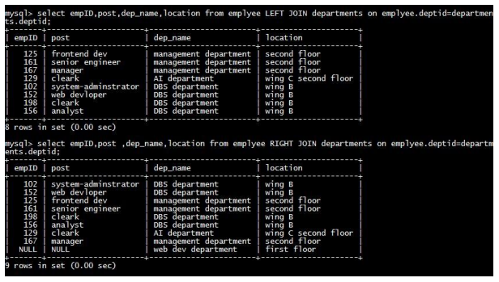

**Prcatical 7 :** To Study and Implement VIEWS in SQL

1) Create a view called manager which stores the information about the entire employee who is manager.

3) Create a view called manager which stores the information about the employee and their respective department name, deptname, job and location.

4) Display information of all the view.

5) Display the manager who works in ‘10’ department.

6) Increment salary of a manager whose age is greater than 50 by 10%.

7) Show the updated information in the view and in the logical relation.

8) Update a dept name of emp who work in CSE to IT dept and show the result of a view as well as logical relation.

9) Drop the view.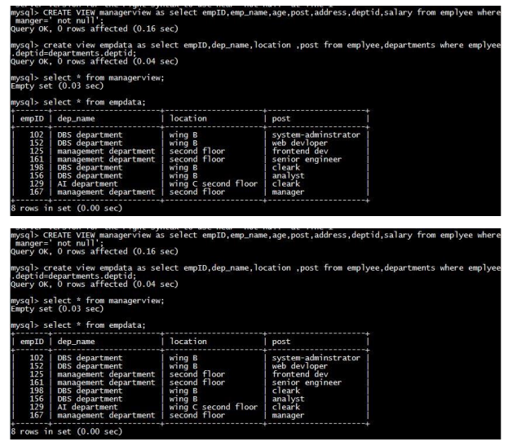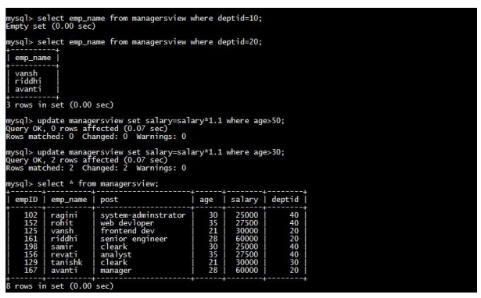

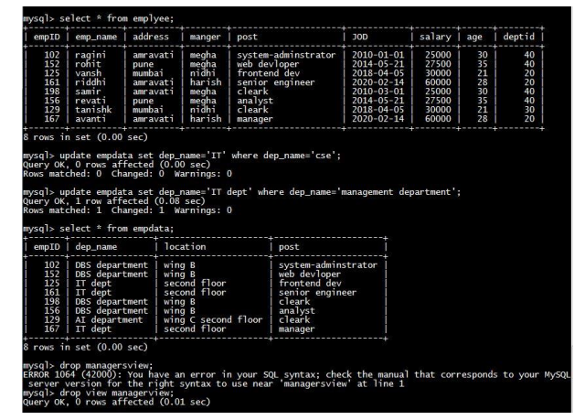

**Practical 8 :** To Study and Implement Triggers in SQL

1) Create trigger to update to product history table when the price of product is updated in the product table.

2) Fire the trigger by executing respective queries.