**There are three pages**

Landing page with Movies Link

<http://localhost:3000/>

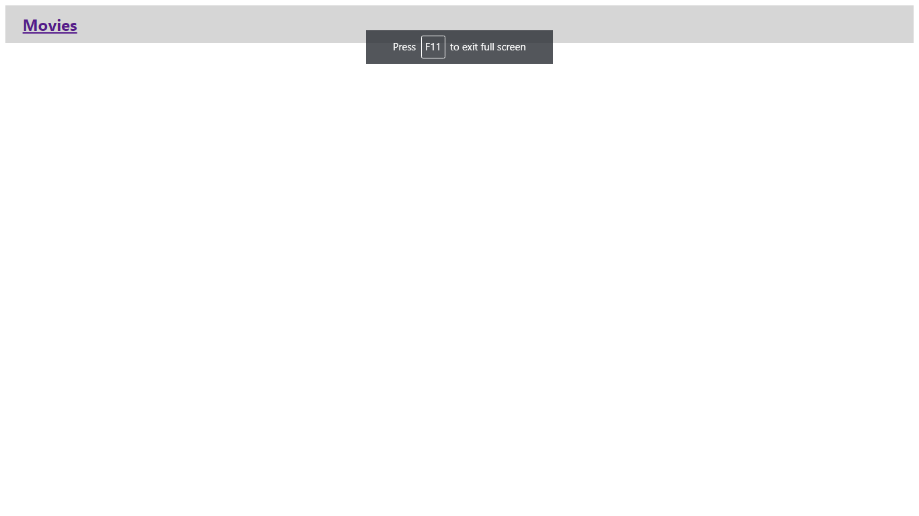

Movie List Page (Populate Last added movies)

<http://localhost:3000/movies>

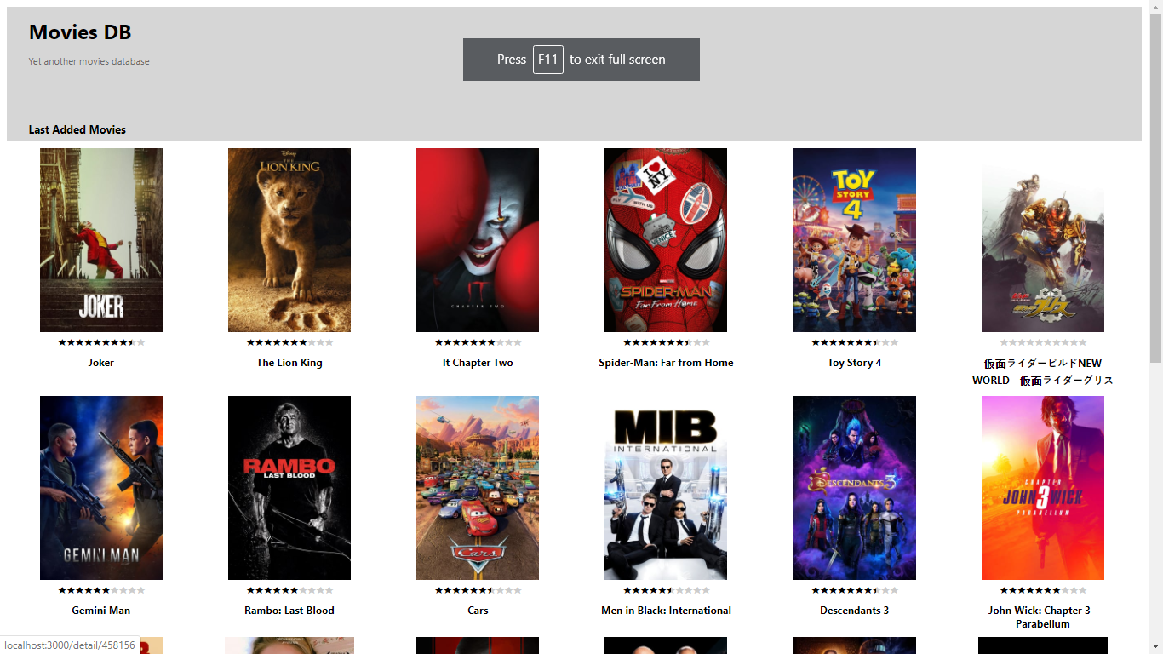

Movie Detail Page(Show Movie Detail)

<http://localhost:3000/detail/475557>

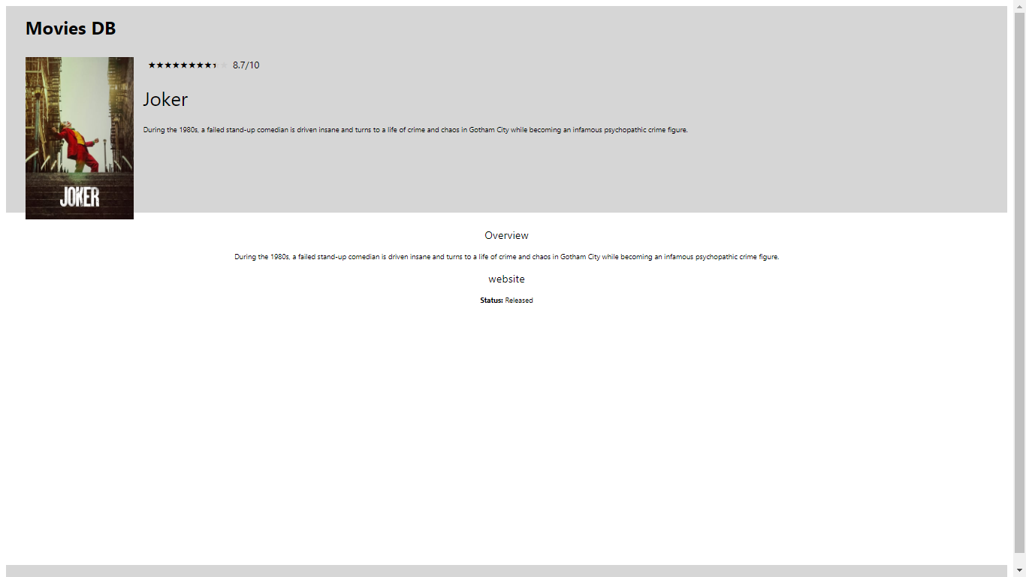

Build CSS to handle Desktop, Tab and mobile. Used Media Query for that.

**Things can be Improve**

* Because of Time constraint couldn’t use SASS fully but tried to use as much as I can.
* I have not written the 100% unit test cases but written for components, action and reducers.