* **Business Model for Car Manufacturing**

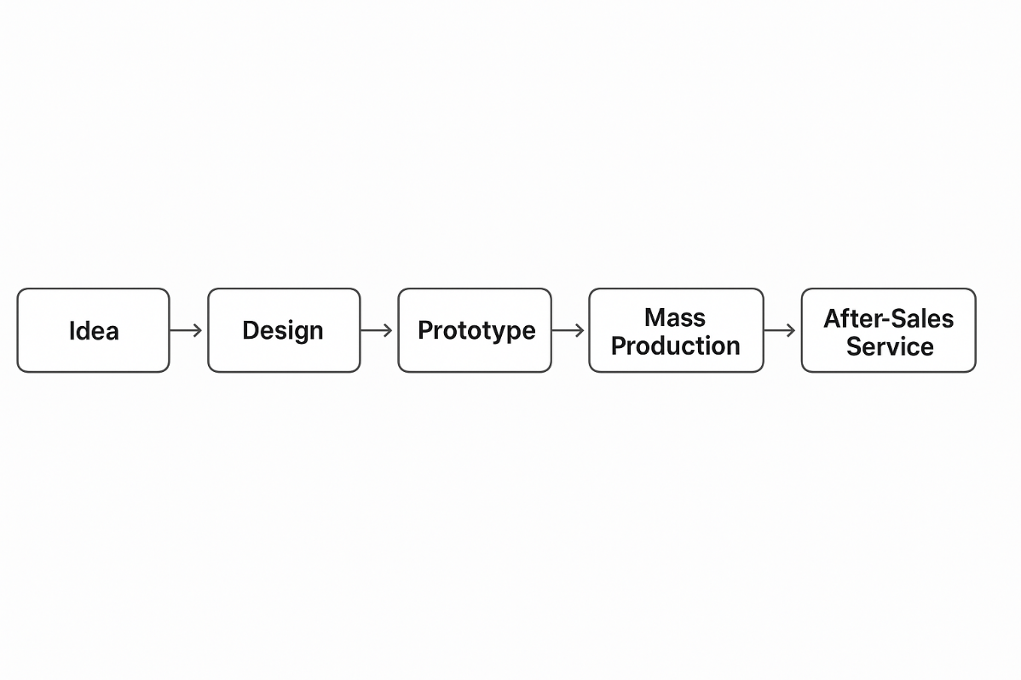

### ****1. Idea → Conceptualizing the Car Model or Feature****

This is the **initial phase** of the vehicle lifecycle and often involves a combination of **market research, trend analysis, customer feedback**, and **regulatory requirements**. Key activities include:

* **Identifying market needs**: What do customers want? (e.g., fuel efficiency, electric options, SUVs, advanced safety)
* **Benchmarking**: Studying competitors’ models and technologies.
* **Technology scouting**: Identifying new innovations (e.g., AI driving systems, battery technology).
* **Concept ideation**: Brainstorming body styles, target demographics, performance goals.
* **Feasibility analysis**: Assessing financial, technical, and regulatory viability.

### ****2. Design → Engineering, CAD Modeling, and Styling****

Once the idea is validated, **detailed design work** begins. This phase has two parallel paths: **aesthetic styling** and **technical engineering**.

#### **Aesthetic & Functional Design:**

* **Exterior and interior styling** using clay modeling, sketches, and digital design software.
* **User Interface/User Experience (UI/UX)** development for infotainment systems, digital dashboards, etc.

#### **Engineering & Development:**

* **Computer-Aided Design (CAD)** and **Computer-Aided Engineering (CAE)** models for parts and assemblies.
* **Powertrain, chassis, suspension**, and **electrical architecture** design.
* **Crash simulation, thermal dynamics, aerodynamics** testing virtually.
* **Integration of new technologies**, such as ADAS (Advanced Driver-Assistance Systems) or electrification.

### ****3. Prototype → Building and Testing Pre-Production Models****

Prototypes bridge the gap between concept and mass production. These are **hand-built or semi-automated test vehicles**.

* **Alpha Prototypes**: Early versions, often used for internal evaluation.
* **Beta Prototypes**: More refined, used for external testing and validation.
* **Mule vehicles**: Existing car bodies fitted with new components for testing.

#### **Testing Includes:**

* **Durability and stress testing**.
* **Crash tests** to ensure safety compliance.
* **Performance testing** (acceleration, braking, emissions).
* **Environmental tests** (hot/cold weather, humidity, corrosion).
* **Compliance testing** for legal and regulatory approval in different markets.

### ****4. Mass Production → Full-Scale Manufacturing in Assembly Lines****

This phase transitions from manual or limited prototype builds to **automated manufacturing** using **robotics and precision assembly lines**.

* **Supply chain coordination** for components and raw materials.
* **Tooling setup** for stamping, welding, painting, and assembly.
* **Quality control** checkpoints at every stage.
* **Just-in-Time (JIT)** production methods to reduce waste.
* **Training of workforce** on assembly and safety procedures.

Final vehicles go through **PDI (Pre-Delivery Inspection)** before being shipped to dealers.

### ****5. After-Sales Service → Maintenance, Warranty, and Customer Support****

Once the car is sold, **customer experience management** and **vehicle lifecycle support** begin.

* **Warranty coverage**: Repair/replacement of faulty components.
* **Scheduled maintenance**: Oil changes, tire rotation, brake inspections, etc.
* **Recall management**: Handling issues discovered post-production.
* **Telematics & OTA (Over-the-Air) updates**: Modern cars can receive software updates remotely.
* **Customer support & feedback systems**: To improve future models and address concerns.
* **Spare parts & accessories supply chain**.

This phase is **crucial for brand loyalty and reputation**.

● **ERP Supports Each Stage in Model**

**1. Idea Stage**

* **ERP Modules Involved**:
  + Product Lifecycle Management (PLM)
  + R&D Management
* **How ERP Supports**:
  + Stores new model concepts
  + Stores market research data
  + Stores competitor analysis
  + Stores feasibility studies in a central database

**2. Design Stage**

* **ERP Modules Involved**:
  + Engineering Module
  + CAD Integration
  + BOM (Bill of Materials) Management
* **How ERP Supports**:
  + Links CAD tools to ERP
  + Generates Bill of Materials (BOM)
  + Tracks design changes
  + Controls version history

**3. Prototype Stage**

* **ERP Modules Involved**:
  + Production Planning (PP)
  + Quality Management (QM)
* **How ERP Supports**:
  + Plans prototype manufacturing
  + Schedules resources
  + Records test results
  + Manages approvals/rejections

**4. Mass Production Stage**

* **ERP Modules Involved**:
  + Manufacturing Execution System (MES)
  + Materials Management (MM)
  + Supply Chain Management (SCM)
* **How ERP Supports**:
  + Controls production schedules
  + Monitors assembly line performance
  + Manages suppliers
  + Tracks inventory in real-time

**5. After-Sales Service Stage**

* **ERP Modules Involved**:
  + Customer Relationship Management (CRM)
  + Service Management
  + Warranty Tracking
* **How ERP Supports**:
  + Manages service requests
  + Manages warranty claims
  + Manages spare parts inventory
  + Captures and analyzes customer feedback