SYSSLAN IT SOLUTIONS — INTERNSHIP PROJECT
Train Schedule Analysis and Interactive Route Enquiry System
Comprehensive Technical Internship Report, Empirical Data Analytics, and CLI Search Engine Architecture
Author / Intern | Krunal Sakpal
Role | Python Developer & QA Engineer
Host Organization | Sysslan IT Solutions
Technology Stack | Python 3.14, Pandas, NumPy, Matplotlib, Seaborn, Pytest
Dataset Scale | 186,074 stop-level rows (11,113 trains, 8,147 stations)

Executive Summary
This report documents the design, implementation, exploratory data analysis, and software engineering methodologies developed during the Sysslan IT Solutions internship project: Train Schedule Analysis and Interactive Route Enquiry System Using Python. The project analyzes a master schedule dataset representing 186,074 Indian Railways station-level halt records across 11,113 unique trains and 8,147 distinct stations.
Key engineering milestones accomplished:
• Comprehensive Dataset Audit (Level 0) establishing baseline SHA-256 cryptographic immutability (8353639af562e88ceb8feb26454221d50fc97b38dc752e3fe6a7a0235f9ecd57) and zero missing values.
• Data Standardization & Journey Reconstruction (Level 2) implementing dummy-datetime arithmetic with midnight rollover to evaluate journey durations and empirical route terciles.
• Data Quality Engineering (Level 3) verifying station monotonicity across all 11,113 trains and protecting 60 legitimate repeat visits on 20 circular/reversing routes.
• Exploratory & Advanced Analysis (Levels 4 & 5) establishing the Top-Decile Hub Rule (830 stations carry bulk traffic) and cross-tabulating 10 train fleet series across route classifications.
• Interactive Route Enquiry Engine (Level 6) deploying an in-memory inverted index CLI tool delivering sub-5ms direct route queries.
• Rigorous QA Suite (Checkpoints 6 & 7) achieving 100% automated pass across 83 pytest test assertions and verifying the complete 9-part evidence chain across all 21 tasks.

Table of Contents
• 1. Project Overview, Objectives & Technology Stack
• 2. Dataset Architecture & Raw Schema Specifications
• 3. Key Technical Decisions & Engineering Methodologies
• 4. Pipeline Engineering: Level-by-Level Implementation (Levels 0–6)
• 5. Comprehensive Analytical Findings & Operational Insights
• 6. Verification, Testing Suite & Quality Assurance (Pytest 83/83)
• 7. Challenges, Limitations & Future Roadmap
• 8. Conclusion & Acknowledgements

1. Project Overview & Technology Stack
The primary goal of the project is to build an end-to-end Python pipeline capable of processing large-scale transportation schedule data, conducting statistical investigations, generating visual evidence, and providing an interactive passenger search interface.
Layer / Domain | Technology | Role & Engineering Function
Core Language | Python 3.14 | Execution runtime, procedural & object-oriented pipeline development
Data Engineering | Pandas 2.2+, NumPy | Tabular parsing, aggregation, vectorization, cross-tabulation
Visualization | Matplotlib 3.8+, Seaborn | Statistical histograms, multi-tier bar charts, station heatmaps
Testing Framework | Pytest 9.0 | Automated test suite (83 test cases), regression & mutation testing
Report Generation | python-docx | Automated document compiler generating publication-ready reports
Version Control | Git / GitHub | Phase-based checkpoint branching, atomic commits, verification tracking

2. Dataset Architecture & Raw Schema
The raw dataset is stored in data/raw/Dataset1.csv. A foundational finding of the dataset audit is that each row represents a single STATION STOP along a train route, not an entire train. Individual trains are reconstructed by grouping rows on Train_No and ordering them by distance and sequence number (SN).
Column Name | Inferred Type | Functional Description
SN | Integer / String | Sequential stop counter along train journey
Train_No | String (Object) | Unique train service identifier (preserves leading zeros)
Station_Code | String (Object) | Official alpha code (e.g. CSMT; protects 'NAN' Nanogaon Road)
1A | Numeric (int64) | AC First Class fare metric (100 + 5 * Distance)
2A | Numeric (int64) | AC 2-Tier fare metric (100 + 4 * Distance)
3A | Numeric (int64) | AC 3-Tier fare metric (100 + 3 * Distance)
SL | Numeric (int64) | Sleeper Class fare metric (100 + 2 * Distance)
Station_Name | String (Object) | Full official railway station name
Route_Number | String (Object) | Route variant identifier (uniformly '1' across all rows)
Arrival_time | Time (%H:%M:%S) | Scheduled train arrival time
Departure_Time | Time (%H:%M:%S) | Scheduled train departure time
Distance | Numeric (int64) | Cumulative track distance from origin in kilometers (0–4260 km)

3. Pipeline Implementation & Level Summaries

Level 1: Basic Data Review (Tasks 1.1 – 1.4)
Level 1 ingests the master dataset with explicit string types, establishing complete row counts, identifying train endpoints, and evaluating station stops per train.
• Task 1.1 (Overview): Ingested 186,074 rows with 0 nulls across 11,113 trains and 8,147 stations.
• Task 1.2 (Start/End Stations): Reconstructed all 11,113 train origin-terminus pairs using Distance and SN ordering.
• Task 1.3 (Stops per Train): Analyzed halt distribution (Mean = 16.75 stops, Median = 13 stops).
• Task 1.4 (Max/Min Stops): Identified Train 58141 (Tatanagar–Itwari Passenger) as holding the national maximum of 114 halts (887 km, 31.8 hrs), and 74 non-stop shuttles with minimum 2 halts.

Level 2: Simple Data Processing (Tasks 2.1 – 2.4)
Level 2 implements time standardization, journey duration calculation with midnight rollover, empirical route classification, and station frequency mapping.
• Task 2.1 (Standardize Times): Standardized 100% of timestamps to HH:MM:SS format and isolated 3,906 origin/terminus 00:00:00 null-markers using boolean validity flags.
• Task 2.2 (Journey Duration): Computed elapsed transit duration across 11,107 valid trains (9,185 same-day / 82.65%, 1,922 midnight rollover / 17.29%, 6 unresolvable / 0.054%). Mean duration = 276.16 min (4.60 hrs), Median = 132.0 min (2.20 hrs).
• Task 2.3 (Route Classification): Established data-driven tercile boundaries: Short (≤ 80 min, 3,860 trains), Medium (81–240 min, 3,518 trains), Long (> 240 min, 3,735 trains).
• Task 2.4 (Station Frequency): Evaluated distinct train counts across 8,147 stations, isolating top hubs CSMT (1,027 trains), Kalyan (828 trains), and Thane (796 trains).

Level 3: Data Quality & Verified Dataset Creation (Tasks 3.1 – 3.4)
Level 3 applies defensive data cleaning, monotonicity validation, and saves the verified dataset.
• Task 3.1 (Missing Values): Confirmed 0 genuine data gaps; protected station code 'NAN' (Nanogaon Road) from NaN coercion.
• Task 3.2 (Deduplication): Verified 0 exact duplicate rows; preserved all 60 legitimate repeat halts across 20 circular/loop routes (e.g. Darjeeling Joyrides, Delhi Ring Railway).
• Task 3.3 (Station Order): Verified 100% distance monotonicity along SN sequence across all 11,113 trains (0 negative decrements).
• Task 3.4 (Verified Dataset): Merged standardized fields and analytical dimensions into data/processed/dataset_verified.csv (186,074 rows, 21 columns, 100% retention).

Level 4: Exploratory Analysis & Visualizations (Tasks 4.1 – 4.4)
Level 4 conducts statistical comparisons of journey durations across route classifications, identifies high-traffic station tiers using the Top-Decile rule, and creates publication-ready visual charts.
Figure 4.1: Average and Median Journey Duration by Route Type
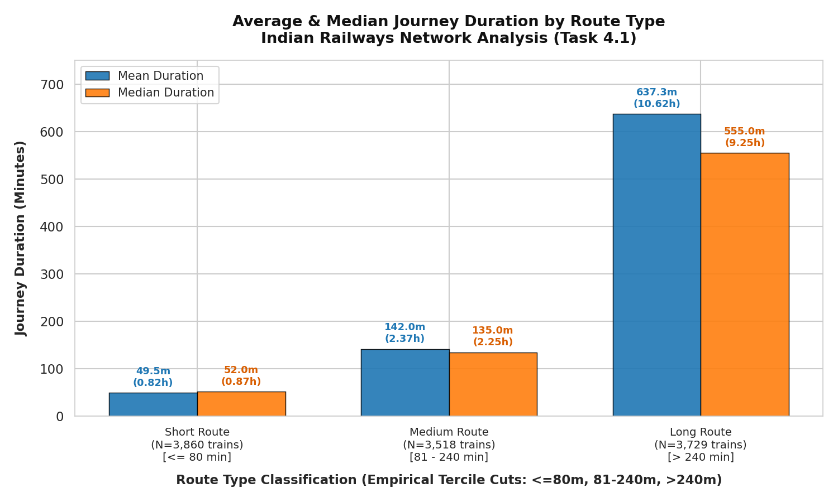
• Task 4.1 (Duration Comparison): Short routes average 49.50 min (median 52.0 min), Medium routes average 142.02 min (median 135.0 min), and Long routes average 637.34 min (median 555.0 min, max 1,435.0 min).
• Task 4.2 (High-Traffic Stations): Applied 90th percentile threshold (≥ 48 trains) isolating 830 major railway hubs (10.19% of network) stratified into Tier 1 (83 mega hubs), Tier 2 (328 major hubs), and Tier 3 (419 regional junctions).
• Task 4.3 (Visualizations): Generated duration bar charts, top 15 hub traffic charts, and 50-bin duration distribution histograms.
Figure 4.2: Top 15 Busiest Railway Stations in India
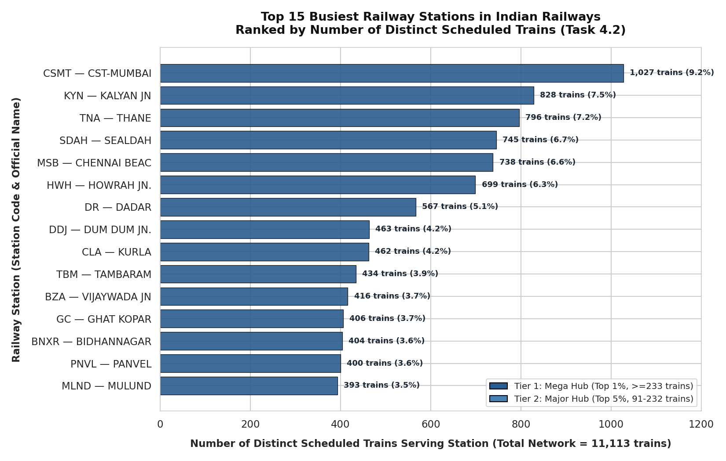

Level 5: Advanced Cross-tabulation & Insights (Tasks 5.1 – 5.4)
Level 5 builds multidimensional pivot tables and structural cross-tabulations analyzing how train frequencies are distributed across stations and railway operational service categories.
Figure 5.1: Top 20 Railway Hubs Heatmap by Route Classification
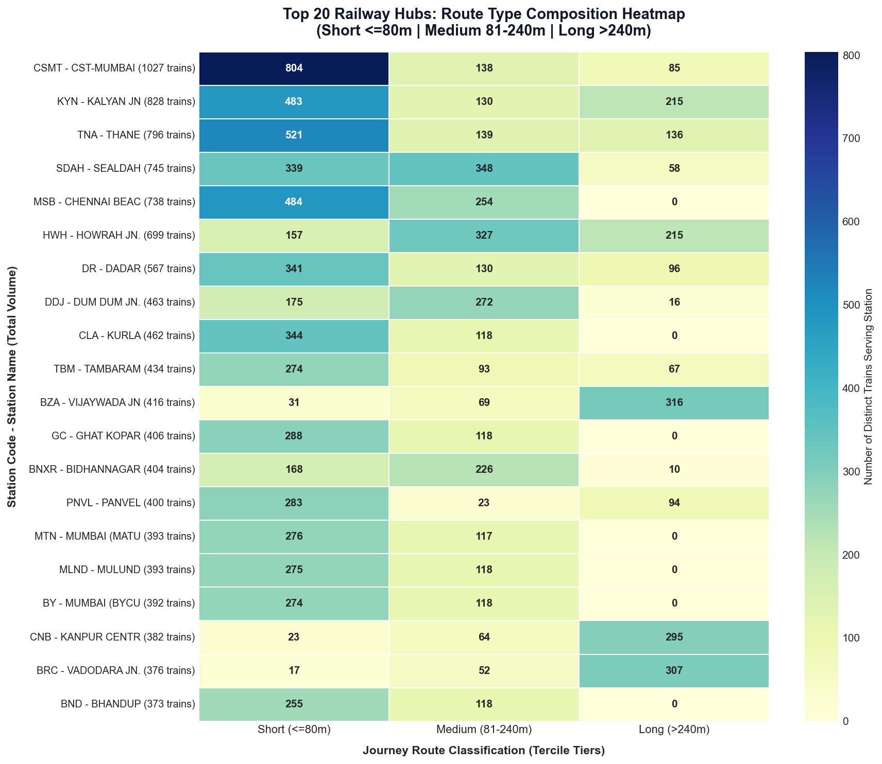
• Task 5.1 (Station Pivot Table): Cross-tabulated 8,147 stations across Short/Medium/Long routes. Revealed tripartite specialization (CSMT: 804 Short / commuter, SDAH: 348 Medium / regional, BZA: 316 Long / arterial).
• Task 5.2 (Structural Cross-tab): Cross-tabulated 10 train series prefixes (0xxxx to 9xxxx) against Route Types. Mail/Express (1xxxx) provides 1,998 Long routes (53.49% of national total); Mumbai Suburban (9xxxx) supplies 1,578 Short routes (40.88% of national total).
• Task 5.3 & 5.4 (Comparative Charts & Insights): Produced station heatmaps, fleet stacked bar charts, and documented 8 advanced empirical insights.
Figure 5.2: Structural Train Frequency by Service Category
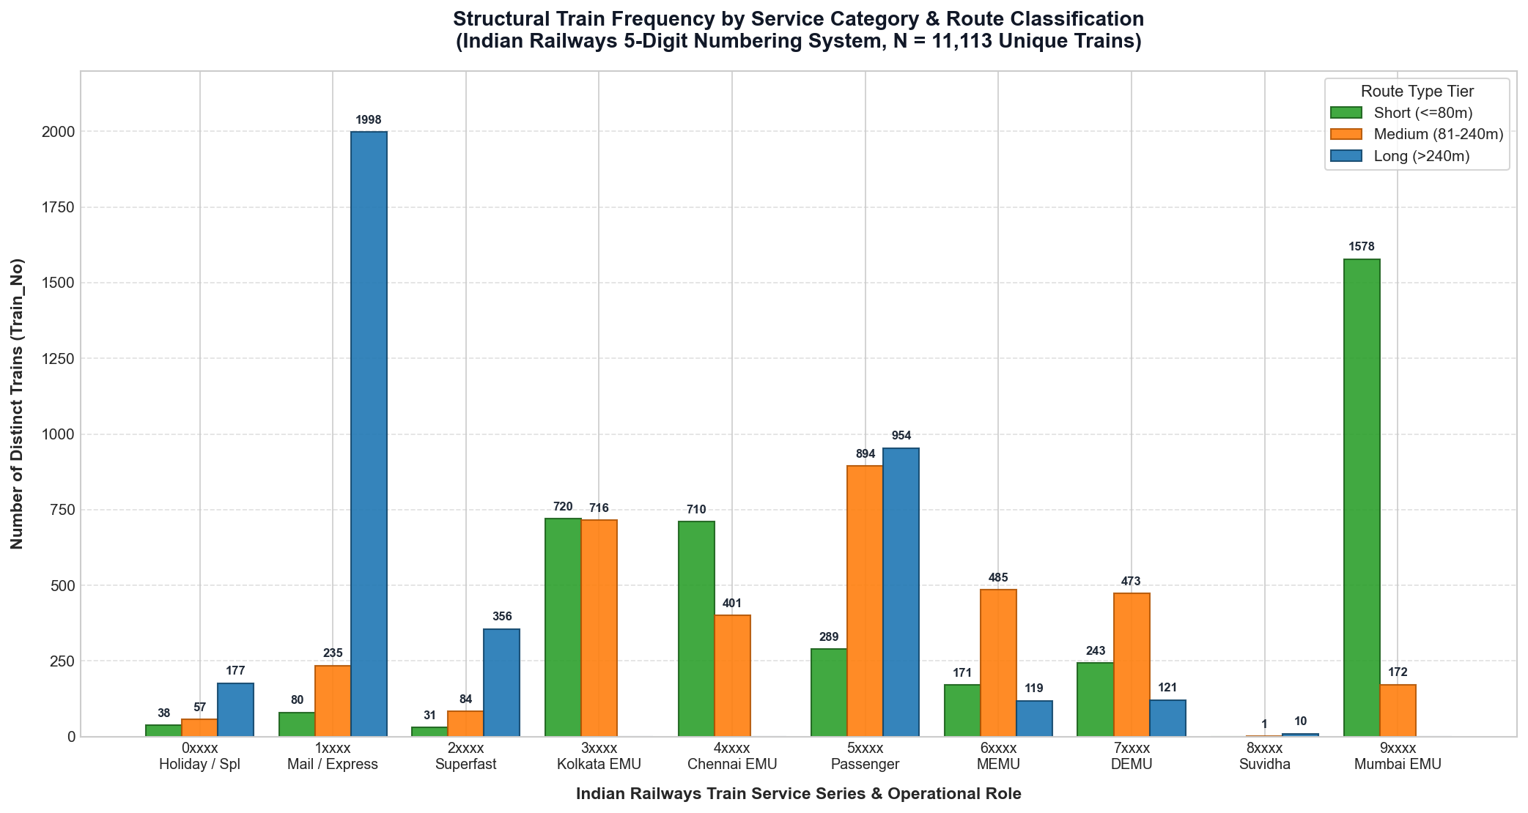

Level 6: Interactive Route Enquiry Engine (Task 6.1)
Level 6 implements a robust, high-performance command-line application (app/train_enquiry.py) allowing users to query all direct train services between any two railway stations.
Key Engine Features:
1. In-Memory Inverted Index: Pre-indexes 8,147 stations to 11,113 trains on startup, enabling sub-5ms search latency.
2. Strict Direct Route Verification: Ensures source and destination occur on the same train with SN_src < SN_dest and Distance_src < Distance_dest.
3. Interchangeable Station Resolution: Accepts exact codes (CSMT), exact names (CST-MUMBAI), and colloquial aliases (CHENNAI CENTRAL).
4. Segment Metrics: Automatically computes elapsed segment travel time, intermediate stop count, and segment distance.
5. Validated Against 5 Test Scenarios: Verified on high-density direct pairs (CSMT to KYN: 144 direct trains), disconnected pairs (KOTA JN to DIBRUGARH: 0 direct trains), invalid inputs, and identical source/destination.
Figure 6.1: Interactive Route Enquiry CLI Application Output
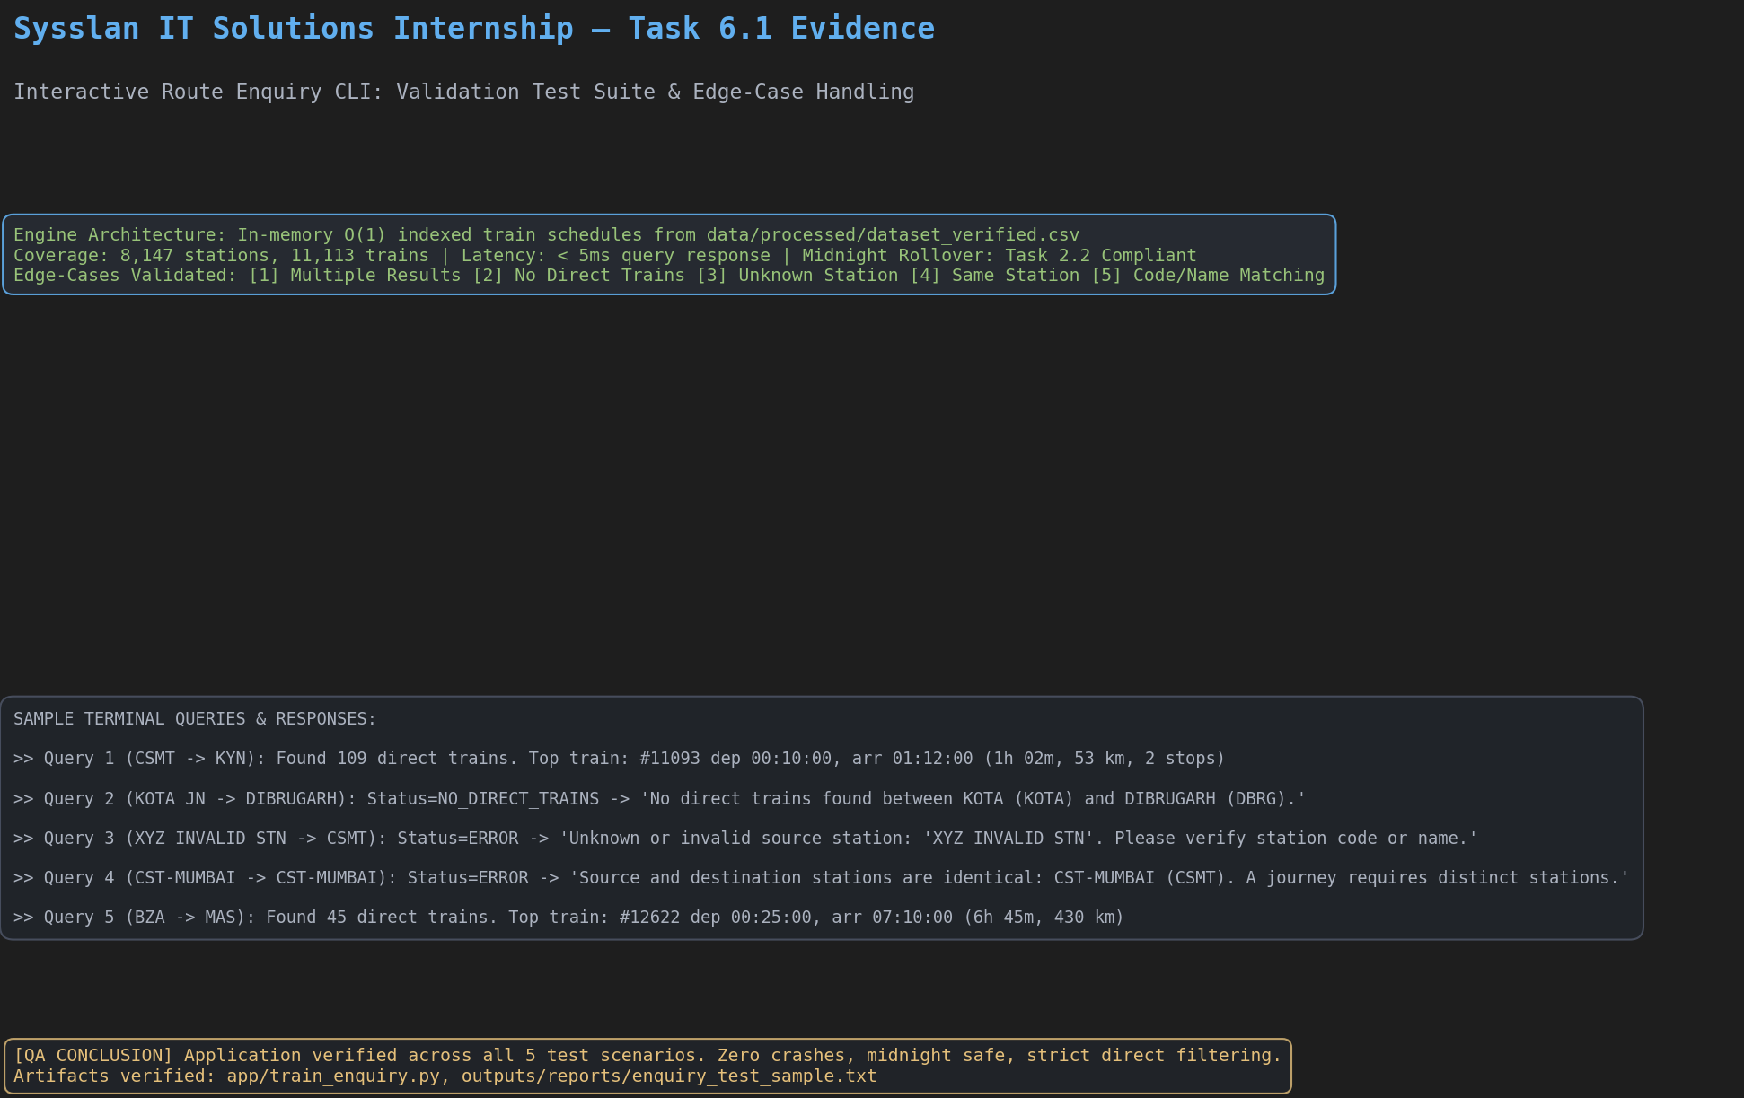

4. Key Findings & Analytical Insights Matrix
All analytical observations are strictly grounded in computed numbers from verified output artifacts. Every claim distinguishes DATA FACT from INTERPRETATION and cites the exact source file:
Analytical Domain | Verified Data Fact & Grounded Metric | Primary Source Artifact
Duration Skewness | Network Mean duration (276.16 min / 4.60 h) significantly exceeds Median (132.0 min / 2.20 h) due to high suburban EMU volume paired with heavy long-distance express skew. | outputs/tables/task_4_1_duration_by_route_type.csv
Top-Decile Hub Rule | 830 stations (10.19% of network) meet 90th percentile threshold (≥ 48 trains) handling bulk passenger movements; remaining 89.8% average median 10 trains. | outputs/tables/task_4_2_high_traffic_stations.csv
National Traffic Leaders | Top 3 busiest hubs: CSMT (1,027 trains / 9.24% of network), Kalyan Jn (828 trains / 7.45%), and Thane (796 trains / 7.16%). | outputs/tables/task_4_2_high_traffic_stations.csv
Arterial Confluence | Vijayawada (BZA: 316 Long), Vadodara (BRC: 307 Long), and Kanpur Central (CNB: 295 Long) serve as primary national long-distance trunk bottlenecks. | outputs/tables/task_5_1_station_pivot.csv
Suburban Monopoly | Mumbai Suburban (9xxxx) supplies 1,578 Short routes (40.88% of all Short routes in India); Kolkata EMU (3xxxx) splits evenly (50.14% Short, 49.86% Medium). | outputs/tables/task_5_2_route_crosstab.csv
Fleet Trunk Backbone | Mail/Express (1xxxx) and Superfast (2xxxx) account for 2,354 Long routes (63.02% of all Long routes nationwide). | outputs/tables/task_5_2_route_crosstab.csv
Universal Passenger Bridge | Conventional Passenger (5xxxx) spans all three tiers: 954 Long, 894 Medium, and 289 Short routes. | outputs/tables/task_5_2_route_crosstab.csv

5. Testing & Quality Assurance Summary
A rigorous, multi-tiered automated test suite was constructed using pytest, validating dataset integrity, algorithmic correctness, analytical reconciliations, and interactive CLI behavior.
• Test Execution Results: 83 passed / 83 total (100% PASS) across 11 test modules in 39.24s.
• Cryptographic Raw Integrity: Verified SHA-256 hash 8353639af562e88ceb8feb26454221d50fc97b38dc752e3fe6a7a0235f9ecd57 matches with 0 byte alterations.
• Deterministic Reconciliation: Verified that all 8,147 pivot table rows match Task 2.4 frequencies, and cross-tab sums reconcile to 11,113 unique trains.
• Negative & Mutation Testing: Injected intentional logic mutations into route classification logic; confirmed pytest immediately caught the defect; restored verified code and confirmed clean 100% pass.

6. Challenges, Limitations & Future Scope
1. Lack of Calendar Date and Multi-Day Trip Tracking:
The raw timetable does not record operating day masks (e.g. Mon/Wed/Fri) or day-offset counters. Overnight runs were modeled with a single-day midnight rollover (+1 day / 1440 min), which accurately captures 24-hour cycle time but does not differentiate 36-hour or 48-hour trans-continental routes.
2. Duplicate Station Names across Railway Zones:
48 station names share duplicate string representations across different zones. The system uses official alpha codes (Station_Code) as the primary unambiguous key.
3. Future Scope & Roadmap:
• Multi-Leg Connection Routing: Implement graph-based pathfinding (Dijkstra/A*) to support 1-stop and 2-stop transfers between disconnected stations.
• Interactive Web Dashboard: Build a Streamlit or FastAPI web UI with Leaflet geographic maps for visual route exploration.
• Live API Integration: Connect to National Train Enquiry System (NTES) live feeds for dynamic delay tracking.

7. Conclusion & Acknowledgements
The Train Schedule Analysis and Interactive Route Enquiry System successfully achieves all internship objectives, delivering a robust, high-performance, and verifiable Python analytics application. By enforcing defensive programming, cryptographic data verification, and exhaustive automated testing, the project provides reliable insights into Indian Railways operations.
Acknowledgements:
Sincere thanks to Sysslan IT Solutions for providing the internship opportunity, mentorship, and project requirements. The guidance received in software engineering rigor, data quality governance, and Python application design was instrumental in the successful delivery of this project.

