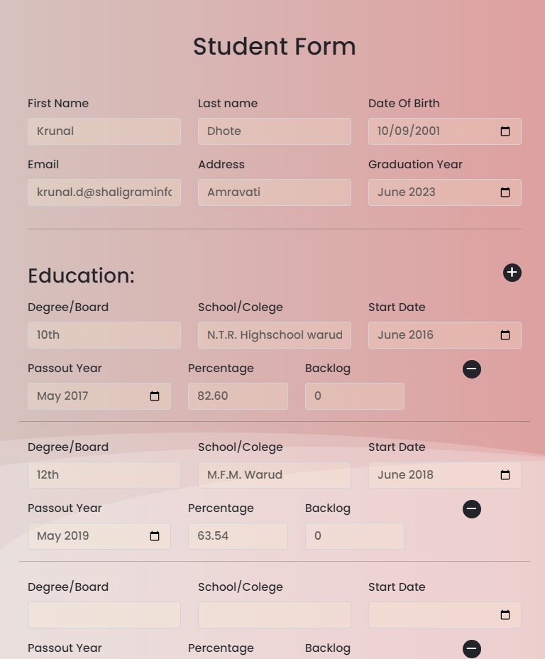

Task 1 : Student Details Form and Add Button with 2 static education details and on clicking Add(+) new field added in education and on clicking remove(-) row should be removed

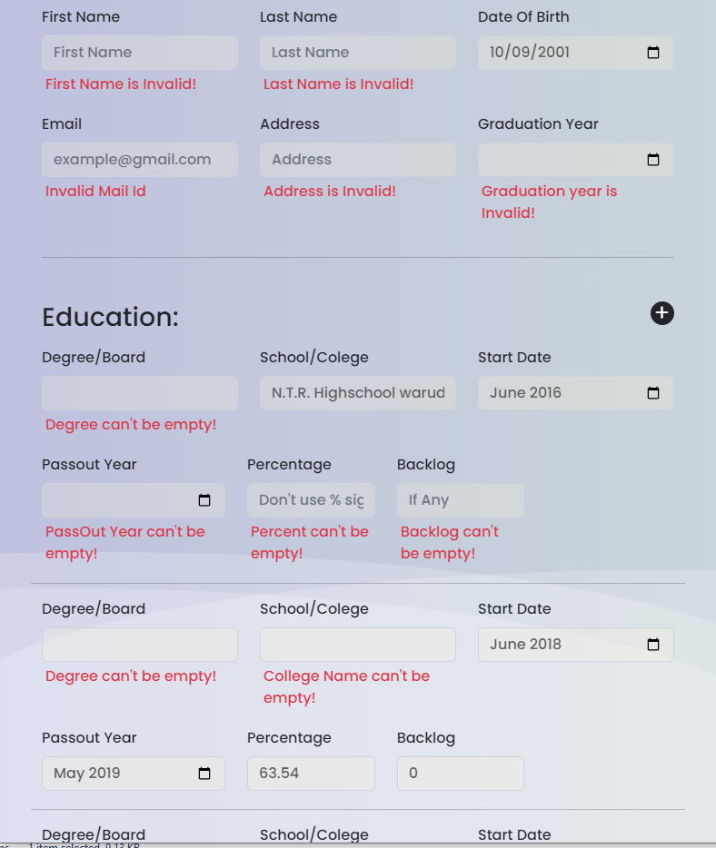

Task 2: validations on each field at once on clicking submit and print data on console as object

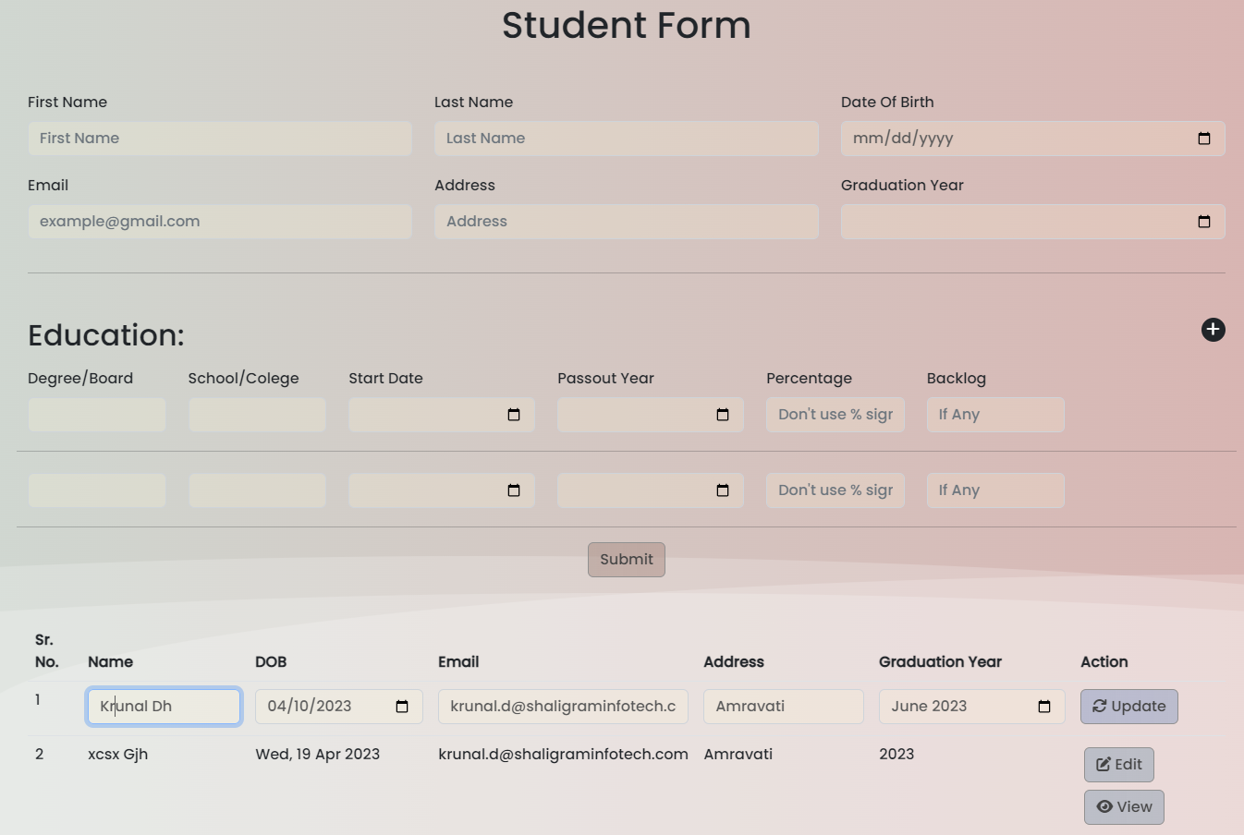

Task 3 : On submit Data will print in table with inline edit and delete functionality, on click edit show the id of object

This is extra work for inline update

Task 4: Bind jQuery datatable with external json or txt file using ajax

Task 5: Create jquery datatable and show ID on click of Edit or Delete.

Task 6: Modify jQuery datatable with Edit and Delete feature

Task 7: GET POST PUT DELETE using API ()

<http://192.168.3.51:1100/api/getAllUser>

<http://192.168.3.51:1100/api/>addUser

<http://192.168.3.51:1100/api/>updateUser/:id

<http://192.168.3.51:1100/api/>deleteUserbyId/:id

http://192.168.3.51:1100/api/getUserById/:Id