Applications of Artificial Intelligence in Machine Learning: Review and Prospect

Krunal vaviya *ComputerEngineering* CHARUSAT UNIVERSITY ANAND,GUJRAT,INDIA 19DCE147

Harit vachhani *ComputerEngineering* CHARUSAT UNIVERSITY ANAND,GUJRAT,INDIA 19DCE145

**ABSTRACT**

# AI is one of the most thrilling ongoing advancements in Artificial Intelligence. Learning calculations in numerous applications that is we utilize everyday. Each time a web search tool like Google or Bing is utilized to look through the web, one reason that functions admirably is on the grounds that a learning calculation, one carried out by Google or Microsoft, has figured out how to rank website pages. Each time Facebook is utilized and it perceives companions' photographs, that is likewise AI. Spam channels in email saves the client from being required to swim through huge loads of spam email, that is likewise a learning calculation. In this paper, a concise survey and future possibility of the tremendous utilizations of AI has been made.

# Keywords

Artificial intelligence, Machine learning, Supervised learning, Unsupervised learning, Reinforcement learning Applications.

# INTRODUCTION

An Artificial Intelligence (AI) program is called Intelligent Agent. Wise specialist will connect with the climate. The specialist can recognize the condition of a climate through its sensors and afterward it can influence the state through its actuators.

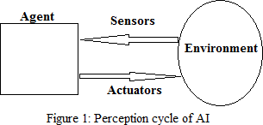

The significant part of AI is the control strategy of the specialist which infers how the data sources acquired from the sensors are meant the actuators, all in all the way that the sensors are planned to the actuators, this is made conceivable by a capacity inside the specialist.

A definitive objective of AI is to foster human like insight in machines. Anyway such a fantasy can be achieved through learning calculations which attempt to copy how the human mind learns.

AI, which is a field that had outgrown the field of computerized reasoning.

Anyway AI programs do the additional fascinating things, for example, web search or photograph labeling or email against spam. Thus, AI was created as another capacity for PCs and today it contacts many fragments of industry and essential science. There is independent mechanical technology, computational science. Around 90% of the information on the planet was created over the most recent two years itself and the incorporation of AI library known as Mahout into Hadoop environment has empowered to experience the difficulties of Big Data, particularly unstructured information.

In the space of AI research the accentuation is given more on picking or fostering a calculation and leading examinations based on the calculation. Such exceptionally one-sided view lessens the effect or true applications.

In this paper the different applications under the suitable classification of AI has been featured. This paper really tries to bring every one of the significant areas of utilizations under one umbrella and present a more broad and reasonable perspective on this present reality applications.

# MACHINE LEARNING

As indicated by Arthur Samuel Machine learning is characterized as the field of study that empowers PCs to learn without being expressly modified. Arthur Samuel was popular for his checkers playing program.

At first when he fostered the checkers playing program, Arthur was superior to the program. Yet, over the long run the checkers playing program realized what were the great board positions and what were awful board positions are by playing many games against itself.

A more conventional definition was given by Tom Mitchell as a PC program is said to gain for a fact (E) as for some undertaking (T) and some exhibition measure (P), assuming that its presentation on T, as estimated by P, improves with experience E then the program is known as an AI program.

In the checkers playing model the experience E, was the experience of having the program messing around against itself. The errand T was the assignment of playing checkers. What's more, the presentation measure P, was the likelihood that it dominated the following match of checkers against some new adversary.

In all fields of designing, increasingly large informational collections that are being gotten utilizing learning calculations.

# TYPES OF MACHINE LEARNING ALGORITHMS

* 1. **Supervised Learning**

This learning system depends on the correlation of processed yield and expected yield, that is learning alludes to registering the blunder and changing the mistake for accomplishing the normal result. For instance an informational index of places of specific size with genuine costs is given, then the administered calculation is to deliver a greater amount of these right responses, for example, for new house what might be the cost.

# Unsupervised Learning

Solo learning is named as educated by its own by finding and embracing, in view of the info design. In this learning the information are partitioned into various bunches and henceforth the learning is known as a grouping calculation. One model where grouping is utilized is in Google News (URL news.google.com).

# Reinforcement Learning

Support learning depends on yield with how a specialist should make moves in a climate in order to amplify some idea of long haul reward. A prize is given for right result and a punishment for wrong result. Support gaining contrasts from the regulated learning issue in that right info/yield matches are rarely introduced, nor sub-par activities unequivocally remedied.

# Recommender Systems

Recommender frameworks can be characterized as a learning strategies by prudence of which online client can alter their locales to meet client's preferences. For instance, online client can get a rating of an item or/and related things when he/she looking through a things in light of the current recommender framework. For that reason it altered the manner in which individuals track down items, data, and, surprisingly, others.

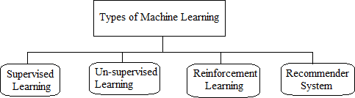

#### Figure-2: Types of Machine Learning

1. **APPLICATIONS OF MACHINE LEARNING AND LITERATURE SURVEY**

This segment explains arranged utilizations of AI as per different AI calculation under regulated learning, solo learning, support learning and recommender learning.

# Unsupervised Learning

In AI, the issue of unaided learning is that of attempting to track down secret design in unlabeled information. Since the models given to the student are unlabeled, there is no mistake or award sign to assess a likely arrangement.

## DNA classification: Understanding genomics

Figure 3 shows a DNA microarray information, the varieties, red, green, dim, etc, show how much various people do or don't have a particular quality. The thought is tostructure a gathering of various people to such an extent that every one of them has a specific quality. So a bunching calculation can be rushed to bunch people into various classifications or into various kinds of individuals. So this is Unsupervised Learning in light of the fact that the calculation isn't given any data ahead of time whether there are type 1 individuals, type 2 people, and type 3 people, etc. Rather a lot of information is given and the calculation consequently tracks down structure in the information into these sorts of people.

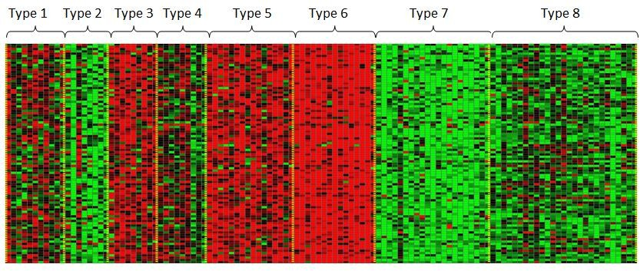

#### Figure 3: DNA microarray data

* + 1. *Organizing large computer clusters:*

At large data communities that are huge PC groups, solo learning assists with sorting out which machines will quite often cooperate, so that on the off chance that those machines are assembled or on the other hand assuming there is some emergency, the server farms can work all the more proficiently.

## Social network analysis:

Unaided Machine learning calculations can consequently distinguish the companions inside a client circle in Facebook or Google, or it can recognize the greatest number of sends shipped off a specific individual and sort into aggregate gatherings.

## Market segmentation:

Many organizations have gigantic data sets of client data. Thus, Unsupervised Machine learning calculations can take a gander at this client informational collection and naturally find market portions and consequently bunch clients into various market fragments so the organization can naturally and all the more proficiently sell or market the different market sections together.

## Astronomical data:

* + - 1. *Astronomical data analysis:*

These grouping calculations give shockingly fascinating valuable hypotheses of how universes are conceived.

## Anomaly/Novelty detection in astronomical data:

Present day galactic observatories are exceptionally cutting-edge and can deliver gigantic measure of information which the scientists lack opportunity and willpower to check out. It is generally typical that these huge scope galactic informational collections can contain inconsistencies/oddities. Along these lines the requirement for machines which can be prepared to go through the information produced and in the process distinguish any oddities that might be available in the informational collection (at a lot quicker rate and generally speaking with better precision) becomes apparent. Irregularity/Novelty Detection is the method involved with observing uncommon things or attributes .

which are unique in relation to our common information about the information. Abnormalities location issues are basically of two sorts: 1) point peculiarity - oddities of this sort are individual heavenly articles that present uncommon attributes. 2) bunch inconsistencies - this is an uncommon assortment of focuses.

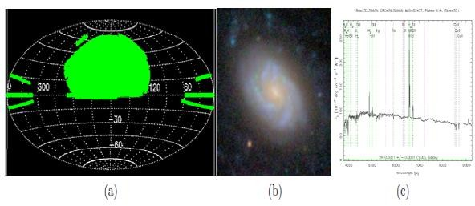

#### Figure 4: Summary of the Sloan Digital Sky Survey (SDSS) data set. (a) The coverage map of SDSS. (b) A sample imaging data. (c) A sample spectroscopic data i.e. the spectrum.

* + 1. *The cocktail party problem:*

At a mixed drink party with two individuals, two individuals talking simultaneously. Two amplifiers are placed in the room at two unique good ways from the speakers; every receiver records an alternate mix of these two speaker voices. Perhaps speaker one is a little stronger in amplifier one and perhaps speaker two is somewhat stronger on mouthpiece two in light of the fact that the 2 receivers are at various positions comparative with the 2 speakers, yet every amplifier would cause a covering blend of the two speakers' voices. These two receiver recorders are given to an Unsupervised Learning calculation called the mixed drink party calculation.

## Medical records:

With the coming of robotization, electronic clinical records have become pervasive, so in the event that clinical records are transformed into clinical information, sickness could be perceived in a superior way.

## Computational biology:

Computational science otherwise called bioinformatics is the utilization of natural information to foster calculations and lay out relations among different organic frameworks. With computerization once more, researcher are gathering bunches of information about quality groupings, DNA successions, quality articulation cluster examination, combinatorial science, etc,

## Analysis of gene expression data: cancer diagnosis:

Malignant growth can be characterized as a class of illnesses that is portrayed with crazy cell development. There are around a 100 distinct sorts of disease killing incalculable individuals across the world. Accordingly distinguishing the sort of disease is a pivotal advance in its treatment. It is done through order of patient examples. The arrangement interaction and results might be improved by breaking down the quality articulation of the patient which might give extra data to the specialists. The consolidation of clinical science and innovation has previously prompted a ton of life saving leap forwards in the field of medication. Subsequently the inclusion of innovation in battling disease is of nothing unexpected. AI procedures, like Bayesian organizations, brain trees, and spiral premise work (RBF) organizations, are utilized for the examination of the datasets and characterizing disease types.

## Speech Activity Detection (SAD):

Force of discourse is an essential way for people to communicate their thoughts. Frequently the sound or discourse contains quiet stops which are stops where discourse is missing; this is the place where discourse action recognition (SAD) tracks down its application. Miserable is a method used to recognize the presence of human discourse, it can assist with decreasing the heap on human audience members by eliminating long and uproarious non-discourse stretches. Miserable is language free and can be of two sorts specifically: Supervised and Unsupervised. Regulated SAD relies to a great extent upon the preparation information so its utilization is restricted to the accessibility of preparing information and consistency of the test climate while Unsupervised SAD is an element based method where execution corrupts with expansion in commotion.

## Acoustic Factor Analysis for Robust Speaker Verification:

Recognizable proof or acknowledgment of the speaker by examining the voice information for confirmation is Speaker Recognition or Verification. Bungle among preparing and test conditions address quite possibly the most difficult issue confronting scientists in this field today. A portion of the wellsprings of presentation of these confuses are: transmission channel contrasts, handset changeability, foundation commotion, and meeting fluctuation because of actual pressure, vocal exertion, for example, murmur, Lombard impact, non-fixed climate, and suddenness of discourse. To empower machines to deliver solid and confirm information specialists need to prepare them to take out or defeat these confuses.

# Supervised Learning

Regulated learning is the AI errand of deriving a capacity from marked preparing information. The preparation information comprise of a bunch of preparing models. In administered learning, every model is a couple comprising of an info object (normally a vector) and an ideal result esteem. A managed learning calculation breaks down the preparation information and produces a surmised work, which can be utilized for planning new models.

## E-mail data:

* + - 1. *Automatic answering of incoming messages:*

Rather than composing a similar answer each time somebody messages with a typical inquiries and issues, presently AI calculations examinations those sends and naturally creates an answer.

* + - 1. *Automatic mail organization into folders:* With the mass measure of messages pouring day to day it demonstrates profoundly badly arranged for clients to physically isolate the messages. In this manner AI ends up being generally valuable by arranging the mail naturally into different client characterized inbox tabs, for example, essential, social, advancements, update, gatherings and so on.

## Email and thread summarization:

The approaching messages are dissected and the significant sentences are separated from the email string and are made into an outline.

## Spam filtering:

It is principally used to channel spontaneous mass Email (UBE),

garbage mail, or spontaneous business email (UCE) from the real messages. The spam channel saves the client from being required to swim through huge loads of spam email, that is likewise a learning calculation. The spam channel can likewise be advanced by watching which messages you do or don't hail as spam.

## Email Batch Detection:

The issue of recognizing groups of messages that have been made by a similar layout should be tended to. This issue is roused by the craving to channel spam all the more successfully by taking advantage of aggregate data about whole bunches of together produced messages. Shippers of spam, phishing, and infection messages try not to mail different indistinguishable duplicates of their messages.

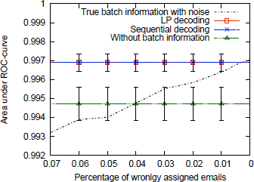

#### Figure 5: Classification accuracy with batch information

* + 1. *Handwriting recognition:*

It turns out one reason it's so economical today to highway a piece of mail across the nations, is that when a location is composed on an envelope, it turns out there's a learning calculation that has figured out how to peruse the penmanship so it can consequently course this envelope on its way, thus it costs less.

## Face recognition:

Human face isn't one of a kind, unbending item and various variables make the presence of the face fluctuate. There are various application regions where face acknowledgment can be taken advantage of, for example, security measure at an ATM, areas of observation, shut circuit cameras, picture information base examination, law enforcement framework, and picture labeling in long range interpersonal communication locales like Face book and so forth.

## Speech recognition:

All discourse acknowledgment programming uses AI. Discourse acknowledgment frameworks include two unmistakable learning stages: one preceding the product is delivered (preparing the overall framework in a speaker-free design), and a second stage after the client buys the product (to accomplish more prominent exactness via preparing in a speaker - subordinate style).

## Information retrieval:

Data recovery (IR) is viewing as material (generally records) of an unstructured nature (typically text) that fulfills a data need from inside enormous assortments (ordinarily put away on PCs). The client gives a layout of their prerequisites maybe a rundown of catchphrases connecting with the point being referred to, or even a model report. The framework scans information base for archives are connected with the client's inquiry, and presents those that are generally important. The data recovery cycle can be separated into four particular stages: ordering, questioning, correlation, and input. All periods of data recovery can be performed physically, yet mechanization has many advantages bigger report assortments can be handled all the more rapidly and reliably.

## Operating system:

One of the primary reasons for utilizing PCs is to take care of business as quick as could really be expected. In such a situation the applications really must beginning and answer rapidly along these lines decreasing he hanging tight time for the client. Different PC clients have different utilization inclinations, which for the most part allude to applications that are utilized most often by the client. This reality can be utilized by the basic working framework for foreseeing the client application decisions and pre-bringing them into the nearby memory for quick beginning up. This is accomplished with the assistance of inbuilt programming which trains itself by noticing the activities of the client over the long run and gaining from them.

## Natural language processing or computer vision:

These are the fields of AI relating to understanding language or getting pictures. A large portion of regular language handling and the majority of PC vision today is applied AI.

## Intrusion detection:

Interruption identification is the method involved with checking the occasions that are happening in the frameworks or organizations and examining them for indications of potential episodes, which are infringement or dangers to PC security approaches, satisfactory use arrangements, or standard security rehearses It is primarily of two kinds in view of the interruptions initially is Misuse or mark based recognition and the other is Anomaly location. [11]

## Anomaly detection or recognizing anomalies:

Recognition of strange groupings of charge card exchanges, discovery of uncommon examples of sensor perusing in a thermal energy station or surprising sound in motor for such reason dynamic AI strategy is utilized where rather than taking a gander at individual activity, a succession of tasks are dissected in general with the goal that it is more vigorous to minor changes in authentic way of behaving.

## Signature based detection:

This method of location searches for proof which shows abuse. In an organization, foreordained assault designs frames a signature and these marks are utilized to decide further organization assaults .Machine learning empowers assessment of the organization traffic with predefined marks and each time information base is refreshed.

## Epileptic Seizure Detection:

Epilepsy is a focal sensory system issue, in which the patient experiences intermittent seizures that happen at capricious times and generally abruptly. Seizures can bring about a pass of consideration or an entire body spasm. Successive seizures increment a singular's gamble of supporting actual wounds and may even bring about death.

#### Epileptic seizure 1.png Figure 6: A seizure within the scalp EEG of a patient

* + 1. *Automated Text Categorization:*

In archive arrangement, the texts are listed and it is an issue in library science, data science and software engineering. The undertaking is to relegate a record to at least one classes. This might be done algorithmically. The records to be arranged might be texts, pictures, music, and so forth. Every sort of record has its extraordinary characterizationproblems. When not in any case determined, text arrangement is suggested. Text arrangement (TC-a.k.a. text characterization, or point recognizing), the action of marking normal language texts with topical classes from a predefined set, is one such undertaking. TC is currently being applied in numerous unique circumstances, going from record ordering in light of a controlled jargon, to archive sifting, computerized metadata age, word sense disambiguation, and so on.

## Automatic Indexing for Boolean Information Retrieval Systems:

Here each report is appointed at least one watchwords or key expressions depicting its substance, where these catchphrases and key expressions have a place with a limited set called controlled word reference.

## Document Organization:

Ordering with a controlled jargon is an occurrence of the overall issue of report base association.

## Text Filtering:

Text separating is the movement of ordering a flood of approaching archives dispatched in a nonconcurrent way by a data maker to a data shopper.

## Word Sense Disambiguation:

Word sense disambiguation (WSD) is the movement of finding, given the event in a text of an uncertain word, the feeling of this specific word event.

## Hierarchical Categorization of Web Pages:

Programmed grouping of Web pages, or destinations, under various leveled indexes.

## Data Center Optimization:

The cutting edge server farm (DC) is a complicated connection of numerous mechanical, electrical and controls frameworks. The sheer number of conceivable working designs and nonlinear interdependencies make it hard to comprehend and advance energy effectiveness. Quite possibly the most complicated challenge is power the executives. Developing energy costs and natural obligation have set the DC business under expanding strain to work on its functional proficiency. The use of AI calculations to existing observing information gives a chance to essentially further develop DC working productivity. A commonplace huge scope DC produces a large number of important informative elements across great many sensors consistently, yet this information is seldom utilized for applications other than observing purposes. Progresses in handling power and checking abilities set out a huge freedom for AI to direct best practice and further develop DC proficiency. The goal is to give an information driven way to deal with upgrading DC execution. Brain network is chosen as the numerical structure for preparing DC energy productivity models. Brain networks are a class of AI calculations that impersonate mental way of behaving by means of cooperations between fake neurons.

## SVM and Dimensionality Reduction in Cognitive Radio:

With the progressing time machine learning is acquiring notoriety and tracking down utilization in different fields. Mental radio is one such field where AI tracks down its application. Mental radio is a radio that permits dynamic programming choices and is intended to give more remote correspondence by recognizing and utilizing the best remote directs accessible in a given region. The control of levels of opportunity (DOF) for example dimensionality decrease is viewed as the underlying stage for radar and detecting signal handling. While, SVM or Support Vector Machines are models that utilization a learning calculation for creating design acknowledgment and grouping capacities. These two methodologies for example dimensionality decrease and SVM can be applied mutually to Cognitive Radio consequently acquiring execution improvements while grouping remote transmission information.

## Classification of Software Engineering Artifacts Using Machine Learning:

A lot of information is delivered throughout improvement of Software projects. The information produced in the process isn't just immense in its amount yet in addition changing in the idea of its items; it can incorporate a scope of various kind of data pieces like the sending subtleties of the product framework, part investigation, article and class models and so forth; this, however the interrelations among these data archives give further experiences to the venture. It is regular that every last one of these antiques makes them recognize credits which can be utilized to sort the information and consequently make them more reasonable and put them to helpful purposes. The issue to this approach is that grouping such immense sum information which is ever on the increment is no assignment for people this is the place where AI comes in.

## Computational Finance:

In this day and age the monetary market is one of the most temperamental and unusual. One must be on his feet continually to make due and find success in this market. In such a climate where market slumps and supported times of misfortune, are normal peculiarity and methods of AI have arisen as the main execution estimates utilized in the business. For instance frameworks have honey bee created where the future stock costs moves can be anticipated via preparing a mechanized astute specialist that find designs in the stock costs dynamic just before a significant market move. During the abuse stage, the specialist notices present status of market. Assuming an example perceived that was seen previously, specialist gives a purchase/sell signal.

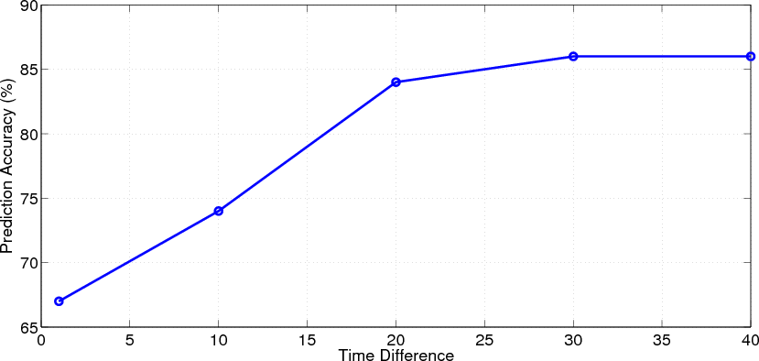

#### Figure 7: Accuracy of long-term prediction

* + 1. *Semantic Scene Classification:*

In design acknowledgment scene order is an exceptionally normal undertaking where the framework checks an image and dissects the different components in it and utilizations them to arrange the picture to a specific class or gathering. In this cycle frequently such a circumstance might happen when the classes are not totally unrelated by definition. For instance a semantic scene grouping, orders pictures into semantic classes like sea shores, dusks or gatherings, in which many pictures might have a place with different semantic classes. Figure 8 shows a picture that falls under both ocean side and a metropolitan scene classes. This different grouping anyway isn't equivocal as one would naturally suspect yet is completely an individual from each class (because of variety).



#### Figure 8: Image that falls under both beach and an urban scene categories

* + 1. *Applications to music:*

Music is a huge circle. How much information and material accessible here is gigantic and pretty much every individual has an alternate taste from others with regards to music. Normally the requirement for characterization emerges. One can characterize music in various ways as there exists an expanse of choices to choose from with regards to picking a component on whose premise the arrangement is to be finished. Melodic information is intricate and frequently exceptionally layered (when addressed as sound) and this is the place where machines provide to our with some much needed help as AI is very appropriate for working with such information. Arrangement is only one of the countless errands that can be executed on such an informational index as music utilizing AI. With the digitalization of music, a new and quickly developing exploration region has arisen, called Music Information Retrieval (MIR) which is an exploration centered around the extraction of data from music sound and melodic scores. Music Production is one more somewhat new field of exploration in this unique circumstance. With AI we can lighten a portion of the distance among artist and machine. Brain organizations can be applied both to music sound signs and MIDI (Music Instrument Digital Interface) information.

## Evolving Signal Processing for Brain- Computer Interfaces (BCI):

A BCI or Brain Computer Interface is joint effort between a mind and a gadget or machine that peruses the electrical signs from the cerebrum the purposes them to direct a few outside exercises like moving the cursor or a prosthetic appendage. The gadget or machine goes about as a point of interaction between the mind and the item to be constrained by the cerebrum. Figure 9 shows a calculated schematic outline of advancing BCI plan standards. Information got from sensors and gadgets inside, on, and around a human subject are changed into enlightening portrayals by means of space explicit sign pre-handling. The subsequent signs are consolidated to deliver psychomotor state portrayals.

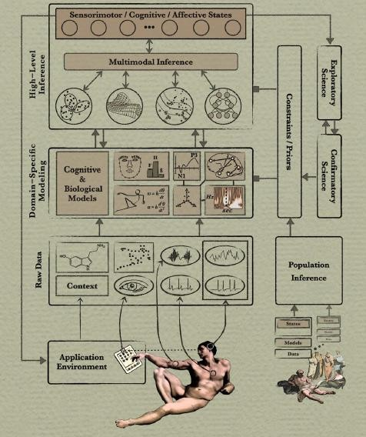

#### Figure 9: Conceptual schematic overview of evolving BCI design principles

* + 1. *Acoustic Environment Identification (AEI) and Audio Forensics:*

A sound recording are inclined to various potential mutilations and antiques like acoustic resonation, foundation commotion, and so on. These unsettling influences which areotherwise considered to be useless and are attributed to degrading the quality of the audio can be put to advantage and used to remove significant data by means of different strategies like Acoustic Environment Identification (AEI), Audio Forensics, and ballistic settings.

# Recommender system

Recommender frameworks are a subclass of data recovery framework that looks to anticipate the 'rating' or 'inclination' that client would provide for a thing, which permit the web-based client to pick the best thing.

## Mobile Learning Environments:

Versatile learning (m-learning) implies ―learning on the move‖ which varies from normal e-realizing where there is wastage of transfer speed [6]. Data can be effortlessly gotten to as and when wanted because of the versatile or compact gadgets. So AI caters the learning system of various clients by giving data which is redone to the inclinations of the client.

* + 1. *Sentiment analysis/ opinion analysis:* Whenever we hear an individual talk we hear the words as well as the feelings in the individual's voice and assuming that the discussion is up close and personal we consider their demeanors to be well. Literary information catches current realities and data yet it for the most part neglects to catch the feelings of the speaker prompting the confusion of the genuine substance of the words. This should be visible as a deficiency of significant data. Consequently, feeling or generally assessment towards the topics for instance, whether an item survey is good or pessimistic. Anyway feeling investigation can be testing and it should refresh itself with the always intricate utilization of explanations to communicate thus learning calculation ends up being altogether valuable with that impact. Opinion arrangement ends up being useful in business insight applications, film surveys and recommender frameworks.

## Database mining (DM):

With the development of the web and robotization came a lot bigger informational indexes than at any other time. In such a situation a significant undertaking is to keep up with these information so that can end up being helpful. Compelling calculations should be fostered that can utilize this information to proficiently learn and serve the clients more. For instance, huge loads of Silicon Valley organizations are today gathering web click information, likewise called click stream information, and are attempting to utilize AI calculations to mine this information to comprehend and serve the clients better.

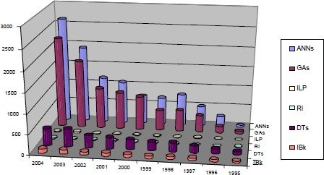

#### Figure 10: Comparative results on ML techniques applied to DM tasks over the period 1995-2004.

* + 1. *Self- customizing programs:*

Today we resort to the web to address a large group of our issues like paying attention to music and watching recordings internet, downloading tunes, motion pictures, applications and so forth, shopping, banking, reserving a spot, making voyaging plans, etc. It is normal experience for clients to get suggestions from the destinations that they visit in light of their action history on that site. The destinations accomplish this through a learning calculation which advances by noticing the client exercises and decisions over the long run and alters itself to the clients' inclinations. Learning calculations are being utilized today to get human learning and to get the mind.

# Reinforcement learning

Support learning is an area of AI enlivened by behaviorist brain science, worried about how programming specialists should make moves in a climate in order to boost some idea of aggregate prize.

## Traffic forecasting service:

With the steadily expanding number of vehicles utilizing on the streets traffic the board appears to a colossal issue nowadays. Machines can be prepared and used to tackle this issue. For instance, frameworks that overlay forecasts about future traffic conditions on a computerized traffic stream map.

## Computer games:

The gaming business has filled colossally in the new years. Computer based intelligence driven specialists are utilized generally to make intuitive gaming experience for the players. These specialists can play an assortment of jobs, for example, player's rivals, colleagues or other non-player characters.

## Machinery applications:

There are those applications that can't be modified manually. For instance, independent helicopters in which the PC could advance without anyone else on the best way to fly the helicopters.

## Semantic Annotation of Ubiquitous Learning Environments:

In this day and age functional information is acquiring significance quick in pretty much every field. It not just aides in procuring reasonable abilities which are more useful on-field yet additionally gives better comprehension of the subject to the individual concentrating on it. Besides assessment of expertise based acquiring frameworks assists specialists with bettering comprehend how understudies are learning. The utilization of semantic comments as a feature of an abilities based mastering climate is exceptionally helpful for this situation. Reproductions of genuine circumstances help in the advancement and of reasonable abilities like navigation, group working, correspondence, and critical thinking. They can be consolidated during the time spent appraisal of understudies' exhibition. The University of Southampton for instance has such a clinical abilities research facility; Figure 11. The ward contains mechanized and intelligent recreated life sized models, non-electronic life sized models, and a scope of supplies which gives clinical set-up and exercises for the understudies.

#### semantic annotations.png

#### Figure 11 Clinical skills laboratory

1. **IMPRESSION AND VIEWS**

With how much informational index getting huge by each spending day, the examination of these tremendous measures of information is past the limit of natural eye. So Artificial specialists assume up the liability of communicating with the climate and thusly impact it. The initiation of the ―Big Data‖ has likewise brought about ad lib of the AI calculations as they have bigger informational collections to acquire insight. The worry isn't the manner by which huge ―Big Data‖ is nevertheless it's more about tracking down designs inside it.

In Machine gaining the fake specialists gains from preparing information or by interfacing with the climate and impacts it to work with the most ideal outcome. So Machine Learning is most certainly a subfield of Artificial Intelligence. This thought has made the current day applications independent.

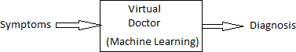

#### Figure-12: Virtual Doctor

With regards to internet searcher, AI not just gives result based on the inquiry content yet additionally gives inclinations to the clients' decisions and action on the web, which has brought about a total insurgency of the web search tools.

AI can demonstrate enormously accommodating during the time spent building a data time machine as displayed in Figure-14. Data time machine requires huge data set of the present and the past. One of the ways of extrapolating the information base of the past is to digitize the chronicled documents where case AI can demonstrate helpful.



#### Figure-13 Information Time Machine

The best outcome up to this point has been the innovation of independent driving vehicles utilizing Machine picking up, making the switches more shrewd in an organization and furthermore application in distributed computing is a major possibility.

As in Machine learning, directed and solo learning are of the two significant sorts. What's more, AI specialists are general issue solvers and can be applied in different fields.

In this way, AI isn't about impeccably imitating human, it's tied in with sorting out the rules that permit specialists to act shrewdly and refining us. Most importantly knowledge is presently not selective to just people.

# CONCLUSION

People have generally tried to fabricate an agreeable life, the verification of this lies in the way that we have generally relied upon machines to finish our work all the more effectively, in a quicker and more productive way. In the past machines have been utilized to decrease the physical work required finish a task, however as of now, with the appearance of AI people trytoconstruct machines which are solid as well as shrewd and thus AI has arisen to turn into an area of study that is ever in the blossom. AI has not recently made the machines independent, presenting the idea of independent registering, however it has likewise diminished the consistent carefulness clients are expected to keep upon the applications. In this paper, examines the four classifications of AI for example managed learning, unaided learning, and support learning and recommender framework and furthermore presents the various applications under them. Aside from that two proposed applications specifically data time machine and virtual specialist have been advanced. The principle motivation behind AI is to foster calculations that aid the production of smart machines in this way diminishing the positions of the developers as the machine learns at the appointed time of time to work on its presentation. Aside from this issue, an extraordinary number of distributions on AI assess new calculations on a small bunch of confined benchmark informational indexes. Despite this multitude of weaknesses AI has tackled changing issues of worldwide effect. AI has shown to be immensely helpful in an assortment of fields, for example, information mining, man-made brainpower, OCR, insights, PC vision, numerical enhancement, and so forth and its significance will in general remain ever on the increment. AI hypotheses and calculation are roused from the natural learning frameworks where the exhibition relies upon factors like how much accessible information, the learning history and experience, and so on, and hence help making sense of human learning. The uses of AI are in this way endless it actually stays a functioning field of exploration with colossal advancement choices and a promising future.

# ACKNOWLEDGMENTS

Our gratitude to the specialists Dr. Susanta Biswas, Kalyani University, who have prompted and empowered us for such sort of improvement. Likewise our extraordinary gratitude to Dr. Somsubhra Gupta, JIS College of Engineering for giving a wide range of required assets.

# REFERENCES

1. Tzanis, George, et al. "Modern Applications of Machine Learning." Proceedings of the 1st Annual SEERC Doctoral Student Conference–DSC. 2006.
2. Horvitz, Eric. "Machine learning, reasoning, and intelligence in daily life: Directions and challenges." Proceedings of. Vol. 360. 2006.
3. Mitchell, Tom Michael. The discipline of machine learning. Carnegie Mellon University, School of Computer Science, Machine Learning Department, 2006.
4. Ball, Gregory R., and Sargur N. Srihari. "Semi- supervised learning for handwriting recognition." Document Analysis and Recognition, 2009. ICDAR'09. 10th International Conference on. IEEE, 2009.
5. Valenti, Roberto, et al. "Machine learning techniques for face analysis." Machine Learning Techniques for Multimedia. Springer Berlin Heidelberg, 2008. 159-187.
6. Al-Hmouz, Ahmed. "An adaptive framework to provide personalisation for mobile learners." (2012).
7. Al-Hmouz, Ahmed, Jun Shen, and Jun Yan. "A machine learning based framework for adaptive mobile learning." Advances in Web Based Learning–ICWL 2009. Springer Berlin Heidelberg, 2009. 34-43.
8. Thore Graepel ―Playing Machines: Machine Learning Applications in Computer Games‖, ICML 2008 Tutorial

- 5 July 2008, Helsinki, Finland.

1. Broder, Andrei, and Vanja Josifovski. "Introduction to computational advertising." (2010).
2. Cunningham, Sally Jo, James Littin, and Ian H. Witten. "Applications of machine learning in information retrieval."