Exploratory Data Analysis (EDA) & Business Intelligence

Submitted By
Name: Krupa
College: Malla Reddy Engineering College for Women
Branch: CSE (Data Science)
Internship: Data Analytics Internship
Task: Task 2 – Exploratory Data Analysis (EDA) & Business Intelligence

1. Objective
The objective of this project is to analyze the Superstore dataset to identify patterns, trends, and business insights using Exploratory Data Analysis (EDA), SQL queries, and data visualization techniques.

2. Dataset Description
Dataset Used: Sample Superstore Dataset
The dataset contains retail sales transactions including:
- Order Details
- Customer Information
- Product Information
- Sales
- Profit
- Discount
- Region
- Category

3. Data Understanding

Dataset Shape
- Rows: 9994
- Columns: 21

Data Types
- Numerical Columns:
  - Sales
  - Profit
  - Quantity
  - Discount
- Categorical Columns:
  - Category
  - Region
  - Customer Name
  - Product Name
  - Ship Mode

Missing Values Analysis
No missing values were found in the dataset.

4. Descriptive Statistics
Key statistical measures were calculated using Pandas.
Observations:
- Sales values vary significantly across transactions.
- Profit contains both positive and negative values.
- Discounts impact overall profitability.

5. Exploratory Data Analysis

5.1 Sales Distribution
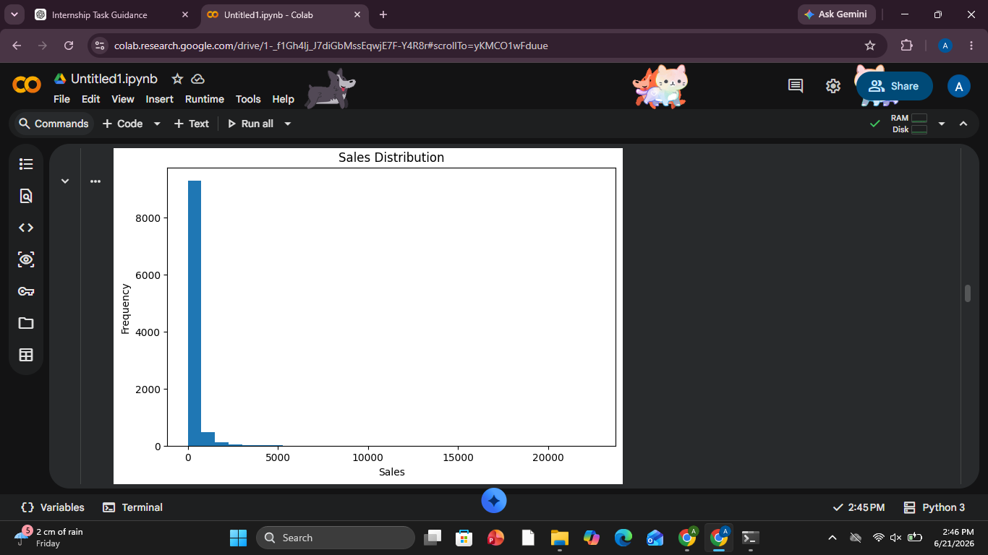
Observation:
Most sales transactions are concentrated in lower sales ranges, with a few high-value transactions.

5.2 Sales by Category
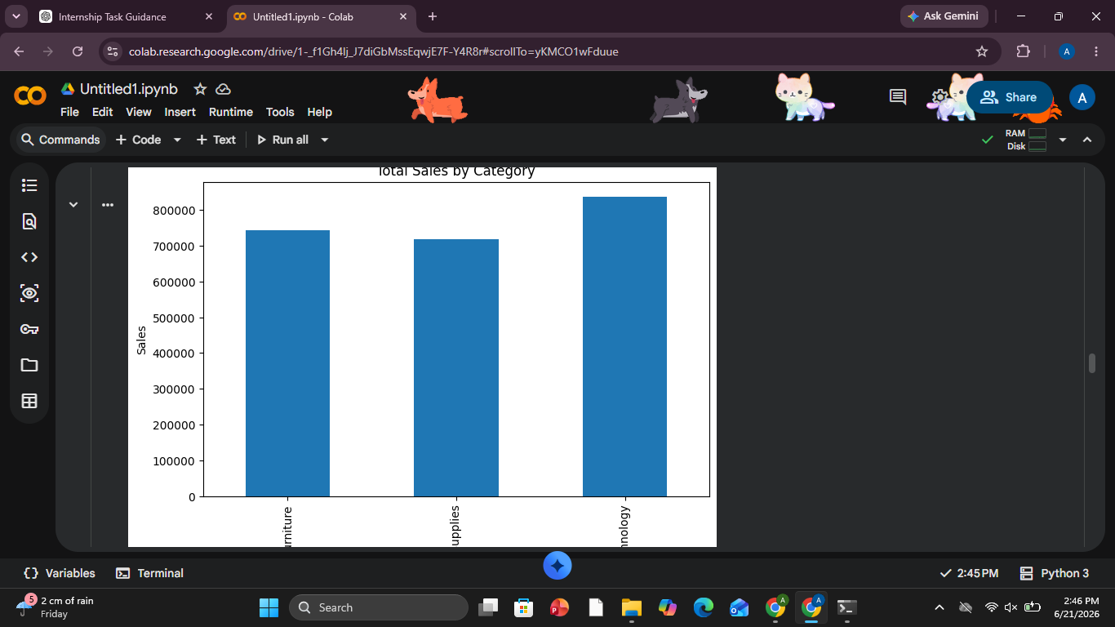
Observation:
Technology generated the highest sales, followed by Furniture and Office Supplies.

5.3 Profit by Region
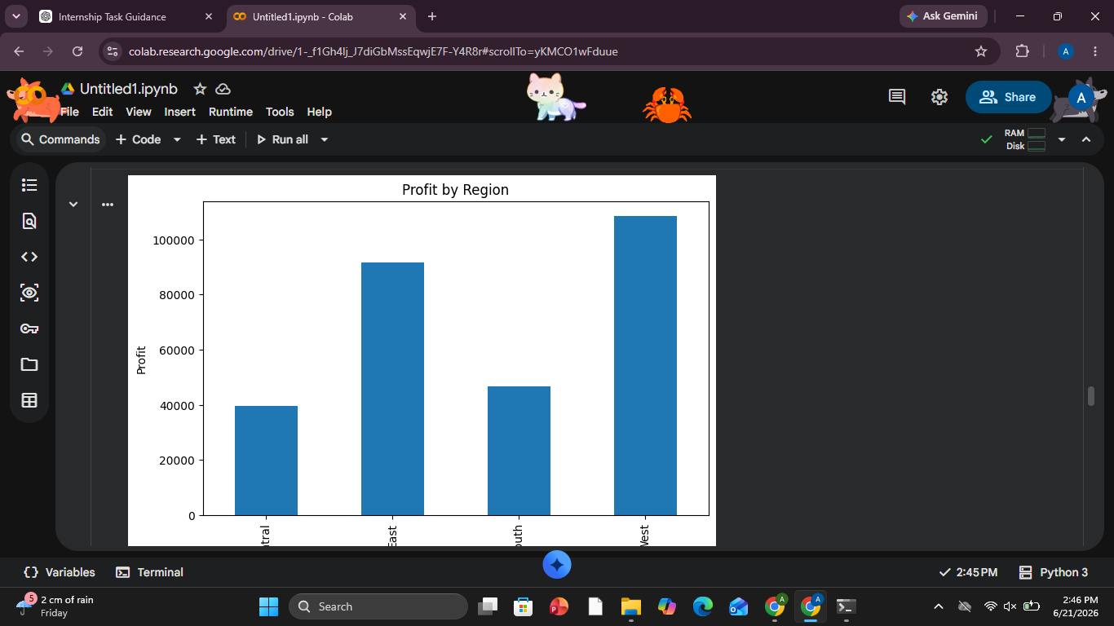
Observation:
The West region generated the highest profit, while the Central region generated the lowest profit.

5.4 Top 10 Products by Sales
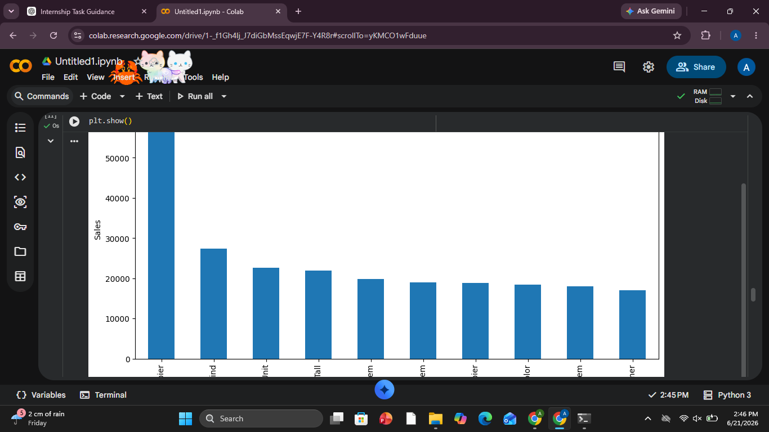
Observation:
A small number of products contribute significantly to total revenue.

5.5 Sales vs Profit Analysis
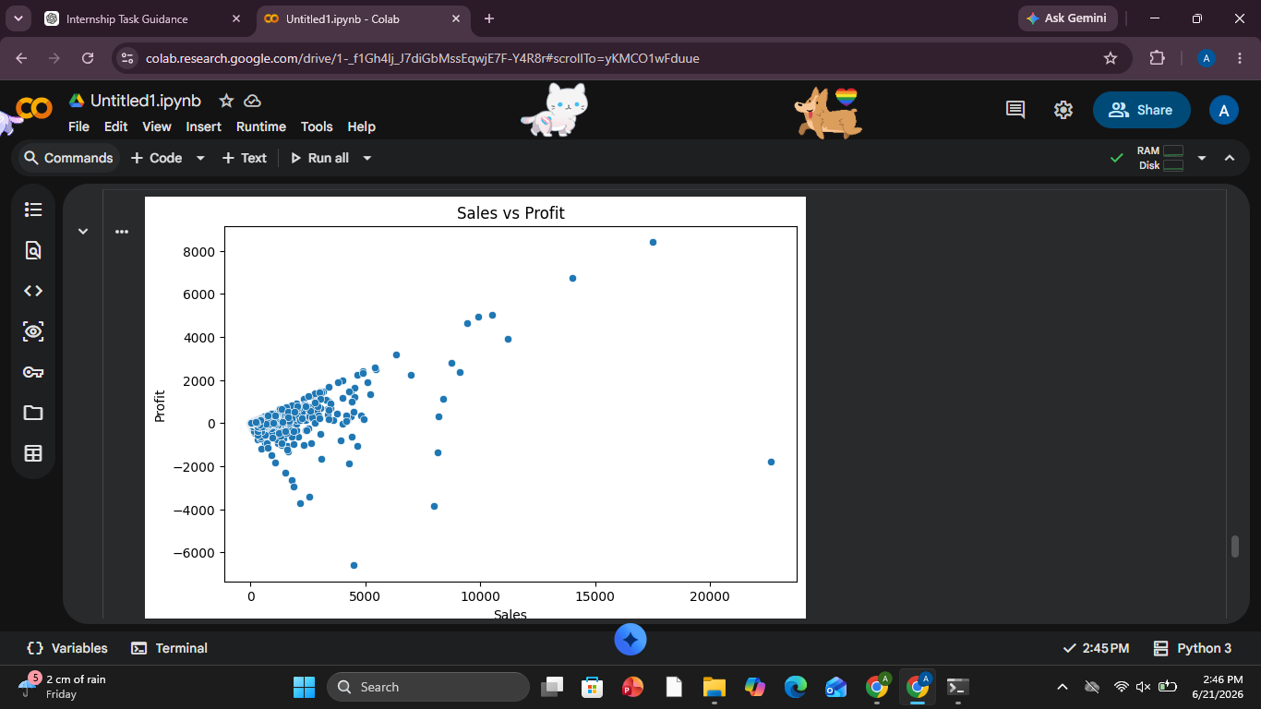
Observation:
Sales and Profit show a positive relationship, although some high-sales transactions result in losses.

5.6 Correlation Heatmap
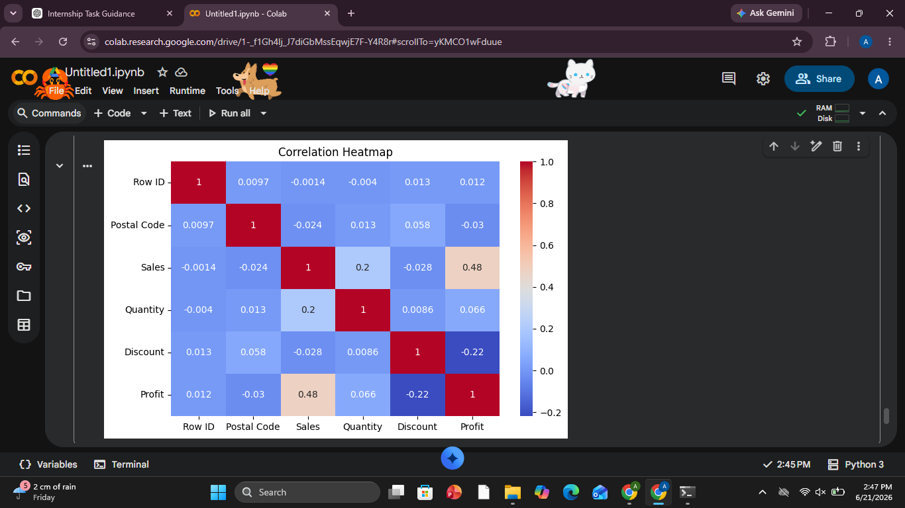
Observation:
- Sales and Profit correlation = 0.48
- Discount and Profit correlation = -0.22
This indicates that increasing discounts negatively affects profitability.

6. Business Insights
- Technology is the highest revenue-generating category.
- West region contributes the highest profit.
- Discounts negatively impact profits.
- Few products generate a large share of total sales.
- Higher sales generally lead to higher profits.

7. KPI Summary
KPI | Value
Total Sales | 2,297,200.86
Total Profit | 286,397.02
Total Orders | 5009
Average Order Value | 229.86

8. SQL Queries Used

Top Products by Sales
SELECT [Product Name],
SUM(Sales) AS Total_Sales
FROM Superstore
GROUP BY [Product Name]
ORDER BY Total_Sales DESC
LIMIT 10;

Profit by Region
SELECT Region,
SUM(Profit) AS Total_Profit
FROM Superstore
GROUP BY Region
ORDER BY Total_Profit DESC;

Sales by Category
SELECT Category,
SUM(Sales) AS Total_Sales
FROM Superstore
GROUP BY Category
ORDER BY Total_Sales DESC;

9. Dashboard Mockup
KPIs Included:
- Total Sales: 2.29M
- Total Profit: 286.4K
- Total Orders:5009
- Average Order Value:229.86
Visualizations Included:
- Sales by Category
- Profit by Region
- Top Products
- Sales vs Profit
- Correlation Heatmap

10. Conclusion
The analysis successfully identified key business trends and performance indicators. Technology products and the West region are major contributors to business growth. Discount strategies should be optimized to improve profitability. The findings can support data-driven decision-making and business strategy.

