**EFS (Elastic File System)**

**Create Elastic File System:**

Go to Elastic File System service

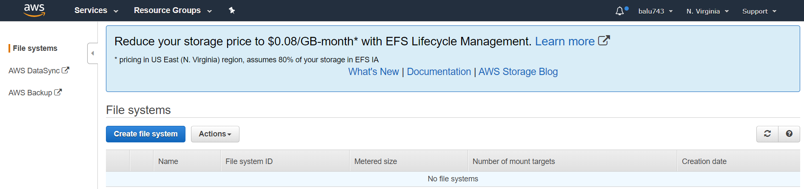

Click on **Create file system**

**Step:1**

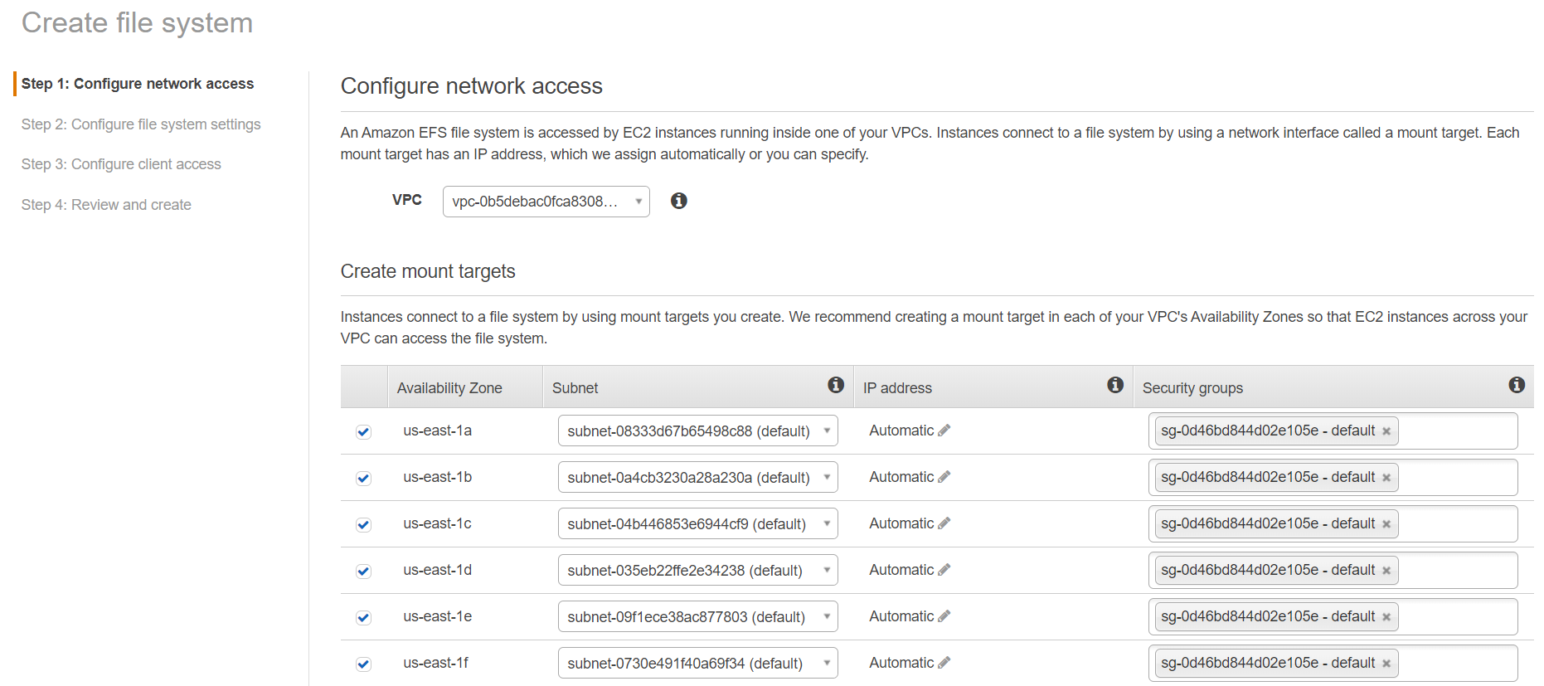

Click on **Next Step**

**Step:2**

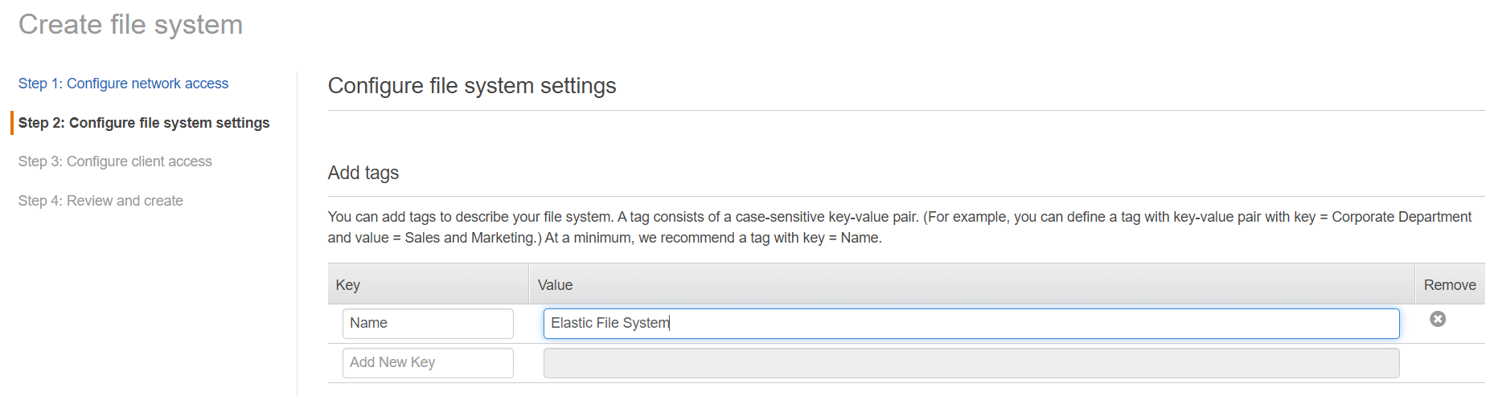

If you like you can add tags

Remaining things keep default and click on **Next Step**

**Step:3**

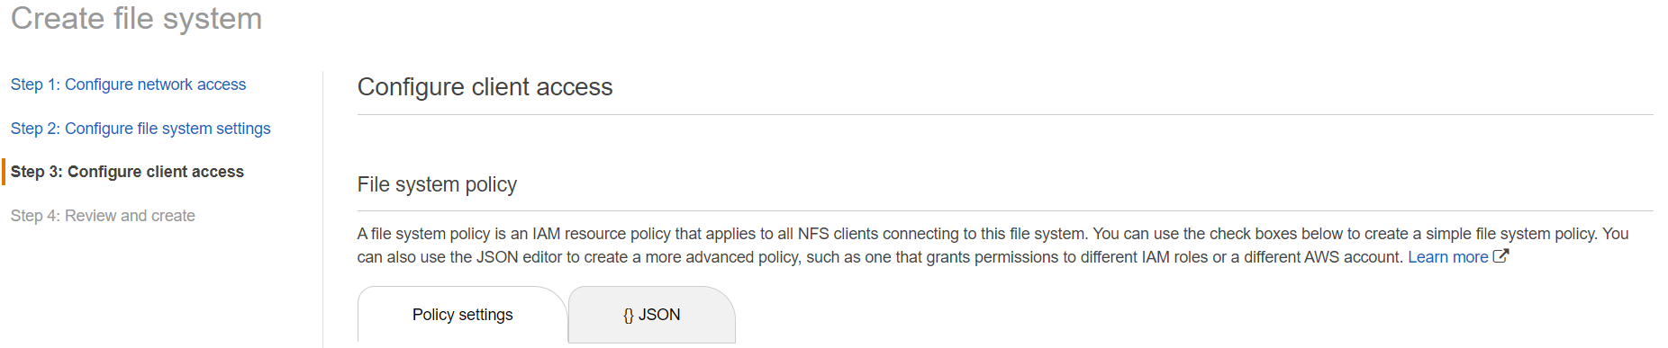

Keep Default and Click on **Next Step**

**Step:4**

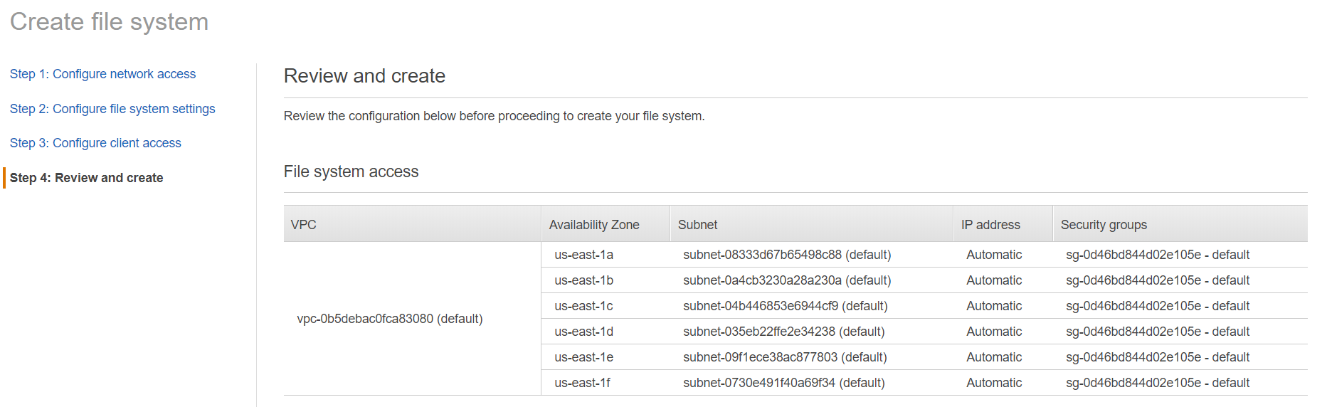

Click on Create **File System**

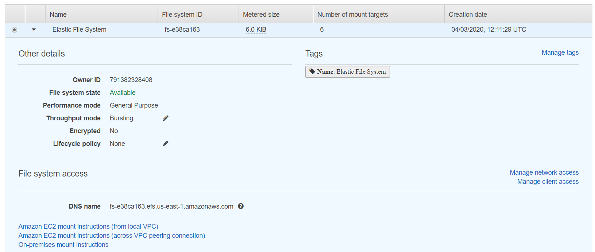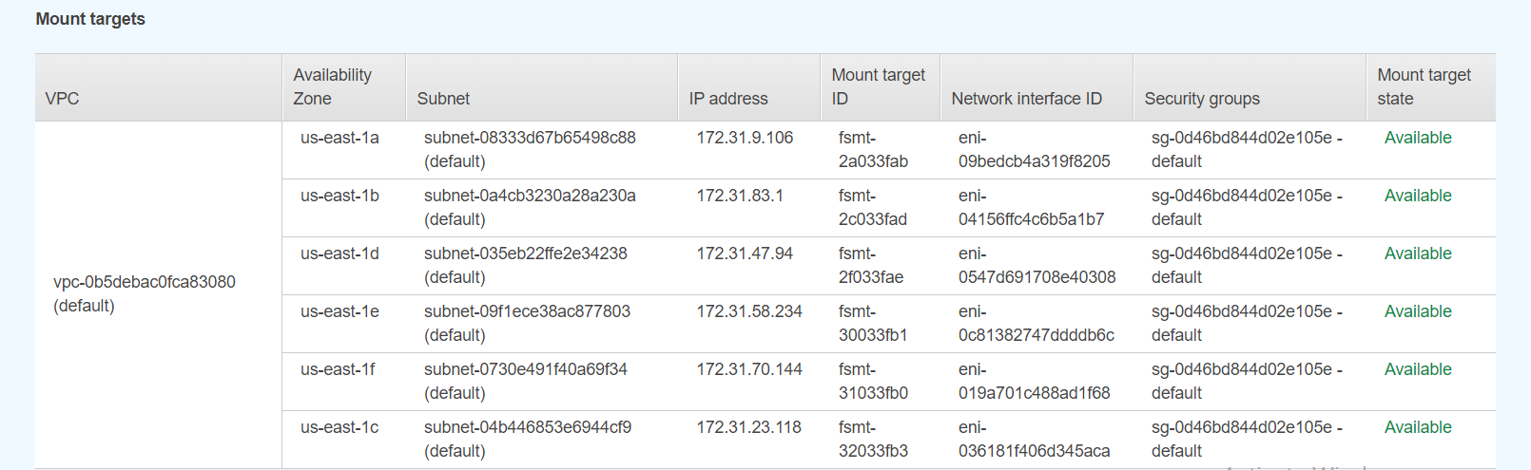

**Create two EC2 Instances:**

Go to EC2 Service



Click on **Launch Instance**

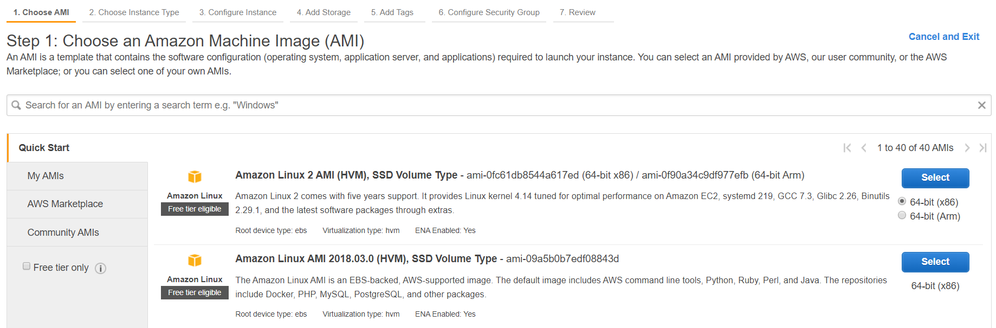

Here I taken Amazon Linux Instance

Click on Select

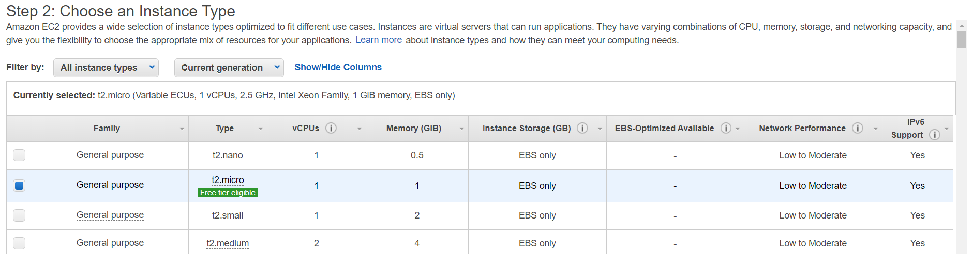

Click on **Next**

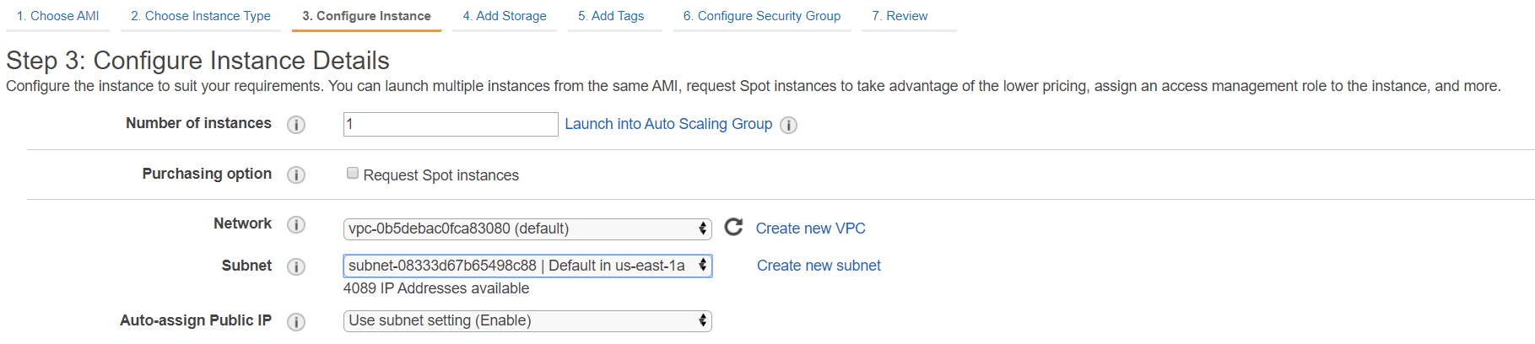

Select Availability Zone as **us-east-1** and click on **Next**

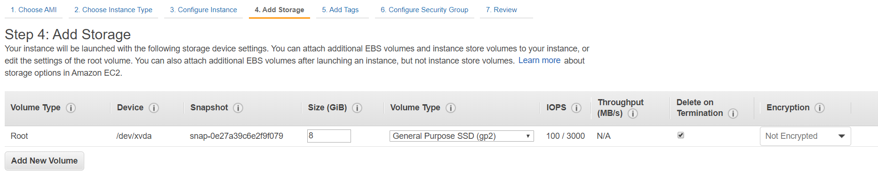

Click on **Next**

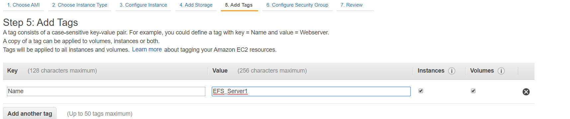

Click on **Next**

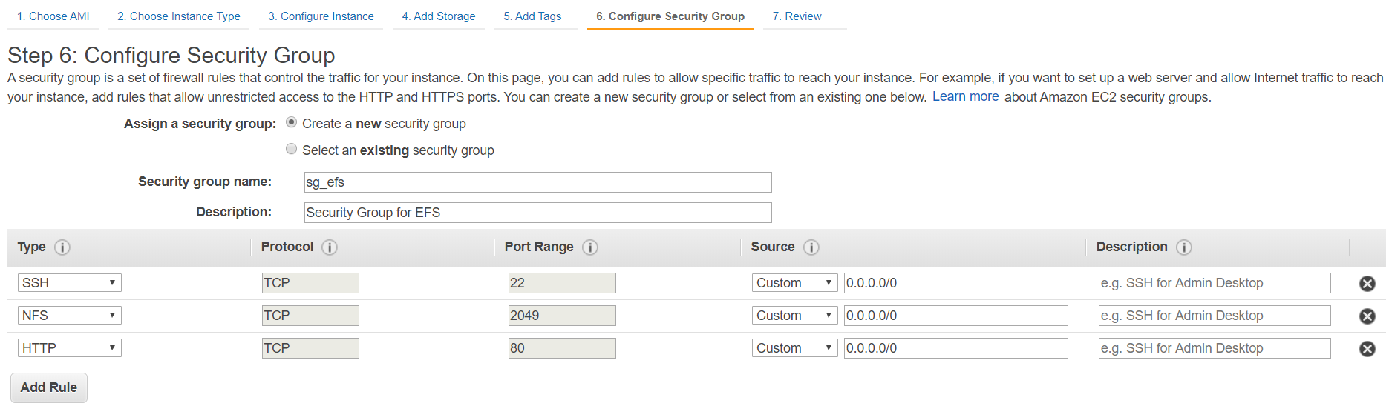

Create new security group with these port numbers and Click on **Review and Launch**

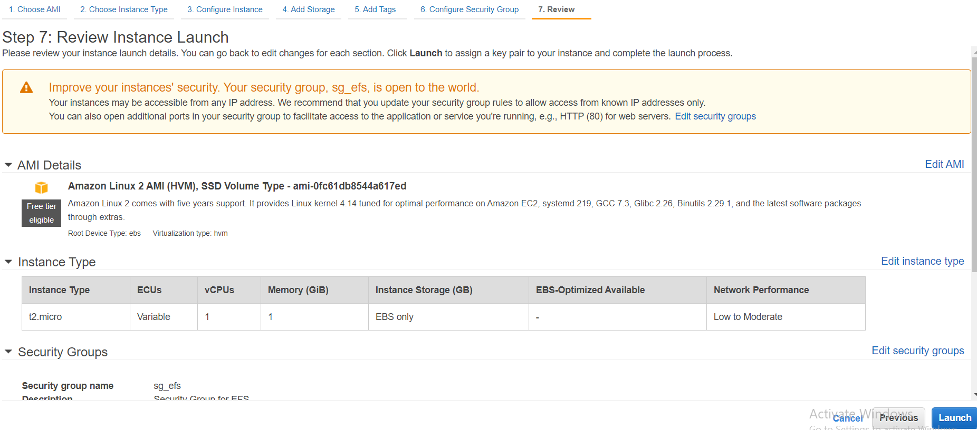

Click on **Launch**

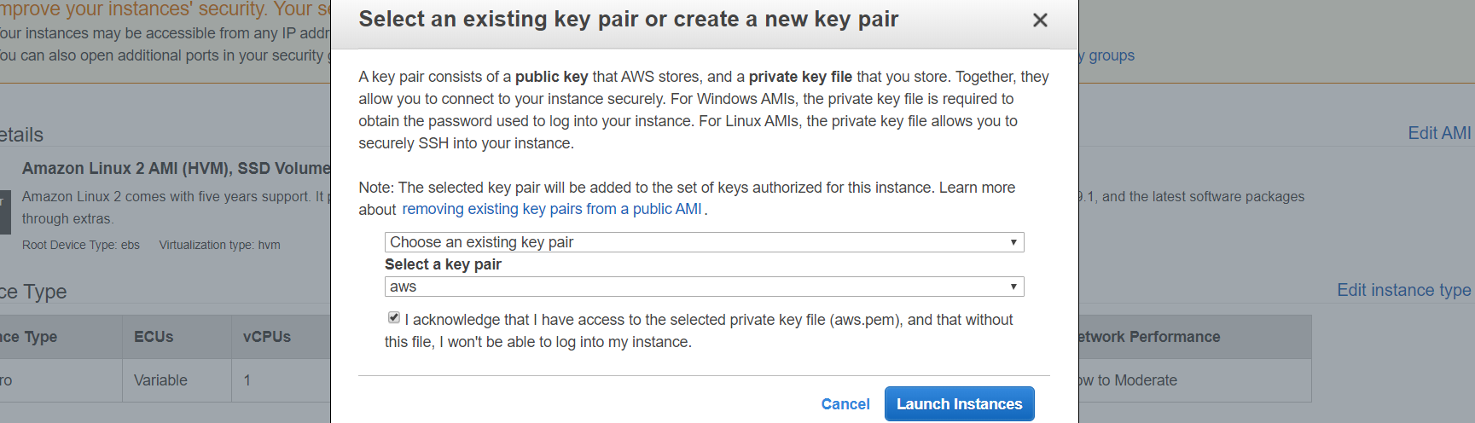

Select Key Pair and Click on **Launch Instances**

Also Create another Instance with another **Availability Zone** (us-east-1b)

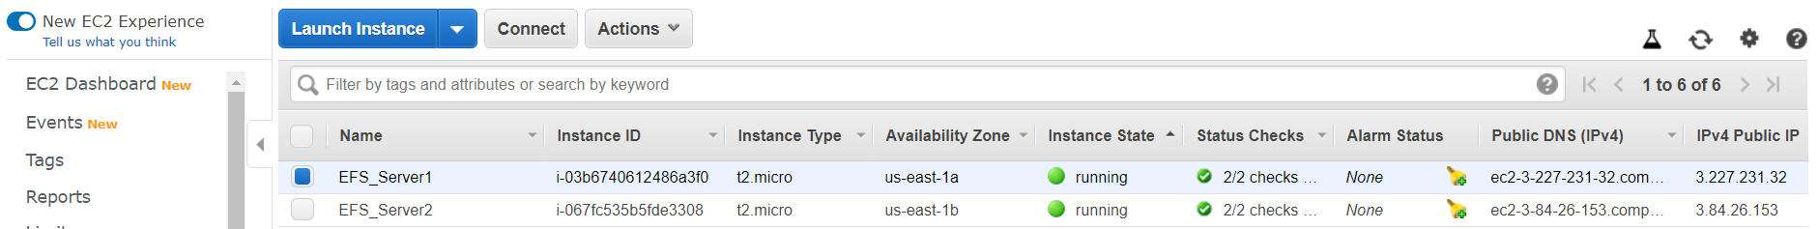

Attach Security group to both the EC2 instances which we given while creating EFS

Go to EC2 sever



Click on **Actions**

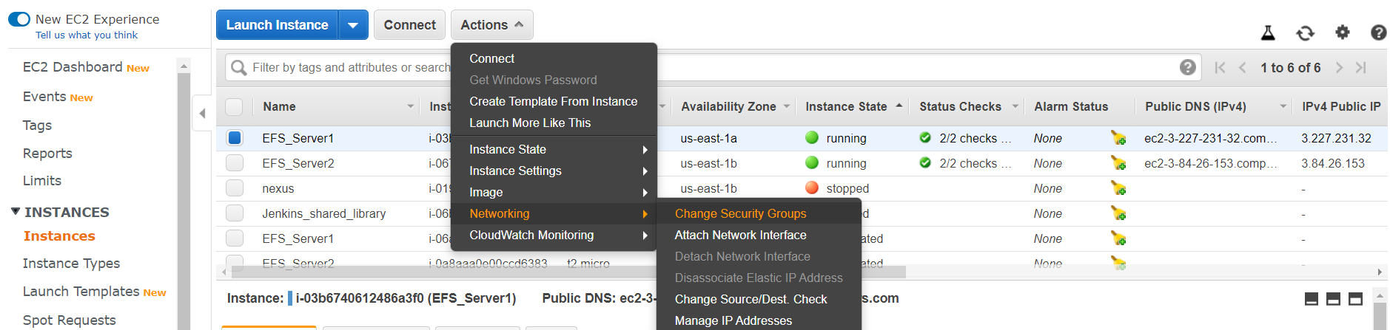

Click on **Networking** and then click on **Change Security Groups**

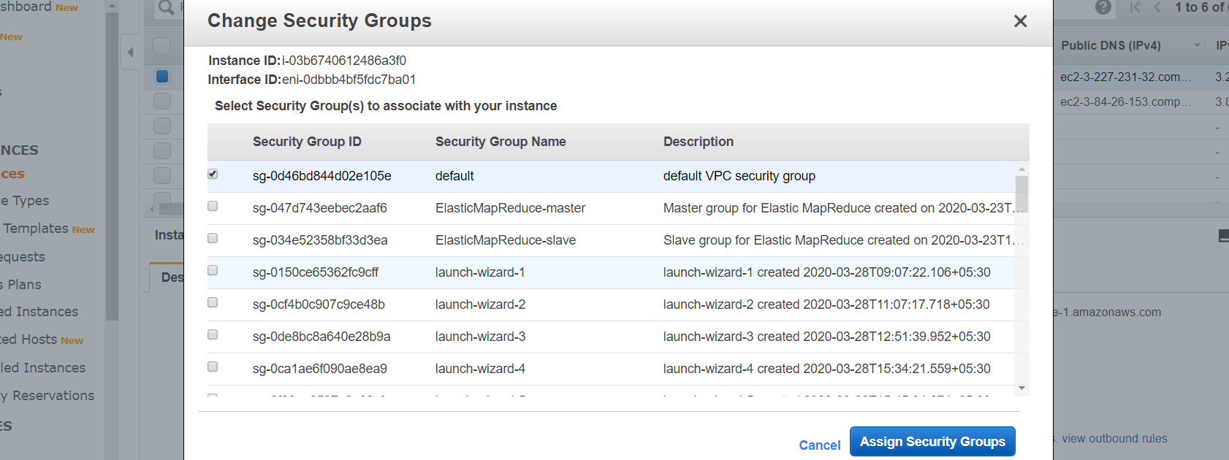

Select Security group and click on **Assign Security Groups**

Now Connect to these two servers using **mobaXterm**:

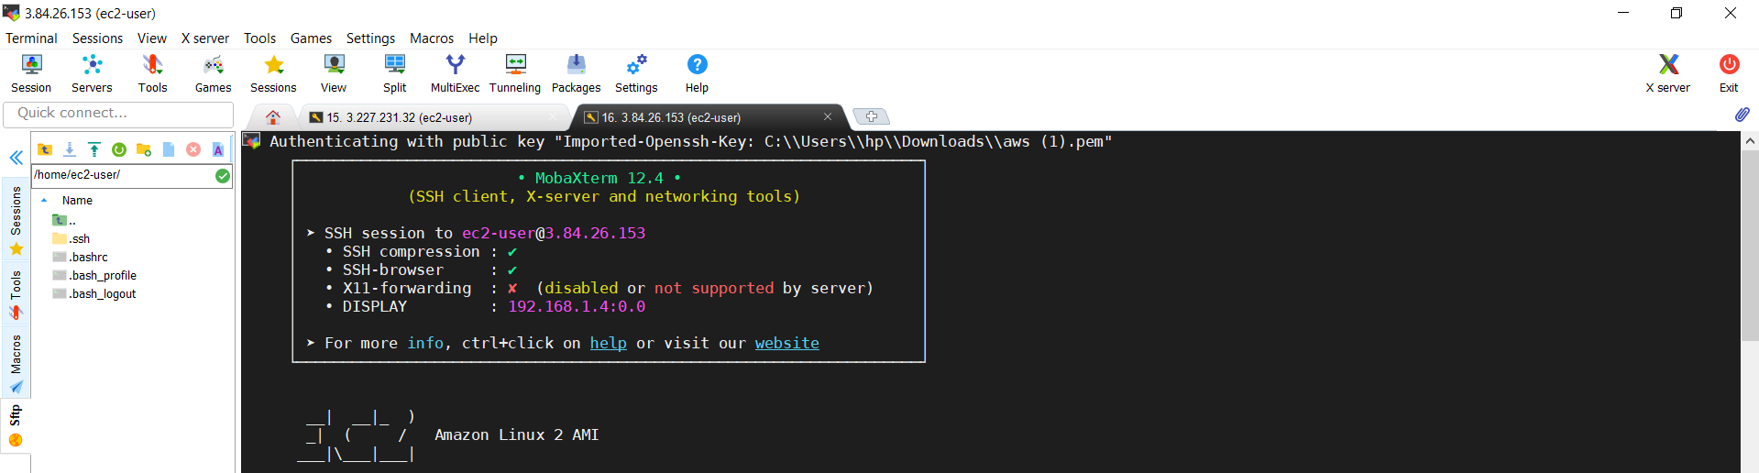

Connect to **root** user and Install **httpd** on both the server

yum install httpd -y

Start **httpd** service

service httpd start

Go to EFS Service

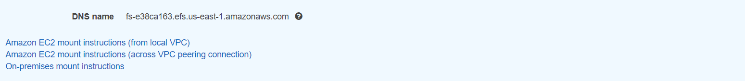

Click on **Amazon EC2 mount instructions (from local VPC)**

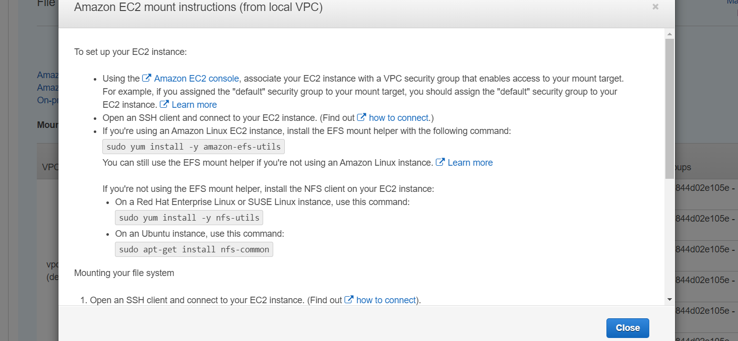

Here they given how to install efs-utils in our ec2-instances

Install the EFS mount helper on both the servers with the following command

yum install -y amazon-efs-utils

Mount your file system with a method listed following. If you need encryption of data in transit, use the EFS mount helper and the TLS mount option. (Run this command on both the servers)

sudo mount -t nfs4 -o nfsvers=4.1,rsize=1048576,wsize=1048576,hard,timeo=600,retrans=2,noresvport fs-e38ca163.efs.us-east-1.amazonaws.com:/ /var/www/html

Now create file **index.html** in one server and check in another server

cd /var/www/html/

vi index.html

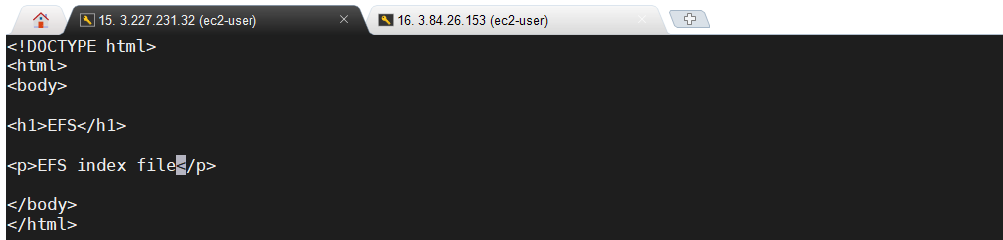

Check file in this Server



Same file check in another server

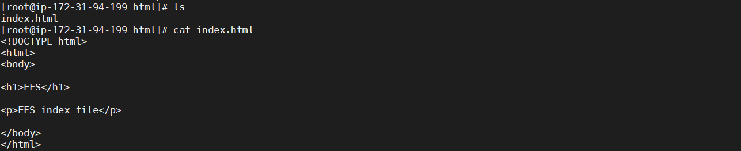

Check in webUI using IP addresses:

**Server:1**

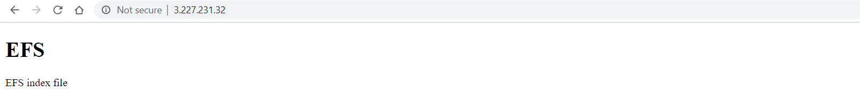**Server:2**

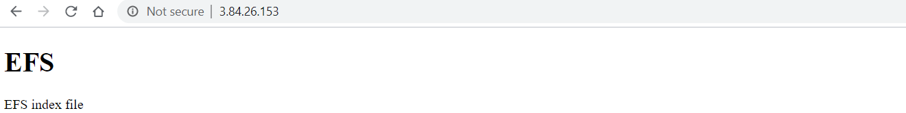

**Another Example:**

Create another file in **server1**

touch example.txt

Check in **server2**

