**GitLab Installation & Migration**

GitLab Installation:

https://linuxize.com/post/how-to-install-and-configure-gitlab-on-centos-7/

https://about.gitlab.com/install/#centos-7

EXTERNAL_URL="http://43.205.104.172" yum install -y gitlab-ce-11.7.3-ce.0.el7

https://www.howtoforge.com/tutorial/how-to-install-and-configure-gitlab-ce-on-centos-7

**Downgrade GitLab:**

https://docs.gitlab.com/ee/update/package/downgrade.html

**GitLab Restoration:**

* Backup Creation

gitlab-rake gitlab:backup:create

* From Source Server:

# cd /var/opt/gitlab/backups

# mv 1694281441_2023_09_09_11.7.3_gitlab_backup.tar /home/systems/

# cd /home/systems/

# ls -ltr

# chown systems:systems 1694281441_2023_09_09_11.7.3_gitlab_backup.tar

* From Destination Server:

# rsync -ravP systems@54.151.250.19:/home/systems/1694281441_2023_09_09_11.7.3_gitlab_backup.tar /home/rati

# mv 1694281441_2023_09_09_11.7.3_gitlab_backup.tar /var/opt/gitlab/backups/

# cd /var/opt/gitlab/backups/

# chown git:git 1694281441_2023_09_09_11.7.3_gitlab_backup.tar

**Note:**

Warning: Your **gitlab.rb** and **gitlab-secrets.json** files contain sensitive data

and are not included in this backup. You will need these files to restore a backup.

Please back them up manually.

-----------------------------------------------

***************************************************

Put backup into below directory;

/var/opt/gitlab/backups

chmod 600 1693299366_2023_08_29_11.7.3_gitlab_backup.tar

cd /var/opt/gitlab/backups

gitlab-rake gitlab:backup:restore BACKUP=

gitlab-ctl restart

gitlab-rake gitlab:check SANITIZE=true

***************************************************

**Upgrade GitLab:**

https://docs.gitlab.com/ee/update/#linux-packages-omnibus-gitlab

gitlab-ctl stop unicorn

gitlab-ctl stop puma

gitlab-ctl stop sidekiq

yum --showduplicates list gitlab-ce

yum install gitlab-ce-11.11.8-ce.0.el7

yum install gitlab-ce-12.0.12-ce.0.el7

yum install gitlab-ce-12.10.14-ce.0.el7

yum install gitlab-ce-13.0.14-ce.0.el7

yum install gitlab-ce-13.12.15-ce.0.el7

yum install gitlab-ce-14.0.12-ce.0.el7

# touch /etc/gitlab/skip-unmigrated-data-check

yum install gitlab-ce-14.1.8-ce.0.el7

yum install gitlab-ce-14.3.6-ce.0.el7

# gitlab-ctl restart redis

# gitlab-ctl reconfigure

yum install gitlab-ce-14.6.2-ce.0.el7

yum install gitlab-ce-14.10.5-ce.0.el7

yum install gitlab-ce-15.0.5-ce.0.el7

yum install gitlab-ce-15.11.13-ce.0.el7

yum install gitlab-ce-16.0.8-ce.0.el7

yum install gitlab-ce-16.2.3-ce.0.el7

yum install gitlab-ce-16.3.2-ce.0.el7

yum install gitlab-ce-16.6.2-ce.0.el7

yum install gitlab-ce-16.7.0-ce.0.el7 ……..

gitlab-ctl status

gitlab-ctl start puma

gitlab-ctl start sidekiq

gitlab-ctl start unicorn

gitlab-ctl status

* To check GitLab Version in CLI;

gitlab-rake gitlab:env:info

**Troubleshooting:**

14.0.11 -> 14.1.8 -> 14.3.6 -> 14.6.2 -> 14.9.5 -> 14.10.5 -> 15.0.2 -> 15.1.0 -> 15.4.6 -> 15.9.1 -> 15.10.0

**DNS Configuration:**

* Change IP to Domain in below file;

vim /etc/gitlab/gitlab.rb

* Then reconfigure GitLab using below command;

gitlab-ctl reconfigure

**SSL Certificate Configuration:**

https://middlewaretechnologies.in/2022/07/how-to-secure-a-gitlab-server-using-self-signed-certificate.html

https://computingforgeeks.com/how-to-secure-gitlab-server-with-ssl-certificate/?expand_article=1

* Edit the external_url in /etc/gitlab/gitlab.rb

# cat /etc/gitlab/gitlab.rb | grep external_url

* Create the /etc/gitlab/ssl directory and copy your key and certificate

# mkdir -p /etc/gitlab/ssl

# chmod 755 /etc/gitlab/ssl

# cd /etc/gitlab/ssl/

# cp gitlab.ninestars.in.key gitlab.ninestars.in.crt /etc/gitlab/ssl/

# chmod 600 *

# vim /etc/gitlab/gitlab.rb

nginx['redirect_http_to_https'] = true

nginx['redirect_http_to_https_port'] = 80

-------------------------------------------------------------------------------------------------

nginx['enable'] = true

nginx['client_max_body_size'] = '250m'

nginx['redirect_http_to_https'] = true

nginx['ssl_certificate'] = "/etc/gitlab/ssl/gitlab.ninestars.in.crt"

nginx['ssl_certificate_key'] = "/etc/gitlab/ssl/gitlab.ninestars.in.key"

* Reconfigure Gitlab

# gitlab-ctl reconfigure

* Validate the Gitlab SSL setup

# openssl s_client -connect gitlab.ninestars.in:443

|  |  |  |
| --- | --- | --- |
| **Check Points** |  |  |
| 1 |  | Repo Skipped in DB Creation |

ami-06df2c3487c0199d0 (test_gitlab1_010823)

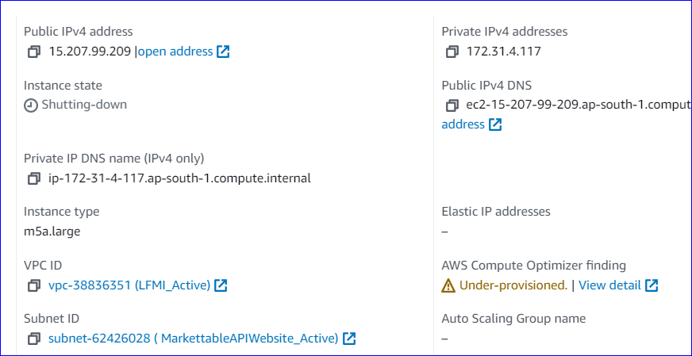

**Note:**

* Don't put 'Y' for automatic installation.

* Should execute "gitlab-ctl restart" after every version upgraded.

* Should not execute "sudo gitlab-ctl pg-upgrade".

* Port 22, 80 & 41999 has been blocked for public access.

* For every version upgradation, backup will create with same version.

* If upgradation failed and GitLab UI is not working as expected then uninstall GitLab current version and install previous version and restore GitLab backup.

* There will be no change in GitLab configuration file, still we should take extra backup in some other place.

-----------------------------------------------------------------------

**Notes:**

yum update -y

gitlab-ctl restart

gitlab-ctl reconfigure

2023-12-18 09:44:49 UTC -- Warning: Your gitlab.rb and gitlab-secrets.json files contain sensitive data

and are not included in this backup. You will need these files to restore a backup.

Please back them up manually.

*********************************************

> yum install gitlab-ce-15.11.13-ce.0.el7

RuntimeError: gitlab_rails['smtp_tls'] and **gitlab_rails['smtp_enable_starttls_auto']** are mutually exclusive.

Set one of them to false. SMTP providers usually use port 465 for TLS and port 587 for STARTTLS

> vim /etc/gitlab/gitlab.rb

gitlab_rails['smtp_enable_starttls_auto'] = false

> gitlab-ctl reconfigure

> Still same version is not installed, then follow below;

> sudo gitlab-ctl pg-upgrade -V 13

==== Upgrade has completed ====

Please verify everything is working and run the following if so

sudo rm -rf /var/opt/gitlab/postgresql/data.12

sudo rm -f /var/opt/gitlab/postgresql-version.old

---------------------------------------------------------------------------