**AWS WAF PRICING**

## AWS WAF Pricing (Ohio)

**Web ACL**: $5 per Web ACL/month

**Managed Rule Group**: $1 per rule group/month

**Request inspection**: $0.60 per 1 million requests (i.e., $0.0000006 per request)

**Additional WCU usage** (beyond 1,500 WCUs): $0.20 per million requests

**Example**: One Web ACL + one managed rule group inspecting 100 million requests/month:

Web ACL: $5

Rule group: $1

Requests: 100 × $0.60 = **$60**

Total WAF cost ≈ **$66/month**

## AWS ALB Pricing (Ohio)

ALB billing consists of:

**Fixed hourly cost**: $0.0225/hour (~$16.43/month)

**Load Balancer Capacity Unit (LCU)**: $0.0082 per LCU-hour

**Data processed by ALB**: $0.008 per GB

**Example estimate** (moderate traffic):

100 GB data/month → ~0.14 GB/hour → ~0.14 LCU (bytes dimension)

LCU cost: 0.14 × $0.0082 × 730 hrs ≈ **$0.84/month**

Base cost: $16.43

Data charge: 100 × $0.008 = **$0.80**

**Total ALB cost ≈ $18.07/month  
  
******* TOTAL ALB + WAF COST = $84/MONTH \*\*\*\*\*\*\*\*\*\***

**URL : https://aws.amazon.com/waf/pricing/?**

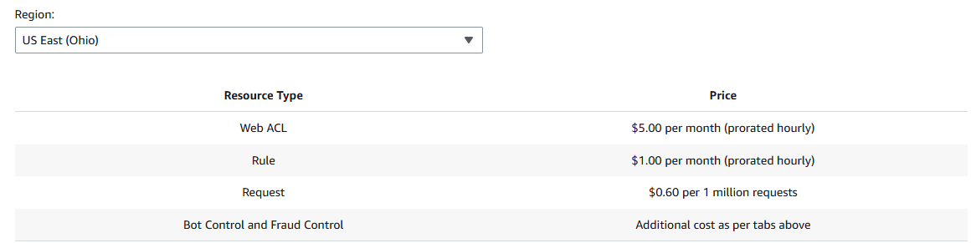

**URL : https://aws.amazon.com/elasticloadbalancing/pricing/?**

