**CHATBOT Plugin For Wordpress**

**Prepared by**

Patel Krupa (16IT078)

**Under the supervision of**

Prof. Hemant Yadav

A Report Submitted to

Charotar University of Science and Technology

for Partial Fulfillment of the Requirements for the

Degree of Bachelor of Technology

in Information Technology

IT345 Software Group Project-II (5th sem)

**Submitted at**



**DEPARTMENT OF INFORMATION TECHNOLOGY**

**Chandubhai S. Patel Institute of Technology**

**At: Changa, Dist: Anand – 388421**

**Nov-Dec 2018**



**CERTIFICATE**

This is to certify that the report entitled “CHARUSAT E-Notice Board” is a bonafied work carried out by **Krupa Patel (16IT078)** under the guidance and supervision of **Prof. Hemant Yadav** for the subject **Software Group Project-III(IT345)** of **5th** Semester of Bachelor of Technology in **Information Technology** at Faculty of Technology & Engineering – CHARUSAT, Gujarat.

To the best of my knowledge and belief, this work embodies the work of candidate herself, has duly been completed, and fulfills the requirement of the ordinance relating to the B.Tech. Degree of the University and is up to the standard in respect of content, presentation and language for being referred to the examiner.

|  |
| --- |
| Under supervision of,  Prof. Hemant Yadav  Assistant Professor  Dept. of Information Technology  CSPIT, Changa, Gujarat. |
| Prof. Parth Shah  Head & Associate Professor  Department of Information Technology  CSPIT, Changa, Gujarat. |

**Chandubhai S Patel Institute of Technology**

At: Changa, Ta. Petlad, Dist. Anand, PIN: 388 421. Gujarat

**ACKNOWLEDGEMENT**

We have found this rare opportunity to evince a word of thanks to all those who played a key role in the successful completion of our project .We sincerely thank our Head of Department Dr**. Parth Shah** Sir for giving the chance as well as support for all the time being. And his able guidance and continuous encouragement made us work in all the challenges during project development .We express deep gratitude to **Hemant Yadav Sir** internal project guide from Faculty of Engineering, CHARUSAT for their valuable suggestions, help and moral support. We also thank to all those who could not find a separate name but have helped directly and indirectly.

Patel Krupa

(16IT078)

**ABSTRACT**

This project is about chatbot for Charusat E-Notice Board. The purpose to developing this project is to learn how to make plugin for wordpress. This project is used the services provided by chatbot engine. This is the plugin for wordpress which will add chatbot to the website of Charusat E-notice Board.

**TABLE OF CONTENTS:**

1. Introduction 05

1.1 Project Overview 05

* 1. Objective 05

1. System Analysis 06

2.1 User Characteristics 06

2.2 Programming Language 06

2.3 Wordpress 06

2.3.1 What is wordpress plugin? 06

2.3.2 Why plugin is required? 07

2.3.3 Chatbot plugin 07

2.3.4 How wordpress plugins work? 07

1. Snapshots 09
2. Implementation 11
3. Constraints And Future Enhancement 12
4. Conclusion 13
5. References 14

LIST OF FIGURES

* Figure 2.1 About activate and deactivate plugin 07
* Figure 2.2 Add shortcode 08
* Figure 3.1 Home Page 09
* Figure 3.2 Initial chatbot page 09
* Figure 3.3 Chatbot 10
* Figure 3.4 Chatbot 10
* Figure 4.1 Structure to interact with services 10

1. **INTRODUCTION**
   1. **Project Overview:**

Students in colleges and universities like to be remain informed of what new events, schedules, competitions etc. are happening in their college or university. Students had to physically go to a notice board in their college/university and get their desired information. I, as a student, personally felt this problem. I saw an opportunity to devise a solution to this problem.

Building a complete software system for the CHARUSAT University is the solution. It involves various software components like web app deployed to the local CHARUSAT internet, a REST API deployed on the same local internet, an Android app which displays notices using the REST API and also integrates IBM Watson chatbot where users can push their queries and it will give the desired response back to the user. Moreover, there are Wordpress plugins which will be deployed to the main CHARUSAT website where users can view the notices or live updates provided in the system.

**1.2 Objective:**

The main purpose to choose this project was to gain knowledge about how to make plugin for wordpress along with its practical implementation and how to deal with real time application. The entire plugin is based on php, HTML, JavaScript, CSS, jQuery. And the other purpose is that I want to contribute something for university.

1. SYSTEM ANALYSIS
   1. **User Characteristics:**

* Every system has their own characteristics but all gives different functionality from each other.
* User has to install this plugin to their wordpress. And then have to write shortcode on page wherever they want to display chatbot. And the shortcode is [chatbot].
  1. **Programming Language:**
* php
* JavaScript
* HTML
* CSS
* jQuery
  1. **Wordpress:**

WordPress is a [free and open-source](https://en.wikipedia.org/wiki/Free_and_open-source_software) [content management system](https://en.wikipedia.org/wiki/Content_management_system) (CMS) based on [PHP](https://en.wikipedia.org/wiki/PHP) and [MySQL](https://en.wikipedia.org/wiki/MySQL). Features include a [plugin architecture](https://en.wikipedia.org/wiki/Plug-in_(computing)) and a [template system](https://en.wikipedia.org/wiki/Web_template_system). It is most associated with [blogging](https://en.wikipedia.org/wiki/Blog), but supports other types of web content including more traditional [mailing lists](https://en.wikipedia.org/wiki/Electronic_mailing_list) and [forums](https://en.wikipedia.org/wiki/Internet_forum), media galleries, and online stores.

**2.3.1 What is wordpress plugin?**

WordPress plugins are apps that allow you to add new features and functionality to your WordPress website. WordPress plugins are small software apps that integrate and run on top of the WordPress software. This allows you to create almost any kind of website with WordPress (not just blogs).

**2.3.2 Why plugin is required?**

The wordpress is not giving access to change core code. So if we have to need some extra functionality so we cannot change or add code directly. So for that we have to add plugins.

* + 1. **Chatbot plugin:**

A chatbot is a computer program or service that sends automatic replies to people's messages or inquiries. Chatbots can be powered by a set of predetermined rules for delivering responses to users. They can also use artificial intelligence (AI) to learn how they should interact.

* + 1. **How Wordpress plugins work?**
* WordPress is written in a way so that other developers can add their own code into it. The WordPress plugin API offers a robust set of hooks and filters which allow developers to modify existing WordPress functionality or add new functionality.
* Each WordPress plugin installed on your site is registered in your WordPress database. You can activate and deactivate them at any time you want.

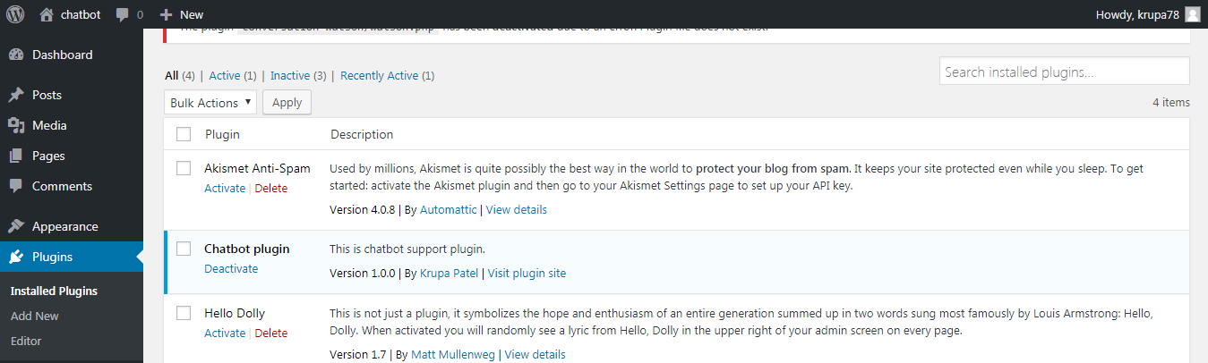

Figure 2.1 About activate and deactivate plugin

* And after installing plugin user has to write shortcode of plugin.

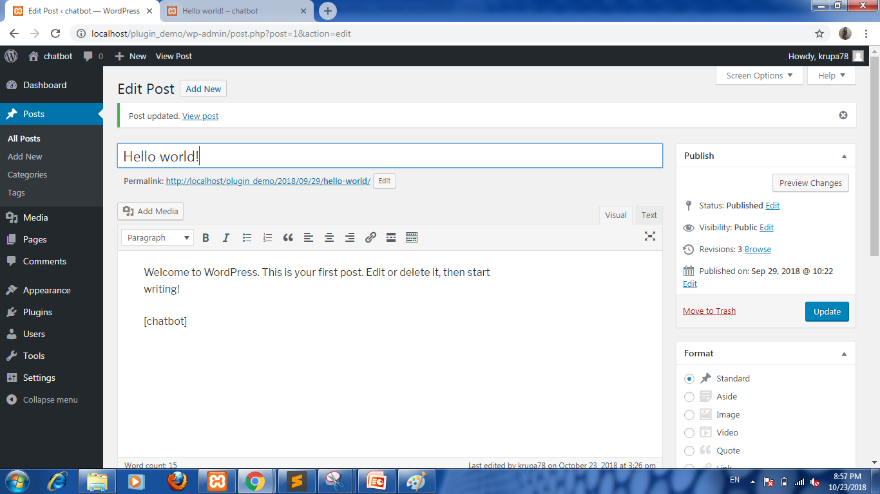

Figure 2.2 Add shortcode

1. **SNAPSHOTS**

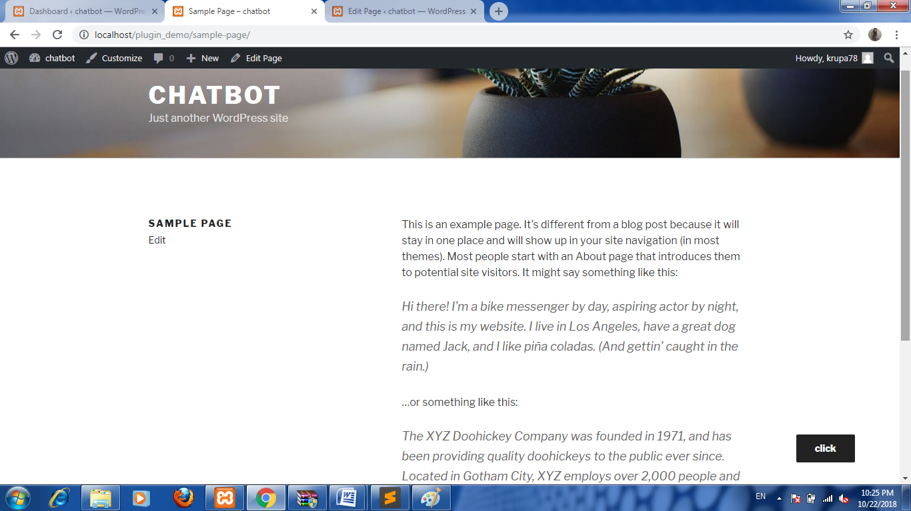

**Figure 3.1 Home Page**

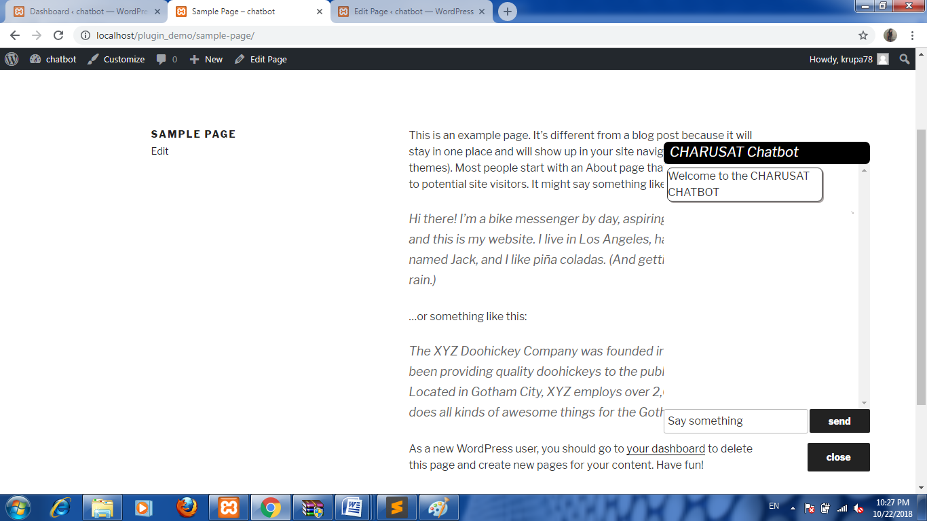

**Figure 3.2 Initial chatbot page**

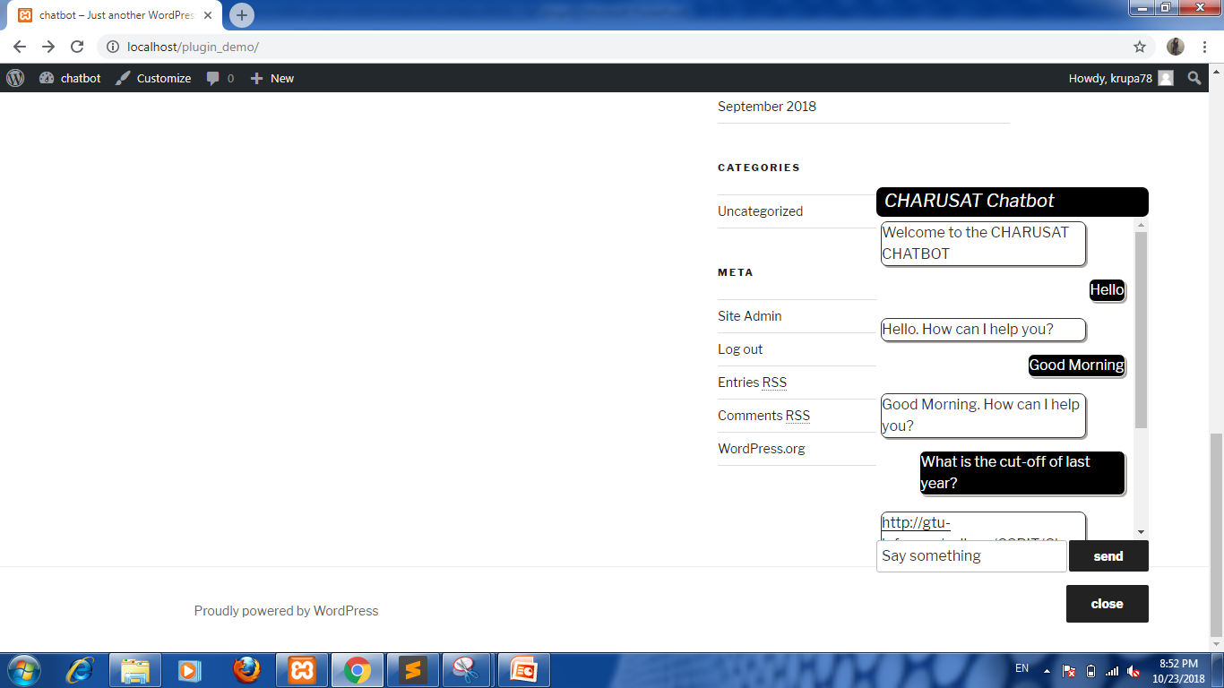

**Figure 3.3 Chatbot**

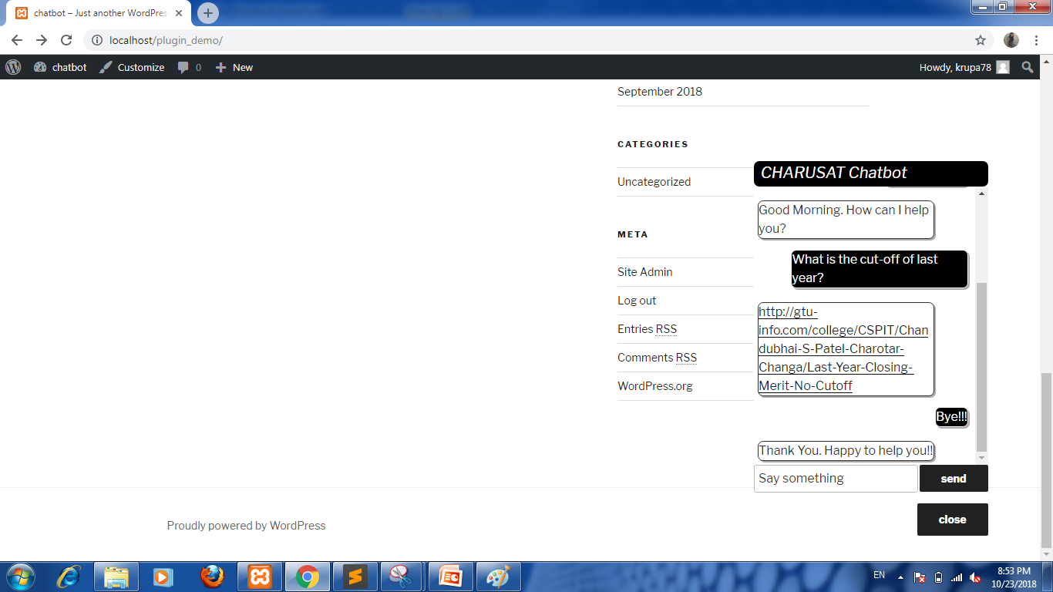

**Figure 3.4 Chatbot**

1. **IMPLEMENTATION**

* In the plugin I use IBM Watson conversation service. The bot engine is made by my one of my mates. I have to use those services for Charusat chatbot.
* But I got an error to connect it with bot API.

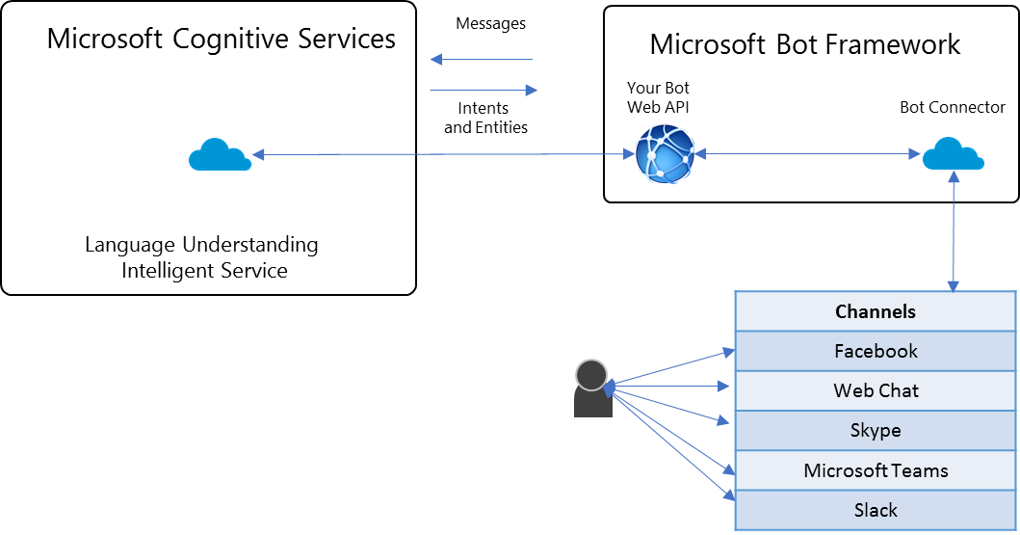

**Figure 4.1 Structure to interact with services**

1. **Constraints And Future Enhancement**

* This chatbot has static content. I got an error to connect it with Watson API.
* So the future enhancement to solve this error and deploy it on Charusat

E-notice board website.

1. **CONCLUSION**

This report leads you through the journey of how I as students learnt so many things and learn how to make plugin and developing it. To develop plugin is such a task with enthusiastic. Though I got an error in development but I learnt lot from it. Throughout the development of this project, my perspective had to be changed from a developer’s one to the user-oriented one. Thanks to Mr. Hemant Yadav and my friends, without whom this project could not be much better than its initial versions.

1. **REFERENCES**

* <https://console.bluemix.net/docs/services/CloudLogAnalysis/index.html>
* Plugin Generator - <https://wppb.me/>
* How to add shortcode - <https://www.youtube.com/watch?v=mm9aQiLEa10>
* To generate plugin - <https://wppb.me/>
* How to make plugin – <https://scotch.io/tutorials/how-to-build-a-wordpress-plugin-part-1>