HANGMAN GAME USING NODE JS

HangMan game is developed using Node js. I have used npm package Prompt to get the user prompts. I have extensively used constructors to modularize the code. I have stored the words(data) comma separated for the hangman game in data.txt. When the user runs the game, he will get a welcome display and will be shown number of “_” for word to guessed.

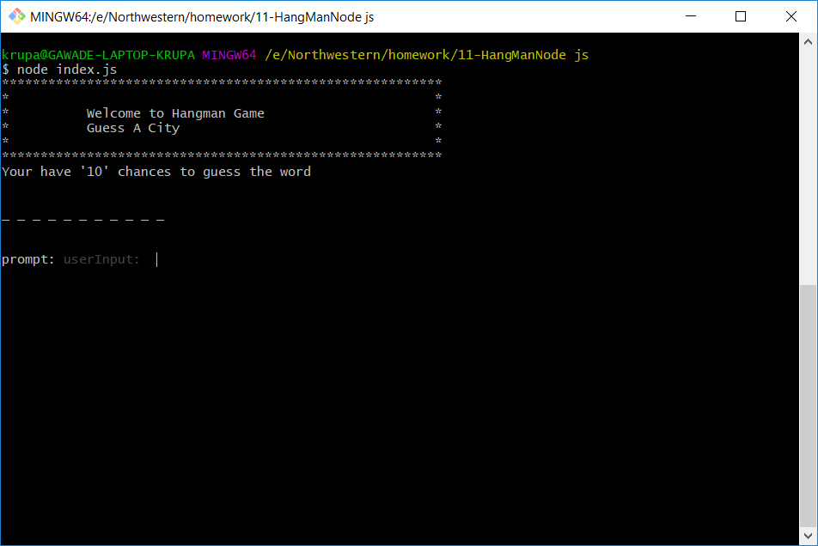

The user starts entering the characters he guess in the word. After entering 1 char, the game displays if the char matches and will be replaced by char in the word. No. of guesses will change with every guess the user makes.

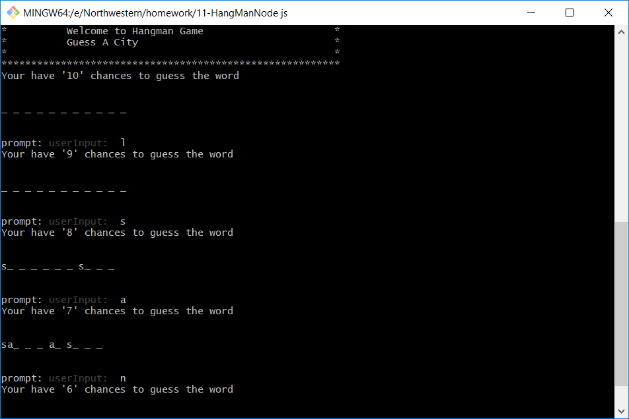

Once the user is able to guess the correct word, a message will display the count of win/loss. The random word will be displayed to the user to guess.

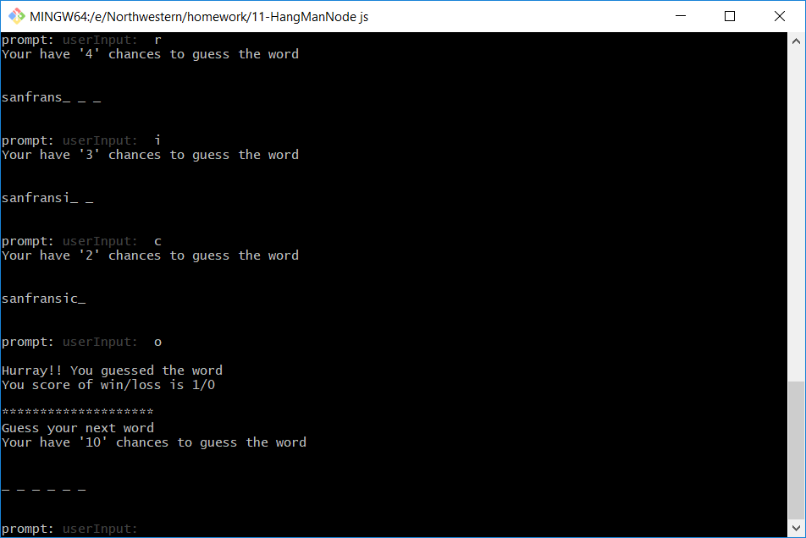

If the user is not able to guess the word and exhausts all his guesses, a message will be displayed to the user and a new word will be displayed to user to guess.

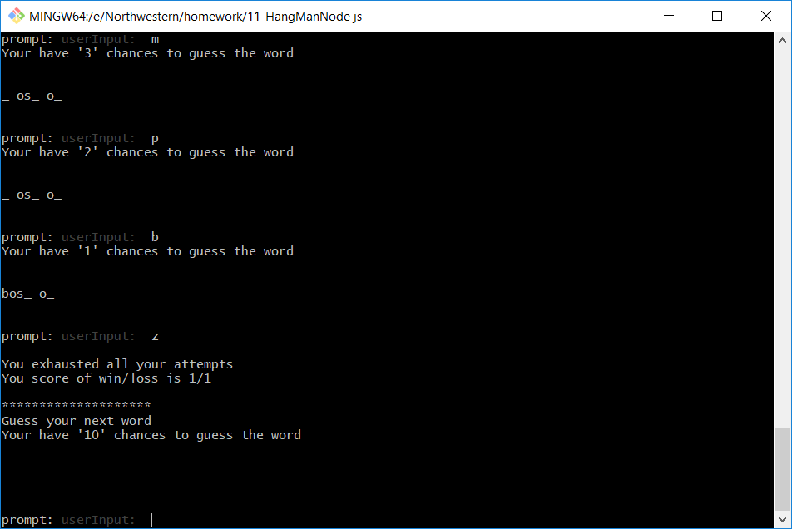

When the user guessed all the words from data file, we display the user total count of win and loss. The game is over.

