FinSight360
Banking Risk & Relationship Analytics Dashboard
A Power BI Project for Client Risk Profiling, Lending Exposure, and Deposit Analysis
Project Report
Tools Used: Power BI • MySQL • Python (Pandas, Seaborn) • DAX

1. Introduction & Problem Statement
Lending decisions in retail and commercial banking carry direct financial risk: every loan approved against an unreliable applicant profile is potential capital at risk, while every creditworthy applicant turned away is lost revenue. Banks therefore need a clear, consolidated view of who their clients are, how much they have borrowed, how much they have deposited, and how those figures break down across demographic and relationship segments.
FinSight360 was built to address exactly this need: to develop a working understanding of risk analytics in banking and financial services, and to demonstrate how client and account data can be organized and visualized to support sound lending and relationship-management decisions.

2. Project Objective & Approach
The goal of this project is to turn raw client-banking records into an interactive decision-support tool. Rather than reviewing applicant profiles one at a time, a relationship manager or risk analyst can use the dashboard to instantly see how loan exposure and deposit balances are distributed across banking relationship type, gender, nationality, income band, occupation, and client tenure — and to use that context when deciding whether an applicant is likely to be a reliable borrower.
The solution was delivered as a multi-page Power BI dashboard, backed by a MySQL data source and supported by a Python-based exploratory data analysis (EDA) pass used to validate distributions and relationships in the data before building the report.

3. About the Dataset
The underlying dataset captures banking relationship and client-level information across roughly 3,000 clients, structured as a set of interlinked tables connected through primary and foreign keys:
- Client – Banking — core client attributes (demographics, income, occupation, nationality) together with their account balances, loans, deposits, and fee structure.
- Banking Relationship — the relationship category each client is managed under (Private Bank, Retail, Commercial, Institutional).
- Gender — gender reference table joined to the client record.
- Investment Advisor — the advisor assigned to manage each client relationship.
- Period — supporting date/time reference table used for time-based analysis.

4. Data Preparation & Transformation
Before the dashboard could be built, several calculated columns were added in Power Query / DAX to make the raw fields analysis-ready:

Engagement Days
The number of days between a client's join date and the present, used as a measure of relationship tenure.
Engagement Days = DATEDIFF('Clients - Banking'[Joined Bank], TODAY(), DAY)

Engagement Timeframe
Engagement Days is bucketed into readable tenure bands so clients can be compared by how long they have banked with the institution:
Engagement Timeframe =
SWITCH(TRUE(),
[Engagement Days] < 365, "< 1 Year",
[Engagement Days] < 1825, "< 5 Years",
[Engagement Days] < 3650, "< 10 Years",
[Engagement Days] < 7300, "< 20 Years",
"> 20 Years"
)

Income Band
Estimated income is grouped into Low, Mid, and High bands so loan and deposit behavior can be segmented by income level:
Income Band =
SWITCH(TRUE(),
[Estimated Income] < 100000, "Low",
[Estimated Income] < 300000, "Mid",
"High"
)

Processing Fees
A processing fee rate is derived from each client's fee structure tier, later used to calculate total fees earned:
Processing Fees =
SWITCH([Fee Structure],
"High", 0.05,
"Mid", 0.03,
"Low", 0.01,
0
)

5. Key Measures (DAX)
The dashboard's KPI cards and visuals are powered by a set of DAX measures built on top of the cleaned tables. The core measures are summarized below.
Measure | DAX Formula
Total Clients | DISTINCTCOUNT('Clients - Banking'[Client ID])
Bank Loan | SUM('Clients - Banking'[Bank Loans])
Business Lending | SUM('Clients - Banking'[Business Lending])
Credit Cards Balance | SUM('Clients - Banking'[Credit Card Balance])
Total Loan | [Bank Loan] + [Business Lending] + [Credit Cards Balance]
Bank Deposit | SUM('Clients - Banking'[Bank Deposits])
Savings Account | SUM('Clients - Banking'[Saving Accounts])
Checking Accounts | SUM('Clients - Banking'[Checking Accounts])
Foreign Currency Account | SUM('Clients - Banking'[Foreign Currency Account])
Total Deposit | [Bank Deposit] + [Savings Account] + [Foreign Currency Account] + [Checking Accounts]
Total CC Amount | SUM('Clients - Banking'[Amount of Credit Cards])
Total Fees | SUMX('Clients - Banking', [Total Loan] * 'Clients - Banking'[Processing Fees])
Engagement Length | SUM('Clients - Banking'[Engagement Days])

6. Dashboard KPI Overview
Across the full client base, the dashboard surfaces the following headline figures:
Total Clients  3,000 | Total Loan  $1.77bn | Total Deposit  $2.01bn
Bank Loan  $1.8bn | Business Lending  $2.6bn | Total Fees  $42.0M
Total CC Amount  $9.53M | Saving Account Amount  $698.7M | Checking Account Amount  $963.3M
Foreign Currency Amount  $89.7M | Credit Cards (count)  4,391 | Bank Deposit  $2.0bn

7. Exploratory Data Analysis — Key Findings
Before finalizing the dashboard, a Python-based EDA pass (pandas, seaborn) was used to inspect distributions and relationships across the numerical account fields. The most notable finding from the correlation analysis:
- Bank Deposits show a strong positive correlation with Checking Accounts, Savings Accounts, and Foreign Currency Account balances — clients who keep a high balance in one account type tend to hold higher balances across their other account types as well, suggesting these clients can be grouped into a distinct “high-balance” relationship segment.
- Categorical fields such as Nationality, Occupation, Risk Weighting, Loyalty Classification, and Income Band were profiled individually and against each other to confirm the dashboard's segment filters (nationality, gender, income band, banking relationship) reflect meaningful, non-trivial splits in the data.

8. Dashboard Walkthrough
The report is organized into four linked pages, all sharing a common set of slicers for banking relationship type, gender, and investment advisor.

8.1 Home
The landing page introduces the dashboard and surfaces the top-line KPIs: total clients, total loan, total deposit, total fees, total credit card amount, and savings account amount, filterable by gender.
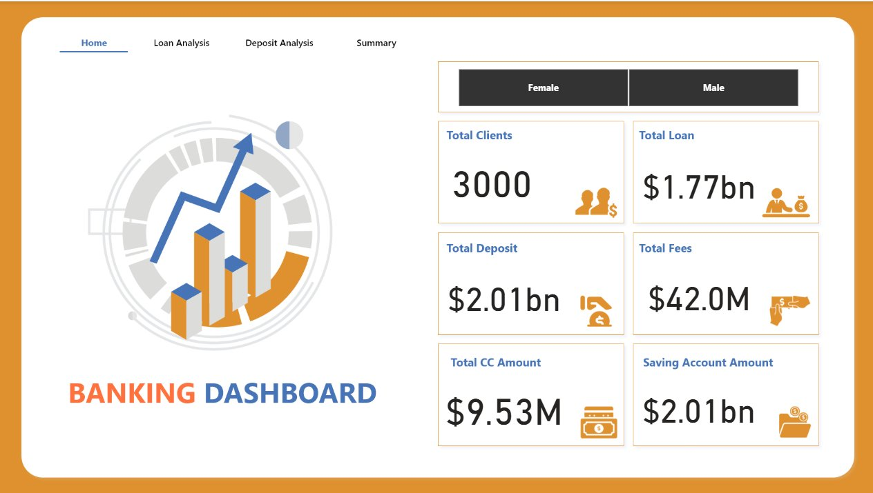
Figure 1 — Home page with headline KPIs

8.2 Loan Analysis
This page breaks down total and bank loan exposure by banking relationship, income band, nationality, and occupation, alongside business lending and credit card counts, so risk patterns across segments are easy to spot.
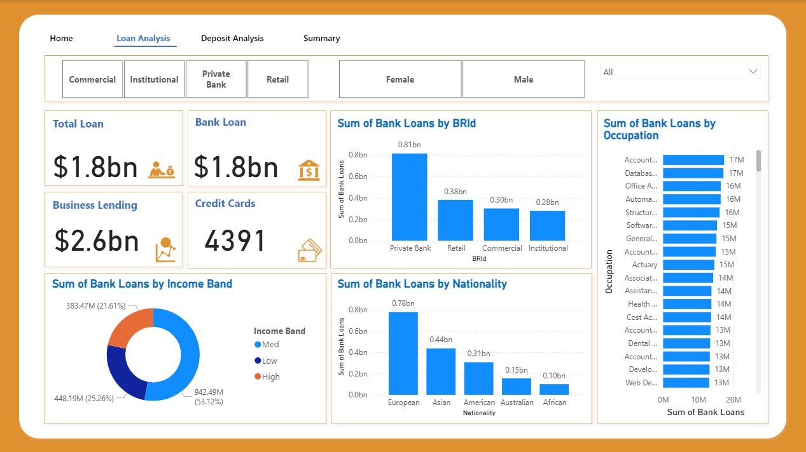
Figure 2 — Loan Analysis page

8.3 Deposit Analysis
This page mirrors the loan view for deposits — total deposit, bank deposit, savings, checking, and foreign currency balances — broken down by income band, nationality, and occupation.
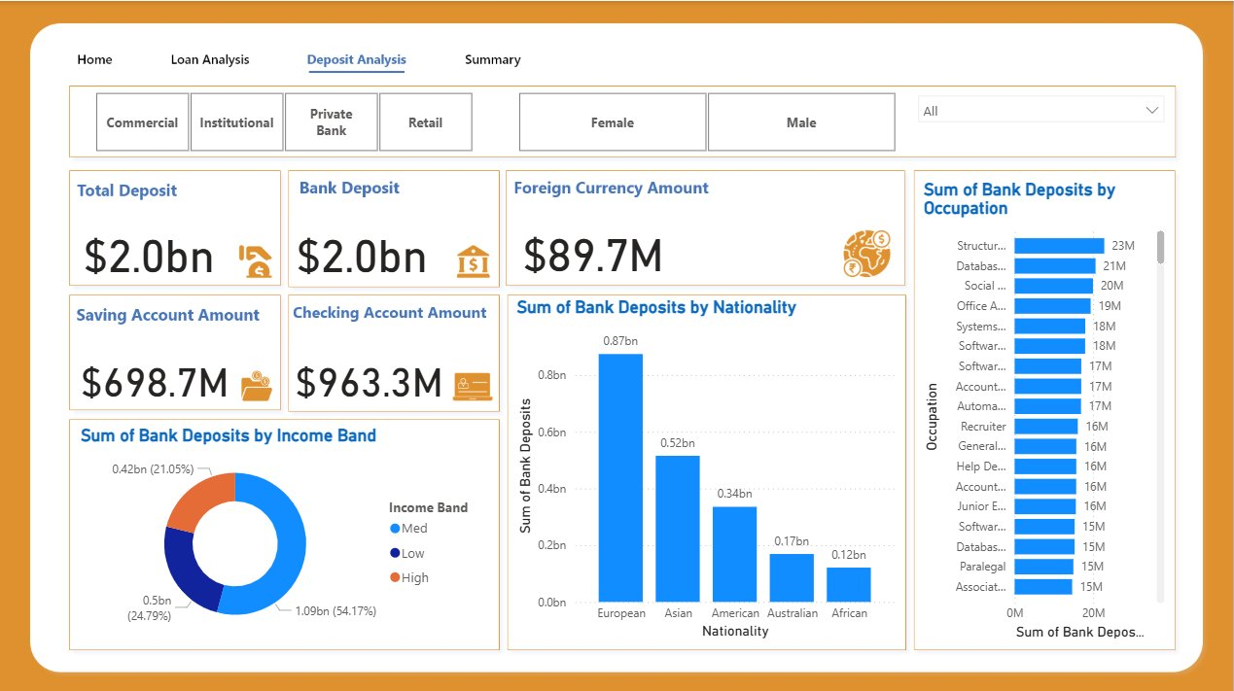
Figure 3 — Deposit Analysis page

8.4 Summary
The Summary page consolidates every KPI from the Loan and Deposit pages into a single scorecard view, giving a one-screen snapshot of a selected client segment.
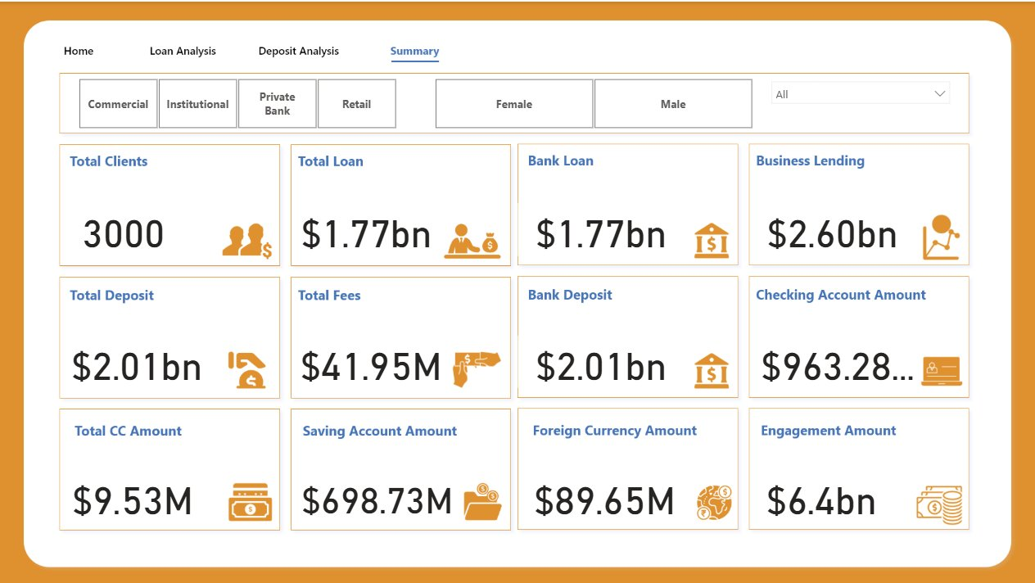
Figure 4 — Summary scorecard page

9. Key Business Insights
- Private Bank is the dominant relationship segment, carrying roughly $0.81bn in loans and the largest share of deposits — far ahead of Retail, Commercial, and Institutional segments.
- European clients account for the largest share of both loans (~$0.78bn) and deposits (~$0.87bn), followed by Asian, American, Australian, and African clients in that order — consistent across both the loan and deposit views.
- Medium-income clients make up just over half of both loan exposure (53%) and deposit value (54%), with High and Low income bands splitting the remainder roughly evenly.
- Total deposits ($2.0bn) exceed total loans ($1.8bn) across the client base, indicating a deposit-heavy balance sheet position overall.
- Occupation-level breakdowns show lending and deposit activity fairly evenly spread across a long tail of professional roles, with no single occupation dominating either book.

10. Conclusion
This project shows how a relatively small set of client and account fields — once cleaned, banded, and aggregated — can be turned into a Power BI dashboard that gives a clear, segment-by-segment view of a bank's lending and deposit book. The Home, Loan Analysis, Deposit Analysis, and Summary pages together let a user move from a high-level overview down to a specific relationship-type, gender, or nationality slice in a few clicks, supporting faster and more consistent lending decisions.

11. Future Scope
- Extend the model with a credit-scoring measure that combines income band, loyalty classification, and risk weighting into a single applicant risk score.
- Add a time-trend view using the Period table to track how loan and deposit balances move quarter over quarter, rather than only as a current snapshot.
- Layer in a default/delinquency flag (if available) to directly connect dashboard segments to actual loan performance, closing the loop between profiling and outcome.
- Compare relationship-type strategies — for example, using the finding that Private Bank clients carry the largest loan book to inform how Retail and Commercial segments might be grown.

