**Module:1 Foundation**

1. How to purchase domain ?

To purchase a domain, follow these steps:

1. **Choose a Domain Name:** Select a unique, memorable name relevant to your website or business.
2. **Check Availability:** Use a domain registrar like GoDaddy, Namecheap, or Google Domains to check if your chosen name is available.
3. **Select a Registrar:** Pick a trusted domain registrar based on pricing, features, and support.
4. **Choose a Domain Extension:** Common extensions include .com, .org, .net, or country-specific ones like .us or .uk.
5. **Create an Account:** Sign up or log in to your chosen registrar.
6. **Add Domain to Cart:** Once available, add the domain to your cart.
7. **Select Registration Duration:** Choose how many years to register the domain for (1 year is standard).
8. **Consider Add-ons:** Decide if you want privacy protection, email forwarding, or other add-ons***.***
9. **Pay and Checkout:** Complete the payment process to secure your domain.

**10.Configure DNS Settings:** After purchase, set up your domain to point to your web host or use it for email.

This process should guide you in acquiring a domain for your website.

**Module 2) Fundamentals of World Wide Web 3**

**2)Upload one page on server using Free server hosting [000webhost.com]**

**Step 1: Sign Up for 000webhost**

**1.** Go to website

**2.** Click on Get Started or Sign Up.

**3.** Create an account using your email or sign up via Google or Facebook.

**Step 2: Create a New Website**

**1.** After logging in, click on Create New Website.

**2.** Choose a name for your website (this will be part of your domain, e.g., yourname.000webhostapp.com).

**3.** Click on Create.

**Step 3: Upload Your Page**

There are two methods to upload your files: through the File Manager or using FTP.

**File Manager**

**1.** On your dashboard, click on File Manager.

**2.** Click on Upload Files.

**3.** Navigate to the folder where you want to upload (usually the public_html folder).

**4.** Drag and drop your HTML, CSS, JavaScript, and other files into the public_html folder.

**5.** Once uploaded, you can view your page by visiting yourname.000webhostapp.com.

**Step 4: Test Your Website**

6. After the upload is complete, visit your domain to test that everything works properly

**Module 1) Fundamentals of IT 3**

**3).SDLC of Student management System.**

**Student Management System**

Schools and Universities are the foundation of knowledge and an educational body on which students rely upon. Therefore, they need to maintain a proper database of its students to keep all the updated records and easily share information with students.

Most schools and Universities count on an advanced software tool knows as 'Student Information System (SIS)' to keep all their student records and administrative operations including, examinations, attendance, and other activities.

Over the recent years, the performance and efficiency of the education industry have been enhanced by using the Student Management System. This tool has productively taken over the workload of the admin department with its well-organized, easy, and reliable online school management software.



**With this tutorial, we will learn the definition of Student Information System and how does it fit with all the other technology you use to run your school?**

**Advertisement**

**What is a Student Management System?**

*"Student Management System (SMS) is a solution tool that is designed to track, maintain and manage all the data generated by a School, including the grades of a student, their attendance, their interpersonal activities records, etc.,"*

**SMS acts as the bottom line database to store all the day-to-day school operations, maintain the proper records of the past few decades, regulate the various operation modules, managing the critical tasks, efficiently handling the administrative processes such as:**

**1. Admissions**

The Student Management System software is created to help manage the student's admissions activities, starting from initial communication to course enrolment.

**2. Billing and Payments**

The Payments paid or received can also be managed and recorded through Student Management System; unlike invoice generation, credit notes, refunds, etc., SMS stores all the necessary information about parents and staff suppliers, and contractors.

**3. Reporting**

Reporting feature benefits the schools to analyze the trends in student behavior and examine the outcomes to boost their performance**.**

**4. Tracking Student's Fees**

Fee tracking is one of the most beneficial features of this online software.

**The school administration department can track billing dates, induce late fee penalty, generate invoice, and automatically gets the report of received payments throughout the year.**

**Student Management System software is helpful for teachers and school supervisors and also support applications and dashboards effective for students and parents as well for communication and combined data collection.**

**The other names of Student Management System are Student Information System (SIS), Student Information Management System (SIMS) and Student Record System (SRS).**

**Benefits of Using Student Management System**

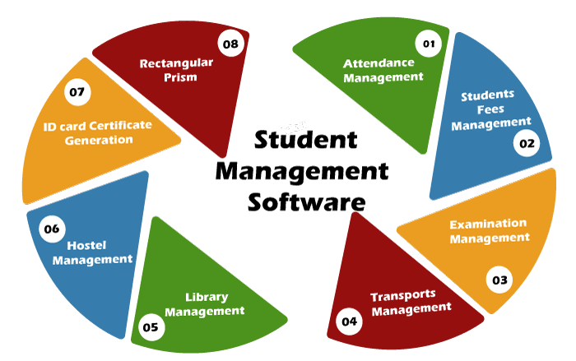

**1.** **Enhances the overall Performance of Students**

One of the mantras to improve academic performance is by constantly monitoring your pace. Therefore, with the help of school administration software, the students utilize their time on studies and all the other tasks, unlike keeping track of their performance; maintaining records all are handled by SMS software.

**2. It helps to Streamline all Task**

Earlier it was too challenging for teachers to keep track of all the activities and tasks allocated to each student, and sometimes it gets overlooked. But life has become easy with the school management software. Because of its efficient dashboard, teachers can easily maintain, monitor, track the performance of every student, and eventually take appropriate measures to get it completed.

**3. Improved Communication**

During a physical batch, whenever a teacher delivers any lesson, it is likely that some students won't catch the lesson perfectly and may have their doubts. But with such strength, it becomes impossible for students to clear their problems.

Also, some students are introvert in nature and may feel shy to ask things in front of the class. SMS has been designed in such a way so it can cater to the above issues. Most software has inbuilt discussion portals allowing students to communicate with their teachers and clear their doubts.

**4. Can be accessed by all Parents**

Parents are also satisfied with the Student Management System software because earlier they find it challenging to catch the details of their child' day-to-day school activities or how they are performing in-class tests or exams.

But thanks to this open-source software that have created the student dashboard so creatively that parents can access and easily monitor their children's performance and ongoing school activities, including homework, project submission, attendance, etc.,

**5. Well-organized Management and Organization of Programs**

The timetable of a class is organized by the school admin department and passed across to teachers and students. Despite being committed to their responsibility, it never relates, and there is always a clash of lectures. With this software, the admin department freezes the timetable online, preventing all the clash errors. In addition to that, every party, including students, teachers, and parents, can easily access it.

**4) Upload your code in Github using command.**

first time use git base url

git config --global user.email "your-email@example.com"

git config --global user.name "Your Name"

new respositry

1) git init

2) git add .

3) git status

4) git commit -m "first commit"

5) git branch -M main

6) git remote add origin https://github.com/Shubham-2122/xyz.git

7) git push -u origin main

new file

1) git add .

2) git status

3) git commit -m "file name"

4) git push -u origin main

Tailwind update component

1)https://www.devui.io/components

2)https://www.pexels.com/search/nature/