* WHAT IS REACT.JS?

= A JavaScript library for building user interfaces.

* Client Side Js library
* All about building modern, reactive user interface for the web
* ReactJs instead of simple js?
* 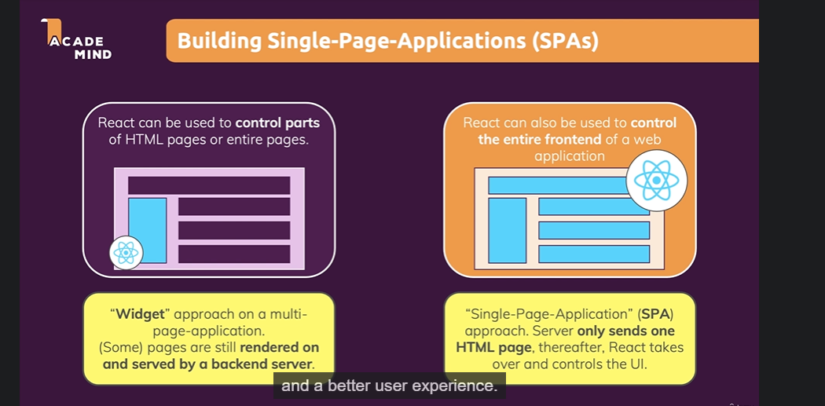
* Alternative of Reactjs

1. Angular
2. Vue