STEPS:

STEP 1:

1.Student

2.Employee

3.Department

4.Student commitees

5.Lab

6.Research

Step 2:

1.Student(Name,phone no,Address,Roll no.,marks,student ID)

2.Employee(Name,Phone no.,Employee ID,designation,salary)

3.Department(IT,Computer,Electronics,EXTC)

4.Student Commitee(Name,no,no of students )

5.Lab(Lab no.,Lab name,No. of equipments)

6.Research(No of publications,research area,name)

Step 3:

1.Has(college and employees)

2.Teaches(teaching staff and courses)

3.Enrolls(students and cources)

4.Maintains(non teaching staff and labs)

5.registers for(students and commitees)

ER DIAGRAM:

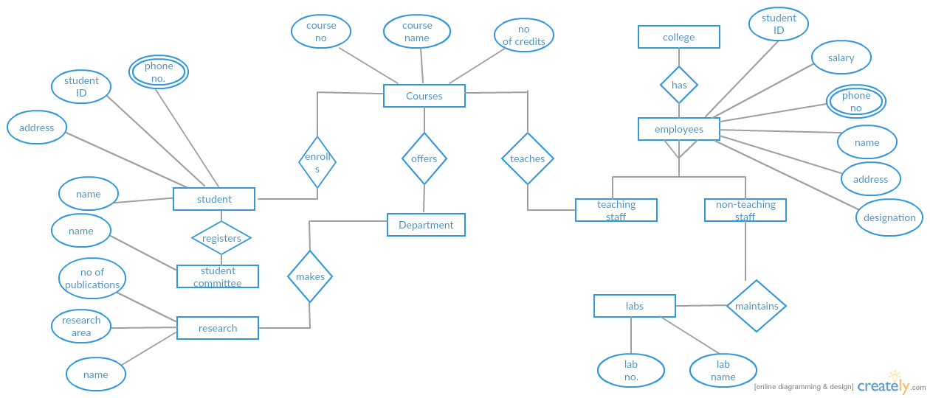

|  |  |  |  |  |  |
| --- | --- | --- | --- | --- | --- |
| Name | Phone no | Address | Roll no | Marks | Student id |
|  |  |  |  |  |  |

TABLES:

student

employee

|  |  |  |  |  |
| --- | --- | --- | --- | --- |
| Name | Phone no | Employee id | Designation | Salary |
|  |  |  |  |  |

department

|  |  |  |  |
| --- | --- | --- | --- |
| IT | Computers | Electronics | EXTC |
|  |  |  |  |

Student committee

|  |  |  |
| --- | --- | --- |
| Name | No | No of students |
|  |  |  |

Lab

|  |  |  |
| --- | --- | --- |
| Lab no | Lab name | No of equipments |
|  |  |  |