A PROJECT REPORT

ON

ALPA BLOG

Submitted in partial fulfillment of the requirement of the degree of

MASTER OF SCIENCE IN RUBY ON RAILS

of

International Technological University


By

KRUPA SHIVARAMAREDDY (86962)
SULTHAN MUBARK SYED (90632)

Under the esteemed guidance of
Bhairav Mehta
Professor for the department of CSE.
(Course SWE 610)

INTERNATIONAL TECHNOLOGICAL UNIVERSITY
2711 N 1st St.
SAN JOSE, CA 95134

ACKNOWLEDGEMENT

We wish to express our sincere gratitude to Bhairav Mehta for providing us an opportunity to take up the project titled “ALPA BLOG” and “FINANCE TRACKER”.
We take this opportunity to express our thankfulness and respect to all those who guided, inspired and helped us in the course of our project

Problem Statement
To develop and maintain a web based application which allow users to create and access information about articles. User can get information about about article that they created and the articles created by others as well.
The user who has an account can able to see all articles created by different users.
Admin user has more accessibility to the application, can view, edit, delete any article in the web application.

.

Objective

The main objective of the project is to satisfy all the requirements and make sure that the product developed is efficient in every possible way.
Our main goal is to make web application is easy accessible to all users with required information to meet their desires.

Front End UI
Front End UI are the screens or interface which the end user will be interacted with in order to use the CIS application. End users use these screens so as to perform actions on the application. As part of developing CIS project, to develop Front End UI screens we have used technologies like HTML, CSS and JavaScript.

HTML: HTML stands for Hyper Text Markup Language. HTML is a language using which can show content on the browsers. HTML includes typical display of text, color, fonts and hyperlinks on the browser.
Note 1: All html code should be enclosed between opened and closed tags (<, >)
Note 2: Few typical tags are html, head, title, body. Every tag should be enclosed <>
File extension : .html
Example <html>
<title>Campus Information System</title>
<head></head>
<body>
<h1>Welcome to HTML</h1>
</body>
</html>

CSS: CSS stands for Cascading Style Sheets. CSS describe how the HTML content should be displayed in a browser. Using CSS, can make HTML page more colorful by applying CSS to HTML code. Using CSS, we can categorize similar content in HTML page and assign particular pattern to be displayed in the browser. Using CSS would save lot of time by categorizing & selecting similar tags & applying CSS.
File Extension : .css
Example
h1{
color: red;
text-align: center;
}

JavaScript: JavaScript is object oriented programming language. Using JavaScript along with HTML and CSS would make the web pages more interactive and effective. Using JavaScript in HTML can change content of the HTML in the browser itself. JavaScript is one of the most popular programming language.

File Extension : .js
Example
"document.getElementById('demo').innerHTML = This is JavaScript!'"

Database
Database is to store data that can be access in various ways whenever required. Database is a structured way of storing data which can be accesses and used later in the system. In CIS project, MySQL is the open source Database which is used.

MySQL: MySQL is an open source relational database management system (RDBMS) which is based on Structured Query Language (SQL). Using SQL language can create a database and maintain all the required information in Structured format and later then access the data from database.

Existing System
Even though existing system is good to access desired information, we made few changes to make our web application for more easy access.
Below is the screen shot for existing web application
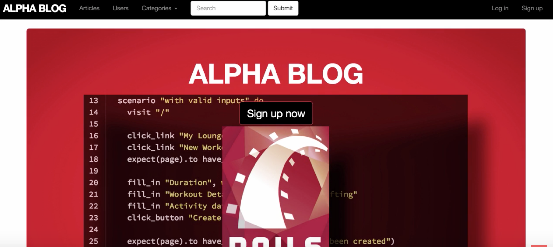
The application Campus Information System is proposed web application software. This application automates all the activities involved in a university such as library management, examination cell, teaching staff information management. Along with this, system also provides virtual tour of campus where a user can watch video on how the activities can be performed. Also provides chat messenger feature using which students and staff can communicate with each other for any university related information. Also have record tracking feature using which any user can search any student or employee in the university. Users can also search for book in library and request for book which they need.

Proposed System
- We made few changes to existing system to make access more easy, we added one create button on our application that saves user time and avoids confusion while creating new article. Instead of searching for the option to create a article users can directly click on create article button to create new article.
Screen shots are below,
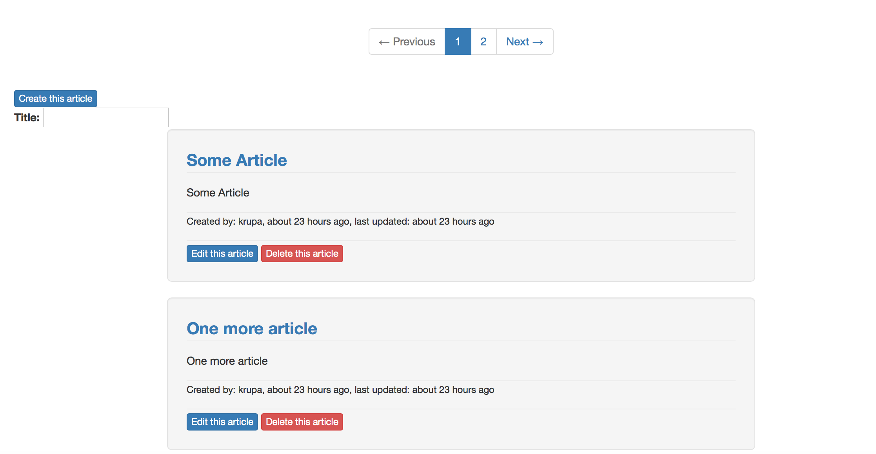
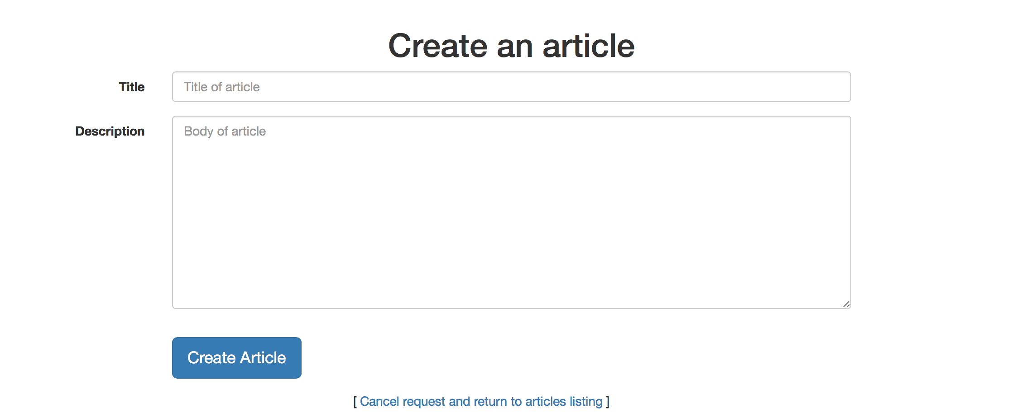
- We made another change in application that is search article by name, this enhancement helps user to found desired article by entering name in title text field, instead of looking all the list for the desired article user can easily found by this enhancement.
We can see the text field for tittle in below screen shot,

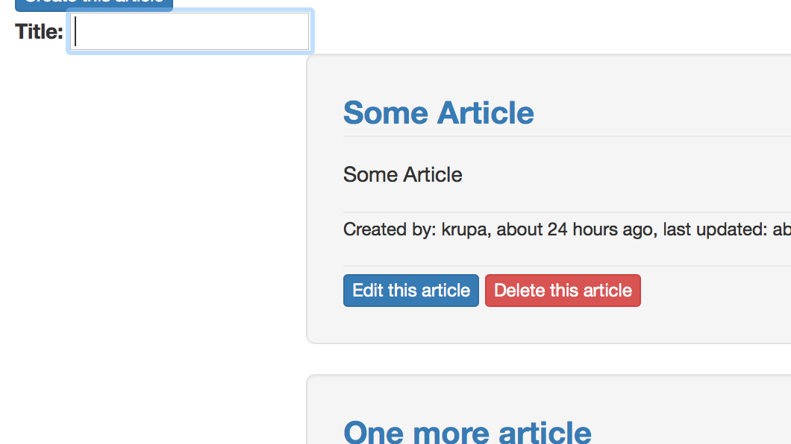

Links to github are below,

https://github.com/krupasg/alpha-blog/commit/024874cfa17ce1e49c891baea16144ebaa4d9cd5

https://github.com/krupasg/alpha-blog/commit/c6c254b5a333f3ae5b4fe41e985540b1b90aeead

FINANCE TRACKER

Enhancements

In existing project its time consuming to see the stock details for a particular company, so we made changes, when we click on the company name it will give directly stock details of that company. Below are the screen shots for enhancements,

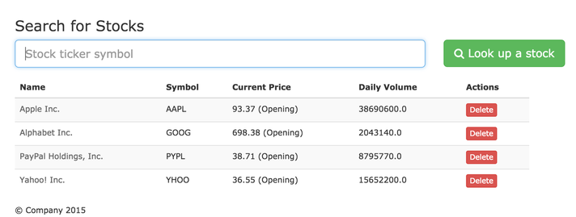

Conclusion

Our Main goal is to make application accessibility easy to all users. Also this is a good idea to share information to all the people who can able to access internet, also it saves time, avoids paper work and physical transfer of files

