NIP Project — Submission Template
Pega Platform project · This document is your complete submission
Read this before you start:
1. Fill in Section 1 completely. The Pega application name must follow the format NIP-[Project]-[YourName].
2. Create a new Operator in Pega with your full name and log in as that operator before taking any screenshot.
3. When you create your test case, enter YOUR FULL NAME in the Issue Description (Vehicle) or Movie Name (Movie) field.
4. Complete only the section for your chosen project. Delete the other project section.
5. Paste one screenshot per user story (10 total). Follow the screenshot rules in your selected project section.
6. Answer every question in Sections 3 and 4 in your own words.
7. Save the file using this format: ProjectName_FirstName_LastName.docx. Use VehicleService or MovieTicket as the ProjectName. Examples: VehicleService_Ravi_Kumar.docx or MovieTicket_Ravi_Kumar.docx.

Section 1 — Your Details
Full Name | KRUPAVARAM PAMULA
Email ID (registered on NIP) | Krupavarampamula16@gmail.com
Phone Number | 9640271969
College Name | Mohan Babu University
Course (e.g. IT, CS) | B.tech., CSE-AIML
State | ANDHRA PRADESH
Project Chosen (Vehicle Service OR Movie Ticket Booking) | Vehicle Service
Pega Application Name (e.g. NIP-VehicleService-YourName) | NIP-VEHICLE SERVICE-KRUPAVARAM PAMULA
Case Type Name (exact) | Vehicle Service Request
Pega Instance URL | https://ce7ja0rw.pegaacademy.net
Operator Name (created in Pega with your full name) | KRUPAVARAM PAMULA

Section 2A — Vehicle Service Management Application
Complete this section only if you selected this project. Delete the other project section before submitting.

Screenshot rules — IMPORTANT before you start:
1. Name your Pega application as: NIP-VehicleService-YourName OR NIP-MovieTicket-YourName
2. Create a new Operator in Pega with your full name (Security → Operators) and log in as that operator.
3. When you create your test case, enter YOUR FULL NAME in the Issue Description (Vehicle) or Movie Name (Movie) field.
4. The logged-in operator name must be visible in every screenshot wherever the Pega interface displays it.
5. The student's full name must be visible in all running-case screenshots.
6. Configuration screenshots must clearly show the relevant application or rule name.
Screenshots that do not show these will not be accepted.

US-001 — Submit Vehicle Service Request
What is expected:
Case created, customer submits Vehicle ID, Vehicle Model, Issue Description. Validation applied.
Screenshot — paste your screenshot below this line:
[ Paste screenshot here - follow the screenshot rules above ]
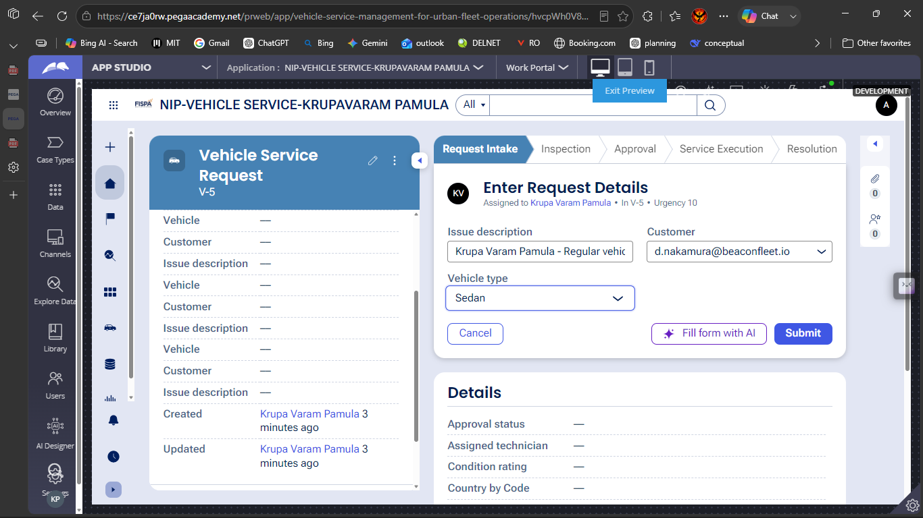

What I built for this (1–2 lines in your own words):
I created the primary Vehicle Service Request case life cycle, setting up sequential stages from Request Intake to Service Execution alongside an alternate Approval Rejection stage.

US-002 — Perform Vehicle Inspection
What is expected:
Inspection stage with Service Advisor step. Inspection Notes and Condition Rating captured.
Screenshot — paste your screenshot below this line:
[ Paste screenshot here - follow the screenshot rules above ]
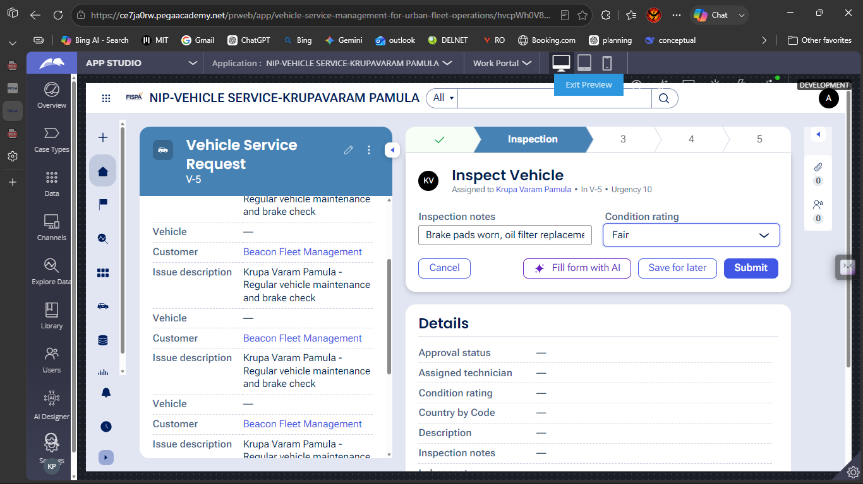

What I built for this (1–2 lines in your own words):
I built the vehicle inspection step where the technician captures physical inspection notes and selects the vehicle's condition rating from a picklist

US-003 — Generate Service Estimate
What is expected:
Labor Cost and Parts Cost captured. Total Cost calculated automatically by declare expression.
Screenshot — paste your screenshot below this line:
[ Paste screenshot here - follow the screenshot rules above ]
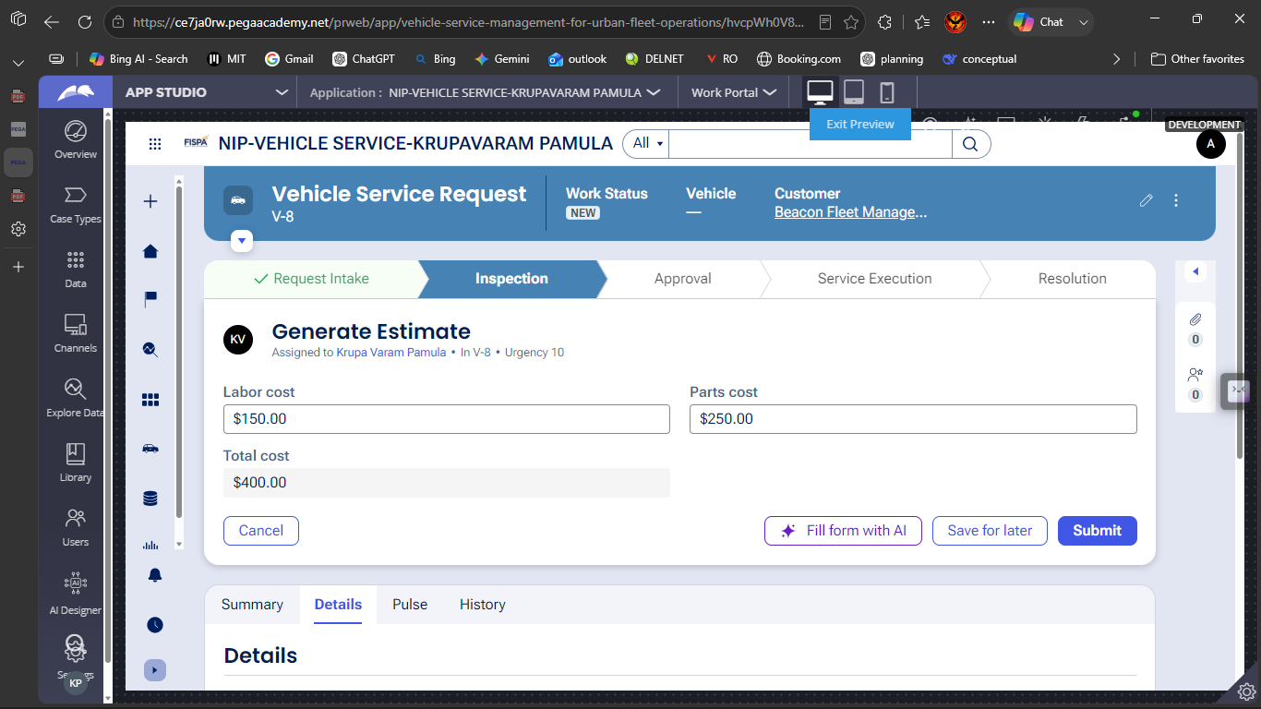

What I built for this (1–2 lines in your own words):
I configured currency input fields for Labor Cost and Parts Cost and created a calculation rule that automatically computes the Total Cost.

US-004 — Approve Service Estimate
What is expected:
Approval stage assigned to Customer. Approval Status captured. Flow branches on approve/reject.
Screenshot — paste your screenshot below this line:
[ Paste screenshot here - follow the screenshot rules above ]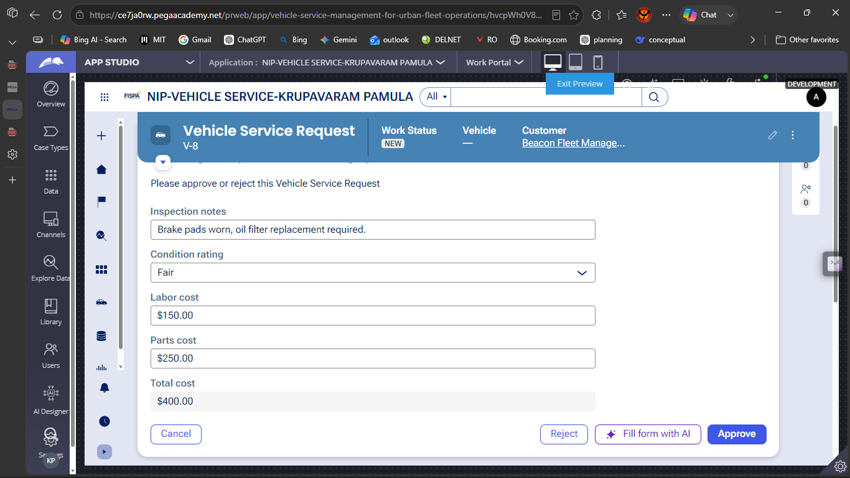

What I built for this (1–2 lines in your own words):
I implemented an approval step displaying all cost estimates to the approver with Approve and Reject actions that branch into resolution or an alternate rejection stage.

US-005 — Maintain Vehicle Data
What is expected:
Reusable Vehicle data object created with Vehicle ID, Model, Type — linked to case.
Screenshot — paste your screenshot below this line:
[ Paste screenshot here - follow the screenshot rules above ]
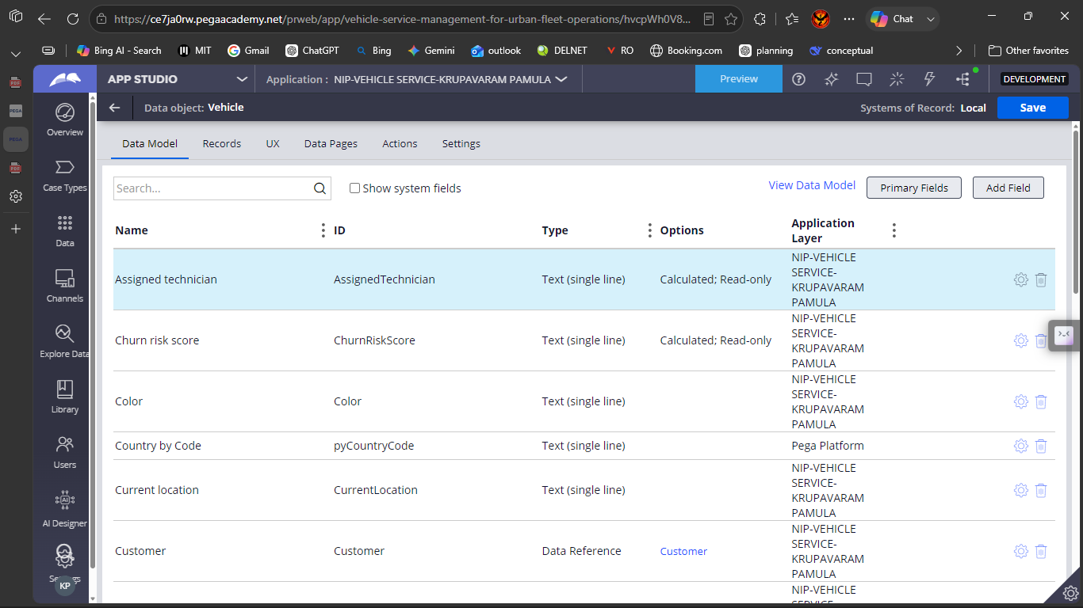

What I built for this (1–2 lines in your own words):
I configured the reusable Vehicle data object and defined its properties such as Model, Type (Heavy/Light), and Registration Number to link fleet data directly to cases.

US-006 — Review Service Estimate
What is expected:
Approval screen shows Labor Cost, Parts Cost and Total Cost clearly to the Customer persona.
Screenshot — paste your screenshot below this line:
[ Paste screenshot here - follow the screenshot rules above ]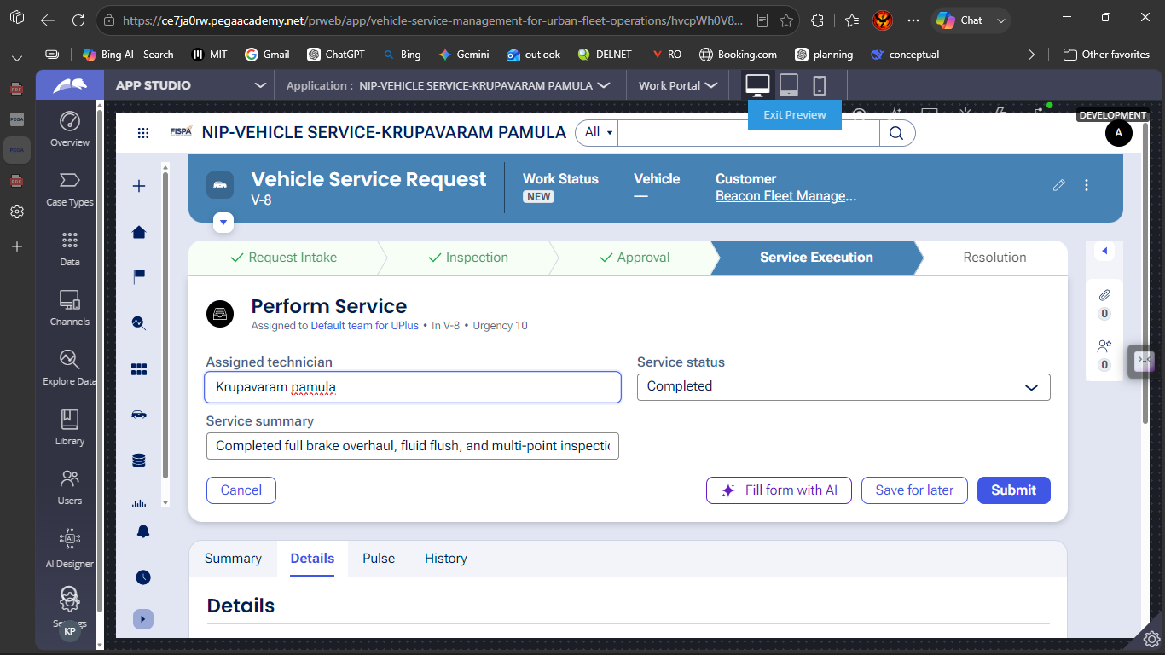

What I built for this (1–2 lines in your own words):
I designed the review interface to display an itemized summary of Labor Cost, Parts Cost, and Total Cost alongside technician notes for full estimate visibility

US-007 — Auto Assign Technician
What is expected:
Service Execution stage with routing to HeavyVehicleQueue or LightVehicleQueue. Assigned Technician and Service Status properties maintained.
Screenshot — paste your screenshot below this line:
[ Paste screenshot here - follow the screenshot rules above ]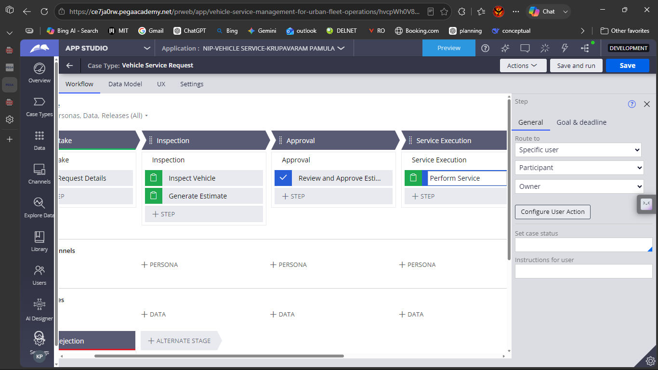

What I built for this (1–2 lines in your own words):
I set up step routing on the service execution task to assign the work to specific operators and track the assigned technician and service status properties.

US-008 — Notify Service Completion
What is expected:
Correspondence rule created and triggered on case resolution. Email includes case and vehicle details.
Screenshot — paste your screenshot below this line:
[ Paste screenshot here - follow the screenshot rules above ]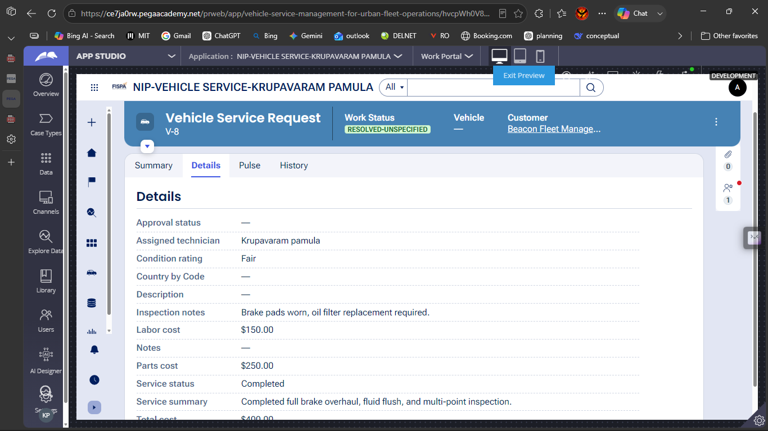

What I built for this (1–2 lines in your own words):
I configured the case resolution step to update the work status to Resolved-Completed and present the complete case history, cost breakdown, and inspection summary

US-009 — Define Service SLA
What is expected:
SLA configured on the case type. Goal: 2 days. Deadline: 3 days. Priority increases on breach.
Screenshot — paste your screenshot below this line:
[ Paste screenshot here - follow the screenshot rules above ]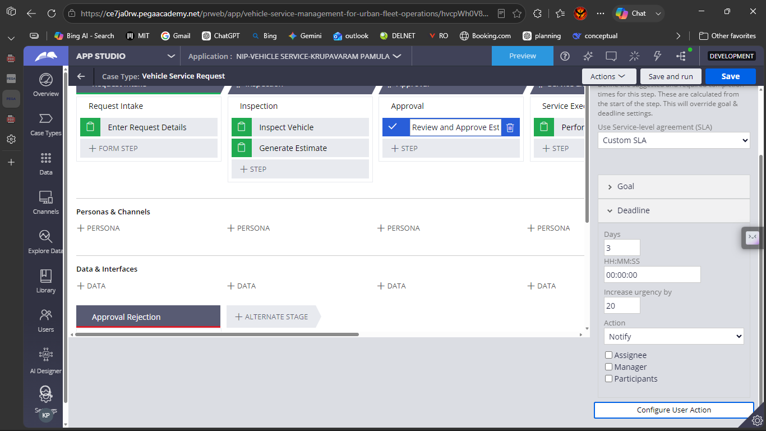

What I built for this (1–2 lines in your own words):
I configured a custom Service Level Agreement with a Goal of 2 day (+10 urgency) and a Deadline of 3 days (+20 urgency) with automated breach notifications

US-010 — Route by Vehicle Type
What is expected:
Routing rule or Decision Table routes to HeavyVehicleQueue or LightVehicleQueue based on Vehicle Type property.
Screenshot — paste your screenshot below this line:
[ Paste screenshot here - follow the screenshot rules above ]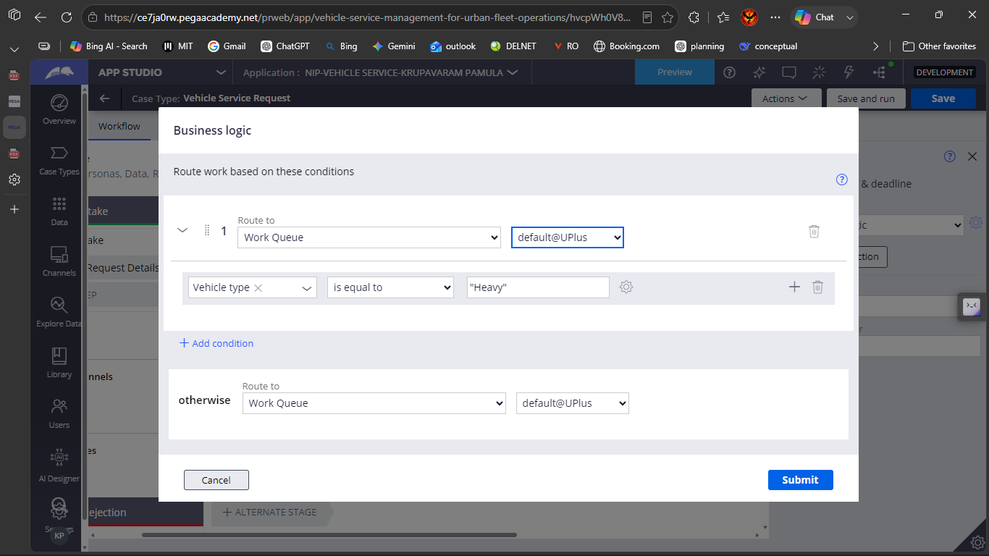

What I built for this (1–2 lines in your own words):
I built conditional business logic routing that evaluates the Vehicle type property and routes work to HeavyVehicleQueue or LightVehicleQueue accordingly

Section 3 — About Your Application
These answers are checked against your screenshots. Write exactly what is in your application.

Q1. List your stages in the order they appear in your case lifecycle.
Stage names in order, separated by commas.
Primary Stages: Request Intake, Inspection, Approval, Service Execution, Resolution. Alternate Stage: Approval Rejection

Q2. Name the data object(s) you created and the properties inside them.
Data object name and its properties.
Data Object: Vehicle
Properties: VehicleID, Model, Type (Picklist: Heavy, Light), RegistrationNumber, OwnershipStatus, Color, CurrentLocation, Customer (Data Reference)

Q3. What is the exact name and type of the rule you used to calculate Total Cost?
Provide:
• Rule Name
• Rule Type
• Properties used in the calculation
• Formula used
Rule Name: total cost
Rule Type: Declare Expression
Properties used: .LaborCost, .PartsCost, .TotalCost
Formula used: .TotalCost = .LaborCost + .PartsCost

Section 4 — Your Understanding
Short, honest and specific answers score well.

Q4. What did Blueprint generate for you, and what did you add or change yourself afterwards?
Be specific about what was already there and what you built or modified on top.
Pega GenAI Blueprint generated the baseline case structure, default stages (Intake, Inspection, Approval, Service Execution), and standard data fields. Afterwards, I customized the data models, created calculation logic for total costs, defined SLA goals and deadlines, set up alternate rejection paths, and configured conditional business logic routing for vehicle queues

Q5. Was there anything Blueprint created that you had to correct or configure further? Describe one example.
A real example from your own work.
Blueprint generated generic text fields for costs and basic routing. I had to manually change the labor and parts fields to Currency types, configure a Declare Expression to compute Total Cost dynamically, and configure custom business logic routing to evaluate vehicle type properties for work queues

Q6. Explain your case flow from creation to resolution, in order.
What happens first, who does what, when the case closes.
First, the customer submits the request details (vehicle info and issue description) during Request Intake. Next, in Inspection, the technician enters inspection notes and logs estimated labor and parts costs, which automatically calculates total cost. In Approval, the customer/manager reviews the estimate; if approved, the case proceeds to Service Execution where the task is routed by vehicle type and the technician logs completed work. Finally, the case reaches Resolution where status is set to Resolved-Completed and the summary is recorded

Q7. Pick two design choices you made in your application and explain why you made them.
For each design choice, provide:
• What you implemented
• Why you chose that approach
• What benefit it provides to the application
1)
WHAT: Using a Declare Expression for TotalCost
WHY: It computes costs automatically in real time whenever Labor or Parts costs are entered/updated without requiring custom code
BENEFIT : Eliminates manual math errors and ensures immediate data consistency across forms

WHAT: Business Logic Routing by Vehicle Type
WHY: Heavy and light fleet vehicles require different garage bays, tools, and technician skill sets
BENEFIT: Optimizes resource allocation by automatically placing cases into the right team's work queue without human triage delay

Q8. What was the hardest part, and how exactly did you fix it?
Specific and honest. A real challenge scores much better than a generic answer.
The hardest part was configuring conditional business logic routing based on the embedded vehicle data property. I resolved it by ensuring the Type field on the Vehicle data object was correctly referenced as a picklist and linking the condition directly to the HeavyVehicleQueue and LightVehicleQueue work baskets

Q9. If the approval step was only needed when Total Cost is above a certain amount, what would you change in your application?
Explain what you would change and where. You do not need to build this.
I would select the Review and Approve Estimate step in App Studio, open the right-side configuration panel, and under Skip stage / Skip step condition, set the condition to Custom condition: .TotalCost > 500 (or specified threshold). If .TotalCost <= 500, the approval step will automatically be skipped and advance straight to Service Execution

Q10. List three exact rule names from your application that you personally created or modified.
Include the rule name and rule type for each one (for example: CalculateTotalCost - Declare Expression).
TOTAL COST - DECLARE EXPRESSION
VEHICLE SERVICE REQUEST SLA - SERVICE LEVEL AGREEMENT
ROUTE BY VEHICLE TYPE - BUSINESS LOGIC ROUTER / DECISION TABLE

Q11. List all personas used in your application.
List the persona names exactly as they appear in your application.
Customer
Service advisor
Technician

Q12. List all work queues used in your application and explain when each one is used.
For each work queue, provide its exact name and the condition or type of work routed to it.
HEAVY VEHICLE QUEUE - CASE TYPE PROPERTY = HEAVY
LIGHT VEHICLE QUEUE - OTHERWISE QUEUE (or) DEFAULT

Before You Submit — Check These
Read through once before uploading.
1. Section 1 filled in. Application named as NIP-[Project]-[YourName]. Names match the actual application.
2. New Operator created in Pega with my full name. I logged in as that operator for all screenshots.
3. Only my chosen project section remains — the other project section is deleted.
4. All 10 user story screenshots are pasted and follow the operator, running-case, application, and rule-name evidence requirements.
5. Every question in Sections 3 and 4, including Q10, Q11, and Q12, is answered in my own words.
6. This file is named using the required format: ProjectName_FirstName_LastName.docx (for example, VehicleService_Ravi_Kumar.docx or MovieTicket_Ravi_Kumar.docx) and uploaded as required.

