Q550 Model in Cognitive Science, Professor Kruschke.
Answers to homework regarding replication of Anderson (1965).

#1, regarding ethics of using human subjects. Everyone summarized the Belmont Report and I.U. web pages fairly well.

#2. Run the replication of Anderson (1965). Everyone eventually did this.

#3. Data analysis. There were a total of 17 data files, although most people did the assignment when there were only 15 data files available. Because of this, I’ll do the analysis using the 15 data files that most people used.
- On the graph of individual users, point out any individual data curves that seem notably different than typical curves.
- On the boxplot, mark any non-monotonicities.

The graphical output is shown below. In the top panel, arrows point to two individuals that seem atypical because of pronounced non-monotonicities in their responses. But this is not a “correct” answer; the question was asking for your subjective impression. In the lower panel, the single non-monotonicity is marked with an arrow and line to emphasize the decrease.
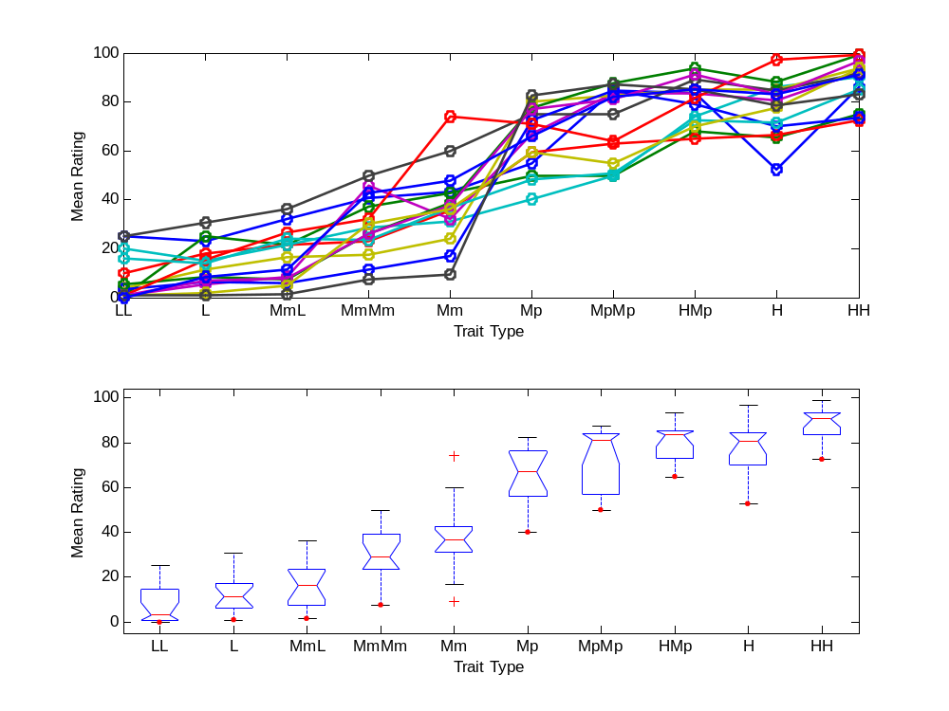
- Consider the results of the t-tests. Are the predictions of the averaging model confirmed, or the adding model, or neither?

The output from running the NHA65stats.m program looks like this:

>> NHA65stats
Data analysis for replication of N. H. Anderson (1965).

Averaging model predicts H - H.Mp > 0:
H - HMp = -2.475, t(14) = -0.89566, p = 0.38557

Averaging model predicts L.Mm - L > 0:
LMm - L = 3.6917, t(14) = 3.3945, p = 0.0043599

Averaging model predicts (( H - H.Mp ) + ( L.Mm - L )) > 0:
AveMod = 0.60833, t(14) = 0.39112, p = 0.7016

For H-HMp, the trend is opposite what is predicted by the averaging model, but the difference is not statistically reliable, so the result is inconclusive.

For LMm-L, the trend is consistent with the averaging model and statistically reliable, so here we have some confidence that the averaging model is applicable.

For the average of the two, the trend is consistent with the averaging model, but also very unreliable, so the result is inconclusive.

Change the code of NHA65stats.m so that the data analysis is restricted just to the second block of trials. The motivation: Suppose in the first block that people are still getting used to the response scale and haven't really settled into stable ratings. Perhaps the second block is less variable than the first. Repeat A, B & C from the previous part.

I’m not going to include the answer here, as it is very nearly the same as the two-block data analysis.

4. Fit the additive and averaging models to the 1965 data. … The parameters values in the parameter vector are, in order: AL AMm AMp AH w I0. The additive model uses a parameter vector with only four components, whereas the averaging model uses a vector with all six.

Try different initial values. Try [ 0 33 67 100 (0.5 50) ] and try [ -50 -17 17 50 (0.5 0) ]. Do the models settle into the same local minimum in both cases?

Posted by Prof. Kruschke on Thursday, 20 February 2003, at 2:16 p.m.: As announced in class, the homework regarding Anderson (1965) is now posted. Erratum: In #4 it says... "Try [ 0 33 67 100 (0.5 50) ] and try [ -50 -17 17 50 (0.5 0) ]." The last two parameters are reversed, i.e., instead of 0.5 50 and 0.5 0 it should be 50 0.5 and 0 0.5.

Here are the commands I entered in MATLAB to fit the averaging model for the first set of initial values:
>> paramInit = [ 0 33 67 100 50 0.5 ];
>> fminsearch(@NHA65aveModel,paramInit);
And the output at the end of the fit was:
L Mm Mp H I w
1.9947 35.1243 68.7694 94.4314 47.9691 0.3538
rmse = 1.0066

With the other initial parameter values:
>> paramInit = [ -50 -17 17 50 0 0.5 ]
>> fminsearch(@NHA65aveModel,paramInit);
the output at the end of the fit was:
L Mm Mp H I w
20.9091 42.6565 65.3047 82.2533 -0.0001 0.8291
rmse = 2.6619

Thus, for the averaging model, the initial values of the search do influence the resulting best fit. The fit from the first run is clearly better. (Notice that the weight, w, for both fits is in the interval 0 to 1, where it should be. The averaging model weights the trait values by w and the initial impression by 1-w, so w must be in the range 0 to 1 for it to make sense.) The fit from the first run might itself be just a local, not global minimum, but it is a very good fit, and I’ll assume it’s the global minimum.

Now for the adding model. First set of initial parameter values (notice just four, not six):
>> paramInit = [ 0 33 67 100 ] ;
>> fminsearch(@NHA65addModel,paramInit)
L Mm Mp H I w
5.1578 11.3779 17.5384 22.3053
rmse = 14.7575

The second set of initial parameter values:
>> paramInit = [ -50 -17 17 50 ];
>> fminsearch(@NHA65addModel,paramInit)
L Mm Mp H I w
5.1579 11.3779 17.5383 22.3053
rmse = 14.7575

So, for the additive model, the two different initial values end up at the same best fit (except for the fourth decimal place in a couple of the parameter values). The resulting fit is terrible.

For the best fitting parameters, use Matlab to plot the predictions of each model along with the data. Does either model make predictions that violate the order of the types in the data?

To do this, you must run the models using the best fitting parameter values that you determined above, and get the predicted ratings from the model. To get the predicted ratings, you had to modify the code slightly to display the model predictions – I just removed the semi-colons from the end of lines that compute the predictions, and ran the model with those parameter values.

One way of plotting the resulting predictions with the data is shown below:
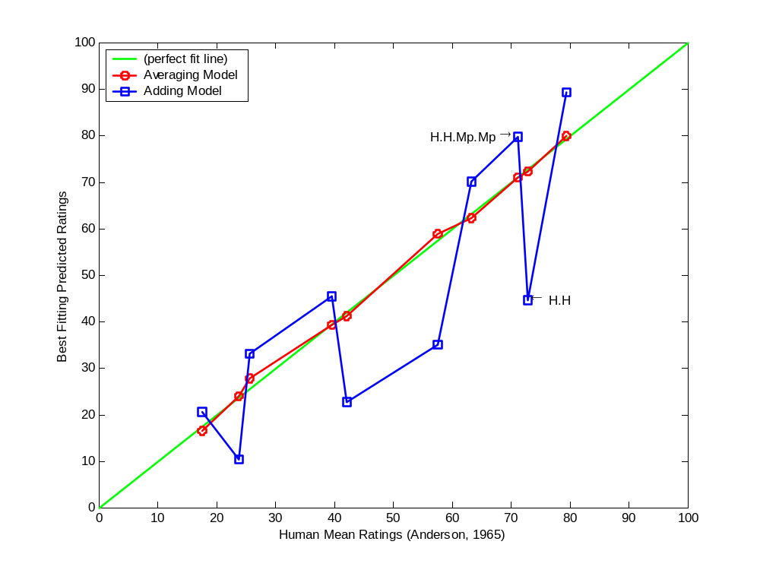
Notice that the X-axis is the human data from Anderson (1965), and the Y-axis is the model predicted ratings. A model that perfectly fit the data would fall exactly on the diagonal line. The averaging model shows a monotonically increasing curve, but the averaging model shows some major ordinal violations; e.g., the drop from H.H.Mp.Mp to H.H pointed out in the graph.

The MATLAB code for the graph is shown below:

nha65_data = [ 79.3900; 72.8500; 71.1100; 63.2000; ...
57.5600; 42.1800; 39.5000; 25.6700; 23.7000; 17.6400 ];

ave_pred = [ 79.8666; 72.2539; 71.0578; 62.2490;...
58.8409; 41.2554; 39.1508; 27.7787; 23.9393; 16.4066 ];

add_pred = [ 89.2211; 44.6105; 79.6871; 70.1531;...
35.0765; 22.7557; 45.5115; 33.0715; 10.3158; 20.6316 ];

plot([0 100],[0 100],':g', ... % diagonal line
nha65_data,ave_pred,'-ro',... % averaging model
nha65_data,add_pred,'-bs',... % adding model
'LineWidth',2)
legend('(perfect fit line)','Averaging Model','Adding Model',2);
xlabel('Human Mean Ratings');
ylabel('Best Fitting Predicted Ratings');
text(71.1100,79.6871,'H.H.Mp.Mp \rightarrow ',...
'HorizontalAlignment','right');
text(72.8500,44.6105,' \leftarrow H.H ',...
'HorizontalAlignment','left');

5. Fit the models to our replication data. The goal of this exercise is for you to get more experience programming Matlab and to see if the models fit our simplified variation of Anderson's (1965) experiment. Modify the model programs so that our class data are fit instead of Anderson's (1965) data. Repeat the two parts of the previous exercise for our class data.

There are two main things that need to be modified in the model programs for this exercise. First, you need to put in the means of our class ratings, instead of Anderson’s (1965) data. Second, you need to alter the programs so that they compute the averages or sums over just two or one traits instead of four or two traits.

Below is an example of modified code for the averaging model. I got a bit carried away and actually rather drastically restructured the program (and I have now posted this more elegant version in place of the original). The main point to notice is that the model now averages two or one traits, not four:

function rmse = NHA65RepAveModel(paramVector)

L = paramVector(1);
Mm = paramVector(2);
Mp = paramVector(3);
H = paramVector(4);
I = paramVector(5);
w = paramVector(6);

disp(' --------------------------------------------------------')
disp(' Using AVERAGING model ')
disp(' L Mm Mp H I w')
disp(paramVector)

if w < 0
w = 0;
disp('** w < 0 reset to 0 **')
end
if w > 1
w = 1;
disp('** w > 1 reset to 1 **')
end

% Data from class participants, 15 subjects
humHH = 88.2500;
humH = 77.9667;
humHMp = 80.4417;
humMpMp = 72.0583;
humMp = 65.3417;
humMm = 37.6667;
humMmMm = 29.4500;
humLMm = 16.3917;
humL = 12.7000;
humLL = 7.6000;

modHH = modelRating([ H H ],I,w) ;
modH = modelRating([ H ],I,w) ;
modHMp = modelRating([ H Mp ],I,w) ;
modMpMp = modelRating([ Mp Mp ],I,w) ;
modMp = modelRating([ Mp ],I,w) ;
modMm = modelRating([ Mm ],I,w) ;
modMmMm = modelRating([ Mm Mm ],I,w) ;
modLMm = modelRating([ L Mm ],I,w) ;
modL = modelRating([ L ],I,w) ;
modLL = modelRating([ L L ],I,w) ;

data = [ ...
humHH ; ...
humH ; ...
humHMp ; ...
humMpMp ; ...
humMp ; ...
humMm ; ...
humMmMm ; ...
humLMm ; ...
humL ; ...
humLL
]

pred = [ ...
modHH ; ...
modH ; ...
modHMp ; ...
modMpMp ; ...
modMp ; ...
modMm ; ...
modMmMm ; ...
modLMm ; ...
modL ; ...
modLL
]

rmse = (sum((data-pred).^2)/length(data))^0.5

% Subfunction AVERAGING MODEL
function rating = modelRating(traitVector,I,w)
numerator = w*sum(traitVector)+(1-w)*I;
denominator = w*length(traitVector)+(1-w);
rating = numerator/denominator;

% ---------------------------------------------------------------

Now, fitting the model at different starting positions:
>> paramInit = [ 0 33 67 100 50 0.5 ]
>> fminsearch(@NHA65RepAveModel,paramInit)
yields
L Mm Mp H I w
-12.5586 24.3580 82.8007 106.0952 46.3825 0.5371
rmse = 1.6046
Note: Exiting: Maximum number of function evaluations has been exceeded - increase MaxFunEvals option. Current function value: 1.604563
But it turns out that the result is essentially at the best fit, even when MaxFunEvals is increased.

Starting at the other initial values,
>> paramInit = [ -50 -17 17 50 0 0.5 ]
>> fminsearch(@NHA65RepAveModel,paramInit)
yields
L Mm Mp H I w
9.9327 36.3055 78.1020 94.4563 -0.0110 0.8493
rmse = 3.4009
which is a much worse fit.

The adding model uses the same code with only two changes: First, the values of I and w are set to 0 instead of read from the paramVector, and, second, the final subfunction is changed to:

% Subfunction ADDING MODEL
function rating = modelRating(traitVector,I,w)
% does not use I or w
rating = sum(traitVector);

Fitting the adding model then yields:
>> paramInit = [ -50 -17 17 50 ]
>> fminsearch(@NHA65RepAddModel,paramInit)
Using ADDING model (no I, no w)
L Mm Mp H I w
4.3655 18.0988 40.1284 49.1300
rmse = 14.9949
The other initial values yield:
>> paramInit = [ 0 33 67 100 ]
>> fminsearch(@NHA65RepAddModel,paramInit)
Using ADDING model (no I, no w)
L Mm Mp H I w
4.3655 18.0988 40.1283 49.1299
rmse = 14.9949

Thus, the adding model yields the same fit regardless of initial values. A plot of the best fitting values, along with the replication data, is shown below.
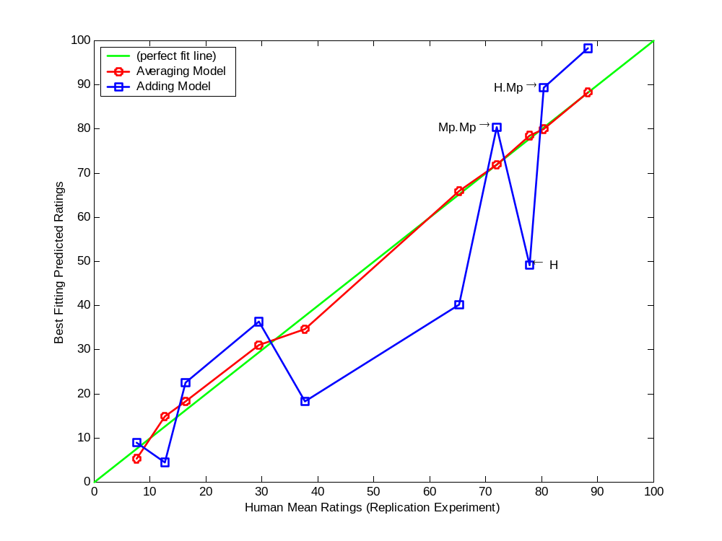
Once again the averaging model shows no ordinal discrepancies from the data, but the adding model does show non-monotonicities.

ADDENDUM: THE ADDING MODEL WITH INITIAL IMPRESSION.
In class I briefly discussed another model, the adding model with an initial impression. The adding model with initial impression uses the same code as the averaging model with only two changes: First, the value of w is set to 0 instead of read from the paramVector, and, second, the final subfunction is changed to:

% Subfunction ADDING WITH INITIAL IMPRESSION MODEL
function rating = modelRating(traitVector,I,w)
% does not use w
rating = sum(traitVector)+I;

The adding with initial impression model fits much better than the adding model, but it still shows ordinal discrepancies from the data:

L Mm Mp H I w
-8.7640 -2.5441 3.6164 8.3834 48.7267
rmse = 3.7781

Predictions, in order of Anderson (1965) data (so should be monotonically decreasing):
82.2601 65.4934 72.7262 63.1922 55.9594 43.6386 38.5505 26.1105 31.1986 13.6705

