Jake Kruse
ES 900
Final Project
Where I Should Live: Earth Engine’s Answer
Given the misery of the last Polar Vortex in Wisconsin, I decided to use Earth Engine to examine some possible relocation candidates, namely Miami and Salt Lake City. For me, temperature, greenness, and snow cover are all things I like in places I’ve lived, so I used Landsat 8 to find yearly averages for surface temperature, EVI, and NDSI. The polygon for each place was drawn around the downtown area.

Temperature
High average temperature is the most important variable to me, and on that account Miami is the clear winner. 57°, 48°, and 44° were the annual average temperatures in Fahrenheit for Miami, Madison, and Salt Lake City, respectively. Surprisingly (for a Wisconsinite), Salt Lake City was colder. However, I believe that due to lack of data for Madison in the winter (due to cloud cover); colloquial evidence says that Salt Lake City is nicer in the winter than Madison.
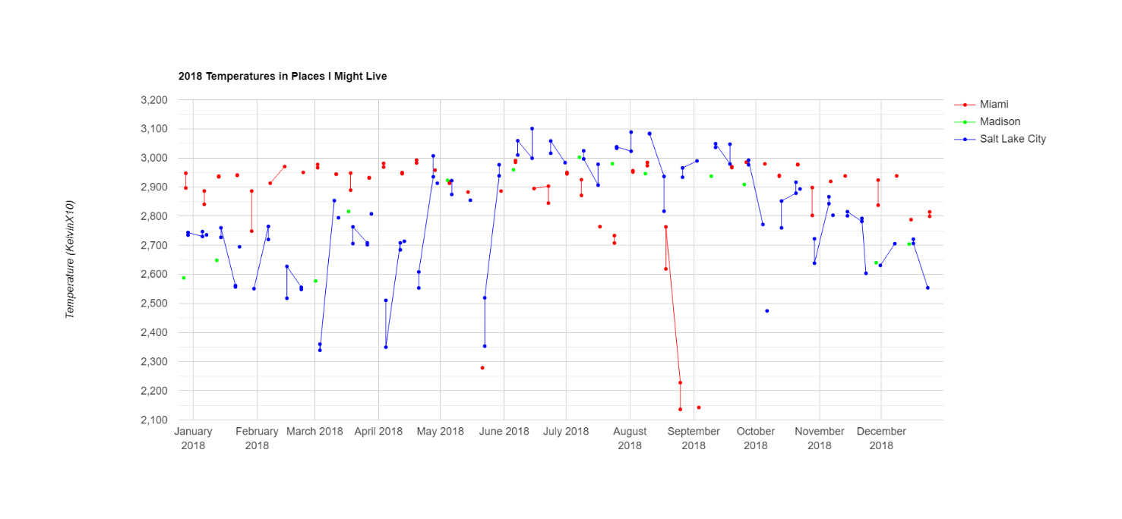
Greenness
EVI values closer to 1 are greener, and Madison came out as the winder, with a summer greenness peak twice that of Salt Lake City and three time that of Miami. In the winter, Madison still had the highest EVI value of all three places. Since the ROIs were selected from the city centers, it stands to reason that Miami has more buildings and pavement than Madison, and Salt Lake City is drier (and thus has less vegetation). If I were to move to Miami on account of vegetation, I’d have to move somewhere on the peripheral of the city where there are more greenspaces.

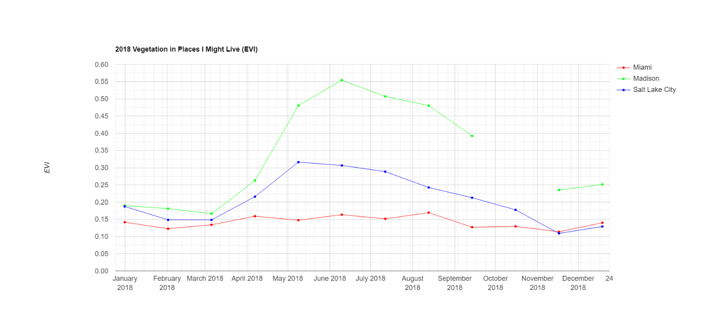
Snow Cover
Snow cover is enjoyable if it’s abundant, but inconvenient if it’s only occasional. However, NDSI clearly accounts for pavement and building, as NDSI averages for Miami, Madison, and Salt Lake City are 0.188, 0.006, and 0.095, respectively; obviously Miami does not have the highest snow cover. Looking only outside the summer months, Salt Lake City always had higher snow cover in 2018 than Madison.

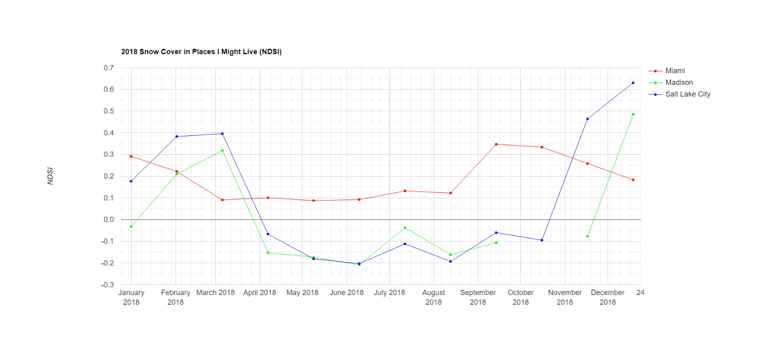
Conclusion
Both Miami and Salt Lake City seem like good alternatives to Madison, though for different reasons. Using multiple years for the average of each variable would provide a more reliable estimate, and would need to be done before making a decision based on this information. The code used for this project can be found here: https://code.earthengine.google.com/0508acfb4f0cc7da2ce5643b6a3e3c26

