

DHOLE PATIL COLLEGE OF ENGINEERING WAGHOLI,PUNE- 412207

A

PROJECT REPORT ON

Student marks calculation

OF

BACHELOR OF ENGINEERING IN INFORMATION TECHNOLOGY

AT

Savitribai Phule Pune University, Pune

Under The Guidance of

Prof. Nehali shinde mam

**DEPARTMENT OF INFORMATION TECHNOLOGY 2021-2022**



DHOLE PATIL COLLEGE OF ENGINEERING WAGHOLI,PUNE- 412207

DEPARTMENT OF INFORMATION TECHNOLOGY

# CERTIFICATE

This is to certify that,

Rohini Balpande 72153944M

Sharvari khade 72154018L

Vrushali Khot 72154148J

Krushna Khedkar 75154020B

Mayuri patil 72154064D

Have successfully completed the project entitle “Student marks calculation” in partial fulfillment for the award of degree of Bachelor if Engineering in Information Technology of savitribai phule Pune University during the academic year 2021-2022. The project report has been approved as is statisfies the academic requriment in respect work prescribed by the said degree.

Date:- 24 May, 2022

Place:-DPCOE

Prof. Nehali Shinde (Project Guide)

Prof. Rahul Ghode (Head of Department)

(External Examiner)

**TABLE OF CONTENTS**

**Sr.no Title**

1. **SYNOPSIS**

**1.1 Project Title**

**1.2 Project option**

**1.3 Internal guide**

**1.4 Technical keywords**

**1.5 Problem statement**

**1.6 Abstract**

**1.7 Goals and objective**

**1.8 Project plane**

**2 TECHNICAL KEYWORDS**

**2.1 Area of Project**

**2.2 Technical keyword**

**3 INRODUCTION**

**3.1 Overview**

**3.2 Need**

**3.3 Basic Concepts**

**3.4Goals**

**3.5Objectives**

**4 Technical Keywords**

**4.1 ER Diagrams**

**4.2 Schema Diagram**

**5 PROJECT DESIGN**

**6 CONCULSION**

**7 REFERENCES**

|  |  |
| --- | --- |
|  |  |
|  |  |
|  |  |
|  |  |

**INTRODUCTION**

We created our mini project of DBMS with the help of java programming language. Our project name is “Student Marks Calculation”. In which firstly we have to made table of students marks calculation. By which we can easily compiled our code. We used software “Intellij idea” which is one of the best platform for java programming. This app was made as part of a group project where five students each made an app and the packaged it into one app but for this we only included the app “intellij idea” there is a navigation bar activity. Compile JDK version 2021.3.2.

“intellij idea” ultimate is a mini platform supports all the language like JVM groovy, scala,cotin..

“itellij idea” is a mini platform supports all the language like JBM, groovy, scala, cotlin…

“itellij idea” ultimate is a superset of most ittelij platform based on id’s , student mark, analyzing system has been design to carry out the mark analyze process in an educational institution. The results of respective departments. If your code based on mainly in python “PYCHAM” is the best ide for us.

**ABSTRACT**

The goal of this project is to create a system that will capture marks, calculate final marks. HOD and Principal can also look out that marks. Hence a multiple user system that will allow each faculty to enter marks from his/her class and others should view the value of college.

There are many students in one class then its became a easy way to calculate students no students marks for that we have just have to enter the subject marks.

**OBJECTIVES** :

The main objective of student marks calculation is to manage the details of student profiles. It manages all the information about student name, student roll no, marks, grade. The project is totally build at administrative level and thus only the administrate is garrented the access.

* This program calculate the grades of a student based on the marks enter by user in each subject.
* Program prints the grade on this logic.
* If the avg is > 50 then the student is “pass” else avg < 50 then student is “fail”.

**TECHNICAL KEYWORDS:**

* Database is name collection of tables.
* Command
* Query
* Table (relation file class)
* Column (field attribute)
* Row (record tuple)
* Client, server
* Java

**PROBLEM DEFINATION AND SCOPE :**

The system is aim at total user-friendly as well as efficient management of varied tasks. These tasks may range from registering new students, managing fees payment, Examination management to all the essential features necessary for making the administrative division of school effective.

In case of manual system they need a lot of time, manpower etc. Here almost all work is computerized. So the accuracy is maintained. Student marks calculation mainly deals with Employee profile, payroll Management and fee collection which can be managed by the admin.

The project deals with the various functioning in student marks calculation.

The main idea is to implement a proper process to system. In our implement a proper process to system.

In our existing system contains a many operation registration, student search, fees, attendance, exam, record, performance of student.

**PROJECT PLAN**

* In order to develop our schedule, We first need to define the activities, Sequence them in the right order, estimate the resource needed, and estimate the time it will take to complete the tasks.
* The activity definition process is a further breakdown of the work package elements of the WBS.
* It documents the specific activities needed to fulfill the deliverables detailed in the WBS.
* These activities are not the deliverables themselves but the individual units of work that must be completed to fulfill the deliverable.
* Activities definition uses everything we already know about the project to divide the work into activities that can be estimated.
* You might want to look at all the lessons learned from similar projects your company has done to get a food idea of what you need to do on the current one.
* Expert judgment in the form of project team members with prior experience developing project scope statements and WBS can help you define activities.
* If you are asked to manage a project in a new domain, you might also use experts in that particular field to help define tasks so you can understand what activities are going to be involved.
* You may want to create an activity list and then have the expert from the very beginning and ask to have making your first draft of the list.
* Some time you start the project without knowing a lot about the work that you will be doing later.
* Rolling-wave planning lets you plan and schedule only the portion that you know enough about to plan well.
* When you don not known portion until you known more.
* These are extra items that are put at high levels in the WBS to allow you to allow you to plan for the unknown.

**LANGUAGES USED IN PROJECT**

* JAVA  **:-** Java is coding language. Which was made in 1991by sunmicrosystems.
* James goslin one of the inventor of java who called as a OAK.
* Java is simple to use.
* Java is simple, portable a language.
* Java having JDK AND JRE for running code.

**ER DIAGRAM OF STUDENT MARKS CALCULATION**

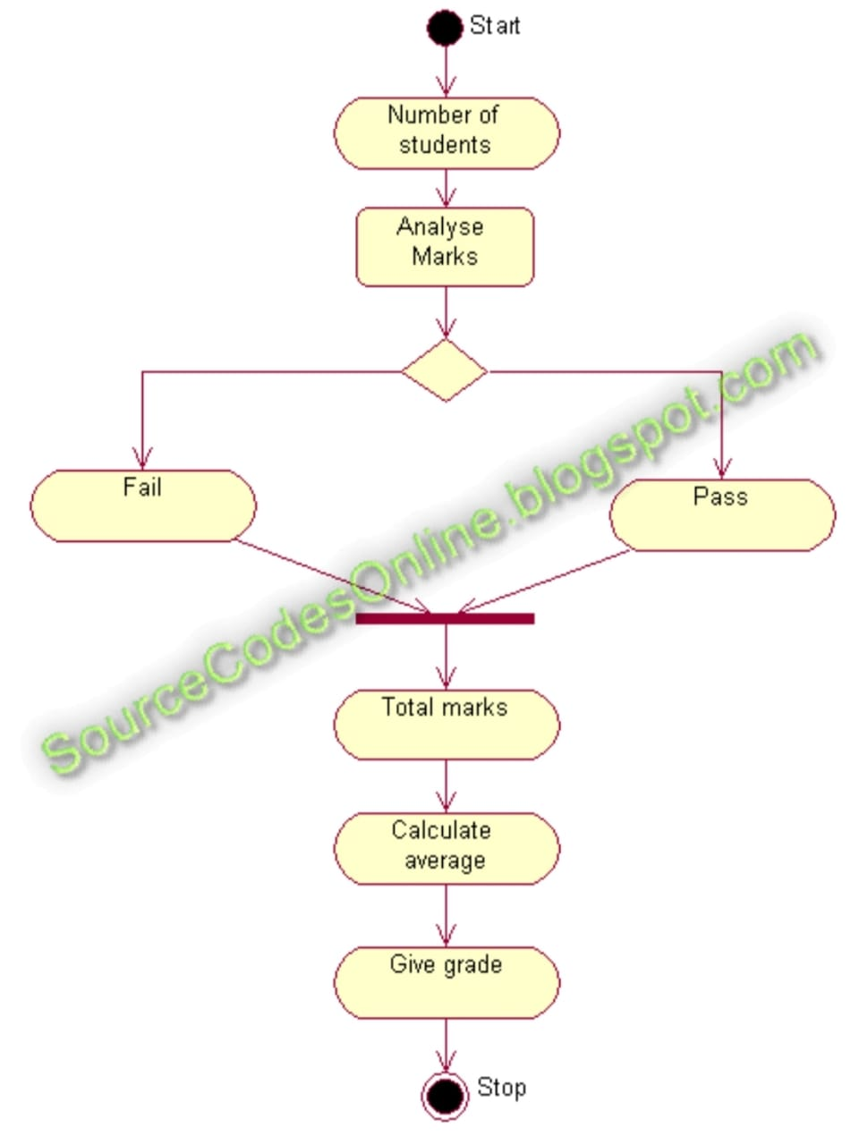

**PROJECT DESIGN**

**import javax.swing.*;**

**import java.awt.event.ActionEvent;**

**import java.awt.event.ActionListener;**

**public class STUDENTMA {**

**private JTextField txtStname;**

**private JTextField txtRl;**

**private JTextField txtDM;**

**private JTextField txtCM;**

**private JTextField txtSM;**

**private JTextField txtMM;**

**private JTextField txtPM;**

**private JTextField txtTM;**

**private JTextField txtAVG;**

**private JTextField txtGRADE;**

**private JButton CALButton;**

**private JPanel Main;**

**public static void main(String[] args) {**

**JFrame frame = new JFrame("STUDENTMA");**

**frame.setContentPane(new STUDENTMA().Main);**

**frame.setDefaultCloseOperation(JFrame.EXIT_ON_CLOSE);**

**frame.pack();**

**frame.setVisible(true);**

**}**

**public STUDENTMA() {**

**CALButton.addActionListener(new ActionListener() {**

**@Override**

**public void actionPerformed(ActionEvent e) {**

**int DBMSmarks,CGmarks,M3marks,SEmarks,PAmarks,TOTAL;**

**double avg;**

**DBMSmarks=Integer.parseInt(txtDM.getText());**

**CGmarks=Integer.parseInt(txtCM.getText());**

**PAmarks=Integer.parseInt(txtPM.getText());**

**SEmarks=Integer.parseInt(txtSM.getText());**

**M3marks=Integer.parseInt(txtMM.getText());**

**TOTAL=DBMSmarks+CGmarks+M3marks+SEmarks+PAmarks;**

**txtTM.setText(String.valueOf(TOTAL));**

**avg=TOTAL/5;**

**txtAVG.setText(String.valueOf(avg));**

**if(avg>50){**

**txtGRADE.setText("PASS");**

**}**

**else**

**{**

**txtGRADE.setText("Fail");**

**}**

**}**

**});**

**}**

**}**

**OUTPUT OF STUDENT MARKS CALCULATION**

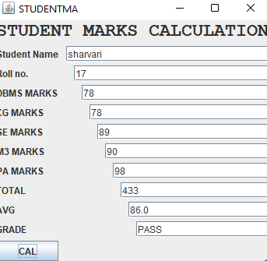

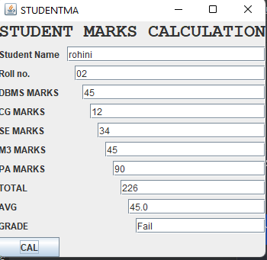

**REFERENCES**

* [**https://www.gigacalculator.com/calculators/marks-percentage-calculator.php**](https://www.gigacalculator.com/calculators/marks-percentage-calculator.php)
* [**https://nool.ontariotechu.ca/study-skills/grade-calculator/index.php**](https://nool.ontariotechu.ca/study-skills/grade-calculator/index.php)
* [**https://tutorial.techaltum.com/c-program-to-find-grade-of-a-student.html**](https://tutorial.techaltum.com/c-program-to-find-grade-of-a-student.html)
* [**https://www.ucas.com/advisers/managing-applications/our-adviser-portal/references-and-predicted-grades**](https://www.ucas.com/advisers/managing-applications/our-adviser-portal/references-and-predicted-grades)
* [**https://codeforwin.org/2015/05/c-program-to-enter-student-marks-and-calculate-percentage-and-grade.html**](https://codeforwin.org/2015/05/c-program-to-enter-student-marks-and-calculate-percentage-and-grade.html)

**CONCULSION**

**To calculate how to compute a student's percentage of marks in an exam, a student's total marks should be divided by the maximum marks, and then multiplied by 100.**

**For instance, if a student receives 95 out of 100 in DBMS, 85 out of 100 in SE, 75 out of 100 in M3, 87 out of 100 in PA And 99 out of 100 in CG. The student's total marks will be added.**

**FUTURE SCOPE**

**It assist the faculty and student to analysis**

**his/her and the whole class performance in a subject. The scope of this project is addressed to solve the issues of long waiting and calculation of grades and percentages in different semesters. Student mark analyzing system has been designed to carry out the mark analysis process in an educational institution. The results of respective departments can be efficiently computed without much of manual involvement. 1.2 Objectives.**

**The purpose of this document is to define the requirements of mark analysis system**

**THANK**

**YOU….**