**About IMPETUS Lubricants**

IMPETUS Lubricants is a leading name in the Indian lubricant industry, dedicated to delivering high-performance engine oils, greases, and automotive solutions. Our mission is to empower vehicles with premium-quality lubricants, ensuring unmatched engine protection, efficiency, and durability.

**Company Profile**

IMPETUS Lubricants has established itself as a reputable manufacturer and supplier of high-performance oils and lubricants since its inception. We are committed to quality, innovation, and customer satisfaction.

**Our Vision**

To be recognized globally as a premier Indian lubricant company known for quality, performance, and trust.

**Our Mission**

To provide high-grade lubricants at competitive prices, backed by strong service and a passionate team that meets customer needs efficiently.

**Why Choose Us?**

We pride ourselves on our ethical business values, thorough product quality testing, timely order fulfillment, and commitment to long-term relationships with our clients.

**Key Company Facts**

|  |  |
| --- | --- |
| **Nature of Business** | Manufacturer, Supplier, Trader, Exporter |
| **Year of Establishment** | 2010 |
| **Monthly Production** | As per Client's Requirement |
| **Ownership Type** | Partnership |
| **Head Office** | Surat, Gujarat, India |

**Our Team**

**Mr. Shailesh Dhola**

CEO & Founder — A Chemical Engineer and MBA from UC Berkeley, leading innovation at IMPETUS.

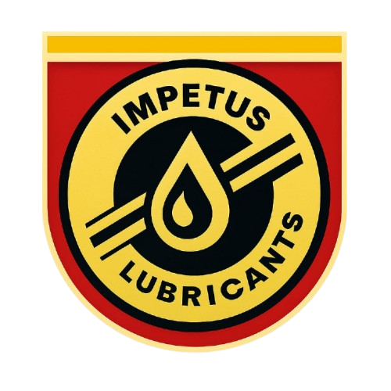

## IMPETUS

# About IMPETUS Lubricants

IMPETUS Lubricants is a leading name in the Indian lubricant industry, committed to delivering high-performance engine oils, greases, and automotive solutions. With a mission to empower vehicles with premium-quality lubricants, we ensure unmatched engine protection, efficiency, and durability — even on the toughest Indian roads.

Our dedication to quality, innovation, and customer trust has helped us build a strong and growing network of dealers and distributors across India. Whether you’re a vehicle owner, a workshop, or a distributor, IMPETUS Lubricants is your reliable partner for long-lasting performance and productivity.

# Company Profile

Welcome to **Volubit Lubricants Industries**, a leading name in the field of high-performance oils and lubricants since 2010.

### About Us

Established in 2010, **Volubit Lubricants Industries** is a reputed manufacturer, supplier, trader, and exporter of premium oils and lubricants. We aim to lead the market by offering quality-driven, cost-effective solutions like EP-0 Grease, API GL5 Gear Saver, CNG Oils, Synthetic Engine Oils, Rust Cleaners, and more. Our core values revolve around transparency, integrity, and total customer satisfaction.

#### Our Vision

To be recognized globally as a premier Indian lubricant company known for quality, performance, and trust.

#### Our Mission

To provide high-grade lubricants at competitive prices, backed by strong service and a passionate team that meets customer needs efficiently.

### Why Choose Us?

* ✅ Ethical business values & client-first approach
* ✅ Thorough product quality testing
* ✅ Timely and secure order fulfillment
* ✅ Commitment to long-term relationships

### Our Infrastructure

Our Surat-based production facility spans over 1000 sq. meters and includes advanced R&D, testing, packaging, and distribution units. Our infrastructure enables us to deliver excellence with speed and scale.

### Meet Our Team

**Mr. Shailesh Dhola**, CEO & Founder — A Chemical Engineer and MBA from UC Berkeley, leading innovation at Volubit.

**Mr. Dharmesh Gabani**, Chairman & Executive Director — A technical expert and global business strategist, shaping our leadership since 2017.

### Product Range Highlights

We focus on both quantity and quality, offering products like:

* 🛢️ SAE 20W40 CNG Oil
* 🧴 Calcium Base MP-3 Grease
* 🚿 Radiator Extra Coolant
* 🧼 Multi Cleaner Spray
* 🔧 Compressor Oil 150

### Key Company Facts

|  |  |
| --- | --- |
| **Nature of Business** | Manufacturer, Supplier, Trader, Exporter |
| **Year of Establishment** | 2010 |
| **No. of Employees** | 25 |
| **Monthly Production** | As per Client's Requirement |
| **Import Export Code** | AAQFV8298M |
| **Annual Turnover** | INR 5 Crore |
| **GST No.** | 24AAQFV8298M1Z0 |
| **Ownership Type** | Partnership |
| **Head Office** | Surat, Gujarat, India |

© IMPETUS Lubricants | All Rights Reserved.