- Import a sample dataset of IPL cricket matches into Power BI and create a Table visual that displays Team Name, Runs Scored, and Match Date.
ANSWERS:
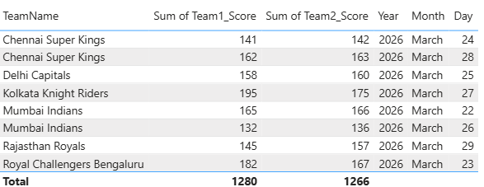

- Using a dataset of Zomato restaurant ratings, create a Matrix visual in Power BI that shows average rating per City and Cuisine type.
ANSWERS:
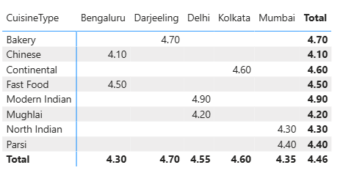
- Design a Card visual in Power BI to display the total number of active users from a Flipkart user data file.
ANSWERS:
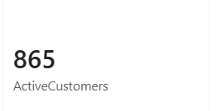
4.) Build a KPI visual in Power BI that tracks the monthly increase in Spotify premium subscriptions and shows whether the current month’s number is higher or lower than the previous month.
ANSWERS:
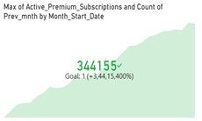

- Create a Bar or Column chart in Power BI using a BookMyShow movie bookings dataset to compare the number of tickets sold for the top 5 movies.
Hint Use the 'Top N' filter to show only the top 5 movies by ticket sales.
ANSWERS:
