- Download and install Power BI Desktop on your computer, then open the application and take a screenshot of the blank report interface
ANSWER: 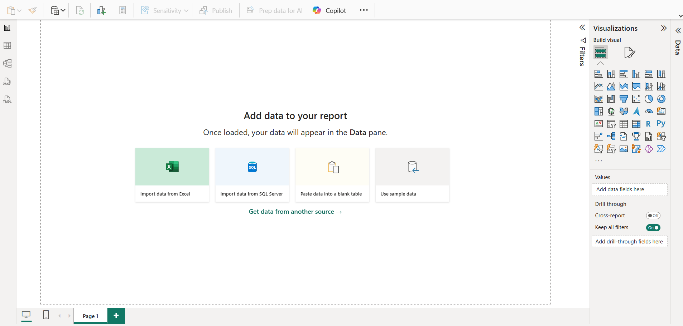

- Explore the Power BI Desktop interface and identify the following components: Report View, Data View, Model View, Fields Pane, Visualizations Pane, and Filters Pane. Write a short description (1-2 lines) for each component.
ANSWER:
Report View → Create reports.
Data View → View data tables.
Model View → Manage table relationships.
Fields Pane → Contains data fields.
Visualizations Pane → Create charts and visuals.
Filters Pane → Filter data displayed in reports.

- Create a new blank report in Power BI Desktop and add a table visual using the Visualizations Pane. Rename the report page to 'My First Dashboard
ANSWERS:
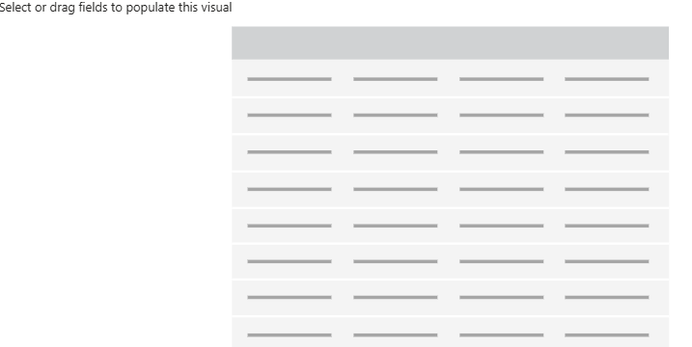

4. List 3 key differences between Excel Dashboards and Power BI Dashboards, focusing on features or workflows you noticed while exploring Power BI Desktop.
ANSWERS:
Data Size
- Excel: Small to medium data.
- Power BI: Large datasets.
Visuals
- Excel: Basic charts.
- Power BI: Interactive charts and dashboards.
Sharing
- Excel: Share files manually.
- Power BI: Online sharing with automatic refresh.

