Section B: Practical Task
- Connect to the Kaggle Superstore dataset and use Power Query to replace null values in the "Postal Code" column with a default string.
ANSWERS:
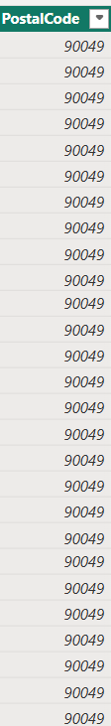

- Create a calculated column using DAX to categorize "Profit" into "High," "Medium," and "Low" based on a multi-condition IF statement.
ANSWERS:
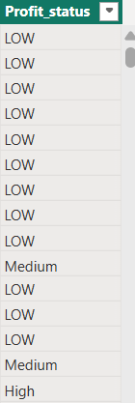

- Develop a dynamic measure using TOTALYTD to calculate Year-to-Date Sales and display it on a KPI card visual.
ANSWERS:
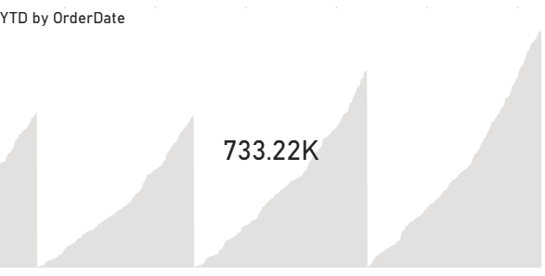

- Configure a Top N filter on a Bar Chart visual to display only the top 5 sub-categories by total profit margin.
ANSWERS:
