- In Power BI Desktop, create two tables: 'Restaurants' (with columns RestaurantID, Name, Cuisine) and 'Reviews' (with columns ReviewID, RestaurantID, Rating, Comment). Identify and set the primary key and foreign key relationships between these tables.
ANSWERS:
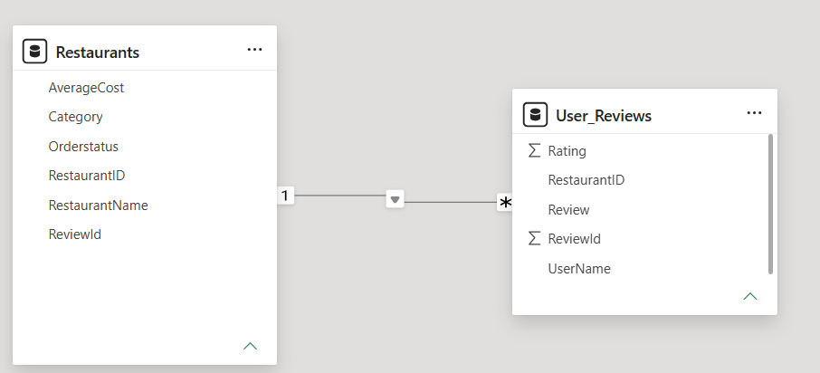

- Design a Star Schema in Power BI for a Zomato-style food delivery dataset by creating a central 'Orders' fact table and at least three dimension tables (such as 'Customers', 'Restaurants', and 'Dishes'). Connect them using appropriate relationships.
ANSWERS:
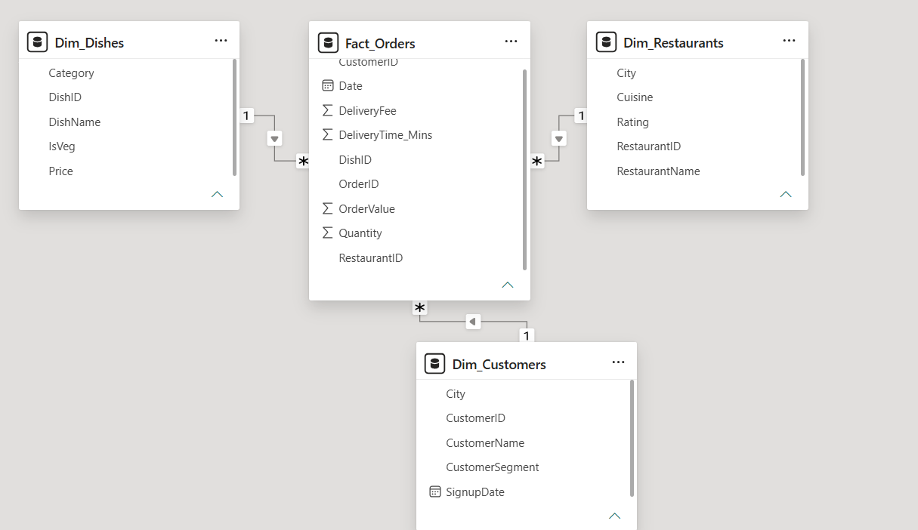

- Modify your Star Schema from the previous task into a Snowflake Schema by normalizing one of the dimension tables (for example, split 'Restaurants' into 'Restaurants' and 'Locations'). Update the relationships in Power BI accordingly. <strong>Hint:</strong> Use the Model view to manage and visualize the new relationships

ANSWERS:
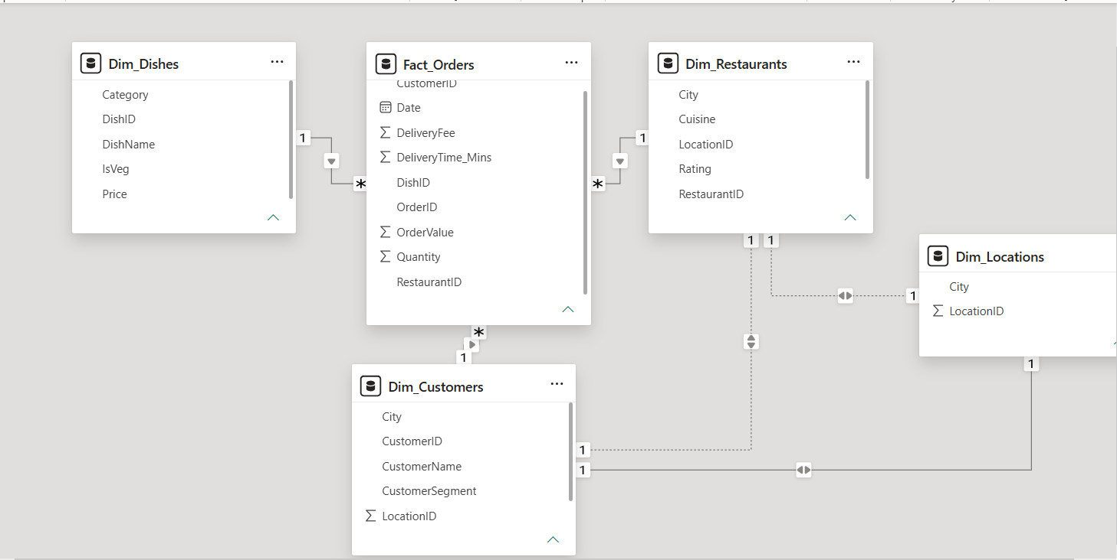

- In Power BI, import two tables: 'Users' (UserID, Name, Email) and 'Playlists' (PlaylistID, Name, UserID). Then add a third table 'Collaborators' (PlaylistID, UserID) to represent many-to-many relationships where multiple users can collaborate on multiple playlists. Set up the correct relationships and explain how Power BI handles this scenario.

ANSWERS:
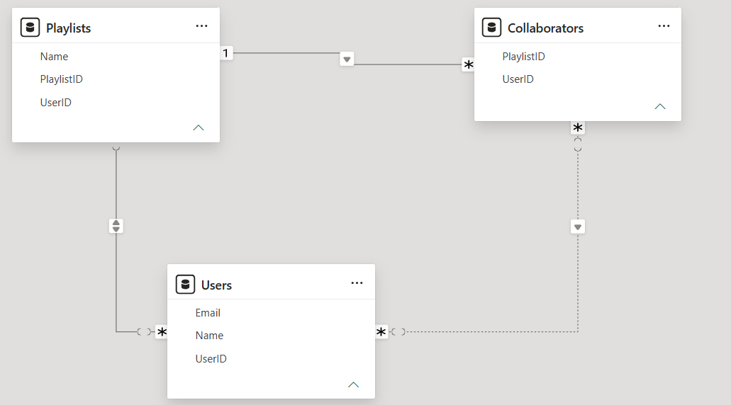

- Given a Power BI model where the 'Orders' table is not showing correct totals for each 'Dish' because of a missing relationship, use the Model view to identify and fix the issue by creating the appropriate one-to-many relationship.<strong>Hint:</strong> Check for unmatched keys or inactive relationships.
ANSWERS:
