Section C: Mini Project
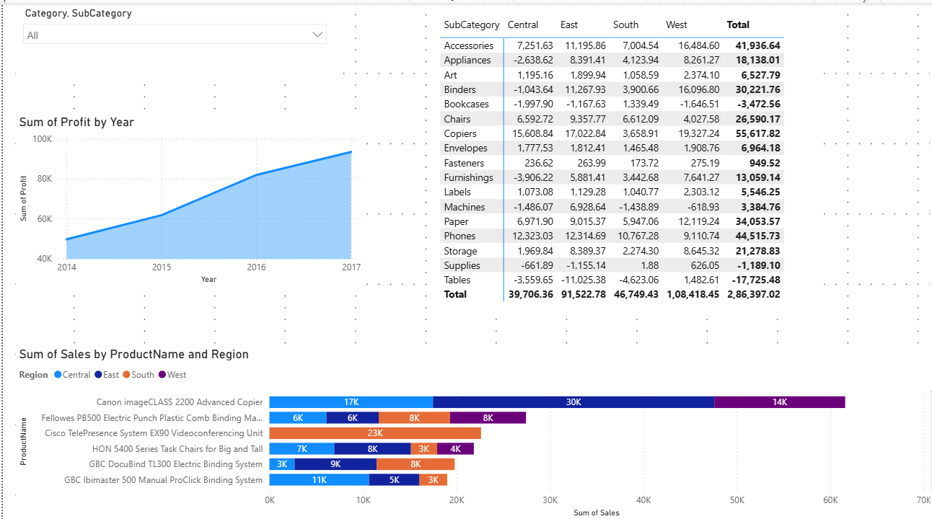
PROBLEM: Give higher discount. Profit are not generating
SOLUTIONS: Give Less discounts Profits are increase.

