- In Power BI Desktop, import a sample dataset of IPL cricket matches and create a bar chart showing total runs by each team. Enable drill-down so that clicking on a team reveals runs by individual players from that team.
ANSWERS:
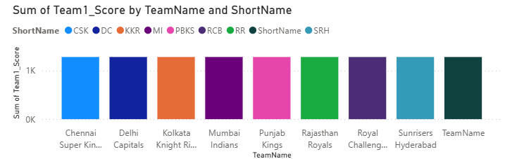

- Create a hierarchy in Power BI using a dataset of movies (for example: Genre > Year > Movie Title). Build a visual that lets users drill through these levels to see box office collections at each stage.

Hint: Use the 'Manage Hierarchy' option in the Fields pane to set up your levels.
ANSWERS:
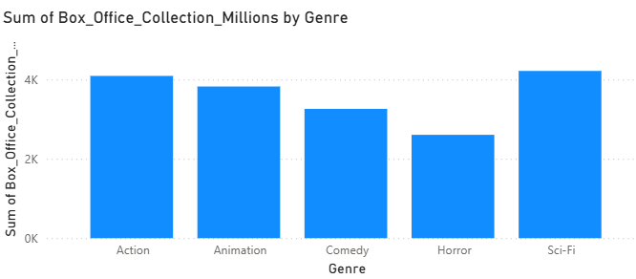

3.) Apply conditional formatting to a table visual displaying restaurant ratings (like Zomato) so that ratings above 4.5 appear in green, between 3 and 4.5 in yellow, and below 3 in red.
ANSWERS:
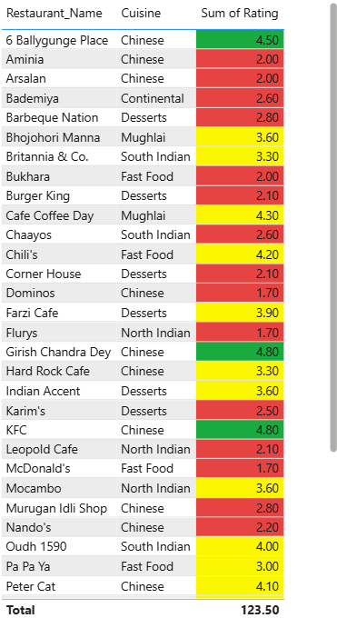

- Go to the Power BI Marketplace and add a custom visual of your choice (for example, a 'Word Cloud' or 'Bullet Chart'). Use it to visualize the most frequently ordered food items from a Swiggy-style order dataset.

Hint: After importing, drag the visual onto your report and assign the relevant field.
ANSWERS:
------------------------------
- Use ChatGPT to help you write a DAX formula that calculates the average delivery time per city from a Flipkart orders dataset, then apply this measure to a visual in your Power BI report.
Hint: Paste your ChatGPT prompt and the generated DAX formula in your submission.
ANSWERS:
