1.) In Power BI, import a sample IPL cricket match dataset and create a model view showing the relationships between Teams, Players, and Matches tables. Set up one relationship as inactive and explain in a comment why it might be useful to have inactive relationships in a sports analytics scenario.
ANSWERS:
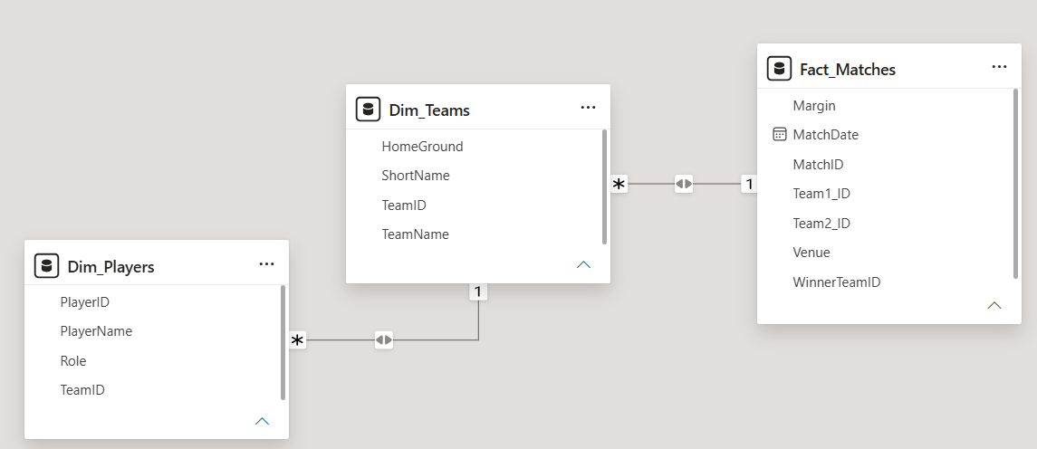
2.) Change the cross filter direction between your Matches and Players tables from single to both in the model view. Observe and describe how this affects the filtering of player stats when you select a specific match in your report.
Hint: Use a slicer or filter in your report to test the impact of the cross filter direction.
ANSWERS:
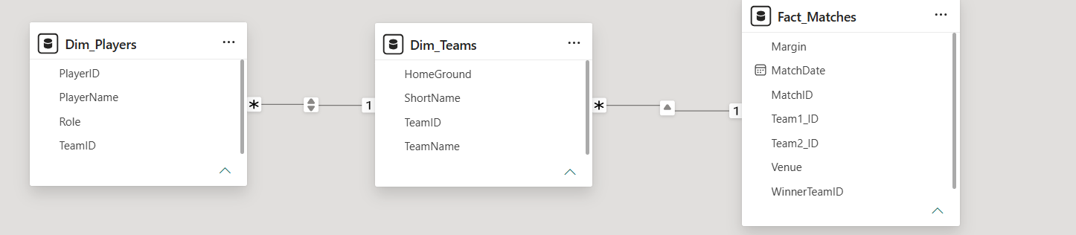
3.) Hide the PlayerEmail and PlayerPhone fields in the Players table from report view in Power BI, so that only relevant stats are visible to end users viewing dashboards.
ANSWERS:
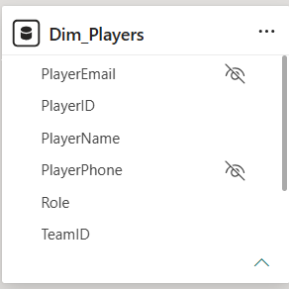

4.) Add a calculated column to the Matches table that labels each match as 'High Scoring' if total runs are above 200, otherwise 'Regular'. Then, create a measure that calculates the average runs per match. Compare how calculated columns and measures behave in your report.
Hint: Use DAX functions for both the calculated column and the measure.
ANSWERS:
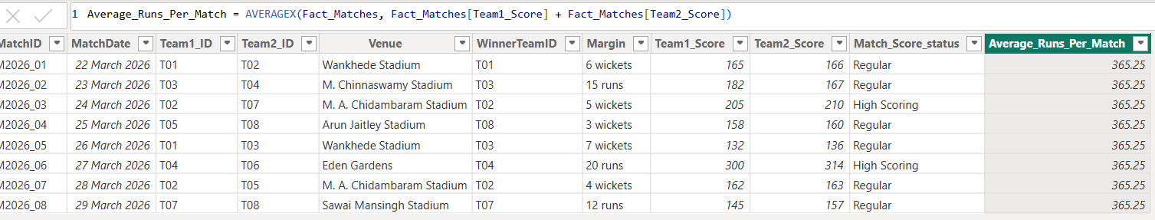
5.) Create a date hierarchy in your Matches table (Year > Month > Day) and use it to build a line chart showing the number of matches played over time, similar to how BookMyShow might display movie releases by date.
