- In Power BI Desktop, create a calculated column named 'OrderAmountINR' in a Sales table that multiplies the 'OrderAmount' column by 83 to convert USD to INR.
ANSWERS:
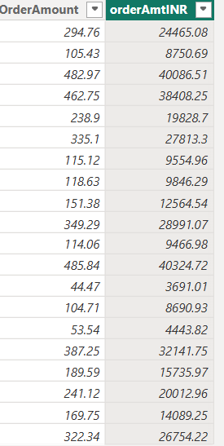

- Build a DAX measure called 'Total Likes' that sums up the 'Likes' column in a Social Posts table, similar to how Instagram shows total likes for a user.
ANSWERS:
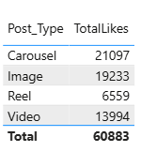

- Create a slicer for 'Genre' in a Movies table and use a DAX measure to display the average 'UserRating' for the selected genre, like filtering movies by category on BookMyShow.
ANSWERS:
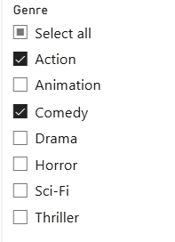

- Compare calculated columns and measures by creating both: a calculated column 'DiscountedPrice' (Price - Discount) and a measure 'TotalDiscountedSales' (sum of DiscountedPrice) in a Flipkart-style Products table.
Hint: Observe how each updates when you use filters or slicers.
ANSWERS:
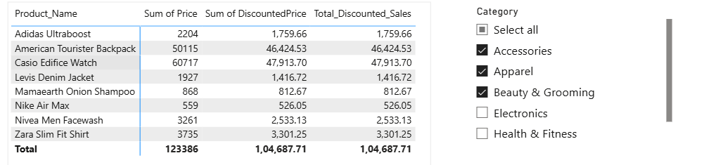

- List all the DAX data types you used in the above tasks and give one example of a real-world app field (from Zomato, Paytm, etc.) that would use each type.
ANSWERS:
